Introduction to Mercury
(Instructions for iPad)

The Cambridge Crystallographic Data Centre (CCDC) curates the Cambridge Crystallographic Database (CSD), which contains over 950,000 structures. A teaching subset of the database is freely available and this can be accessed using a web browser at the link found below.
https://www.ccdc.cam.ac.uk/structures/search?compound=Teaching%20Subset
We will be using this resource regularly over the course of the semester and this exercise will provide an introduction to finding structures in the database and how visualize and analyze these structures on an iPad. (Note that these instructions will also be valid for accessing the structures using a web browser on a laptop or desktop computer.)

Accessing Structures
You can access and search the structures in the teaching subset using the CCDC’s Access Structures page (https://www.ccdc.cam.ac.uk/structures/).
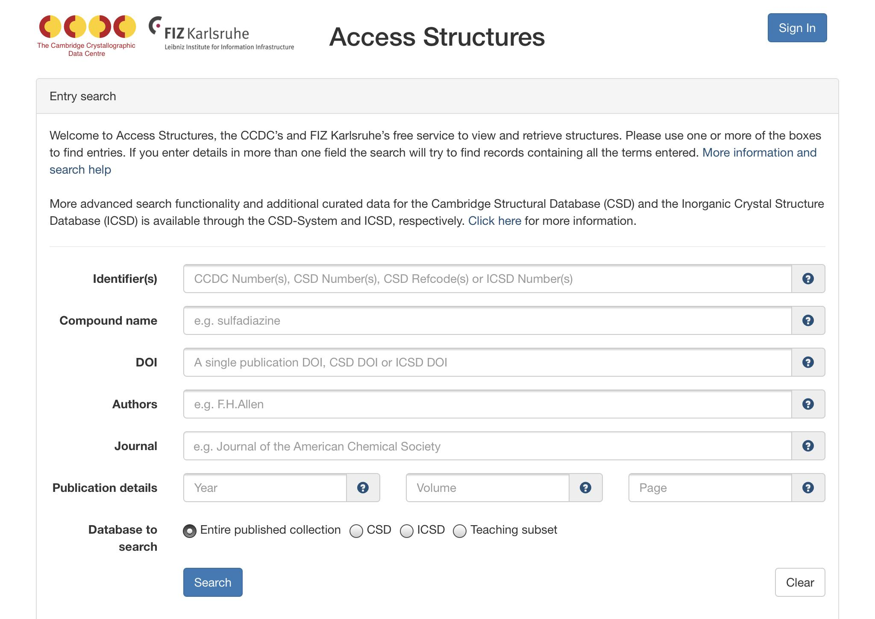

In the Identifiers box, enter the accession code for the structure of interest (in this case, BAZSUR) and hit the Search button. The following page will appear.
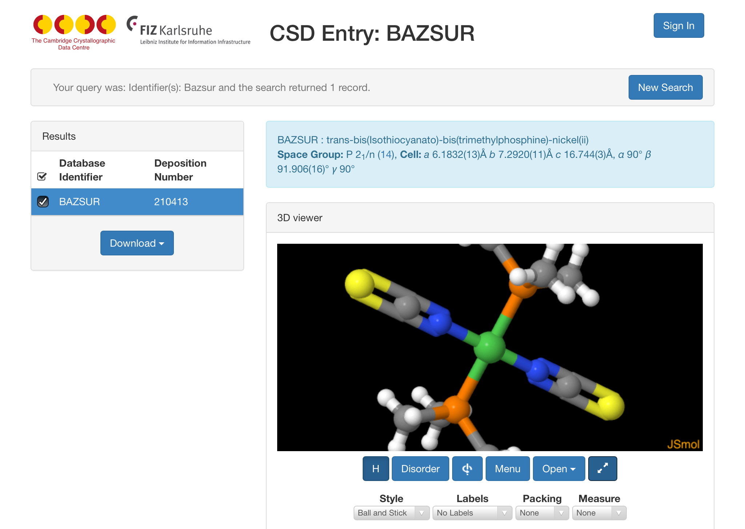

Structural Information
From this window, you are able to get all of the background information about this structure.

Please enter or write the name and formula of the complex below.

Please enter or write the literature reference for the structure below.

Please draw the diagram of the complex below. (You can also take a screenshot of the diagram provided on the page and inserting it below.)

Visualizing Structures

Choose the Expand button (the blue button with the diagonal arrow) so that you can view a larger structure.
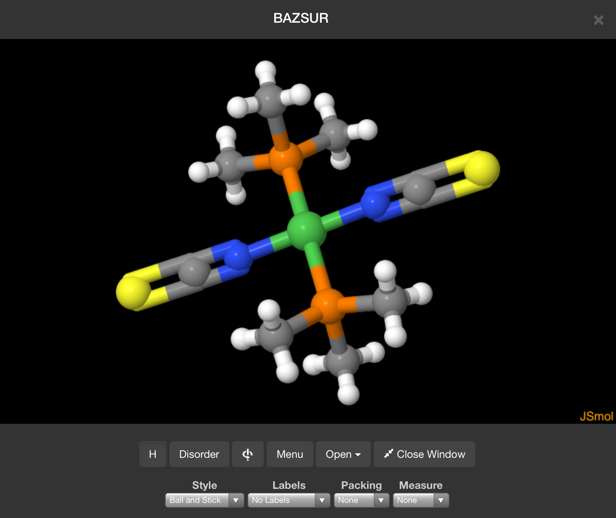

The molecule can be manipulated using several common gestures:
- A one-finger hold and drag will rotate the structure.
- A two-finger hold and drag will translate the structure.
- A pinch/unpinch will zoom out from/in towards the structure.

The buttons at the bottom of the window allow you to perform several common functions. (These buttons are also available on the original web page.) From left to right the buttons have the following functions:
- H: This button toggles between showing/hiding the hydrogen atoms in the structure.
- Disorder: This allows the visualization of any disorder present in the structure.
- : This button switches the view from a static to a rotating structure.
- Menu: This menu provides access to many advanced JSmol commands. (This will not routinely used in this class.)
- Open: This allows you to open the structure in an external viewer. (This is not used on the iPad, only on desktop or laptop computers.)
- Close Window: This button closes the expanded window and returns to the original web page.
The representation of the structure can be changed by choosing options from the Style menu found at the bottom of the window. (In the figures included in this document, the “Ball and Stick” style is used.) Take a few moments and look at the different representations (wireframe, capped sticks, ball and stick, and spacefill) that could be used.

Some (or all) of the atoms in the structure can be labeled by choosing an option from the Labels menu (below left) found at the bottom of the window.
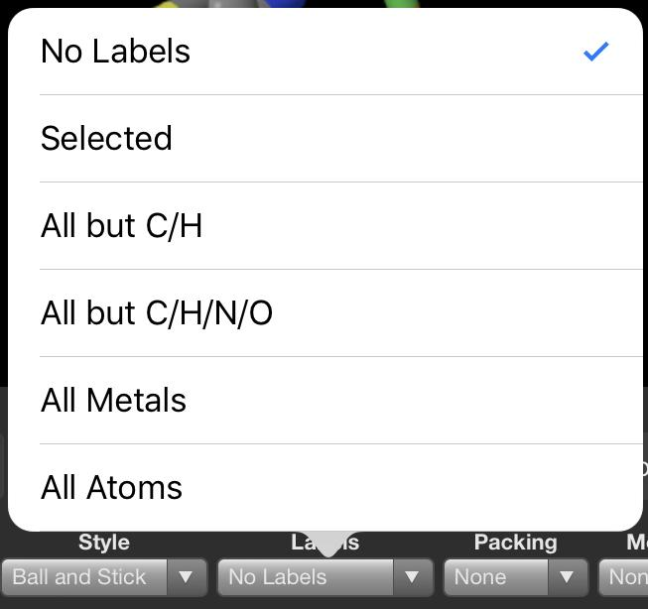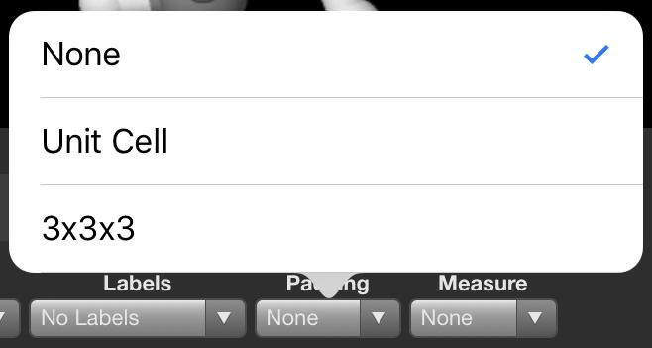
The Packing menu (above right) provides several options for changing how the structure is displayed: None, where one molecule/complex is shown; Unit Cell, where all molecules fully or partially contained in a single unit cell are shown; and 3x3x3, where an array of unit cells are displayed.

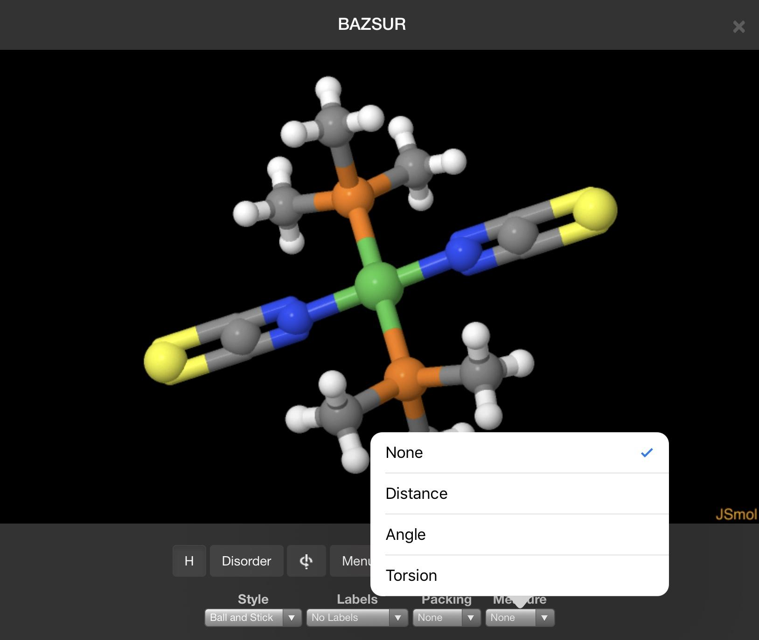
Analyzing Structures

Bond lengths and angles can be measured using the the Measurement drop-down menu. From the menu you must first choose the appropriate measurement. To begin a measurement, tap twice on the first atom and then tap twice on the final atom to end the measurement. If there are any atoms that need to be chosen in between, tap them once. (To clear the measurement, you can either repeat the taps you made to create the measurement or choose None from the Measurement menu.)

For example, to measure the Ni-N bond length, you would choose Distance from the Measurement menu, then tap twice on the nickel (green) and then twice on one of the nitrogens (blue). (Note that there is no visual clue when you have tapped or double-tapped on an atom.) The measurement will then appear on the screen.

Please measure the distances between the nickel and the 4 attached atoms and enter them in the table below. The numbering indicated in the table can be seen when the atoms in the structure are labeled. The atom numbers may be hard to see because they may overlap with the atoms.

Bond | Bond length (Å)
Ni₁-N₁
Ni₁-N_{1B}
Ni₁-P₁
Ni₁-P_{1B}

To measure the bond angles in the structure, choose Angle and then choose the three atoms that define the angle in succession, starting with one of the “terminal” atoms. For example, to measure the P₁-Ni₁-N₁ angle, double tap on N₁ first, then single tap on Ni₁, then double tap on P₁ to get the angle defined by those three atoms (as shown in the figure below). Measure the angles listed and enter them in the table below.
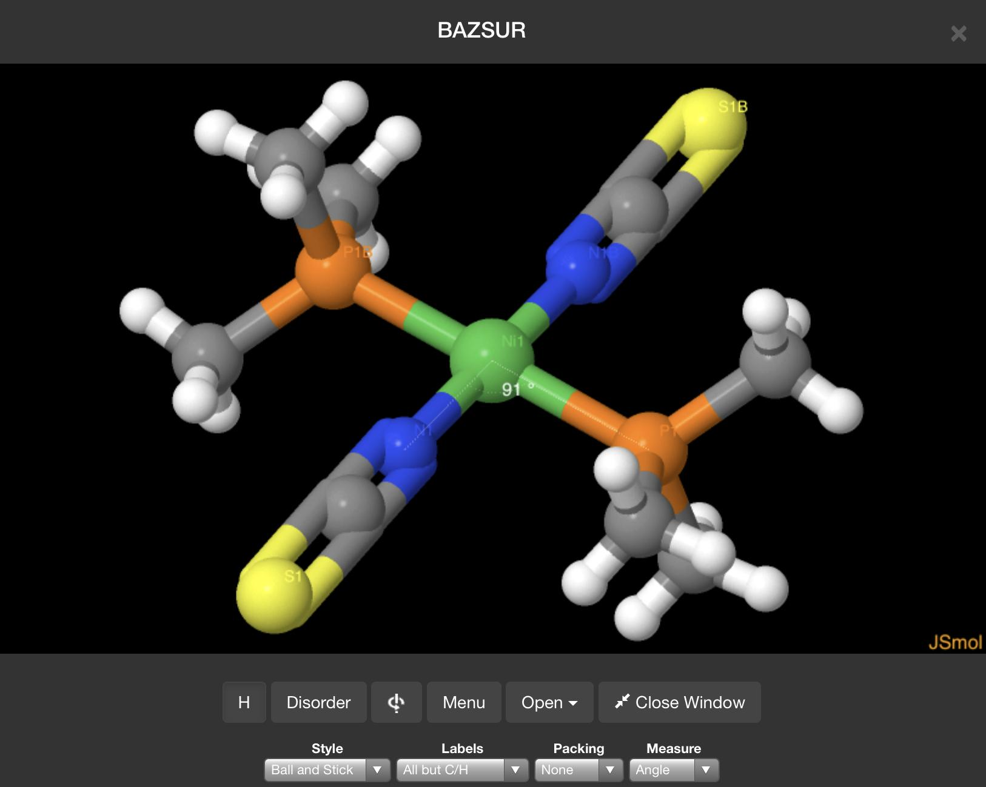
Angle | Bond Angle (º)
P₁-Ni₁-N₁
N₁-Ni₁-P_{1B}
P_{1B}-Ni₁-N_{1B}
N_{1B}-Ni₁-P₁
N₁-Ni₁-N_{1B}
P₁-Ni₁-P_{1B}

Given the bond angle measurements that you just made, what is the geometry of the complex?

Geometry =
Further work
Once you have finished this exercise, please call up the structure with the code BILMIS. Please go through the same steps that we followed above and provide the requested information below.

Please enter the name and formula of the complex below.

Please enter the literature reference for the structure below.

Please draw the diagram of the complex below.

Please determine the bond lengths of the following bonds.
Bond | Bond length (Å)
Mo₁-C₁
Mo₁-C₂
Mo₁-C₃
Mo₁-C₄
Mo₁-P₁
Mo₁-P₂

Please determine the bond angles listed in the table below.
Angle | Bond Angle (º)
C₁-Mo₁-C₂
C₁-Mo₁-C₃
C₁-Mo₁-C₄
C₂-Mo₁-C₃
C₂-Mo₁-C₄
C₃-Mo₁-C₄
C₁-Mo₁-P₂
P₁-Mo₁-P₂
P₁-Mo₁-C₁
P₁-Mo₁-C₂
P₁-Mo₁-C₃
P₁-Mo₁-C₄
P₂-Mo₁-C₁
P₂-Mo₁-C₂
P₂-Mo₁-C₃
P₂-Mo₁-C₄

Given the bond angle measurements that you just made, what is the geometry of the complex?

