**Cobalt-Ammine complexes and theories of bonding in metals**

**Introduction**

In 1893, Alfred Werner proposed a new way of describing metal-containing compounds that (eventually) established inorganic chemistry as a separate discipline by showing that metal bonding is distinct from that of organic and ionic species. Thirty-five years earlier, in 1858, Friedrich Kekule and Archibald Couper had independently developed the highly successful concept of chemical structure for organic compounds that we use today. This model was based on tetrahedral carbons arranged in specific ways (often in long chains), with other atoms bound to them as necessary to complete carbon’s octet. These ideas revolutionized the study of organic chemistry, and provided a framework for understanding the new field of chemical synthesis.

Understandably, chemists were eager to apply the new theories of bonding developed for organic molecules to other kinds of compounds. The cobalt-ammines (also called ammoniates or ammonates) are a class of compounds that contain a cobalt atom bound to varying numbers of ammonia molecules, and often include another anion as well. For instance, the cobalt ammonate chlorides are: CoCl3*6NH3, CoCl3*5NH3, CoCl3*4NH3.[1] (Note that the only difference in these compounds is the number of ammonia molecules present.) These compounds were highly colored, and displayed unexpected electrical properties.

At the time, electrochemistry was a primary method for determining the structure of compounds. A salt dissolved in water conducts electricity in proportion to the number of ions it produces. For instance, precipitation of silver chloride from a silver nitrate solution reduces the total number of ions from 3 to 1, and will also decrease the electrical conductivity of the solution to 1/3 of its original value:

AgNO3 (aq) + Cl- (aq) 🡪 AgCl (s) + NO3- (aq)

Using this measure, chemists found that the cobalt ammines precipitated different numbers of chlorine ions when mixed in solution with silver nitrate. This indicated that each of the cobalt compounds produced a different number of chlorine ions in solution. But why should these chemicals have different numbers of ammonia groups and different numbers of chlorine ions in solution?

To answer this question, Christian Blomstrand (1869) developed a “chain theory” of bonding for the cobalt ammine compounds, which was later adapted by his student, Sophus Jørgensen (1884). Drawing structures analogous to organic chemicals, they arrived at a cobalt metal bound to long chains of ammonia, with a chlorine at the end of each group. They proposed that the rate of precipitation for the chloride ions depended on their distance from the cobalt. Chlorines bound directly to the metal were assumed not to precipitate at all.

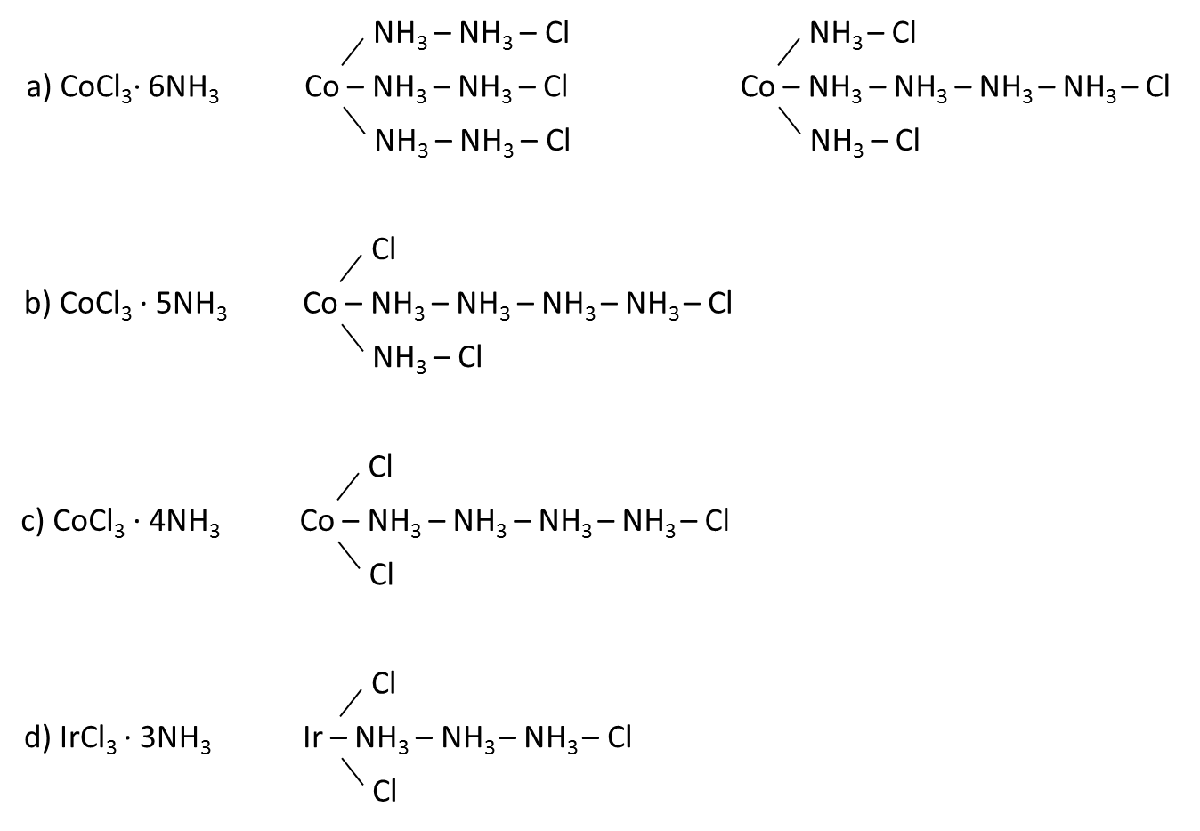

Figure 1. a) Two possible isomers for the compound CoCl3· 6NH3. According to the chain theory, ammonia groups were arranged in long chains, similar to the bonding of carbon in organic compounds.Blomstrand’s original representation (left) showed three equal chains of ammonia groups bound to the metal. Jørgensen’s adaptation used chains of different lengths (right) to account for the rate of chlorine deposition based on distance from the metal ion. b-c) Compounds with fewer ammonia molecules were drawn with direct Co-Cl bonds. d) IrCl3 · 3NH3 was the first compound to have three ammonias in a chain, but its precipitation behavior did not match the predictions of chain theory. Figure adapted from ref 1.

The chain theory explained the rate and number of chloride ions precipitated, but it did not explain why ammonia groups were only found in groups of 1, 2, or 4 (never 3), or why there were never more than 6 ammonia groups in a compound. Eventually, Jørgensen managed to synthesize an iridium compound with only 3 ammonia groups in its chain. The chain theory predicted that this compound should have had one ionizable chlorine and two that would stay bound to the metal, but experiments showed that *no* chloride ions were formed when this compound was dissolved in solution!

Alfred Werner was a young, unpaid lecturer whose background was in organic stereochemistry, but he was very interested in the problem of describing inorganic materials. In a flash of insight said to have come to him in a dream, Werner discarded the chain theory for a geometric model of bonding in metals.1, [2] Instead, he proposed that metals have two types of valence rather than the single valence used in Lewis dot structures.

According to Werner, the primary valence for a metal consists of the electrons necessary to balance the charge on the metal ion (the charge, in turn, depends on the oxidation number of the metal). The chain theory assumed that Co3+ could only form three bonds, because it had a primary valence of 3. Werner recognized that the experimental data fit better with a constant *coordination number* of 6 for the metal atom. The “secondary valence” relates to this geometrical arrangement of groups around the metal center. These groups may or may not contribute to the overall charge of the complex: often, neutral groups are bound to the metal center via coordinate covalent bonds. (A coordinate covalent bond is one where one atom contributes two electrons to make a bond.) Instead of relying exclusively on Lewis-structure covalent bonds where each atom contributes one electron, Werner realized that metal complexes are better described by realizing that metals can make both covalent and coordinate covalent bonds. For this reason, the chemical species created via metal-ligand bonds are often referred to as *coordination* complexes, and the combination of these complexes with charged counterions to make a chemically neutral compound is called a coordination compound.[3]

Using his idea of two different valence arrangements, Werner proposed the following structures for the cobalt ammine complexes:



**a**

**b**

**c**

**d**

Figure 2. Werner’s geometrical interpretation of metal complexes. Simple covalent bonds are represented by straight lines, coordinate covalent bonds by arrows. a) The structure of CoCl3*6NH3. The metal ion forms 6 coordinate covalent bonds to ammonia, with 3 free chlorine ions in solution.

b) CoCl3*5NH3 has 5 coordinate covalent bonds, and one of the chlorines is covalently bound to the metal. c) CoCl3*4NH3 has 2 covalent bonds between the metal and chlorines, and so has only one free chlorine. d) IrCl3*3NH3 has a three covalent and three coordinate covalent bonds.

In this model, each metal center has a total of 6 ligands bound to it, creating a coordination sphere with octahedral geometry. Some ligands form simple covalent bonds through sharing of electrons, while others donate a lone pair to form a coordinate covalent bond. Any charge that is not balanced by ligands in the coordination sphere is balanced by ions in the crystal structure or in solution. For CoCl3*6NH3, the metal ion is surrounded by 6 ammonia molecules which form coordinate covalent bonds. This leaves an overall +3 charge on the coordination complex, which is balanced by 3 free chlorine ions in solution. These are the chlorine ions that precipitate when the compound is reacted with AgNO3. CoCl3*5NH3 and CoCl3*4NH3 have only two and one free chlorine ions, respectively, because the other chlorines are covalently bound to the metal. The three-ammonia complex that Jørgensen synthesized from iridium has no free chlorines, and so does not conduct electricity in solution. The modern formulas for these complexes differentiate between first and second valence bonding in metals using parentheses: CoCl3*6NH3 is represented as [Co(NH3)6]Cl3, and CoCl3*4NH3 is shown as [Co(NH3)4]Cl, clearly showing which chlorine atoms participate in covalent and which in ionic bonds.

Werner’s insight fit the facts available, but he did not have substantial experimental evidence to prove that it was a better model than chain theory. The debate over which model was best continued for 18 years. Each time that Werner published new data supporting his theory, Blomstrand and Jørgensen supplied alternate interpretations that were consistent with chain theory for each of his observations.

One consequence of Werner’s geometrical depiction of metal complexes became very important in establishing his model as the correct one. As mentioned previously, Werner’s background was in the stereochemistry of organic compounds, and he quickly realized that there would be more than one isomer for metal complexes arranged in the geometry he proposed. For an octahedral geometry with ligands that bind to the metal only once, there are two possible stereoisomers, called *cis* and *trans*, as shown in figure 3.

Using more complicated ligands that bind to the metal twice per molecule (called bidentate ligands), like the one shown in figure 3d, Werner was able to generate many metal complexes that showed optical activity. He received the Nobel Prize for this work in 1913. Up to this point, scientists thought that it was impossible for any molecule to have optical activity without a chiral carbon. Even after Werner won the Nobel Prize many scientists claimed that it was the *carbon* in his molecules (and not the metal geometry) that created the optical activity that he observed. Werner and his doctoral student Sophie Mattissen synthesized a fully inorganic complex (containing absolutely no carbons) that showed optical activity in 1914, thus proving that optical activity is a result of geometry rather than a special property of organic molecules.



**a**

**b**

**c**

Trans isomer

Cis isomer

Cis isomer

Figure 3. Stereoisomers of metal complexes. a) Two of the same ligand are across from each other. b and c) Two similar ligands occupy adjacent sites on the metal. d) with more complicated ligands, it is possible to optical isomerism in coordination complexes, leading to optical activity (dashed line represents a mirror plane).



**d**

Though Werner made great strides in explaining the geometry and bonding of coordination compounds, he was unable to explain their color. A full explanation of how transition metal complexes come to be so colorful had to wait for the development of quantum mechanics and the description of energy levels in a molecule in terms of molecular orbital theory. This theory was developed between 1930 and 1960, more than half a century after Werner first explained the structure of coordination complexes.[4] We will discuss this theory in more depth later in the semester.

In this lab experiment, each student will synthesize *one* of the cobalt complexes shown in Figure 2. All three syntheses begin with cobalt (II) nitrate hexahydrate, which is oxidized to Co (III) using hydrogen peroxide in the presence of ammonia.

Co(NO3)2 + NH3 + (NH4)2CO3 + H2O2 🡪 [Co(NH3)4CO3]NO3 + 2NH4+ + NO3- + OH-

**Safety**

*Specific hazards:*

Hydrochloric acid is a strong, corrosive acid and ammonia is a corrosive base. Both are potentially hazardous both in gas and aqueous form, and produce strong fumes. Both are provided at a very high concentration, and must be handled with care. They should only be used in the hood. Hydrogen peroxide is a strong oxidizer and will cause burns and bleaching of clothing at the concentration used in this lab. Contact with skin should be avoided, and any spills should be washed off immediately with cold water. Ethanol and methanol are flammable liquids. Cobalt (II) nitrate hexahydrate and cobalt (II) chloride hexahydrate are very toxic to aquatic life and should only be disposed in appropriate chemical waste containers. Both solids can cause skin and respiratory tract irritation, and are potential carcinogen/mutagens. Avoid skin contact and work in the hood to avoid breathing in dust or vapors. Cobalt (II) nitrate hexahydrate is also an oxidizing solid that can accelerate combustion, and should be kept away from flames.

**Experiment**

*Note:* these procedures are taken with minor adaptation from the references indicated on each section heading.

For this lab, you will work in groups of three. Each student will carry out **one** synthesis (marked A, B, or C below), and then you will compare notes to analyze your products. If there are any groups with additional members, they should synthesize trans-[Co(NH3)4Cl2]Cl using synthesis A below. You only need to prepare a procedure in your lab notebook for the synthesis that you have been assigned!

**A. Synthesis of trans-[Co(NH3)4Cl2]Cl**

*Note:* This reaction requires two steps, both of which should be carried out in week 1 of the lab. First, you will synthesize the tetraammine(carbonato)cobalt nitrate precursor, and then you will replace the carbonate group with chlorines to make the final product.

*Synthesizing [Co(NH3)4CO3]NO3 precursor: [5]*

1) Weigh out 20 g of ammonium carbonate in and dissolve in 60 mL H2O in a 150 mL beaker. Add 60 mL of concentrated ammonia solution.

2) In a separate beaker, dissolve 15 g of cobalt (II) nitrate hexahydrate in 30 mL of distilled water.

3) While stirring, slowly pour the ammonium carbonate solution into the cobalt nitrate solution.

4) Add 8 mL of 30% hydrogen peroxide solution a few mL at a time, taking care not to let the solution bubble over as the hydrogen peroxide reacts.

5) Pour 90 mL of distilled water into an empty 1000 mL beaker, and mark the level of the water on the outside of the dish with a sharpie. Discard the water and dry out the dish.

6) Pour your cobalt solution into the marked beaker and concentrate it by evaporating the solvent on a hotplate until the solution volume reaches the line marked on the dish. A light steam should rise off of the surface of your solution during heating, but be sure that it does not boil! (A thermometer may help with this – the boiling point of water is 100°C)

7) While the solution is evaporating, add 5 g of ammonium carbonate a little bit at a time, waiting several minutes between additions.

8) When the solution has reached an appropriate volume, remove it from the heat and filter the hot solution quickly through a Buchner funnel.

9) Collect the filtrate in an Erlenmeyer flask, and cool it in an ice bath for several minutes. Red crystals should form as the solution cools; filter these from the solvent by vacuum filtration (you can use the same Buchner funnel without washing, but should replace the filter paper between filtrations).

10) Wash the product crystals first with a few mL of water and then with a few mL of ice cold ethanol. Allow them to dry for a few minutes and weigh.

*Synthesizing trans-[Co(NH3)4Cl2]Cl: [6]*

1) Set up a sand bath at 80°C.

2) Dissolve 1 g of your product from the previous synthesis ([Co(NH3)4CO3]NO3) in 5 mL of distilled water in a 50-mL flask

3) Heat the solution to 50-60°C in the sand bath, stirring with a magnetic stir bar. Monitor the temperature of your solution using a thermometer. Hold at 50-60°C for 3 minutes.

4) Add 3 mL of concentrated HCl as quickly as possible without allowing the solution to “boil” over.

5) Continue to heat the solution to 80°C for 5 mins, stirring vigorously.

**Note:** The temperature is critical for this step of the experiment.

6) During the heating step, a dark green precipitate should form. Cool the solution quickly by submerging it in an ice bath until it reaches room temperature, and collect the crystals by vacuum filtration.

7) Weigh a filter paper and set up the Buchner funnel again.

8) Transfer the crystals from step 6 to a 150 mL beaker and dissolve in 30 mL of ice-cold H2O, swirling briefly to dissolve any purple crystals of the *cis* isomer. Filter immediately, and wash the product crystals with 2 mL of ice-cold methanol. Draw air through the product crystals for several minutes, then transfer the crystals and filter paper to a watch glass and allow to air dry. Next week, weigh your product crystals to calculate yield.

8) Allow the filtrate to sit in an ice bath, and see if you obtain any of the purple *cis* crystals. If so, filter and calculate a percent yield for this isomer also.

**B. Synthesis of [Co(NH3)5Cl]Cl2** **[7]**

1) Heat 200 mL of water to 80°C in a 1000 mL beaker on a hotplate to make a hot water bath. While it is heating up, continue setting up the experiment.

2) Measure out 35 mL of water and pour it into a 250 mL beaker. Record the liquid level on the outside of the beaker using a sharpie, and then discard the water and dry the beaker.

3) Weigh 4 g of ammonium chloride directly into your marked beaker

4) Slowly add 25 mL of 15 M ammonia solution to the ammonium chloride, stirring to dissolve the solids.

5) Add 8 g of cobalt (II) chloride hexahydrate to your reaction beaker, using a magnetic stirrer to help dissolve the solids.

6) Slowly add 7 mL of 30% hydrogen peroxide solution, being careful not to allow the solution to “boil” over. Continue stirring until all of the bubbling stops.

7) Add 5 mL of 12 M HCl while stirring, and repeat 4 times for a total of 25 mL. Stir for a minute between each addition. White dust may form on the sides of your beaker during the reaction. This is caused by the reaction of gaseous HCl and ammonia to form NH4Cl.

8) Transfer your reaction beaker to the hot water bath, and heat at 80°C for at least 30 minutes.

9) Remove your reaction beaker from the heat and cool to room temperature in a cold water bath. Once it reaches room temperature, transfer it to an ice bath and hold until the temperature drops below 10°C.

10) Filter your solution using a Buchner funnel, and suck air over the solids for at least 1 minute to help dry them.

11) Return the solids to your reaction beaker and rinse the filter cup with distilled water, collecting the wash water in your reaction beaker.

12) Rinse down the sides of your reaction beaker using distilled water, until your solution reaches the mark that you made in step 2 (approximately 35 mL).

13) Add 25 mL of 15 M ammonia to your solution, and stir.

14) Add 60 mL of 12 M HCl to the solution.

15) Heat in the hot water bath at 80°C for at least 30 minutes.

16) Cool the reaction beaker for 2 minutes in the room temperature water bath, then transfer to an ice bath, stirring occasionally with a glass stirring rod as it cools (this helps to nucleate crystals).

17) While your solution cools, weigh a filter paper and set up a Buchner funnel. Stir your solution to break up any chunks of crystals that have formed, and swirl to keep the crystals moving. Pour your solution quickly and carefully into the Buchner funnel, transferring as many solids as possible. Do not rinse out the beaker or your product crystals, as they will readily dissolve.

18) Draw air through the product crystals for several minutes, then transfer the crystals and filter paper to a watch glass and allow the product to air dry. Next week, weigh your product crystals to calculate yield.

**C. Synthesis of [Co(NH3)6]Cl3 7**

1) Heat 200 mL of water to 60°C in a 1000 mL beaker on a hotplate to make a hot water bath. While it is heating up, continue setting up the experiment.

2) Measure out 100 mL of water and pour it into a 250 mL beaker. Record the liquid level on the outside of the beaker using a sharpie, and then discard the water and dry the beaker.

3) Add 10 g of ammonium chloride to your marked beaker.

4) Slowly add 40 mL of distilled water, stirring until the solids dissolve.

5) Weigh 8 g of cobalt (II) chloride hexahydrate and add it to your reaction beaker, using a magnetic stirrer to help dissolve the solids.

6) Add 40 mL of 15 M ammonia and stir for approximately 30 seconds.

7) Add 0.8 g of activated charcoal. Clean up any spills with a wet paper towel.

8) Slowly add 17 mL of 30% hydrogen peroxide solution, stirring between each addition. Be careful not to let the solution “boil” over, as the hydrogen peroxide reaction evolves a large quantity of gas. Stir until all of the bubbling stops.

9) Place the reaction beaker in the hot water bath and hold at 60°C for at least 30 minutes, stirring occasionally.

10) Remove your reaction beaker from the hot water bath and place it in a cool water bath until it reaches room temperature. Transfer it to an ice bath, stirring occasionally with a glass stirring rod to help initiate crystallization. Keep the beaker in the ice bath until its temperature is less than 10°C.

11) Filter the solution using a Buchner funnel to collect the crystals.

12) Pull air through the solids for a minute to dry, then return them to your reaction beaker.

13) Rinse the filter paper and funnel with distilled water, collecting the liquid in your reaction beaker.

14) Rinse down the sides of the reaction beaker and stirring rod with distilled water, then continue to add water until the liquid level reaches the 100 mL mark that you made with the sharpie in step 2.

15) Add 5 mL of 12 M HCl, and stir

16) Place the beaker directly on your hotplate and heat to boiling. Continue stirring with a magnetic stirrer while heating.

17) Set up your Buchner funnel with a clean filter flask, and carefully pour the boiling liquid onto the filter paper. Rinse the reaction beaker with small amounts of water as necessary, but do not be concerned if a small amount of black material remains in the beaker (this is the activated charcoal).

18) Carefully clean your reaction beaker, wiping with a paper towel to dry it and remove any remaining charcoal. Transfer the liquid filtrate from the previous step back into the reaction beaker. If crystals have already formed in the flask, swirl before pouring to ensure transfer of as much of the solids as possible.

19) Add 15 mL of 12 M HCl to your reaction flask and stir.

20) Place your reaction in an ice bath and stir occasionally with a glass stirring rod as it cools. Cool below 10°C for at least 5 minutes.

21) While your solution cools, weigh a filter paper and set up a Buchner funnel. Stir your solution to break up any chunks of crystals that have formed, and swirl to keep the crystals moving. Pour your solution quickly and carefully into the Buchner funnel, transferring as many solids as possible. Do not rinse out the beaker or your product crystals, as they will readily dissolve.

22) Draw air through the product crystals for several minutes, then transfer the crystals and filter paper to a watch glass and allow the product to air dry. Next week, weigh your product crystals to calculate yield.

**Week 2: Analysis of Cobalt complexes**

This week, each student will work with the complex that they synthesized last week. First, you will assemble in groups with other students who synthesized the same complex to compare results to be sure that yours are consistent with others in the lab. Then, you should meet in groups with students who synthesized the other compounds (so that each group has a compound A, B, and C) to see how the spectra and molecular orbitals compare for the different compounds.

**UV/VIS:**

1) Weigh out 0.01 g of your product from last week in a small test tube or vial.

2) Measure out exactly 2 mL of distilled water using an autopipette. **DO NOT** add the water to your solids yet!

3) Obtain a quartz cuvette for the UV/VIS instrument and run a blank with distilled water

**Note:** everyone will be using the same solvent, so the blank should only need to be run once, unless there is an unexpected change in the experiment.

4) When it is your turn to use the instrument, add the water to your solid and swirl to mix. Immediately pipet your solution into the quartz cuvette, wipe the sides, and measure its spectrum. Do not delay this step, as your compound may begin to react with the water as soon as it dissolves! Save your spectrum in the class folder with your initials and the letter corresponding to the synthesis that you did, followed by _t0. (Example: EMG_A_t0). Record the λmax for your sample in your notebook.

**Molecular modeling using Spartan:**

This activity is adapted from a similar assignment described in ref 8.[8]

**Calculating molecular orbitals for the cobalt complexes:**

1. Open up the computer program *Spartan*.

2. Click on the ‘New File’ icon 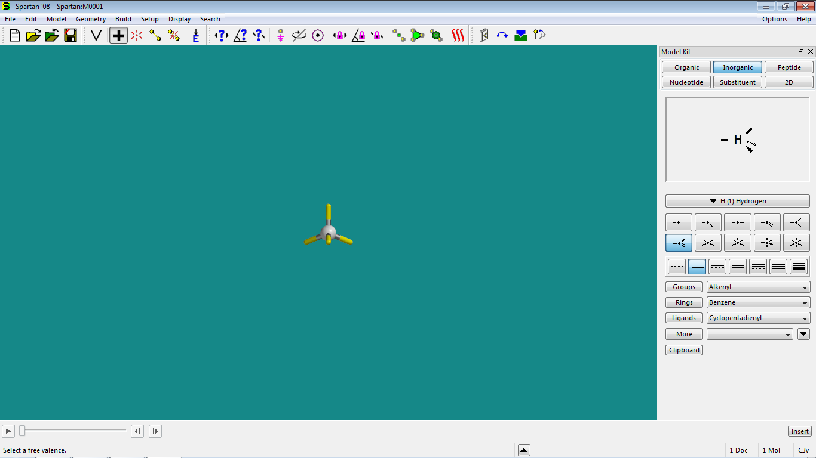 in the upper left hand corner of the window.

3. Build your molecule:

a. From the ‘Inorganic’ model kit, select cobalt from the pull-down menu.

b. Choose the ‘bipyramidal’ geometry 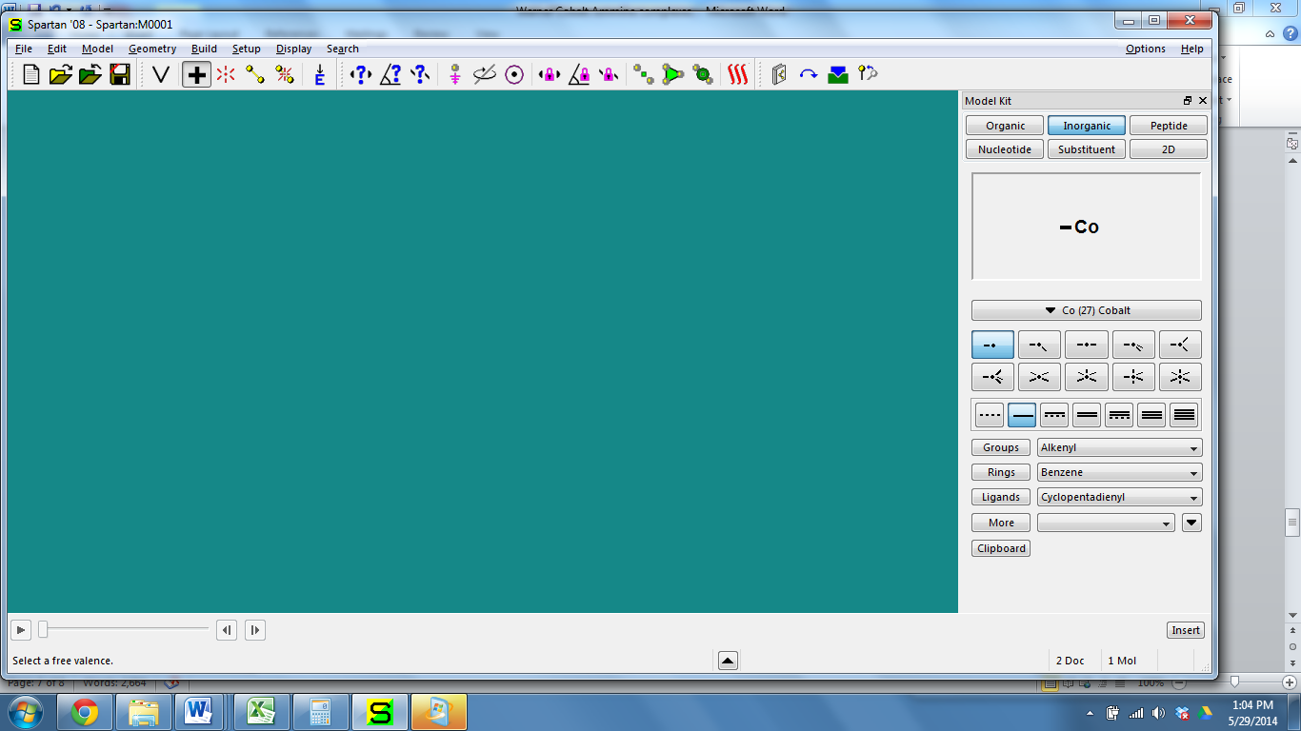

c. Click the mouse on the workspace to drop the atom.

d. Choose ‘ammonia’ from the ‘ligands’ menu at the bottom of the inorganic model screen.

e. Click on each valence on the atom to add the appropriate number of ammonia groups to your molecule.

f. If your complex contains chlorine, select Cl from the periodic table shown, and click on the valences shown to add the correct number of chlorines to your molecule. When you are finished, check that all 6 valences are full.

g. Save your file to the Chem 248 folder on the desktop with your name and the appropriate complex name. Example: “LASTNAME_Co6NH3”.

4. Set up the quantum chemical calculations.

a. From the ‘Setup’ menu, select ‘Calculations’. A window should appear that contains all of the relevant information for setting up a calculation.

b. From the ‘Calculate’ box, select the following drop-down options:

i. ‘Energy’

ii. ‘Ground’ state

iii. with ‘Density functional theory’

iv. ‘B3LYP’ at the ‘631G*’ level

v. in ‘Vacuum’

c. In the ‘Compute’ box, select the ‘UV-VIS’ checkbox

d. Ensure that the ‘Total Charge’ is specified as ‘+3’ and the ‘Multiplicity’ is set to ‘singlet’ (Note that the total charge will be different for each of the complexes, depending on the number of chlorines bound to the metal!)

e. Click ‘Submit’.

f. Click ‘OK’ to acknowledge that the calculation has started.

g. When the calculation has completed, click ‘OK’ to acknowledge.

**While waiting for the calculation to finish, take an IR spectrum of your compound using a KBr pellet.** See the instructor if you’re not sure how to do this! Print out a copy of the spectrum for your lab report.

5. Determine plots of the molecular orbitals.

a. From the ‘Setup’ menu, select ‘Surfaces’. A window should appear that contains all of the relevant information for setting up molecular orbital plots.

b. Click on the ‘Add’ button.

c. From the ‘Surface’ pull-down menu, select ‘LUMO’.

d. Ensure that ‘medium’ resolution is selected.

e. Click on the ‘Apply’ button.

f. Repeat steps c – e using the ‘HOMO’ surface.

g. Repeat steps c – e using the ‘HOMO{-}’ surface. Be sure to create a surface for all ‘HOMO{-}’ orbitals from 1 through 15.

h. Click on the ‘OK’ button.

i. View one orbital at a time by selecting each of the check boxes.

j. Identify the *d* atomic orbitals. Look for orbitals that have a color change between the metal and the ligand, and ones where the shape of the orbitals shown on the metal match the *d* orbitals that you saw for the atom. Save an image for each MO containing *d*-bonding. Be sure to name your file with the appropriate orbital designation: LAST_NAME_Co6NH3_HOMO-1.

k. Save an image for each one by selecting the ‘Save As’ icon  and choosing ‘JPEG’ from the ‘Save as type:’ menu. Be sure to name your file with the appropriate orbital designation: LAST_NAME_Co_HOMO-1.

6. Choose ‘Display’ and then ‘Spectra’, and select the UV/VIS tab. Choose ‘Draw calculated.’ Record the maximum absorbance from the plot, and save a .jpg file to include in your lab notebook.

7. Save the changes that you have made to your Spartan model, and then exit the program.

8. Make sure to save your images to the class folder on the Google drive so that you can **include them in your lab report**!

**Lab report**

Your lab report should focus primarily on discussing the compound that *you* synthesized and the measurements that *you* took (or the calculations that you did). You should also *briefly* summarize the results from your group and compare them to results from other groups. You will write a formal methods section for this lab, which will focus only on the synthesis that you completed. You do *not* need to include the analysis from week 2 in your formal methods section, other than to list the analytical results that you used to confirm that you got the right substance (e.g. “The absorption maximum for a 10mg/mL solution of the product in water was determined to be 475 nm by UV/VIS spectroscopy.”).

**Post-Lab Questions**

1) The relative size of an atomic orbital in an MO diagram indicates how much that atomic orbital contributes electrons to the molecular orbital (larger = more contribution). Keeping this in mind, to which MOs does the metal contribute most? Indicate these orbitals in your lab report for each complex studied.

2) How well does the λmax from your calculated UV/VIS data (from Spartan) match your experimental data? If it does not match well, speculate on some possible reasons for the error.

3) How do the UV/VIS spectra of the three complexes synthesized differ from one another? Does the λmax that you measured agree with your observations of the solution?

1. Rodgers, G. Descriptive Inorganic, Coordination, and Solid State Chemistry, 3rd ed. Brooks & Cole, 2012, pp 12-20.
2. Greenaway, A.; Lancashire, R. Cobalt (III) Ammines – “Werner” Complexes. *J. Chem. Educ*. **1982**, 59(5) 419-20.
3. Wulfsberg, G. Principles of Descriptive Inorganic Chemistry. University Science Books, 1991, pp 229-230.
4. Shriver, D.; Weller, M.; Overton, T.; Rourke, J.; Armstrong, F. Inorganic Chemistry, 6th ed. W.H. Freeman, 2014, pp 209.
5. Angelici, R. J. Synthesis and Technique in Inorganic Chemistry. University Science Books, 1996, pp 131-7.
6. Borer, L.L.; Erdman, H.W.; Norris, C.; Williams, J.; Worrell, J. Synthesis of trans-Tetraamminedichlorocobalt (III) chloride, *Inorganic Syntheses*, Vol 31, 1997, pp 270-271.
7. MacAlester College, Lab handout, Chem 111L. Published online. Retrieved 6/13/2014 from: <http://www.macalester.edu/~kuwata/Classes/2004-05/chem%20111/111l%20experiment%206%20-%20co%20synthesis.pdf>

   I emailed Dr. Kuwata and Dr. Rossi at Macalester, and they informed me that the lab instructions cited above are an older version of a laboratory developed by Emil Slowinski and Wayne Wosley, and published in a Cengage text. For an updated lab procedure and extensive safety and technique notes for students, see: Slowinski, E.; Wolsey, W.; Rossi, R. Chemical Principles in the Laboratory 11th ed. 2016, 2012 Cengage Learning, Boston, MA. ISBN 978-1305264434
8. Neshyba, S. “Molecular Orbital of Transition Metal Complexes.” Virtual Inorganic Pedagogical Electronic Resource, www.ionicviper.org. Published 2/5/2014.