Reaction Mechanisms - Ligand Substitutions
Created by George G. Stanley, Department of Chemistry, Louisiana State University (gstanley@lsu.edu) and posted on VIPEr on August 14, 2017. Copyright Geroge G. Stanley, 2017. This work is licensed under the Creative Commons Attribution-NonCommercial-ShareAlike CC BY-NC-SA. To view a copy of this license visit {http://creativecommons.org/licenses/by-nc-sa/4.0/}.
A substitution reaction is one in which an existing ligand on a metal center is replaced by another ligand. Exactly how this occurs depends on the electron count of the metal complex, the existing ligands on the metal, and their steric and electronic properties.
MLn + xP MLn-xPx + xL
The mechanism of this substitution will almost always depend on whether the parent MLn complex is coordinatively saturated or not!

Cavet: “A mechanism is a theory deduced from the available experimental data. The experimental results are facts; the mechanism is conjecture based on those facts”
Lowry & Richardson

“You can never prove that your mechanism is right - only wrong.”
Guy in the audience asking
about your proposed mechanism
Substitutions reactions occur by a combination of ligand addition and ligand dissociation reactions.
Saturated Complex: Dissociative Pathway!
Unsaturated Complex: Associative Pathway (usually)
Dissociative pathway (sometimes)
Most of the substitutions we will study will involve 2e- pathways. Odd e- or radical pathways are known, but less common.

Ligand Addition (association): this is when an incoming ligand coordinates to a metal center that has one or more empty orbitals available.
Ligand Dissociation: this is when a ligand coordinated to a metal dissociates (falls off). The probability of a specific ligand dissociating depends on how strongly or weakly it is coordinated to the metal center and steric effects.
A ligand substitution can occur either by an associative or dissociative route. The exact mechanism depends in large part on the electron-count of the metal complex undergoing the ligand substitution. The simplest case is when one is dealing with an 18e- metal complex. In this case one almost always has a dissociative substitution. In a dissociative substitution, one of the existing ligands on the metal center has to fall off (ligand dissociation), this opens up a free coordination site (16e-, if one started from an 18e- complex) to which the new ligand can coordinate.
18e- complexes almost always do ligand substitutions through initial ligand dissociation. Dissociative substitution can also occur in 16e- (or in very unusual cases, lower electron count systems) complexes. These cases either involve sterically bulky ligands that block the open coordination site, or third row square planar d8 complex like Pt(+2) where there are strong electronic factors that limit the coordination of an additional ligand to the empty axial site.
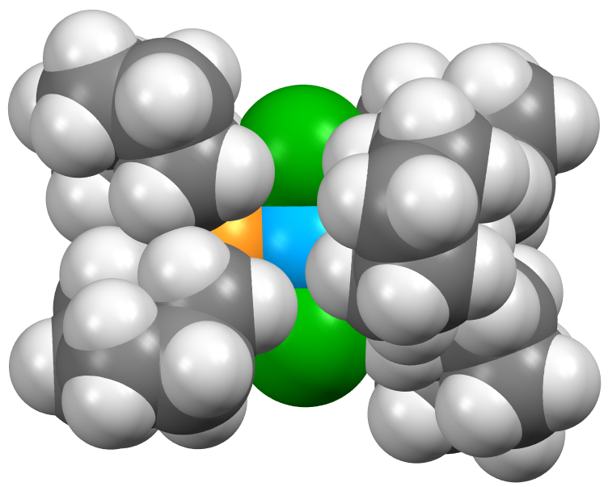 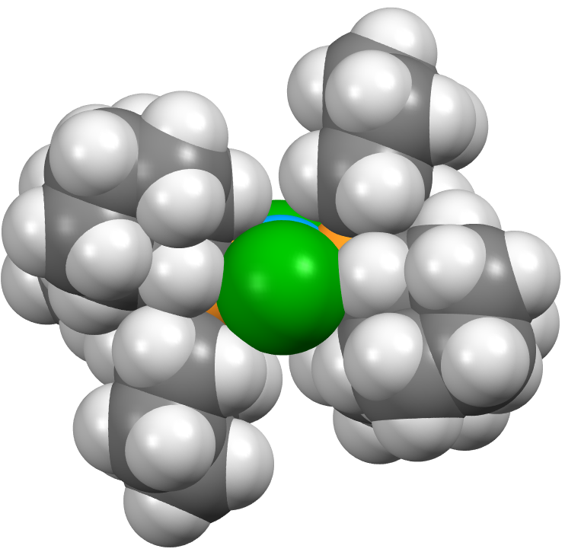
In the following example, the filled and spatially extended Pt dz2 orbital can act as an electronic block:

Problem: The rate of substitution reactions on square planar d8 complexes goes in the order: Ni > Pd >> Pt. Explain why.

Steric Factors
Bulky (large) ligands occupy more space around a metal center and can block incoming ligands trying to access vacant coordination sites on a metal. Due to steric hindrance, however, they are also more often to dissociate to relieve the steric strain. Consider, for example, the following equilibrium:
KD
Ni(PR3)4 Ni(PR3)3 + PR3
25ºC
Ligand: | P(OEt)3 | P(O-p-tolyl)3 | P(O-i-Pr)3 | P(O-o-tolyl)3 | PPh3
Cone angle: | 109º | 128º | 130º | 141º | 145º
KD : | < 10−10 | 6 x 10−10 | 2.7 x 10−5 | 4 x 10−2 | > 1000
Note that there is virtually no Ni(PPh3)4 in solution. There is too much steric hindrance with the bulky PPh3 ligands. Note that steric effects often turn on suddenly – you don’t see much effect and then wammo!
Problem: There is also an electronic effect in the previous example that favors PPh3 dissociation. What is it?

Solvent Effects
Consider the following dissociative substitution rxn discussed earlier:
The 14e- three coordinate intermediate is actually almost immediately coordinated by a solvent molecule to produce the solvated 16e- complex shown to the far right. The solvent is usually weakly coordinated and readily dissociates to constantly produce the 14e- reactive intermediate.
Few organometallic chemists formally write solvated metal complexes down in their mechanisms, but they certainly are formed.
The coordinating ability of the solvent, therefore, can often affect reactions. The presence of lone pairs and electron-rich donor atoms on the solvent usually makes it a better ligand. Some common coordinating solvents are shown on the next page.
The polarity of the solvent can also have a definite impact on a reaction. Polar solvents are usually quite good for reactions, such as that shown above, involving charged species. A non-polar hydrocarbon solvent (like toluene, for example) would probably inhibit the chloride dissociation mechanism. Instead, the dissociation of the neutral, less polar phosphine ligand would probably be favored.
Some Common Coordinating Solvents
bp = 189ºC
mp = 18ºC
bp = 153ºC
mp = -61ºC
Note that one often avoids oxygen containing solvents due to the reactivity of early transition metals towards them. Water is rarely used in organometallic chemistry since many of the reactive metal-alkyl complexes are basic enough to react with water.
Non-coordinating solvents are a misnomer since anything can coordinate to a metal center that is unsaturated and electron-deficient enough. But saturated hydrocarbons like hexane are classic “non-coordinating” solvents. Arene solvents can coordinate via their π-systems, but usually not too strongly.
A common less coordinating, but polar solvent, is CH2Cl2, which is one of the less reactive chlorocarbon solvents. Clorobenzene is another relatively non-reactive, but somewhat polar solvent.

Trans Effect
The trans effect concerns the electronic effect of one ligand on another ligand when they are trans (opposite) to one another. The classical trans effect involves two σ-donating ligands trans to one another. The stronger σ-donor ligand preferentially weakens the bond of the weaker σ-donor ligand trans to it, making it easier to dissociate and do a ligand substitution reaction.
There is a cis effect, but it is much weaker and basically ignored:

Note that when most chemists talk about the trans effect they are referring to the σ-σ type of trans effect, where a strong σ-donor weakens the σ-donating ligand trans to it.
Do NOT overestimate the importance of the trans-effect. As you will see on the following pages there are other forms that have different effects.
π-Acceptor Trans Effects
There are other types of electronic trans effects that involve π-backbonding ligands. We will focus here on CO ligands as the most common type.
The bonding of a π-backbonding ligand to a metal with two or more d electrons is weakened when there is a trans π-backbonding ligand. The competition of both π-backbonding ligands for the same d orbital electrons reduces the amount of π-backbonding that can occur and, therefore, weakens the M-CO bond strength.
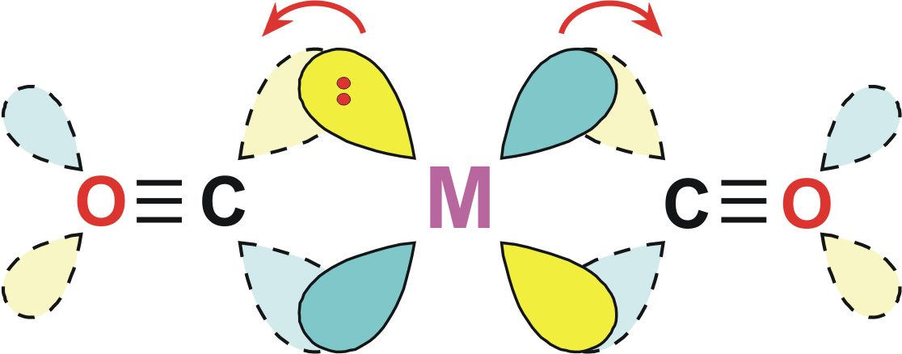
Complex | νCO cm−1
Mo(CO)3[P(OMe)3]3 | 1977, 1888
Mo(CO)3(pyridine)3 | 1888, 1746
Conversely, a π-backbonding ligand is usually strengthened by being trans to a good σ-donating ligand that can’t π-backbond. Compare the CO infrared stretching frequencies for the following two complexes:
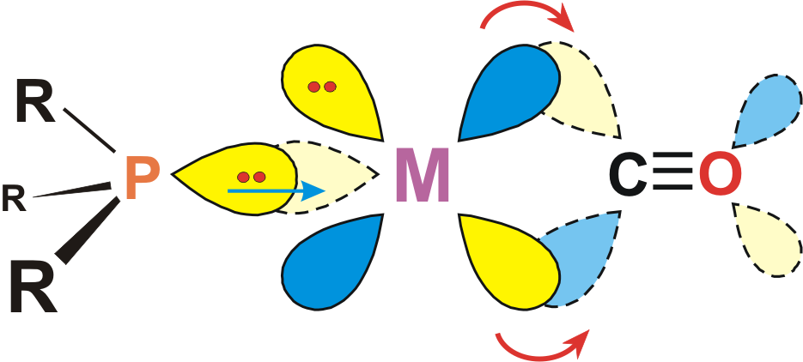
The P(OMe)3 ligand has about the same σ-donor ability as pyridine, but is a considerably better π-acceptor ligand, thus completing with the trans CO ligands more than pyridine.
There is a further strengthening of M-CO π-backbonding when the trans ligand has π-donation properties that can push up the energy of the filled d orbitals and, in turn, make them better π-donors to the CO. This can occur even when the ligand is not an especially strong donor.
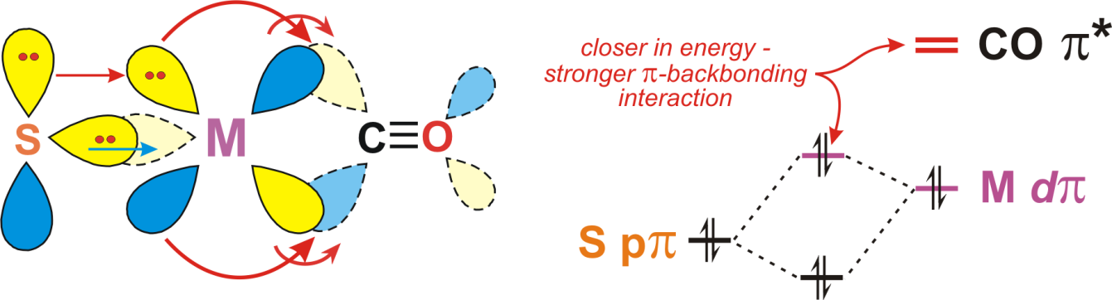
An example of this can be seen in the following three complexes and their “anomalous” νCO stretching frequencies:
Even though the trans PPh2 is a better σ-donor than the P=S, or certainly the P=O ligand, the “π-pushing” effect mentioned above enhances the trans CO π-backbonding for the P=S and P=O ligands.
Problem: Consider the following series of substitution reactions.
As one replaces each CO ligand with a PMe3, the next CO substitution is progressively more and more difficult requiring higher temperatures and longer times. Once one forms Cr(CO)3(PMe3)3, it is extremely difficult to replace another carbonyl ligand. Why?
Associative Substitutions
These occur first by a ligand addition to the metal complex followed by the dissociation of one of the original ligands. You typically need to have an unsaturated (17e- or lower) complex in order to propose an associative substitution mechanism.

Although one could theoretically have a ligand addition to an 18e- complex to form a 20e- transition state (or intermediate) that would then dissociate a ligand to reform an 18e- system, there are very few verified examples of this in the literature.
So associative substitutions are generally limited to 17e- and lower electron-count systems where the incoming ligand is not sterically or electronically blocked from bonding (coordinating) to the metal center.

“AC/DC” Ligands
Multidentate ligands (those donate more than 2e- and occupy more than one coordination site on a metal) can often change their coordination number to donate fewer electrons, thus opening up a coordination site that can allow an associative substitution (or just ligand addition).
The Cp ligand can do this by shifting from an η5 to η3 (or even η1) coordination mode as shown in the example below:
But shifting the η5-Cp to the η3-Cp coordination mode incurs a moderately high energy cost due to the loss of aromaticity in the Cp ring. So this is NOT that common.
Indenyl Effect
The indenyl ligand family, however, shows dramatically enhanced substitution reactions due to the ability to switch the aromaticity between the Cp and arene ring via the following resonance structures:
This dramatically lowers the barrier for the η5-Cp to η3-Cp resonance structure, opening up a free coordination site and allowing far easier ligand additions and substitution reactions.
Consider the following relative rates of ligand substitution using the following Cp-class ligands:
Ligand:
Relative rate of substitution: | > 1010 | 3.8 x 108 | 6.1 x 105 | 1 | 2.2 x 10−2
The fluorenyl ligand accelerates the ligand substitution reaction by a factor of over 1010 !! Holy Cow!
Although the indenyl effect should theoretically generate great catalysts due to the ability to readily open up free coordination sites on the metal, it also, unfortunately, makes the indenyl ligand considerably easier to substitute off the metal completely.
Pentadienyl
The pentadienyl ligand is an acyclic version of Cp that does not have any aromatic stabilization. This has two important effects:
1) No aromatic stabilization means that the π-orbitals are higher in energy and are, therefore, better donors than Cp−. Similarly, the π*-antibonding orbitals are lower in energy and are better π-acceptors than Cp− (but the low electronegativity limits the amount of π-backbonding that can occur).
2) The lack of aromatic stabilization means that there is a much smaller barrier for η5-pentadienyl η3-pentadienylη1-pentadienyl transformations.

Allyl
The allyl anion has a similar facile ability to switch between η3 and η1 coordination modes that can promote ligand additions and/or substitutions.

Nitrosyl
We usually count the nitrosyl ligand as a cationic 2e- donor, isoelectronic with CO. But it can adopt an anionic 2e- configuration with a bent coordination geometry:
This can occasionally lead to interesting behavior where the linear to bent, cationic to anionic electronic state can open up a coordination site on the metal by essentially oxidizing it (shuttling 2e- from the metal to the NO+ turning it into NO−). Given the extremely strong π-backbonding ability of NO+, this isn’t particularly surprising. The linear NO+ form can usually be easily differentiated from the bent anionic form by IR spectroscopy because of the large change in NO bond order (triple to double bond).
Radical Odd Electron Systems
17e-
One typically sees fairly dramatic rate enhancements for ligand substitution reactions of 103 to 107 compared to 18e- systems.
The mechanism for the 17e- [V(CO)6]• radical is believed to be associative to give a 19e- complex. The 19e- configuration weakens and labilizes one of the V-CO bonds allowing a CO to dissociate, dropping the complex back to a 17e- configuration.
This is supported by the following experimental data:
Rate = k[V(CO)6]• [PPh3] (second order)
ΔS‡ = −28 J/mol K (negative entropy indicates ordered transition state)
This is a general observation for most odd electron complexes studied. The key is that the 19e- configuration is not as unstable as a 20e- electron count that places 2e- into a M-L antibonding orbital. In a 17e- complex, one electron is actually going into either a M-L bonding or non-bonding orbital, while the next electron goes into the M-L antibonding orbital. This makes the associative ligand addition considerably easier compared to an 18e- system.

Electron Transfer Catalysis (ETC)
One can “force” a stable, kinetically inert 18e- complex into a considerably more reactive state by oxidizing it to a 17e- configuration, thus opening up half a free orbital to which a ligand can bind initiating a ligand substitution reaction. The metal can then be reduced back to the 18e- state.
Or one could reduce the metal to an unstable 19e- state, which would labilize off the weakest coordinated ligand taking the metal complex down to a more reasonable 17e- count. The metal center can then be oxidized back to a 16e- state, giving an open orbital for a new ligand to coordinate to.
This is usually done electrochemically and since there is no net change in the number of electrons on the metal (oxidation is followed by reduction), it is considered a catalytic substitution reaction. An example is shown below.

Problem: One could use electron transfer catalysis (ETC) to further activate the very inert trans-Cr(CO)3(PMe3)3 complex that we discussed earlier for another CO substitution. To initiate the ETC you can either oxidize the complex to [Cr(CO)3(PMe3)3]+ or reduce it to [Cr(CO)3(PMe3)3]−. Only one of these would be likely to substitute off a CO ligand to replace it with a PMe3 ligand. Which one would you use and why?

