**Metal Nitrosyl Complexes** This Work, Exploration of Nitrosyl Complexes, by [Kraft](https://www.ionicviper.org/user/kraft) is licensed under a

[Creative Commons Attribution-NonCommercial-ShareAlike 3.0 Unported license](http://creativecommons.org/licenses/by-nc-sa/3.0/).

**Learning goals:** Students should be able to deduce:

* The formal electron count of nitrosyl complexes.
* Whether a nitrosyl ligand is formally NO+ or NO- in a given coordination complex and if a linear or bent M-N-O geometry is expected.

**Introduction:**

Nitric oxide (NO) can coordinate to a metal to form what is called a nitrosyl complex. NO typically binds to metals through the nitrogen atom instead of oxygen just as CO binds through carbon. Why?

NO differs from CO in that in its neutral state, it has an odd number of electrons. In a nitrosyl complex, three possible electronic formalisms for the NO ligand are NO, NO+, and NO-. As a starting point to help remember how these different formalisms result in the different ways in which NO binds to a metal, let's draw the Lewis structures for each of these:

NO NO+ NO-



Using your Lewis structures and VSEPR theory:

If NO is represented as NO+ when coordinated to a metal, what would the M-N-O bond angle be?

If NO is represented as NO- when coordinated to a metal, what would the M-N-O bond angle be?

If NO is represented as NO*•* when coordinated to a metal, what would the M-N-O bond angle be?

You should now see that the M-N-O angle is suggestive of the electronic formalism of the coordinated NO ligand (but this is not always the case!)

**Counting Electrons in NO Complexes.** Using the donor pair method, we can count NO, NO+, and NO- all as 2e- donors regardless of the formal charge of NO because in all cases, we will assume that a single bond is formed with the metal. However, note that the formal charge on the NO ligand influences the formal oxidation state of the metal. Therefore, *in order to count electrons correctly, the coordination mode of NO (linear or bent) must be known* as worked out in the following example:

*Example:* What is the electron count for [Cr(CN)5(NO)]4-  if the Cr-N-O angle is 120°? If it is 180°?

Bent (120°): 5 CN- 10 e- Linear (180°): 5 CN- 10 e-

1 NO- 2 e- 1 NO+ 2 e-

Cr2+ 4 e- Cr0 6 e-

Total 16 e- Total 18 e-

**Problem Set:**

1. The W-N-O angle in the complex below is 169.4°. What is the electron count for the complex?

(Tsang, J. Y. K., et. al. *J. Am. Chem. Soc.* **2006**, *128*, 14762-3).



2. The reaction of CpRe(CO)(NO)CH3 with 2 equiv. of PMe3 gives the product shown on the right. (Casey, C. P.; Jones, W. D. *J. Am. Chem. Soc.* **1980**, *102*, 6154-6156).



a. Given that the product is an 18-electron complex and that the M-N-O angle is 180°, what is the oxidation state of Re?

b. What is the oxidation state of Re in the reactant? How do you know?

3. The complex ion, [Fe(CN)5(NO)]2-, has 18 electrons. Would you expect the M-N-O angle to be linear or bent? Why?

4. The following is an 18-electron complex with an unknown M-N-O angle. What is the identity of the 1st-row transition metal if the M-N-O arrangement is linear? What is the identity of the 1st-row metal if the M-N-O arrangement is bent?



5. The first-ever actinide nitrosyl complex, (Me4Cp)3U(NO), has been synthesized this year. Its x-ray crystal structure is shown below. Magnetic susceptibility studies of the compound revealed a magnetic moment corresponding to a complex possessing 2 unpaired electrons. The x-ray structure shows the N—O bond distance to be 1.231 Å which is in the range of known transition-metal complexes in which NO acts as NO-. Discuss whether these observations are expected or unexpected with respect to the binding mode of NO shown in the x-ray crystal structure.

(Siladkea, N. A., et. al*. J. Am. Chem. Soc.* **2012**, 134(2), 1243–1249).

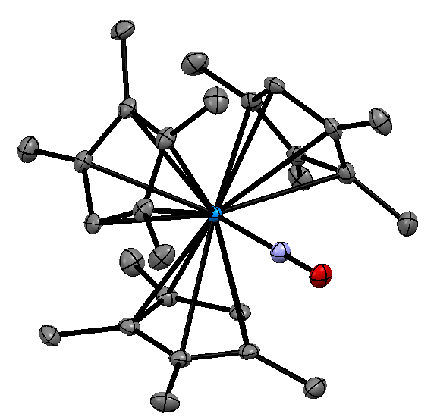

6. The copper nitrosyl complex, [Cu(CH3NO2)5(NO)][PF6]2 is the first of its kind to be structurally characterized. The researchers prepared the complex by adding NOPF6 to copper metal powder in nitromethane solvent. The observed structure possesses five CH3NO2 ligands and one NO ligand in an Oh arrangement with a strong Jahn-Teller distortion. The Cu-N-O bond angle is 121° and the Cu—N bond length is considerably longer (1.955 Å) than in other Cu—NO complexes (1.76 – 1.79 Å). In fact, NO is so weakly coordinated that NO gas can be removed from the complex simply by applying vacuum at room temperature.

(Wright, A. M.; Wu, G.; Hayton, T. W. *J. Am. Chem. Soc.* **2010**, 132(41), 14336–14337).

a. What is the electron count for [Cu(CH3NO2)5(NO)][PF6]2?

b. Provide a reason why the Cu—N interaction is so weak.