Prior to class, students should download the article, “Mechanism of N–N Bond Formation by Transition Metal–Nitrosyl Complexes: Modeling Flavodiiron Nitric Oxide Reductases” by Casey Van Stappen and Nicolai Lehnert. Students should examine the structure of the paper, and carefully read the abstract. Additional attention to Schemes 1, 3, 4, Table 1, and Figures 1 and 6 in the body of the paper is strongly encouraged. After completing this, answer questions 1-6 prior to class. Questions 7-14 are then used as the starting point of the in-class discussion.

Discussion questions:
1)Draw/write the balanced chemical reaction performed by the flavodiiron nitric oxide reductase.

2) Below is the structure of a similar compound to the model complex. Determine the oxidation states of the two metal centers in the structure, and determine the number of d electrons for each metal. What are the coordination numbers of the two metal centers, and suggest their possible geometries? What is the denticity of the BPMP ligand? Bonus question: what is different between this compound and the model compound in the paper (compare with Scheme 1)?

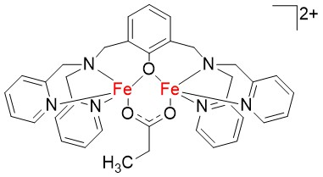

3) Referring to the Scheme 3 (the top half), what is the spin state of NO and Fe³⁺ in this complex? Is the Fe³⁺ in a high or low spin state?

4) Consider the following reaction pathway in the diagram below, which is similar to Scheme 4:
- Label each species as a reactant, product, transition state, or intermediate species on the diagram.
- Categorize each step in the reaction scheme as either endo- or exothermic.
- What is the rate limiting step, and what is the approximate activation energy?

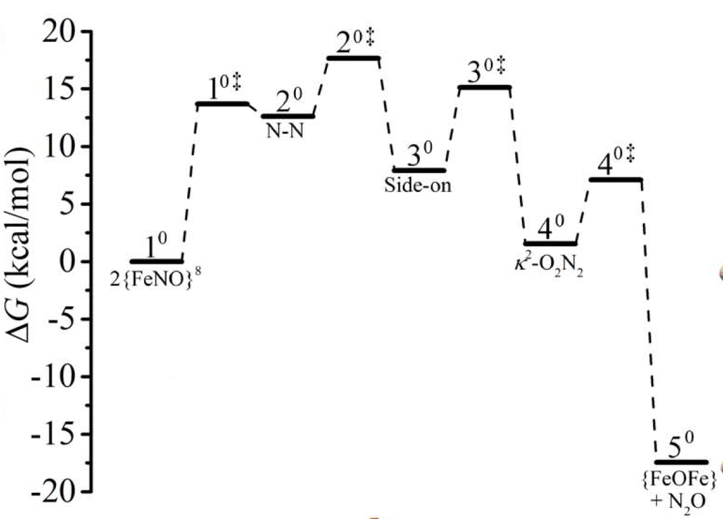

5) Draw the best Lewis structures of NO⁺, NO⁻, and NO. Draw the molecular orbital diagram for each. Calculate the bond order from each of the MO diagrams. Experimentally, the bond orders for NO⁺, NO⁻, and NO are 3, 2, and 2.5, respectively. Do the MO diagrams or the Lewis structures more accurately represent this?

6) There are multiple possible structures for N₂O. Draw as many as you can (at least 3). Which of these is the BEST Lewis Structure for N₂O? (students may or may not be scaffolded by suggesting that the molecule can only have N as the central atom)

7) Draw the Lewis structure and all possible resonance structures for hyponitrite, N₂O₂²⁻. Circle the resonance structure that contributes the most to the average structure. Compare that Lewis structure to the MO diagram in Figure 6 of the paper, and explain why each of the four MOs are labeled as either σ or π. Additionally, identify which are bonding MOs, and which are antibonding MOs.

8) Table 1 gives the percent composition of the MOs for the ligands and metal centers in the diiron nitrosyl complex. Looking at these values, which orbital(s) comprise the Fe-N bond for each Fe center? What do these values indicate about the degree of covalency involved in the Fe-N bond?

9) Define the terms antiferromagnetism and non-innocent ligand. Give an example of a non-innocent ligand identified in the paper.

10) What are the sections of this Inorganic Chemistry article? Give one sentence that describes the purpose of each section.

11) If you number each of the 11 sentences in the abstract, how many deal with material related to the introduction section? Methods? Results? Discussion? Conclusion?

12) Which sentence in the abstract best captures the heart of the paper?

13) Why do you think the authors chose the graphical abstract that they did?

14) What is the overall goal and conclusion of the research presented in the paper?

