The N₅⁺ Cation: Explosive Chemistry and Raman Analysis

Literature Discussion Assignment
Read the following article and answer the pre-lecture questions before class. You may be asked to share your answers to the pre-lecture questions during the lecture:
Ralf Haiges, Stefan Schneider, Thorsten Schroer, and Karl O. Christe, “High-Energy-Density Materials: Synthesis and Characterization of N₅⁺[P(N₃)₆]–, N₅⁺[B(N₃)₄]–, N₅⁺[HF₂] – ·nHF, N₅⁺[BF₄]–, N₅⁺[PF₆]–, and N₅⁺[SO₃F] –,” Angew. Chem. Int. Ed. 2004, 43, 4919-4924.

Pre-lecture questions:
- Equation 2 has a typo! Rewrite the correct equation. Hint: Be sure to follow conservation of mass.

- In 25 words or less, describe the main achievement of this work.

- Vibrational modes can be observed using Raman and/or IR spectroscopy. What is the physical property of a molecule that has to change upon vibration for it to be observed using Raman spectroscopy? What is the physical property of a molecule that has to change upon vibration for it to be observed using IR spectroscopy?

- The Lewis structure of N₅⁺ is given below.
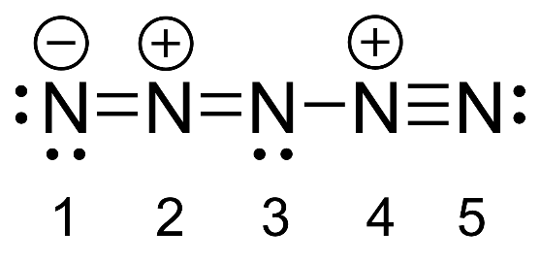
Considering the structure of the central N, what is the point group? If using a flowchart, write every step in your answer.

- According to the structure given for N₅⁺, predict the number of normal modes for N₅⁺.

- When given a character table, how would you determine whether an irreducible representation can correspond to an IR-active normal mode? In the point group that you have chosen, list the irreducible representations which can be IR active.

- How would you determine whether an irreducible representation can correspond to an Raman-active normal mode? In the point group that you have chosen, list the irreducible representations which can be Raman active.

You will be asked to answer the following questions during lecture in small groups:
- (a) Write out the complete representation for all motion of the N₅⁺ cation. (b) Subtract off the representations for translational and rotational motion, and reduce the representation for all vibrational motion to obtain the symmetries of the normal modes. How many peaks would you expect to see in the IR spectrum? In the Raman spectrum?

- Is there a counter ion that if paired with this cation, we would not be able to use the IR and Raman data to determine the structure of N₅⁺?

- Why were all of the reactions conducted at low temperatures?

