Solid State Structures

INTRODUCTION
This tutorial will introduce you to some of the three-dimensional crystal structures exhibited by ionic and metallic solids. You will examine the simple cubic, body-centered cubic, face-centered cubic, and the hexagonal closest-packed systems. To facilitate visualization of the structures at the atomic level, you will use the Crystal Explorer website www.chem.purdue.edu/Courses/StructureLabs/Crystal%20Explorer%202/structurefiles/toc.html
created by Talitha Selby, Illene Kelly and William Robinson at Purdue University. You will also find the Solid State Model Kit (available through the Institute for Chemical Education) very helpful in visualizing the structures.

A crystal lattice is generated by stacking its simplest repeating unit, called the unit cell, in three dimensions. In order to understand the lattice, only the unit cell needs to be examined. Seven basic crystal systems are categorized by the ratio of the length of the sides (a,b,c) of the unit cell and the size of the three angles (α,β,γ ) between the sides. This tutorial will focus primarily on the cubic system in which a, b, and c are equal to one another, and α, β, and γ are all right angles. Within the cubic system there are three lattices in which the atoms can be arranged: simple cubic, body-centered cubic, and face-centered cubic or cubic closest-packed. We will also examine the hexagonal closest-packed lattice. These basic unit cells will be used to describe the diamond structure and structures that contain two types of ions: NaCl, CsCl, ZnS (zinc blende), and CaF₂.

PROCEDURE and REPORT
I. Simple Cubic Lattice. The unit cell for the simple cubic system is shown in Figure 1.

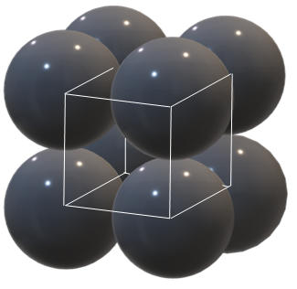
Figure 1
Double click on ‘SC Unit Cell Models’ to view Space Filling and Ball and Stick models of a single unit cell for this lattice. You can use the mouse to rotate the image. Examine the simple cubic unit cell. The space where eight spheres come together is called a cubic "hole". Return to the main menu and click on ‘The Extended SC Metal Structure’. You should see an expanded view of this lattice type with 27 spheres forming a larger cube. Each edge of the cube has three spheres. View the structure using the Ball and Stick option. Using the Solid State Model Kit (SSMK), build the Simple Cubic model on page 9 of the instruction manual.
How many unit cells are constructed with the 27 spheres (1)? Click on ‘How a SC Metal’s Unit Cell Shares Atoms’ in the main menu. How many unit cells share the red sphere in the center (2)? What fraction of this sphere lies within each unit cell (3)? Click on ‘Nearest Neighbors in SC Metals’ in the main menu. How many nearest neighbors does the center sphere have (4)? This is its coordination number. Note that if the lattice continues in all directions, each sphere has the same coordination number. Considering the fraction of each sphere that contributes to each unit cell, how many spheres make up one unit cell (5)? How many cubic holes are there per unit cell (6)? Return to ‘SC Unit Cell Models’.
Call the length of the edge or side of the unit cell a, represented by the line connecting the center of one sphere to the center of the sphere adjacent to it. Find the expression for the value of a in terms of r, the radius of the sphere (7).

Examine the unit cell for cesium chloride, CsCl, by clicking ‘CsCl Unit Cell Models’. The structure can also be described by an alternate unit cell. The relationship between the two possible unit cells can be seen by clicking on ‘Alternate CsCl Unit Cells’. Build the models (SSMK pp. 12-13). The structure can be described as two interpenetrating simple cubic lattices. Considering the Cl- ions form a simple cubic lattice, where are the Cs+ ions located (8)? What is the coordination number for Cs+ (9)? What is the coordination number for Cl- (10)?

II. Body Centered Cubic System
The unit cell for the body centered cubic system is shown in Figure 2. Many metals exhibit bcc lattices including Na, Cr, and Fe.
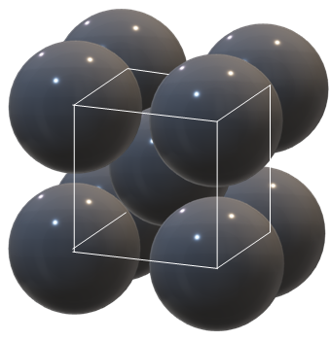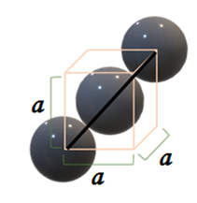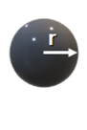
(a) (b)
Figure 2

Click on ‘BCC Unit Cell Models’. Visualize the line of three spheres in the cube that are touching. Build the Body Centered Cubic model (SSMK p. 11). In terms of the geometry of the cube, where do you find the spheres that touch each other (11)? Click on ‘Nearest neighbors in BCC Metals’. What is the coordination number for each sphere (12)? What is the length of the body diagonal expressed as r, the radius of a sphere (13)? What is the length of the edge of this unit cell, a, expressed in terms of r (14)? Considering the fraction of each sphere that contributes to each unit cell, how many spheres make up one unit cell (15)? How is the CsCl unit cell distinct from the body centered cubic unit cell (16)?

III. Hexagonal Closest-Packing
A portion of the lattice for the hexagonal closest-packed structure (hcp) is shown in Figure 3. Metals such as Co, Zn, and Mg exhibit an hcp lattice.
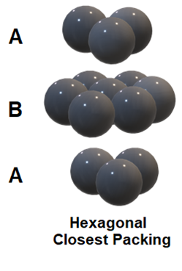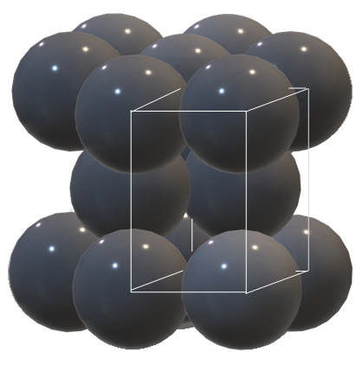
(a) (b)
Figure 3

We will first view the packing arrangement of spheres. For simplicity, only three finite planes of spheres are shown. Since each sphere in the top layer is directly above a sphere in the bottom layer and the middle layer is displaced from them horizontally, the top and bottom layers are referred to as A planes and the middle layer is a B plane. Imagine an infinite number of spheres in each plane. Additional planes would continue to stack in ABABABA....... fashion. Build the hcp model (SSMK p.17).

Notice the hcp arrangement of spheres in Figure 3(b). Note that the hcp unit cell is not cubic. You are viewing three rhombohedral unit cells. One unit cell is highlighted for you. The sphere in the second layer is completely inside the unit cell. The spheres at the corners of the unit cell are only partially inside the unit cell. Figure 4 shows a single unit cell (a) and a bird’s eye view of the unit cell (b).

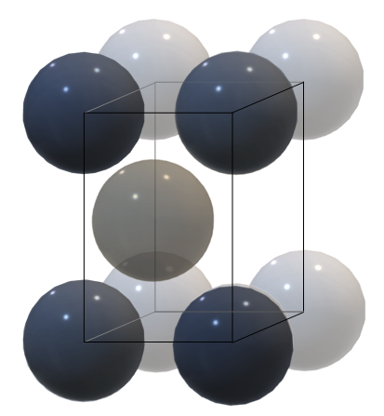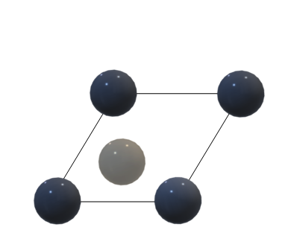
(a) (b)
Figure 4

Click on ‘Cubic- and Hexagonal-closest Packed Structures’ and view the hcp packing on the right side. How many total spheres in all three layers are touching the center sphere (17)? This number is the coordination number for all atoms in a hexagonal closest-packed lattice.

Click on ‘Tetrahedra and Octahedra in Closest Packed Structures’. Locate a vacancy formed by one sphere fitting over three spheres in a lower or upper layer. Select the options that highlight the tetrahedra in the fragment being shown and the vacancies in the center of them. Such vacancies are called tetrahedral holes. What is the coordination number of an atom or ion that occupies a tetrahedral hole (18)? Select the options that highlight an octahedron and the vacancy in the center of it. This is a vacancy formed where six spheres come together such that three spheres in one layer are staggered relative to three spheres in an adjacent layer. Use your mouse to position the octahedron so you can view it looking down an axis going through the center of both layers of spheres. What is the coordination number of an atom or ion that occupies an octahedral hole (19)? Click on ‘Tetrahedral, Octahedral, and Cubic Holes’ and select the options to view the ions inside each type of hole. Is an octahedral hole larger or smaller than a tetrahedral hole (20)?

IV. Cubic Closest-Packing (or Face Centered Cubic Unit Cell)
Now consider an alternate closest packing arrangement where the third layer of spheres staggers the second layer of spheres but is not aligned with the spheres in the first layer (Figure 5a). (see ‘Cubic- and Hexagonal-closest Packed Structures’). This stacking arrangement follows an ABCABCA..... pattern as the crystal continues in three dimensions. This type of packing is called cubic closest packed (ccp). Cubic closest packing results in a face centered cubic (fcc) unit cell (Figure 5b). Click on ‘FCC Unit Cell Models’ in the main menu to view Space Filling and Ball and Stick models of a single unit cell for this lattice.
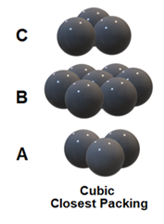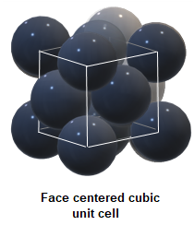
(a) (b)
Figure 5

Select the options that highlight the relationship between the fcc unit cell and the cubic-closest packed lattice. This relationship can also be seen by viewing ‘The Extended FCC Metal Structure’. Select Highlight one set of closest packed planes and use the mouse to rotate the structure until you can see the ABCABCA..... pattern. Then select Highlight one unit cell. Click on ‘Nearest Neighbors in FCC Metals’ and determine the coordination number of the central sphere (21). How many unit cells does the central sphere contribute to (22)? Build the Face Centered Cubic Model (SSMK p. 19) and the ccp model (SSMK p.21) to help you visualize how the fcc unit cell fits into the ccp packing arrangement. What is the length of the edge of this unit cell, a, expressed in terms of r (23)?

Like the hcp arrangement of spheres, the cubic closest packing of spheres creates tetrahedral and octahedral holes. The white spheres in Figure 6 mark the locations of the tetrahedral holes in the unit cell. If the unit cell were divided into octants, each tetrahedral hole would be at the center of an octant. How many tetrahedral holes are completely contained within this face-centered cube (24)? The white spheres in Figure 7 mark the locations of the octahedral holes in the unit cell. How many octahedral holes are completely contained within this face-centered cube (25)? How many octahedral holes are partially contained within this face-centered cube (26)? Metals such as Al, Ca, and Ni exhibit fcc lattices.

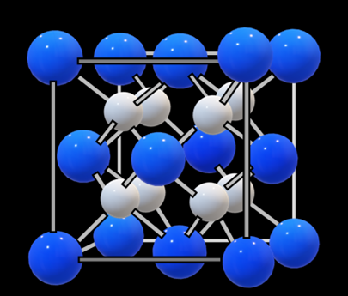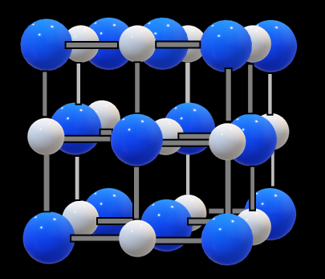

Figure 6: Tetrahedral holes in fcc Figure 7: Octahedral holes in fcc

V. Other Unit Cells
In structures that contain more than one type of atom or ion, consider the packing of each type of atoms with the other atoms or ions occupying the holes. Each of the following structures is the name also given to any structure that has the same arrangement of atoms or ions. For example, KBr adopts the sodium chloride structure and CdS can adopt the zinc blende structure.

NaCl -- Examine the NaCl lattice by clicking on ‘NaCl Unit Cell Models’ and ‘Nearest Neighbors in Sodium Chloride’. The NaCl model may also be helpful (SSMK p. 23). How many Na+ surround each Cl- (27)? How many Cl- surround each Na+ (28)? What type of unit cell is adopted by the chloride ions (29)? In what type of holes are the Na+ located (30)? What percentage of these holes are occupied (31)? Click on ‘Alternate NaCl Unit Cells’. What type of unit cell is adopted by the sodium ions (32)? In what type of holes are the Cl- located (33)? What percentage of these holes are occupied (34)?

CsCl -- Examine the CsCl lattice again by clicking on ‘Alternate CsCl Unit Cells’. Are either the cesium ions or chloride ions closest packed (35)?

Zinc blende -- Examine the zinc blende, ZnS, unit cell by clicking on ‘ZnS Unit Cell Models’ and ‘Alternate ZnS Unit Cells’. The zincblende model may also be helpful (SSMK p. 32). What type of packing arrangement do the S2- ions form (36)? In what type of holes are the Zn2+ ions located (37)? What percentage of these holes are occupied (38)? What type of packing arrangement do the Zn2+ions form (39)? In what type of holes are the S2- ions located (40)? What percentage of these holes are occupied (41)?

Fluorite -- Examine the fluorite, CaF2, unit cell by clicking on ‘CaF₂ Unit Cell Models’. Build the Fluorite model (SSMK p. 15). What type of unit cell do the Ca2+ (purple) ions form (42)? Are the calcium ions closest packed (43)? In what type of holes are the F- (green) ions located (44)? What percentage of these types of holes are occupied by the F- ions (45)? Are the fluoride ions closest packed (46)?

Diamond -- View the unit cell for the diamond lattice by clicking on ‘Diamond Unit Cell Models’. Build the diamond model (SSMK p. 44). What type of unit cell do the outer carbon atoms form (47)? In what type of holes are the carbon atoms inside the unit cell (48)? What percentage of these types of holes are occupied (49)? What is the coordination number of each carbon in diamond (50)?

Solid State Structures Report Sheet NAME_________________________________

I. Simple Cubic Lattice
1. How many unit cells are constructed with the 27 spheres? ____________________

2. How many unit cells share the red sphere? ____________________

3. What fraction of this sphere lies within each unit cell? ____________________

4. How many nearest neighbors does each sphere have? ____________________

5. How many spheres make up one unit cell? ____________________

6. How many cubic holes per unit cell? ____________________

7. Express the value of a in terms of r. ____________________

8. Where are the Cs+ located? ____________________

9. What is the coordination number for Cs+? ____________________

10. What is the coordination number for Cl-? ____________________

II. Body Centered Cubic System
11. Where do you find the spheres that touch each other? ____________________

12. What is the coordination number of each sphere? ____________________

13. What is the length of the body diagonal in terms of r? ____________________

14. What is the length of a in terms of r? ____________________

15. How many spheres make up one unit cell? ____________________

16. How is CsCl distinct from the bcc lattice?

III. Hexagonal Closest-Packed System
17. How many total spheres are touching the center sphere? ____________________

18. What is the coordination number of an atom or ion that occupies a tetrahedral hole? ____________________

19. What is the coordination number of an atom or ion that occupies an octahedral hole? ____________________

20. Is an octahedral hole larger or smaller than a tetrahedral hole? ____________________

IV. Face Centered Cubic or Cubic Closest-Packed
21. What is the coordination number of the central sphere? ____________________

22. How many unit cells does the central sphere contribute to? ____________________

23. What is the length of a in terms of r? ____________________

24. How many tetrahedral holes are inside the fcc unit cell? ____________________

25. How many octahedral holes are inside the fcc unit cell? ____________________

26. How many partial octahedral holes are inside each fcc unit cell? ____________________

V. Unit Cells of Ions and Elements
27. How many Na+ surround a Cl-? ____________________

28. How many Cl- surround a Na+? ____________________

29. What type of unit cell is adopted by the chloride ions? ____________________

30. In what type of holes are the Na+ located? ____________________

31. What percentage of these holes are occupied? ____________________

32. What type of unit cell is adopted by the sodium ions? ____________________

33. In what type of holes are the Cl- located? ____________________

34. What percentage of these holes are occupied? ____________________

35. Is the CsCl lattice closest-packed? ____________________

36. What type of packing arrangement do the S²⁻ ions form? ____________________

37. In what type of holes are the Zn²⁺ ions located? ____________________

38. What percentage of the holes are occupied by Zn²⁺ ions? ____________________

39. What type of packing arrangement do the Zn²⁺ ions form? ___________________

40. In what type of holes are the S²⁻ ions located? ___________________

41. What percentage of these holes are occupied? ___________________

42. What type of unit cell do the Ca²⁺ form? ____________________

43. Are the calcium ions closest packed? ____________________

44. In what type of holes are the F- ions located? ____________________

45. What percentage of the holes are occupied by F- ? ____________________

46. Are the fluoride ions closest packed? ____________________

47. Type of unit cell for outer carbon atoms? ____________________

48. In what type of holes are the carbon atoms inside the unit cell located? ____________________

49. What percentage of these holes are occupied? ____________________

50. What is the coordination number of each carbon in diamond? ____________________

Lisensky, George, et al. Instruction Manual to accompany Solid-State Model Kit. Institute for Chemical Education: University of Wisconsin-Madison, 1992.

