**Alkyl, Aryl, Carbene, Alkylidene & Carbyne Ligands**



Anionic

2 e- donors

Alkyls are typically very **strong** anionic -donors, second only to hydrides. They have virtually no -acceptor ability.

Increasing the carbon substitution (replacing hydrogens with hydrocarbon groups, methyl  ethyl  isopropyl) usually increases the donor strength, but steric factors can come into play and weaken the metal-alkyl bond (e.g., t-butyl groups are often too sterically hindered to bind well).

Replacing the hydrogens with fluorine atoms (very electron withdrawing) dramatically reduces the donor ability of the alkyl (aryl). For example, CF3 and C6F5 are not very strong donors.

Metal alkyls are also typically quite to extremely reactive to molecular O2, water, and a variety of other ligands and reagents. As with hydrides, they play a very important and active role in catalysis.

**-Hydride Elimination**

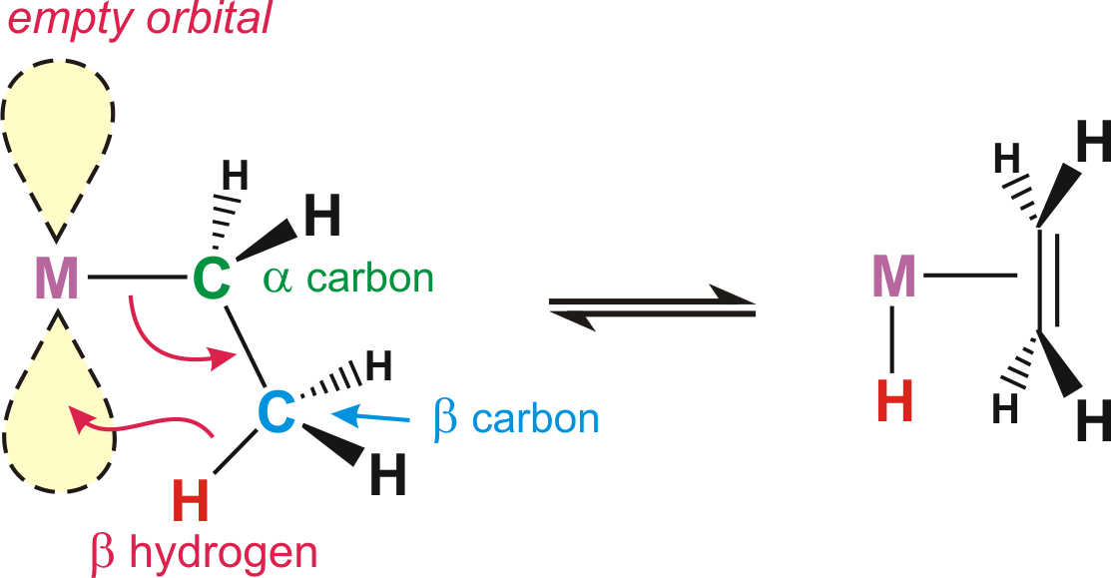

One of the most common “side” reactions of alkyls is called the -hydride elimination reaction:

The main driving force for -hydride elimination is the formation of a stronger M-H bond (usually stronger than M-alkyl) and the generation of an alkene ligand that reduces the unsaturation of the metal complex. The reverse reaction, however, also can occur and is called a **migratory insertion**. This is very important in transition metal reaction chemistry and catalysis, as we will see in later chapters.

**Note that in order to have a -hydride elimination you MUST have an empty orbital on the metal cisoidal (next) to the alkyl ligand. You also must have -hydrogens present on the alkyl.**

In order to prepare stable M-alkyl complexes one, therefore, often needs to stay away from alkyls with -hydrogens (or avoid metals with empty coordination sites). Some common ligands used to avoid -hydride elimination reactions are shown below.



**Problems:**

**a) Why doesn’t a 16e- M-phenyl do a -hydride elimination?**

 

**b) Would a 16 e- M-(*t*-butyl) complex be stable or not? Why?**

-Hydride Elimination

A less common reaction with metal alkyls is the -hydride elimination, where a hydrogen atom on the -carbon is added to the metal to generate a M=CR2 (carbene or alkylidene) group and a hydride:



*Practice your electron counting!!*

Note that just as with a -hydride elimination, **it is important to have an empty orbital cis to the -hydrogen in order to have the -hydride elimination occur.** In the next section on carbene/alkylidene ligands, we will see that depending on how you electron count, an -hydride elimination can also be considered to be a C-H bond oxidative addition (see that chapter as well).

Synthesis:

The most common way of making metal alkyls is to do what is called a transmetallation, that is react a transition metal halide with a alkali or main group metal alkyl, which is typically far more ionic and reactive:

**M–X + LiR  M–R + LiX**

**Other reactive alkyl reagents: RMgX (Gignard), R2Zn, R2Hg, R2Cu, AlR3**

**WCl6 + 6AlMe3  WMe6 + 6AlClMe2**

**Problem:** **Based on DFT calculations, which complex is more electron-rich at the metal: [W(CH3)7]‒ or W(CO)6 ?? Why?**

The other common way of making M-alkyls is to react a moderately electron-rich metal center with an alkyl halide (RCl, RBr or RI):

**MLn + RBr  R–MLnBr**

This, once again, is called an oxidative addition.



This will be discussed more fully in the ***oxidative addition*** reaction chapter.

Aryl Ligands



Aryl ligands are relatively strong anionic two electron donors, essentially just like alkyls. Since they cannot easily -hydride eliminate (formation of the benzyne intermediate is typically too unstable), metal aryl complexes are usually relatively stable compared to alkyls with -hydrogens. But “stable” is a relative term since transition metal aryl complexes are usually quite air-sensitive.

Aryls do have the potential for both -donation and -backbonding through the filled aryl -orbitals and empty * antibonding orbitals. This can provide additional stability to a metal complex, depending on whether the metal needs additional electrons from the ligand or wants to dump excess electron density onto the ligand.

**Problem:** **Cp2Re-CH2CH3 is very stable under inert atmosphere, but Cp2Sc-CH2CH3 readily decomposes. Why?**

**Fischer Carbenes**

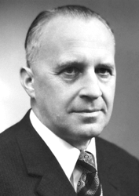**Ernst O. Fischer**

Technical University of Munich,   
Germany. Picture from "Ernst Otto Fischer - Facts". Nobelprize.org. Nobel Media AB 2014. Web. 29 Jul 2016.

<http://www.nobelprize.org/nobel_prizes/chemistry/laureates/1973/fischer-facts.html>

In 1964 Fischer’s group prepared the first transition metal carbon double bond, which he called a carbene, after the very reactive neutral organic CR2 fragment.



The reaction of Cr(CO)6 with Li[N(*i*-Pr)2], followed by reaction with Et3O+ generated the analogous Cr carbene complex with Et and N(*i*-Pr)2 groups on the carbene. A crystal structure of this complex revealed the following unusual features of the (OC)5Cr=C(Et)[N(*i*-Pr)2] group:



Thus, the X-ray structure indicated that the actual electronic structure of this “carbene” was really more like one of these resonance hybrids:



The presence of 5 electron-withdrawing CO ligands would certainly help “suck up” the formal negative charge that these resonance structures put on the metal.

The bonding description commonly used to describe Fischer Carbenes is to treat the carbene as a neutral 2e- donor ligand that really only makes a single bond to the metal (BUT, ***chemists often draw it as a double bond***!!). In considering the carbene as a neutral ligand, it has one filled orbital (***sp2*** hybrid) that donates its lone pair to an empty orbital on the metal in a typical ligand fashion. But it also has one empty orbital (pure ***p*** character) that wants to interact with a lone pair of electrons in order to form a stabilizing bonding interaction. This is a singlet state carbene formalism and the possible orbital interactions are shown below:

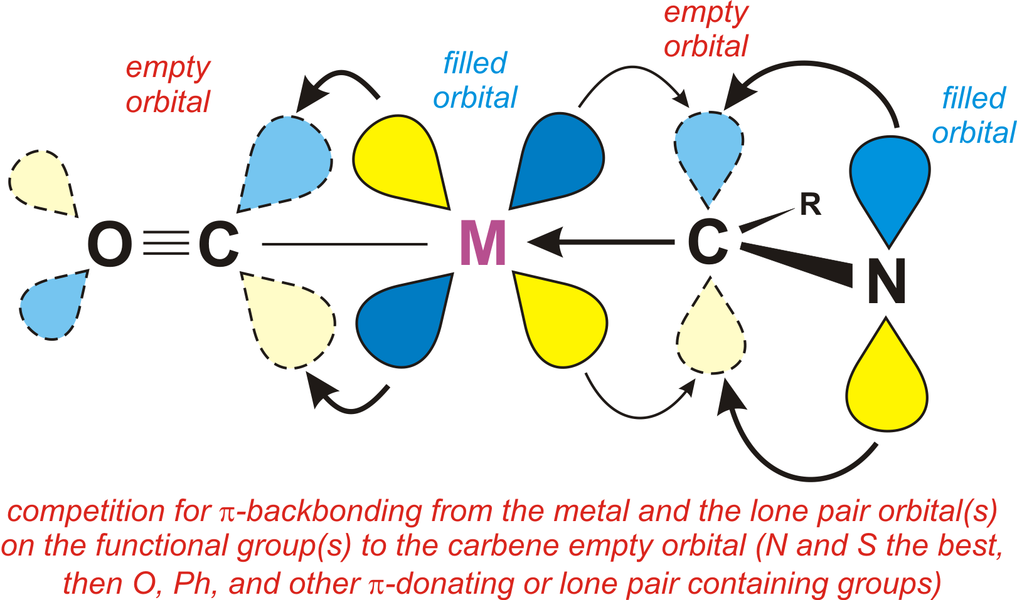

If the metal is electron deficient (perhaps due to all the good -acceptor CO ligands) then it **can’t** -donate very well to the carbene. Thus we end up with a M-C single bond (*even though we draw a double bond*!) and some multiple bond character between the carbene carbon and the -donor groups attached to it (like a NR2, OR, SR, Ph, etc).

Most Fischer Carbenes have *d****6*** metal configurations (assuming that we electron count the carbene ligand as a neutral 2 e- donor), but *d****4*** and *d****8*** systems are known.

The bond strength in Fischer Carbenes depends on several factors:

|  |  |  |
| --- | --- | --- |
|  | **Weak M=C** | **Strong M=C** |
| **Metal** | Electron-deficient  (electron withdrawing ligands like CO, NO, 1st row metal, electronegative metal) | Electron-rich  (electron donating ligands, 3rd row metal) |
| **Carbene groups** | Good donating groups that can -bond to the carbene (like NR2, SR, OR, Ph); *more than one donating group really weakens the M-C bond*!! | Simple sigma donors like H or CH3 that can’t -donate to the Carbene carbon atom. |

Note that most Fischer Carbenes favor the **weak bonding situation**, where the metal has a *d****6*** configuration (counting the carbene as neutral ligand), CO ligands, and the carbene has -donating groups. The *d****6*** configuration naturally favors the middle to late transition metals. The strong carbene bonding situation is actually considerably more reactive, much like the reactivity of a C=C double bond vs. a C-C single bond. The C=C double bond is stronger than the single bond, but it is kinetically considerably more reactive due to its unsaturation.

**Problem: Choose the complex that has the stronger M=C bond. Is there a large or small difference in bond strengths? Explain.**

**a) [Cp(CO)2(PPh3)Mo=CH2]+ -or- [Cp(CO)2(PPh3)W=CH2]+**

**Grot < 6 Kcal/mol Grot = 8.3 Kcal/mol**

**b) [Cp(CO)2(PPh3)W=CH2]+ -or- [Cp(CO)2(PEt3)W=CH2]+**

**Grot = 8.3 Kcal/mol Grot = 9.0 Kcal/mol**

**c) [Cp(dppe)Fe=CH2]+ -or- [Cp(NO)(PPh3)Re=CH2]+ (tricky!)**

**Problem:** **Order the following Fischer Carbenes from the weakest to the strongest M=C bond. Explain.**



The other reactivity characteristic of Fischer Carbenes is that because the carbene carbon atom formally has an empty *p* orbital, it is very susceptible to nucleophillic attacks there. On the other hand, electrophiles tend to attack the metal center where there are a number of metal based lone pairs available.

**Schrock Alkylidenes**

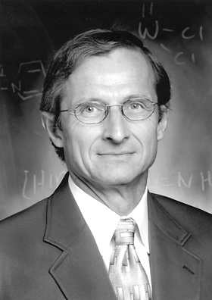**Richard Schrock**

MIT

Picture from "Richard R. Schrock - Facts". Nobelprize.org. Nobel Media AB 2014. Web. 29 Jul 2016.

<http://www.nobelprize.org/nobel_prizes/chemistry/laureates/2005/schrock-facts.html>

In 1973 Richard Schrock, while working at DuPont central research, prepared the first early transition metal complex with a metal=carbon double bond:



This turned out to be a key development in early transition metal chemistry.

Unlike most Fischer Carbenes, these early transition metal alkylidene complexes did have clear-cut and strong metal=carbon double bonds. For example, the crystal structure of the Cp2Ta(=CH2)(CH3) complex has the following bond distances:



The reason that Schrock gave these “carbene” complexes a different name (alkylidenes) was not just because of the structural differences. These early transition metal alkylidene complexes had very different (almost opposite) reactivities compared to Fischer Carbenes:

|  |  |
| --- | --- |
| **Fischer Carbenes** | **Schrock Alkylidenes** |
| Nucleophillic attacks at carbon atom of carbene (carbon is electron deficient) | Electrophillic attacks at carbon atom of alkylidene (carbon is electron-rich) |
| Electrophillic attacks on metal center (metal is more electron-rich, often d6 18 e- system) | Nucleophillic attacks on metal center (metal is electron-deficient, usually d2 or d0 16 or 14 e- count) |
| Carbene is *stabilized* by heteroatom groups that can -bond to it. Likes NR2, SR, OR, or Ph groups. | Alkylidene is *destabilized* by heteroatom groups that can -bond to it. Strongly prefers H or simple alkyl groups. |
| Later transition metals favored, especially with d6 counts (carbene as neutral 2e- donor ligand) | Early transition metals favored, especially with d0 centers (alkylidene as dianionic 4e- donor) |

The bonding description commonly used to describe Schrock Alkylidenes is to treat the alkylidene as a dianionic 4e- donor ligand, which is what the electron counting and valence rules from the first chapter would indicate.

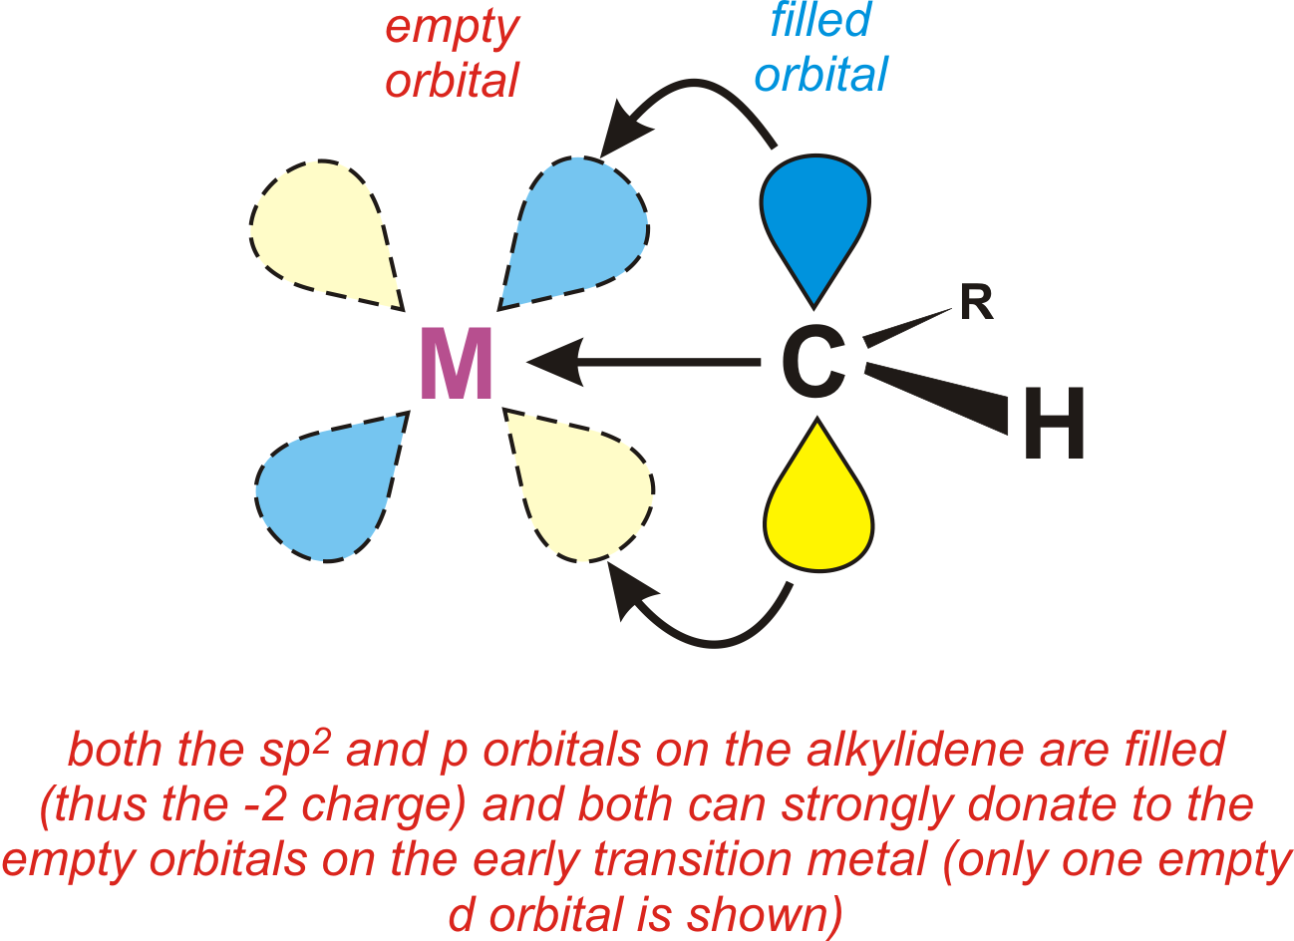

The filled *p*-orbital on the alkylidene carbon nicely explains the tendency for electrophiles to attack at this site, while in a Fischer carbene this same orbital is formally empty and thus susceptible to a nucleophillic attack.

Similarly, the d0 metal center in the typical Schrock alkylidene usually only has a 12 to 16 e- count (often 14 e-), this means that there are several empty low energy orbitals that are very attractive to any nucleophile that can sterically access the metal center. In Fischer carbenes, the metal is typically d6 and 18e-, thus there are no empty orbitals on the metal for a nucleophile to attack.

One other way to view a Schrock alkylidene is as a neutral ligand, just as with a Fischer carbene, but that it is in the triplet carbene state and interacting with a spin unpaired d2 metal center:

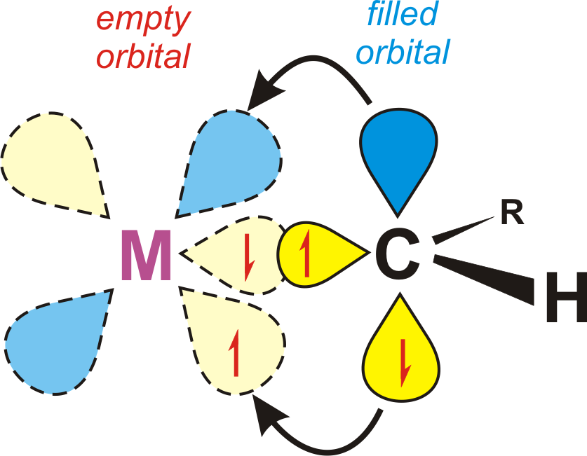

The view of an alkylidene as a neutral triplet carbene forming a strong covalent double bond to a triplet metal center is very analogous to the covalent C=C double bond in organic chemistry.

Molecular orbital (MO) diagrams for generic Schrock alkylidene and Fischer carbene ligands are shown below starting with both carbon fragments as neutral triplet (alkylidene) and singlet (carbene) groups:



Note that the higher energy early transition metal orbitals match up much better with the higher energy triplet alkylidene orbitals – this leads to considerably stronger covalent bonding (both MO diagrams are on the same energy scale).

So How Should I Electron Count??

The various methods of electron-counting carbenes and alkylidenes are:

1) both as neutral 2 e- donor ligands (but still draw a M=C double bond)

2) both as dianionic 4 e- donor ligands

3) Fischer carbenes as neutral 2 e- donor ligands. Typically group 6 or higher metals with a d6 or d8 electron count (sometimes d4).

4) Schrock alkylidenes as dianionic 4 e- donor ligands. Typically group 4 or 5 metals with d0 electron counts. Also later transition metals in high oxidation states (d0, d2, or d4).

Of course, in order to do method 3 or 4, you have to realize whether you have a Fischer or Schrock system. This isn’t always easy just looking at the complex. I recommend initially adopting methods 1 or 2 until you have a better mastery of the differences between the two systems.

It is somewhat important to be able to tell them apart since Schrock alkylidenes almost always have stronger (but often still reactive) M=C bonds compared to Fischer carbenes. So on a question asking you to order a series of carbene and/or alkylidene complexes, it is generally important to figure out which is which. On this type of question I’ll only give you a maximum of one Schrock alkylidene since the factors determining alkylidene bond strengths are not anywhere as clear cut as those for Fischer carbenes.

**As far as the overall electron-count is concerned, it DOESN’T matter which electron-counting method you use, since both give you the same overall electron-count!!**

Example: Identify the following complexes as Fischer carbene or Schrock alkylidene.



NMR Data

There isn’t any clear cut experimental way of distinguishing Fischer carbenes from Schrock alkylidenes. Some complexes, of course, will fall between (shades of gray) and can’t be clearly identified as belonging to either category.

13C NMR data is potentially one way of distinguishing between carbenes and alkylidenes because the chemical shift of the carbene carbon is usually quite sensitive to the chemical environment, electron density, and bonding factors. Unfortunately, the NMR data, although sometimes useful, generally won’t allow one to identify when a system is a carbene or alkylidene, as shown to the right.

|  |  |  |
| --- | --- | --- |
| **Compound** | **13C  (ppm)** | **Class** |
| **Cp2Ta(=CH2)(Me)** | **224** | **Schrock** |
| **(t-BuCH2)3Ta(=CH(t-Bu)** | **250** | **Schrock** |
| **(OC)5Cr(=CH(NMe2))** | **246** | **Fischer** |
| **(OC)5Cr(=CPh(OMe))** | **351** | **Fischer** |
| **(OC)5Cr(=CPh2)** | **399** | **Fischer** |

1H NMR data has provided useful information about carbene rotational barriers. As with most double bonds, there is a rotational barrier for the M=CR2 bond. For Schrock alkylidenes this is usually quite high (G‡ > 100 kJ/mol), but for the more weakly bonded Fischer carbenes this can often be readily determined from variable temperature 1H NMR studies.

The Cr carbene shown below actually has more double bond character between the carbene carbon and the -OMe group relative to the Cr=C bond. At 25ºC the methoxy CH3 group shows a single 1H NMR resonance indicating that there is relatively fast rotation about the C-OMe bond, while at 40ºC there are two resonances for the *cis* and *trans* methoxy CH3 conformers, consistent with partial double bond character.



The “Hot” Carbene Ligand

The hottest carbene ligands are imidazole-based N-heterocyclic carbenes (NHC’s) shown below. The flanking N atoms and R groups provides steric and electronic stabilization making this a reactive, but synthetically accessible ligand. NHC’s are usually strong -donors, often exceeding the donor ability of an alkylated PR3 ligand (see plot below). The backbone double bond may or may not be present (along with other R groups).

4571-CO-carbene-phosphine-donor-plot



Note that this ligand is usually drawn with a single bond to the metal. But it is NOT an anionic alkyl and there is NOT a H atom on the carbon atom bound to the metal center!! It is typically electron-counted as a neutral Fischer carbene. Because of the two flanking N atoms that can -donate into the empty carbene *p*-orbital, it is not considered to be a good -acceptor. This -donation, however, does help make it a stronger -donor by compensating for the -withdrawing electro­negative N atoms.

**Some Early References to N-heterocyclic carbenes:**

Wolfgang A. Herrmann, “N-Heterocyclic Carbenes. Part 31. N-Heterocyclic Carbenes: A New Concept in Organometallic Catalysis.” *Angew. Chem. Int. Ed.*, **2002**, *41*, 1290-1309.

Robert H. Crabtree (& coworkers), “Abnormal C5-Bound N-Heterocyclic Carbenes: Extremely Strong Electron Donor Ligands and Their Iridium(I) and Iridium(III) Complexes.” *Organometallics*, **2004**, *23*, 2461-2468 (modified CO plot above from this reference).

**Problem: Order the following M=C complexes from the one with the highest M=CR2 rotational barrier to the lowest. What factors affect the M=C rotational barrier? Identify each complex as either a Fisher carbene or a Schrock alkylidene.**



**Carbynes/Alkylidynes** 

E. O. Fischer accidentally prepared the first M≡C-R triple bonded compound in 1973:



He called this a carbyne after alkyne, which refers to a C≡C triple bond. Early transition metal versions were prepared first by Schrock in 1978 via -deprotonation of the alkylidene:



These were called alkylidynes by Schrock. Fortunately, while there are some differences between early and later transition metal carbon triple bonds, we can treat them as basically being the same. Thus, one can simply treat carbynes and alkylidynes as trianionic (-3) 6e- donating ligands. They are very strong donors as might be expected from the relatively low electronegativity of carbon and the -3 formal charge.



An remarkable X-ray structure of one of Schrock’s compounds that contains a W-C single bond, a W=C double bond, and a W≡C triple bond is shown below and beautifully illustrates the dramatic and progressive shortening of the W-C bonds as you increase the bond order:



Carbynes are also rather good bridging groups for two or three metal centers. When bridging two metals, one usually assumes delocalized bonding and that the carbyne donates 3e- to each metal center:



X-ray structures (as the one above) usually show equal M-(-carbyne) bond distances completely supporting the idea that the bonding is delocalized. When there isn’t M-M bonding present, most authors will draw a circle in the dimetallocyclobutane ring to indicate delocalized bonding (that doesn’t necessarily mean it is aromatic, but it may be depending on the - and *d*-electron count).

**Problem: Which of the following ligands will coordinate the strongest to the empty coordination site on the metal complex shown below.**

**CO, PMe3, P(OMe)3, CH3, F, CF3**

**Mn(CO)5+**

**Problem: Professor Standshort instructed his graduate student Fred Fasthands to make a Pd(alkyl)2(PPh3)2 complex. Fred immediately rushed into the lab and ran the following reaction:**

**PdCl2 + 2PMe3 + 2EtMgBr  icky black stuff + ethylene (*g*)**

**Thelma Thinksalot, a younger yet wiser undergraduate in the lab (who was taking Prof. Standshort’s organometallics class), suggested that Fred use the exact same conditions *except* that he should use PhCH2MgBr (benzyl Grignard) instead of EtMgBr. Fred frantically did so and found that the reaction now gave a quantitative yield of orange Pd(CH2Ph)2(PMe3)2.**

**Why didn't the first reaction work and why did the second work fine? What other alkyl groups might work?**