**Cyclopentadienyl - Cp**

Created by George G. Stanley, Department of Chemistry, Louisiana State University (gstanley@lsu.edu) and posted on VIPEr on August 14, 2017. Copyright Geroge G. Stanley, 2017. This work is licensed under the Creative Commons Attribution-NonCommercial-ShareAlike CC BY-NC-SA. To view a copy of this license visit {http://creativecommons.org/licenses/by-nc-sa/4.0/}.

The cyclopentadienyl ligand is one of the most common and popular ligands in organometallic chemistry.



It is an anionic ligand that normally coordinates in an 5 mode as a 6e- donor, but it can adopt 3- and 1-coordination modes.



Free neutral cyclopentadiene, which is deprotonated with a strong base to generate the Cp, is unstable and reacts with itself via a Diels-Alder reaction to make the dicyclopentadiene. One typically regenerates cyclopentadiene by distilling (“cracking”) it from the high boiling dimer solution and storing it in a refrigerator, but it slowly re-dimerizes to make dicyclopentadiene.



Brief History of Ferrocene:

|  |  |
| --- | --- |
| 1901 | Synthesis of KC5H5 from K and C5H6 |
| 1951 | Miller, Tebboth & Tremaine  Sythesis of Fe(C5H5)2 from the reaction of C5H6 with freshly reduced Fe at 300ºC |
| 1951 | Kealy & Pauson  3C5H5MgBr + FeCl3  Cp2Fe +  + 3MgBrCl  They were trying to make fulvalene!    They proposed that they had made: |
| 1952 | E. O. Fischer proposes a *“Double-cone structure”*  X-ray structural data  Diamagnetism  Chemical behavior |
| 1952 | Geoffrey Wilkinson & Robert Woodward: *“Sandwich Structure”*    IR spectroscopy  Diamagnetism  Dipole moment = 0  Woodward noted that the Cp rings were susceptible towards electrophillic substitutions, similar to the aromatic behavior of benzene.  Thus the common name: **ferrocene** |
| 1973 | Fischer & Wilkinson receive the Nobel Prize in Chemistry for their “discovery” of ferrocene, which played a key role in opening up the new area of organometallic chemistry. |

For a short historical account see *Chemical & Engineering News*, Dec 3, **2001** (I have copies of the article) or the special Ferrocene issue of *Journal of Organometallic Chemistry*, Vol 637-639, Issue 1, 3 December 2001.

The structure of ferrocene does have a sandwich structure with a bonding interaction from each ring carbon to the metal, although virtually all researchers only draw a single bond from the metal to the middle of the Cp ring(s) as shown to the right below.

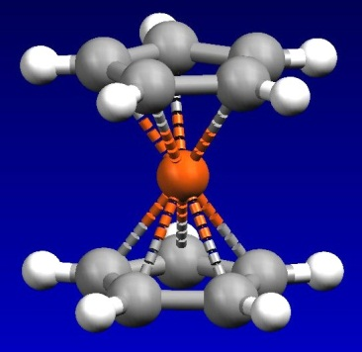 

**Some Properties of Metallocenes**

|  |  |  |  |
| --- | --- | --- | --- |
| **Complex** | **Color** | **mp/ºC** | **Miscellaneous** |
| “Ti(C5H5)2” | green | 200 (decomp.) | bimetallic with two m-H bridges and a fulvalene bridging ligand (structure shown later) |
| V(C5H5)2 | purple | 167 | very air‑sensitive, paramagnetic |
| “Nb(C5H5)2” | yellow | - | bimetallic with 1,5-C5H4 bridges and terminal hydrides (structure shown later). |
| Cr(C5H5)2 | scarlet | 173 | very air‑sensitive |
| “Mo(C5H5)2” | Black | - | several bimetallic isomers with fulvalene and h1,h5 bridges and terminal hydrides (structures shown later), diamagnetic, air-sensitive. |
| “W(C5H5)2” | yellow‑green | - | same as Mo |
| Mn(C5H5)2 | brown | 173 | air-sensitive and easily hydrolyzed, interesting high-spin to low-spin interconversion |
| Fe(C5H5)2 | orange | 173 | air-stable, can be oxidized to blue-green [Fe(C5H5)2]+ which, in turn, is a good “inert” oxidizing agent. |
| Co(C5H5)2 | purple-black | 174 | air-sensitive, paramagnetic 19e- complex, can be oxidized to the air-stable 18e- yellow [Co(C5H5)2]+ |
| Ni(C5H5)2 | green | 173 | 20e- complex, slow oxidation in air to the labile, orange cation [Ni(C5H5)2]+ |

Adapted from Elschenbroich & Salzer, “Organometallics”, VCH, 1989

Structural Features

The parallel sandwich structures have the following structural features:

|  |  |  |
| --- | --- | --- |
| **Distances (Å)** | | |
| **M** | **M-C** | **Cp…Cp** | **C-C** |
| **Fe** | **2.04** | **3.29** | **1.42** |
| **[Fe]+** | **2.07** | **3.40** | **1.40** |
| **Ru** | **2.19** | **3.64** | **1.43** |
| **Os** | **2.19** | **3.61** | **1.45** |
| **Co** | **2.10** | **3.44** | **1.41** |
| **[Co]+** | **2.03** | **3.24** | **1.42** |
| **Ni** | **2.18** | **3.63** | **1.41** |

Note the various trends in the bond distances. The changes in the neutral Fe, Co, Ni metallocenes are a direct result of going from 18e- (Fe) to 19e- (Co) to 20e- (Ni) counts. The extra electrons for the Co and Ni complexes are going into M-Cp antibonding orbitals, which are delocalized and progressively weaken the M-Cp bonding, leading to the increase in bond distances. This in spite of the fact that the metal’s covalent radius is *decreasing* as one goes from Fe  Ni (effective atomic number contraction effect).

**Problem: Explain why the Fe-C distance *lengthens* for [Cp2Fe]+, while the Co-C distance *shortens* for [Cp2Co]+**.

Oxidation of Cp2Os does not produce a simple cationic monomer as seen for Co and Fe. Instead one gets dimerization to produce the following bimetallic complex that has an Os-Os bond (3.04 Å).

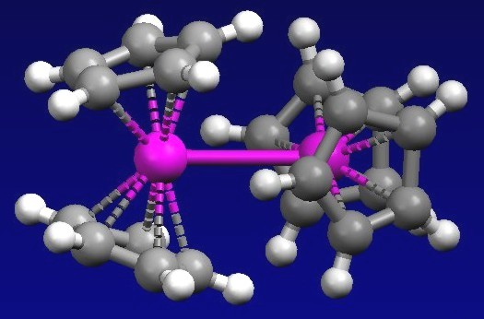

**Problem: Is this complex para- or diamagnetic?**

The simple neutral bis-Cp complexes of the early transition metals are quite different because they are in very low **+2** oxidation states (very electron-rich) and quite unsaturated. Thus, they are very reactive towards oxidative addition and other reactions.

“Nb(C5H5)2”, for example, is nominally a 15 e- complex with a highly reactive d3 Nb electronic configuration. Two molecules of niobocene react with one another via C-H bond activation (oxidative addition) to produce the structure shown to the right. Note that two of the Cp rings are dianionic forming both a traditional aninic 5 6e- -type donor to one metal, while bridging over and acting as an anionic 2e- -donor to the other metal center. Practice your electron counting on this.



“Ti(C5H5)2”, is nominally a 14 e- complex with a highly reactive d2 electronic configuration. Two molecules of titanocene also react with one another via C-H bond activation (oxidative addition) to produce a bimetallic complex that may well look just like the niobium complex just discussed. But it has a further reaction (perhaps due to steric crowding brought on by the smaller Ti centers) leading to the coupling of the two -bound Cp’s to produce C-C bound bis-Cp and the complex shown below. The more sterically crowded pentamethyl-Cp (Cp*) complex simply does a hydride abstraction and stops at the complex also shown below.



Ti-Ti = 2.99 Å

**Problem:**  **Electron-count the bimetallic Ti complex to the above left. Should it have a Ti-Ti bond or not? Show your electron counting.**

**Problem: What advantage does the Cp*2Ti complex (above middle) gain by doing a hydride abstraction to produce the hydride complex to the above right (previous page)?**

The “Mo(C5H5)2” and “W(C5H5)2” complexes might appear to have a “reasonable” 16 e- count, but they are quite reactive, like their early transition metal cousins, and also self-react with one another via C-H bond activations to produce several isomeric bimetallic complexes shown below.



**Problem: Electron-count the following complex. What does the arrow between the two Mo atoms indicates? It is NOT a covalent Mo-Mo bond. What name for this type of bonding would you use?**



Cp Variants





Azulene is neutral, so 5-coordination of the C5 ring only provides 5e-, to get 6e- one needs to use one of the C7 ring carbon -orbitals!

MO Comparison of Cp vs. Arene Ligands

