**Introductory WebMO Exercises**

These directions assume no prior knowledge of the WebMO interface and provide detailed, click-by-click instructions on building molecules and setting up calculations.

After completing this exercise, students will be able to:

1. Draw a molecule in WebMO
2. Rotate, translate, and zoom the molecule
3. Choose a theory and basis set for calculations
4. Optimize the geometry of a molecule
5. Determine the bond lengths, bond angle, and dihedral angles in a molecule in WebMO
6. Calculate molecular orbitals in WebMO
7. Use the Z-matrix editor and coordinate scans to compare the energies of different molecular geometries

Use your provided login credentials to login to WebMO.

**Exercise 1 - Study of H-X-H Bond Angles**

*Structure of CH4*

Go to “New Job” and select “Create New Job.” A window opens where you build molecules.

The default atom that is selected is carbon. (Note: If you wish to choose a different atom, you may simply type the atom symbol *or* click on the Periodic Table icon, 2nd down the left side, and choose the atom you want).

Click once in the center of the workspace. A gray carbon atom appears. (If you click too many times and have extra atoms, choose Edit > Undo).

Next click the paintbrush icon on the left. This will activate “Comprehensive Cleanup using Idealized Geometry.” **You should now have methane.** (Note: There are additional cleanup techniques under the Cleanup menu item at the top.)

Experiment with the Rotate, Translate, and Zoom tools (third, fourth, and fifth icons on left side).

This structure contains idealized bond lengths and angles. A more accurate structure can be found by carrying out an energy minimization using molecular mechanics, semiempirical methods, or *ab initio* calculations. To reduce the time required for the calculations and to obtain reasonable results, the semi-empirical method PM3 will be used. This method is available in most molecular modeling programs.

Click the blue “continue” arrow in the lower right side of the Build Molecule window. Choose Mopac as the computational engine.

Click the blue “continue” arrow.

Type in/Choose the following:

Job Name: CH4 PM3 Geom Opt

Calculation: Geometry Optimization (ALWAYS do this first.)

Theory: PM3

Charge: 0

Multiplicity: Singlet

Click on the blue “continue” arrow. You should now see your job listed. To kill or stop a job, you would click on the red “X” under Actions on the right side.

When the status of the job is “complete,” click on the hyperlinked name (CH4 PM3 Geom Opt) to open the “View Job” window.

Choose the Select arrow (4th icon down on left).

Click on one of the H atoms in the structure (it will be highlighted).

Click on the C atom (both atoms are now highlighted).

The bond length is displayed just below the molecule. Record the value of the C-H bond length___________Å (1.091Å literature). You can “clear” the atom selections by clicking on the background, away from the molecule. Check the other C-H bond lengths.

Click on one of the H atoms, then the C atom, followed by another H atom. The bond angle is displayed just below the molecule. Record the value of the H-C-H bond angle ___________° (109.4712° literature). Check the other H-C-H bond angles.

Scroll down and review the information under Calculated Quantities.

When finished, click the Job Manager link under Actions (to the left of the molecule display).

To delete files, click the box to the left of the desired file and choose Delete on the menu.

To continue on to the next exercise, go to New Job and choose Create New Job.

*Structure of NH3*

Build NH3 using the above procedure.

Use Job Name H3N PM3 Geom Opt, and perform the geometry optimization as before (PM3).

Record the value of the N-H bond length __________Å (~0.999Å, 1.012Å literature). Record the value of the H-N-H bond angle __________° (~107.8°, 106.67° literature). Scroll down and review the information under Calculated Quantities.

Click on the magnifying glass next to the reported Dipole Moment, then rotate the molecule to see the vector. The vector represents the direction and relative magnitude of the dipole moment.

Return to Job manager, and choose Create New Job.

*Structure of H2O*

Build H2O using the above procedure.

Use Job Name H2O PM3 Geom Opt, and perform the geometry optimization as before (PM3).

Record the value of the O-H bond length __________Å (~0.951Å, 0.959Å literature). Record the value of the H-O-H bond angle __________° (~107.7°, 103.9° literature). Check out the Dipole Moment, as with NH3 above.

Return to Job Manager.

1. What conclusion(s) can you make concerning the H-X-H bond angle and the number of unshared (lone) pairs of electrons around the central atom X?
2. What conclusions can you make concerning the size of the central atom X and the X-H bond length?

**Exercise 2 - Study of the Molecular Orbitals in Ethene, CH2CH2**

Return to Job manager, and choose Create New Job.

Click once in the workspace. A gray carbon atom appears. **Click on this atom and drag to one side and release.** You should now have C-C. Click and Drag from the center of one C atom to the center of the other C atom to form the double bond.

Click on the paintbrush item to clean up the structure. **You should now have ethene.**

Click the blue “continue” arrow in the lower right side of the Build Molecule window. Choose Mopac as the computational engine.

Click on the blue “continue” arrow.

Use Job Name C2H4 PM3 Geom Opt, and perform the geometry optimization as before (PM3). Once the job is complete, click on the hyperlinked name to open the “View Job” window.

Click the **New Job Using This Geometry** button (at the bottom), click the blue “continue” arrow, choose Mopac, and type in/choose the following:

Job Name: C2H4 PM3 MO

Calculation: Molecular orbitals

Theory: PM3

Charge: 0

Multiplicity: Singlet

Click on the blue “continue” arrow. You should now see your job listed.

Once the job is complete, click on the hyperlinked name (C2H4 PM3 MO) to open the “View Job” window.

Scroll down to the Molecular Orbitals table. Using the energy values and occupancy as your judge, identify the HOMO and LUMO. View these orbitals by clicking on the magnifying glass icon. Note that the orbitals are now listed in the Molecule Viewer window. (If the list is in the way, you may close it.) The orbitals can be rotated by clicking and dragging in the viewer window. Were your choices correct? View some of the other orbitals. What do the colors mean?

**Exercise 3 - Study of Rotation Barrier Energy about Carbon-Carbon Bonds**

Build C2H6 using the above procedure. Be sure to do the Cleanup as before.

Choose Tools > Edit Z-Matrix to open the Z-Matrix Editor window. In this window, each atom is numbered. Identify the two H atoms that form a dihedral angle (H-C-C-H) of ~180° (or -180°). In the pull-down menu to the right of this listed dihedral angle, choose “S” (See below for H6 and H3):

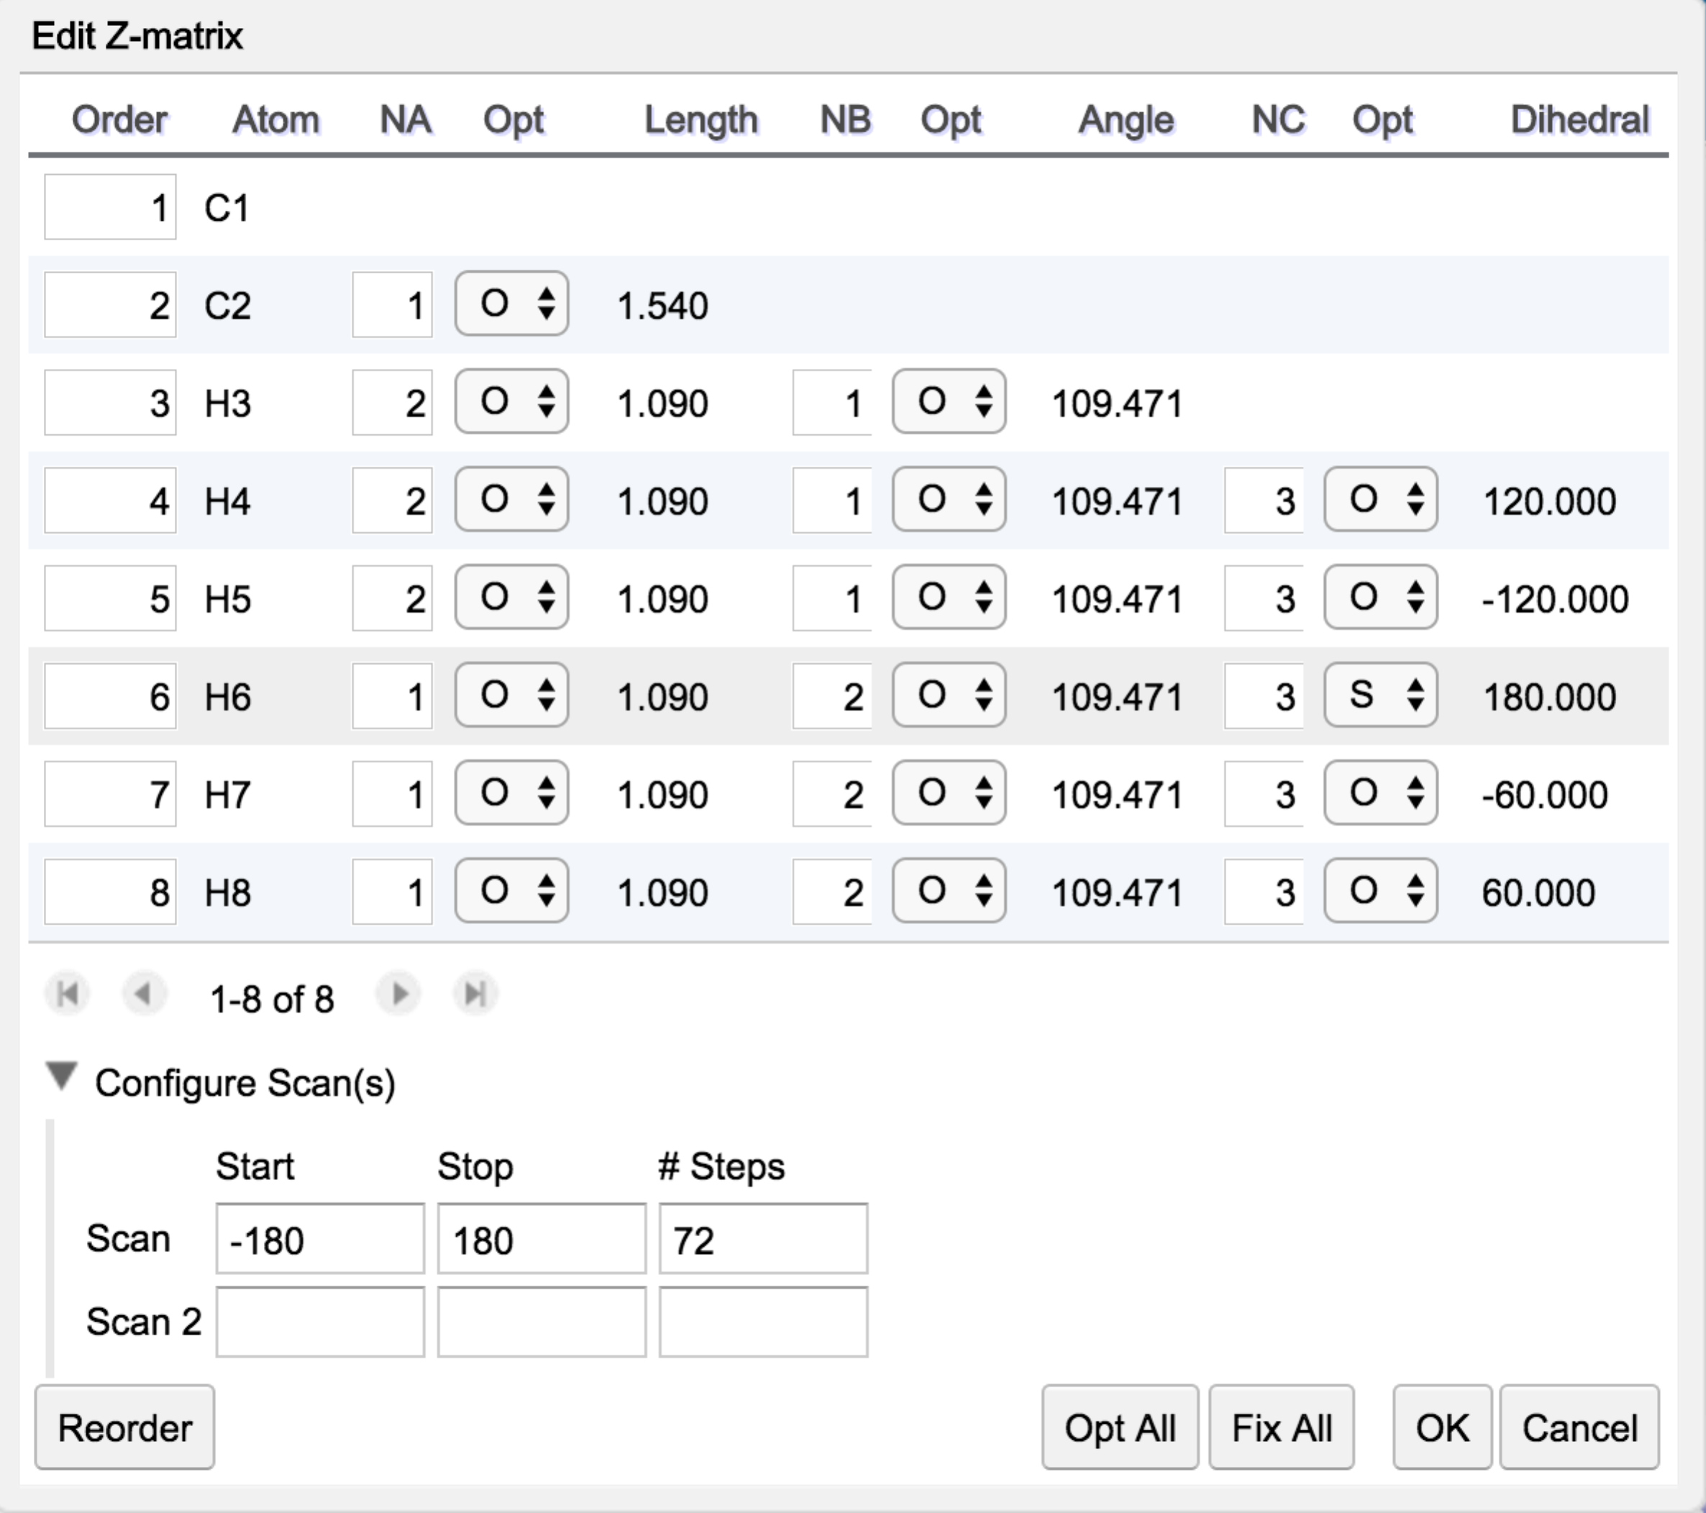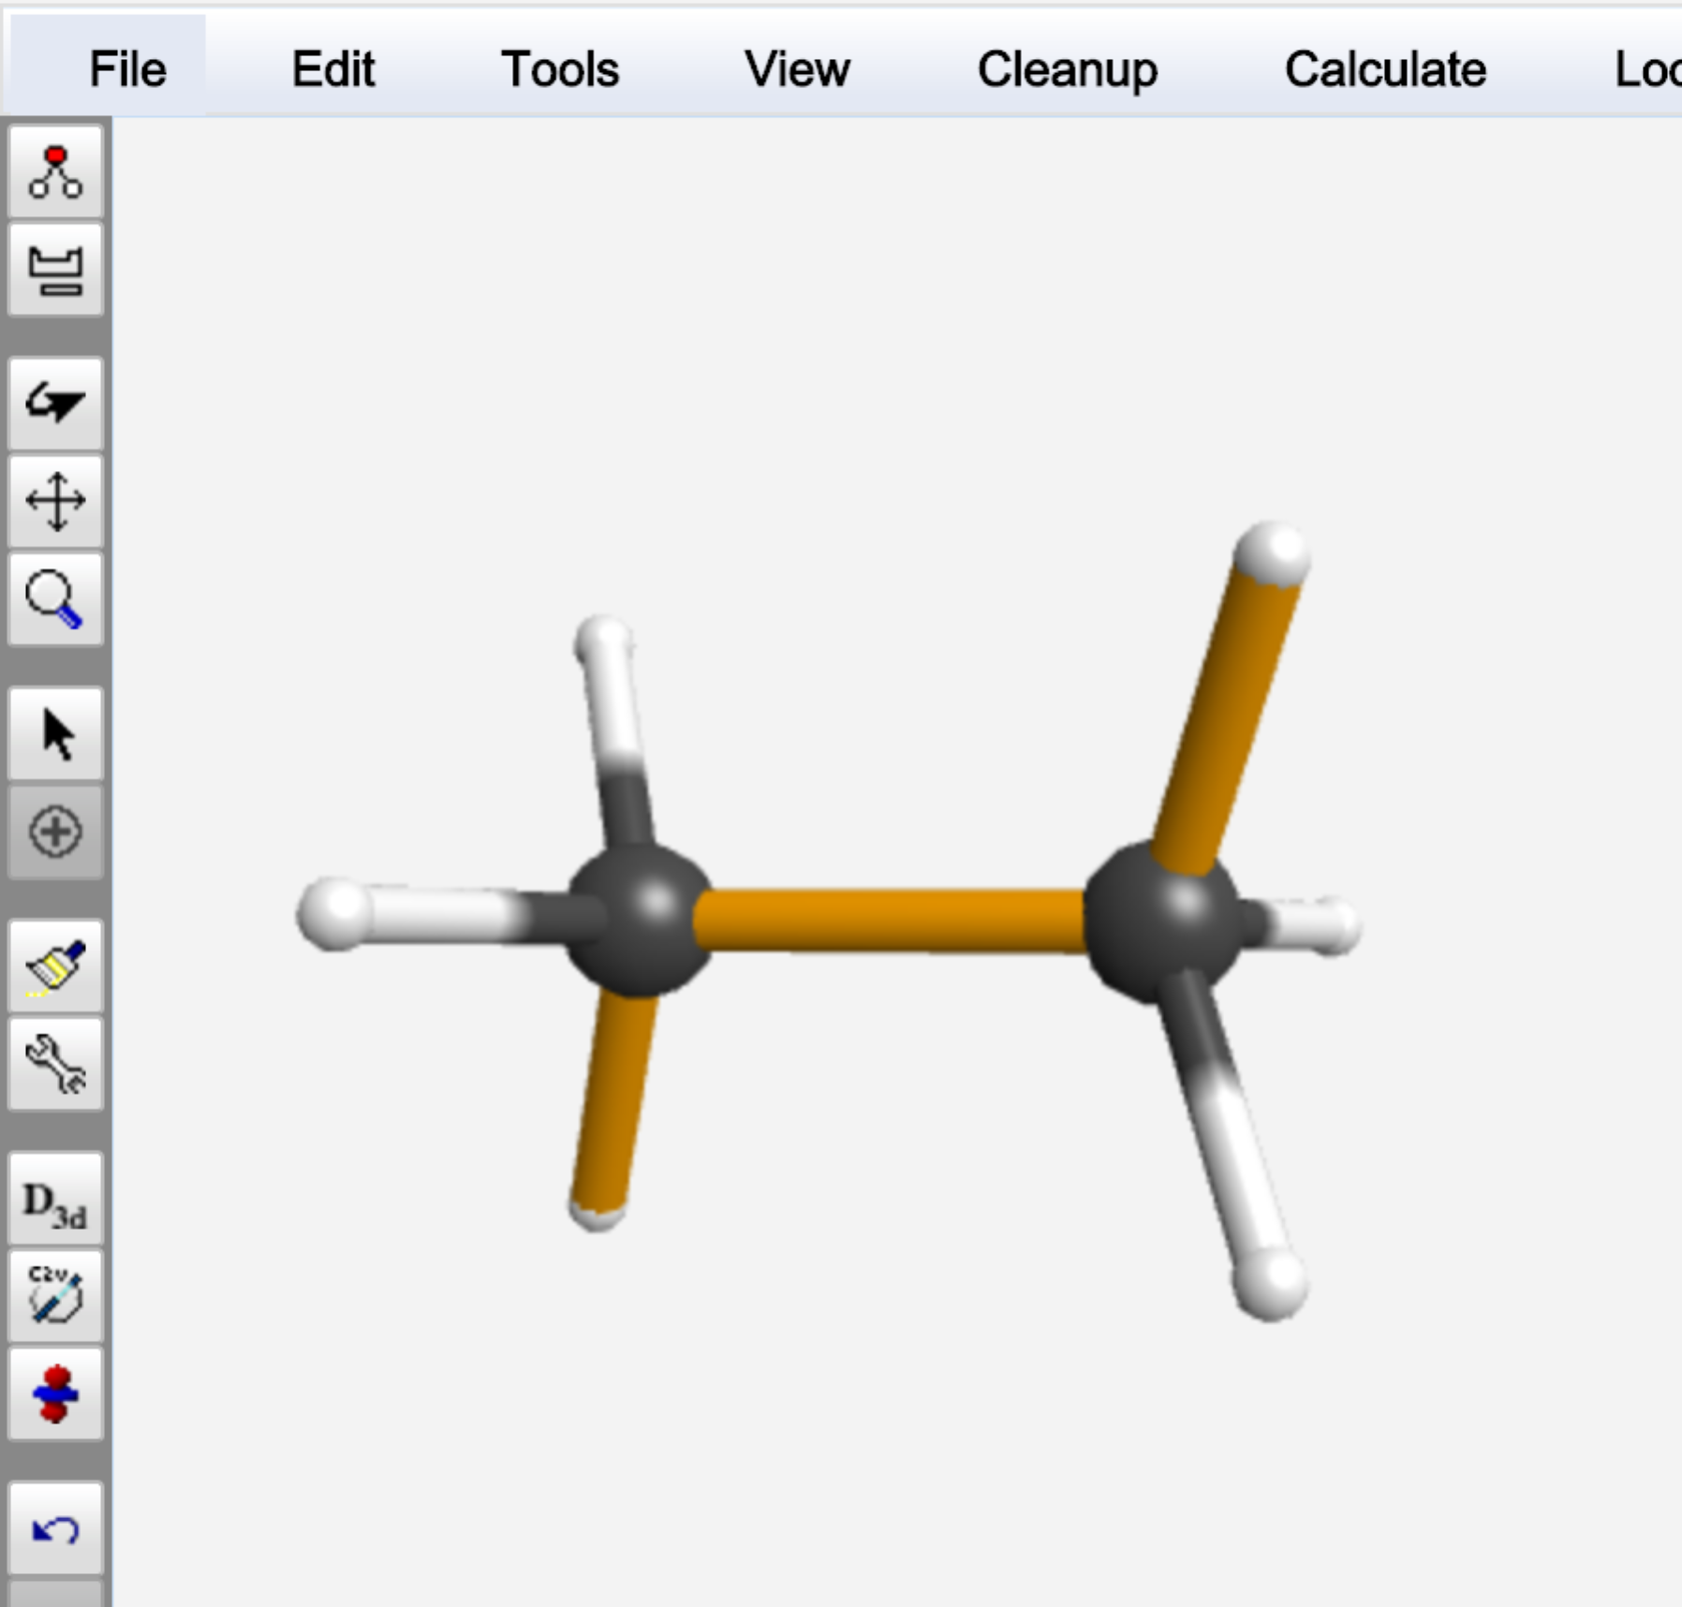

As shown above, enter the Start (-180) and Stop (180) scan values, along with 72 steps, then click OK to close the Z-Matrix Editor window. The dihedral angle you selected will now be highlighted with gold bonds. You can use this to verify that you have set up the scan correctly.

Click the blue “continue” arrow. Choose Mopac.

Use the following Job Options:

Job Name: C2H6 PM3 Angle

Calculation: Coordinate Scan

Theory: PM3

Charge: 0

Multiplicity: Singlet

Click the blue “continue” arrow. You should see the job in the queue.

When the job is complete, click on the linked name. Scroll down to the Coordinate Scan table and click on the magnifying glass on the table title bar. A Coordinate Scan window opens showing the plot of Energy vs. dihedral angle.

Does the graph make sense? Describe the relationship between the dihedral angle and energy.

View a movie of the dihedral angle rotation by clicking on the video icon in the top of the Coordinate Scan Box. *Practice using the controls to the left of the molecule to stop, start, and step through the video.* Note the changing Coordinate and the Energy values at the bottom of the viewer window.