Comparing the Solid- and Solution-State Stoichiometry of Metal Complexes with Schiff-base Ligands

Peter R. Craig, J. Katana Ngala and Katrina R. Wiens

Summary
Coordination compounds can adopt different metal-to-ligand stoichiometries in the solid and solution states. In this laboratory project, students compare gravimetric analysis with Job's method to determine whether the metal-to-ligand stoichiometry is conserved between these two environments.
Students investigate the stoichiometry of eight metal ion complexes of the Schiff-base ligand salicylaldehyde benzoyl hydrazone (SBH) in both the solid and solution states using gravimetric analysis and UV-Vis spectroscopy. This work expands upon a previously published study by Wilkinson et al., which focused on Cu²⁺ and Fe³⁺ complexes of SBH, and critically examines the findings of Salawu et al., who reported the preparation and characterization of Co²⁺, Ni²⁺, Cu²⁺, Pb²⁺, and Zn²⁺ complexes of SBH. In addition, we introduce La³⁺, Mn^{2+,} and VO²⁺ complexes, selecting a total of eight systems for student investigation, with an emphasis on complexes that are labile with respect to ligand exchange.
This laboratory sequence is suitable for both second-semester general chemistry students and sophomore-level inorganic chemistry students. Depending on the course context, introductory coordination chemistry concepts may be integrated into lectures or pre-laboratory discussions. At McDaniel College, this sequence has served as an introductory research experience. The extent to which the experience remains research-based in subsequent offerings depends on the reproducibility of the experimental results. Incorporating metal ions whose SBH complexes have not previously been reported provides additional opportunities for authentic student research. This flexibility allows students to engage in authentic research early in their academic careers.
The full sequence has been implemented over seven weeks for groups of two to three students (seven 3-hour laboratory sessions). This timeframe may be reduced if:

- students have prior familiarity with coordination chemistry, UV-Vis spectroscopy (theory and practice), analytical balance operation, volumetric techniques, laboratory safety protocols, and limiting reagent/theoretical yield calculations;
- the Schiff-base ligand SBH is prepared in advance of use;
- sufficient instrumentation (UV-Vis spectrometers, analytical balances, and computers) is available for each student group;
- students have access to and working knowledge of SciFinder for literature searching and ChemDraw for documenting reaction schemes.

References
Wilkinson, S. M.; Sheedy, T. M.; New, E. J. Synthesis and Characterization of Metal Complexes with Schiff Ligands. J. Chem. Educ. 2016, 93, 2, 351-354.
Salawu, O. W.; Onoja, P. K.; Sale, J. F. Studies on some metal(II) sulphates salts chelates of salicylaldehyde benzoic acid hydrazone and acetylaldehyde benzoic acid hydrazone. Chem. Sin. 2011, 2, 25-34.

Table of Contents

Representative Schedule 3
CAS Numbers and Safety Data of Chemicals used in this Project 4
Learning Outcomes 5
Week 1: Project Introduction 6
Week 2: SBH Synthesis 9
Week 3: Metal Complex Synthesis 11
Week 4 and 5: Job’s Plot 14
Student Results Sheet 18
Week 6: ChemDraw & SciFinder 20
Week 7: Project Presentation 21
Grading Sheet: Group Oral Presentation (40 pts) 29
Grading Sheet: Individual Final Written Formal Lab Report (40 pts) 33

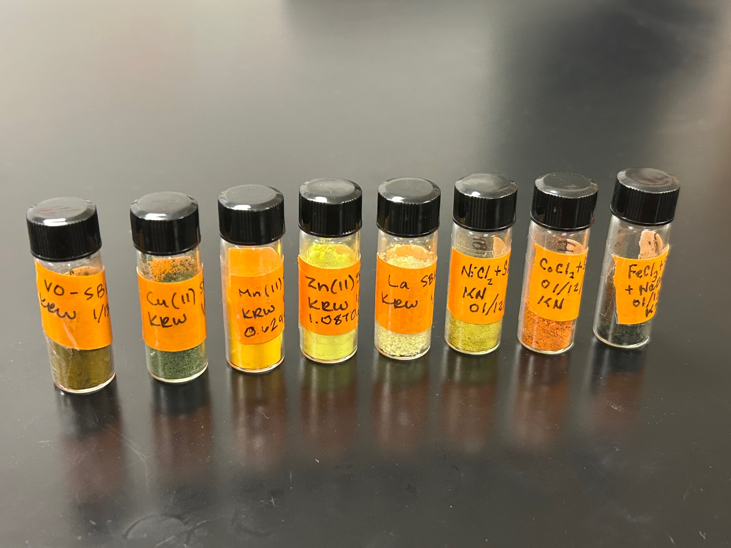

Representative Schedule

This research-based laboratory sequence is designed to be completed over seven 3-hour laboratory sessions. The intended schedule is as follows:

Week 1: Project Introduction
Week 2: SBH Synthesis
Week 3: Metal Complex Synthesis
Week 4: Job’s Plot 1
Week 5: Job’s Plot 2*
Week 6: ChemDraw & SciFinder
Week 7: Project Presentation

In Week 1, students are introduced to the project and receive instruction in the use of ChemDraw. They will construct a reaction scheme for the synthesis of the Schiff-base ligand salicylaldehyde benzoyl hydrazone (SBH) and establish access to SciFinder for literature searching to support their oral presentation and final written report. Depending on the instructor, metal ion assignments for each laboratory group may also be made at this stage. Detailed instructions for subsequent weeks are provided below.

It should be emphasized that this is a research-based project. As such, experimental outcomes are not predetermined and may vary between groups. This represents a departure from traditional laboratory exercises and requires careful and thorough documentation of all procedures and observations in laboratory notebooks. Instructors may review notebook entries weekly and provide formative feedback to support student progress; however, these entries are not formally graded.

Students are expected to use laboratory time efficiently and proactively. In some cases, it may be necessary to prepare additional quantities of materials in advance to ensure continued progress in subsequent sessions, even if this is not the primary objective of a given laboratory period.

Assessment for the project is based on a group oral presentation (40 points) and an individual final written report (40 points). Specific dates, rubrics, and submission guidelines will be provided by the instructor.

*Note: If all student groups in a laboratory section are able to collect the required UV-Vis spectral data within a single session, only one Job’s plot session is necessary. The schedule may be adjusted accordingly.

CAS Numbers and Safety Data of Chemicals used in this project

The following table lists CAS numbers and approximate acute oral LD₅₀ values in rats (mg·kg⁻¹) for chemicals used in this project. Values are compiled from publicly available Safety Data Sheets (SDS) and toxicology databases and are intended for instructional use only. Acute oral LD₅₀ values (rat) represent the mass of the chemical in mg per kg of rat that kills (LD or lethal dose) 50% of the population studied when given orally. These data provide students with a relative sense of compound toxicity, so they can take appropriate precautions (secondary containment, chemical transfer method choice, use of fume hood or specialty safety apparatus, etc.)

Table 1: Chemical CAS Numbers and Safety Data
Chemical Name | CAS Number | LD₅₀ (rat, oral) mg/kg
Benzhydrazide | 613-94-5 | No reliable oral LD₅₀ reported
95% Ethanol | 64-17-5 | 7060
Cobalt(II) chloride hexahydrate | 7791-13-1 | 537
Copper(II) chloride dihydrate | 10125-13-0 | 584
Iron(III) chloride hexahydrate | 10025-77-1 | 316
Lanthanum(III) chloride heptahydrate | 10025-84-0 | 4184
Manganese(II) chloride tetrahydrate | 13446-34-9 | 1484
Methanol | 67-56-1 | 5628
Nickel(II) chloride hexahydrate | 7791-20-0 | 105
Salicylaldehyde | 90-02-8 | 520
Salicylaldehyde benzoyl hydrazone | 3232-37-9 | No reliable oral LD₅₀ reported
Sodium acetate trihydrate | 6131-90-4 | 2700
Vanadyl sulfate dihydrate | 123334-20-3 | 467
Zinc(II) chloride | 7646-85-7 | 350

Sources:
- Sigma-Aldrich / Merck Safety Data Sheets
- Fisher Scientific Safety Data Sheets
- PubChem Compound Database (NIH)
- OECD Screening Information Data Sets (SIDS)
- TOXNET / HSDB (archived data)

Learning Outcomes

After completing this project, students will have the following laboratory skills:
- Dropwise addition of reagents
- Vacuum filtration
- Analytical balance use
- Conducting condensation reactions
- Synthesis of metal complexes
- Preparation of solutions of specified concentrations
- UV-Vis spectrometer use
- Use of a graduated pipette
- Making dilutions

After undertaking this project, giving a group oral presentation, and writing the individual final written formal lab report, students will understand:
- How percent yield evaluates solid state stoichiometry options (gravimetric analysis)
- How to use LoggerPro and/or Excel for plotting and fitting data
- How to determine binding solution stoichiometry from absorbance data (Job’s Plot)
- The relationship between absorbance and observed color
- How to interpret and extract data from UV-Vis spectra, including identifying λ_{max}, determining absorbance values, and relating spectral features to concentration and electronic transitions.

Week 1: Project Introduction

Schiff-bases are a class of organic compounds that contain a carbon-nitrogen double bond (C=N). They are formed when a molecule containing an amine group reacts with an aldehyde or ketone, producing water as a by-product. The carbon-nitrogen double bond is the defining feature of all Schiff-bases and is responsible for many of their useful chemical properties, including their ability to bind metal ions.

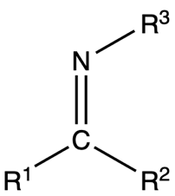

Figure 1. General structure of a Schiff-base. The carbon-nitrogen double bond (C=N) is the characteristic feature of this class of compounds. The groups designated R¹, R², and R³ can represent hydrogen atoms or a wide variety of organic groups.

In this experiment, the Schiff-base ligand salicylaldehyde benzoyl hydrazone (SBH) is prepared via the reaction of salicylaldehyde with benzhydrazide. Once synthesized, the ligand is reacted with a metal ion to form a metal-ligand complex. Each laboratory group will be assigned a different metal ion.

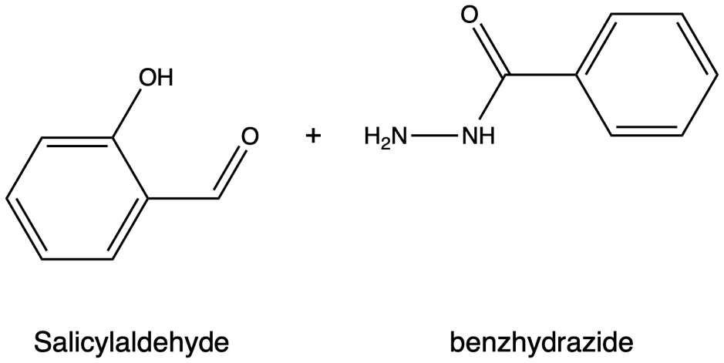

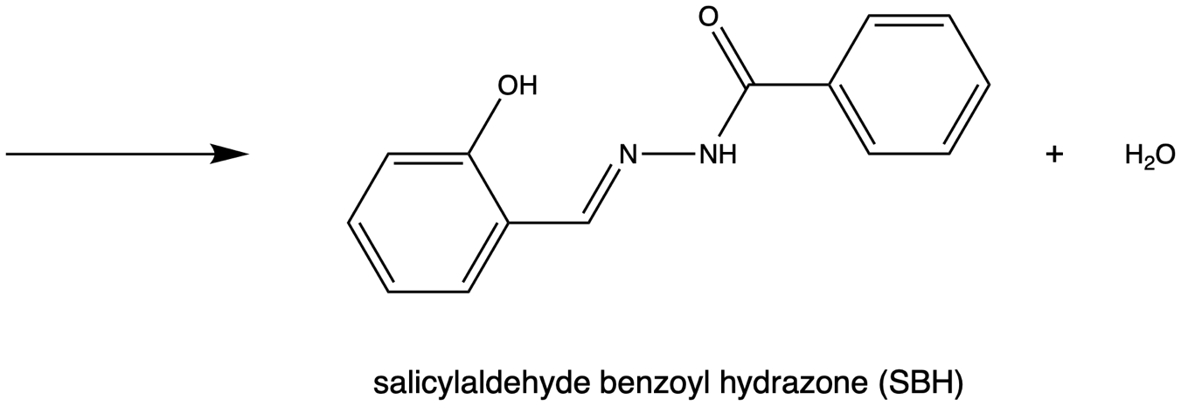

Figure 2. Synthesis of the Schiff-base ligand salicylaldehyde benzoyl hydrazone (SBH).

The stoichiometry of a metal-ligand complex (i.e., the number of ligands coordinated to each metal ion) depends on both the identity of the metal ion and the nature of the ligand. In this experiment, Job’s method of continuous variation is employed to determine the metal-to-ligand ratio of the complexes in solution. It is important to note that the solution-phase stoichiometry determined by this method may differ from that of the isolated solid complex.

In Job’s method, a series of solutions is prepared such that the total number of moles of metal and ligand, n_{total}, remains constant:
n_{total} = n_{M} + n_{L}

The composition of each solution is described using mole fractions of metal and ligand:
X_{L} = n_{L}/n_{total} X_{M} = 1 - n_{L}/n_{total} = n_{M}/n_{total}

The concentration of the metal-ligand complex formed in each solution is governed by the limiting reagent and reaches a maximum when the metal and ligand are combined in their stoichiometric ratio. By monitoring absorbance at a wavelength where only the complex absorbs, the maximum absorbance corresponds to this stoichiometric composition in solution.

A plot of absorbance versus ligand mole fraction (a Job’s plot) typically exhibits two linear regions corresponding to conditions in which either the metal or ligand is the limiting reagent. The intersection of these regions identifies the stoichiometric ratio. The ligand-to-metal ratio in a complex of the form ML_{a} can then be determined from the mole fraction at this point:
a = n_{L}/n_{M} = X_{L}/(1 - X_{L})

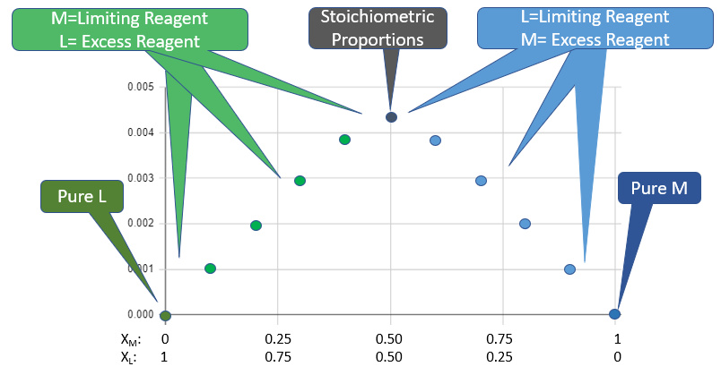
Figure 3. Regions of a Job’s plot. The x-axis shows the mole fractions of metal (X_{M}) and ligand (X_{L}), varying from pure ligand (left) to pure metal ion (right). The maximum corresponds to the stoichiometric mixing ratio.
Reproduced from Belford, “8.02: Background,” LibreTexts, https://chem.libretexts.org/Courses/University_of_Arkansas_Little_Rock/Belford_Poirot_GenChem_Lab/Chem_1403L%3A_General_Chemistry_Lab/08%3A_Formation_Constants/8.02%3A_Background

Week 2: SBH Synthesis

Equipment and Supplies (per group)
(we typically run up to eight groups per lab section)
- Benzhydrazide (1.0 g)
- 1 x metal spatula
- 1 x plastic weigh boat
- Access to an analytical balance
- 2 x 100 mL beakers
- 1 x stir bar
- Deionized (DI) water (40 mL)
- 1 x magnetic stirrer/hotplate (or glass stirring rod if unavailable)
- Salicylaldehyde (1.6 mL)
- 1 x 2 mL graduated glass pipette and pipette pump
- 95% ethanol (~50 mL)
- 1 x plastic pipette. Alternately, a Pasteur pipette and rubber bulb can be used
- 1 x Büchner funnel with appropriate adapter
- 1 x Büchner (vacuum) flask
- 1 x Whatman Grade 1 filter paper (to fit the funnel)
- 1 x clamp
- 1 x retort stand
- 1 x screw top 2-dram vial for product storage
Additional 95% ethanol may be required if recrystallization is performed.

Procedure
This reaction should be carried out in a fume hood.

Weigh 1.0 g of benzhydrazide using a spatula and weigh boat. Transfer the solid to a 100 mL beaker and add a magnetic stir bar. Dissolve the benzhydrazide in 40 mL of deionized (DI) water with stirring.

In a second 100 mL beaker, measure 1.6 mL of salicylaldehyde using a 2 mL graduated pipette and pipette pump. Dissolve this in 15 mL of 95% ethanol.

Using a plastic pipette, add the salicylaldehyde solution dropwise to the benzhydrazide solution with continuous stirring. After the addition is complete, continue stirring the mixture for 10 minutes.

Remove the stir bar. Collect the product by vacuum filtration using a Büchner funnel fitted with Whatman Grade 1 filter paper. Ensure the Büchner flask is securely clamped to a retort stand. Wash the solid twice with 5 mL portions of ice-cold 95% ethanol.

If additional product forms in the filtrate or passes through the filter, the filtration may be repeated to maximize recovery. Continue pulling air through the solid for 5–10 minutes to aid drying.

Recrystallization from hot 95% ethanol may be performed to improve purity, depending on time constraints and instructor guidance.

Transfer the air-dried product to a vial with a screw-top lid using a clean metal spatula. Label the vial with your name, the compound name, the date, and the product mass (determined by difference using the analytical balance). Store the labeled vial on the back bench until the next lab session.

If the product is not fully dry, leave the vial lid slightly loosened to allow residual solvent to evaporate. Reweigh the vial during the next lab session to obtain a more accurate mass by difference.

Calculations
Calculate the percentage yield of the reaction to assess its efficiency. Relevant molar masses and solution densities are provided on reagent bottles.

SBH:
Formula: C₁₄H₁₂N₂O₂
Molar mass: 240.26 g/mol

Week 3: Metal Complex Synthesis

Equipment and Supplies (per group)
(we typically run up to eight groups per lab section)
- Sodium acetate trihydrate (0.40 g)
- Salicylaldehyde benzoyl hydrazone (SBH; 0.70 g)
- Assigned metal salt (see table below)
- 3 x metal spatulas
- 3 x plastic weigh boats
- Access to an analytical balance
- 1 x 100 mL beaker
- 1 x 250 mL beaker (or larger) and ice for ice bath
- 1 x 100 mL Erlenmeyer flask
- 1 x stir bar
- 1 x 10 mL graduated cylinder
- Deionized (DI) water (25 mL)
- 95% ethanol (10 mL)
- 1 x magnetic stirrer/hotplate (or heat gun if unavailable)
- 1 x Büchner funnel with appropriate adapter
- 1 x Büchner (vacuum) flask
- 1 x Whatman Grade 1 filter paper (to fit the funnel)
- 1 x clamp
- 1 x retort stand
- 1 x screw top 2-dram vial for product storage

Your group will be assigned one of eight metal salts to investigate in this experiment. Be sure to write down which one your group is assigned. Note the amount of metal salt needed depends on which one your group is assigned. The amounts for all the options are given below:

Table 2: Masses to use of assigned metal salts
Assigned metal salt | Mass of metal salt to weigh out (g)
Cobalt(II) chloride hexahydrate | 0.35
Copper(II) chloride dihydrate | 0.50
Iron(III) chloride | 0.25
Lanthanum(III) chloride heptahydrate | 0.55
Manganese(II) chloride tetrahydrate | 0.30
Nickel(II) chloride hexahydrate | 0.35
Vanadyl sulfate dihydrate | 0.40
Zinc(II) chloride | 0.40

Procedure
This reaction should be carried out in a fume hood.

In a 100 mL beaker, weigh out the assigned metal salt using the amount listed in the table above. Add 0.40 g of sodium acetate trihydrate, followed by 5 mL of deionized (DI) water. Swirl until the solids dissolve.

Weigh 0.70 g of the SBH prepared in Week 2 into a 100 mL Erlenmeyer flask. Add 10 mL of 95% ethanol, a magnetic stir bar, and heat and stir the mixture gently on a stirrer/hotplate (at about 50°C) until the SBH has fully dissolved.

Once the SBH has dissolved, add the aqueous metal salt/sodium acetate solution to the hot SBH solution, maintaining magnetic stirring throughout this process. When precipitation begins, place the flask in an ice-water bath and allow it to stand for 10 minutes.

Remove the stir bar. Collect the solid by vacuum filtration using a Büchner funnel fitted with Whatman Grade 1 filter paper. Wash the solid twice with 10 mL portions of ice-cold DI water. Continue pulling air through the solid for at least 10 minutes to help dry the product.

Transfer the dry solid to a vial. Label the vial with your name, the compound name, the date, and the product mass, determined by difference. Place the labeled vial(s) containing your metal complex and any excess SBH on the back bench for storage until the next lab session.

If the product is not fully dry, leave the vial lid slightly loosened to allow residual solvent to evaporate. Reweigh the vial during the next lab session to obtain a more accurate mass by difference.

Calculations
Calculate the percentage yield for this second reaction. To do this, you will need to assume a solid-state stoichiometry for your metal-SBH complex. In this sense, you are performing a form of gravimetric analysis.

When SBH binds to a metal ion, it typically does so in a deprotonated form (see summary references). In this procedure, deprotonation is promoted by the addition of sodium acetate trihydrate:

SBH + OAc⁻ [SB]⁻ + HOAc (where OAc⁻ = acetate anion)

The resulting [SB]⁻ ligand coordinates to the metal center through the phenolate oxygen, imine nitrogen, and amide oxygen atoms (see structure below).

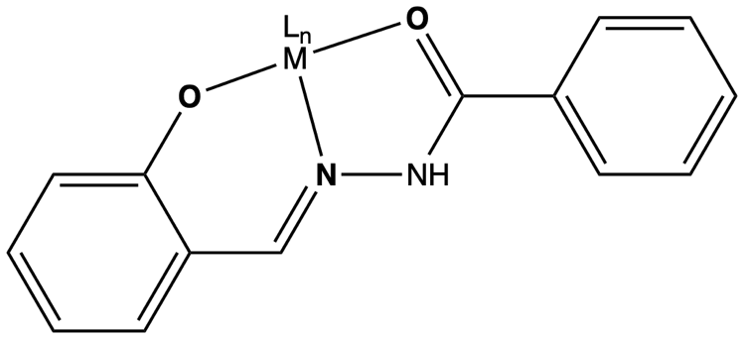

Figure 4. Metal ion coordination of the SBH ligand.

Determining Stoichiometry
Your task is to determine the value of n in a complex of the form:

[M(SB)_{n}](OAc)_{x}

assuming that [SB]⁻ is the primary coordinating ligand.

Example: M = La³⁺
Consider three possible product formulations:
- Case 1: La(SB)₃ (n = 3)
- Molecular formula: La(C₁₄H₁₁N₂O₂)₃
- Molar mass: 856.65 g/mol
- Case 2: [La(SB)₂]OAc (n = 2)
- Molecular formula: La(C₁₄H₁₁N₂O₂)₂(CH₃CO₂)
- Molar mass: 676.45 g/mol
- Case 3: [La(SB)](OAc)₂ (n = 1)
- Molecular formula: La(C₁₄H₁₁N₂O₂)(CH₃CO₂)₂
- Molar mass: 496.24 g/mol

Reagent Amounts
- LaCl₃·7H₂O:
0.55 g/371.37 g/mol = 1.5 mmol
- SBH:
0.70 g/240.26 g/mol = 2.9 mmol
- NaOAc·3H₂O:
0.40 g/136.08 g/mol = 2.9 mmol

Theoretical Yields
- Case 1 (La(SB)₃):
Theoretical yield = 0.83 g
Limiting reagent: SBH
- Case 2 ([La(SB)₂]OAc):
Theoretical yield = 0.99 g
Limiting reagent: SBH
- Case 3 ([La(SB)](OAc)₂):
Theoretical yield = 0.73 g
Limiting reagent: NaOAc·3H₂O

Interpreting Your Result
If, for example, 0.88 g of dry product is isolated, comparison with the theoretical yields suggests that the product is most consistent with Case 2, corresponding to a 1:2 metal-to-ligand stoichiometry in the solid state.

If your calculated yield exceeds 100% for a given assumption, this indicates that the assumed formula is incorrect and should be revised.

Week 4 and 5: Job’s Plot

Equipment and Supplies (per group)
(we have four suitable spectrometers, so for an eight-group lab section, we have four groups working in week 4 and the remainder in week 5)
- Vernier Go Direct® SpectroVis® Plus Spectrometer
- Vernier LoggerPro and Microsoft Excel software on a computer connected to the spectrometer
- Vials of SBH (week 2) and metal complex of SBH (week 3)
- Sodium acetate trihydrate (< 1.0 g)
- 2 x Plastic cuvette. Quartz is ideal here, but plastic is more practical for student use.
- 3 x 25 mL volumetric flask
- 95% Ethanol (300 mL)
- 2 x metal spatulas
- 3 x glass funnels
- 3 x 100 mL beaker; this and the previous four items being used to prepare solutions 1-3
- 1 x 400 mL beaker for waste
- 1 x 150 mL beaker for ethanol
- 2 x 1 mL graduated glass pipette and pipette pump
- 2 x Pasteur pipette and rubber bulb

Preparation of solutions
- Prepare a solution with a target concentration of ~1.0 mM SBH in 95% ethanol, in a 25.0 mL volumetric flask. Record the exact mass that you weighed out, and calculate the precise concentration on your results sheet, which you should paste into your lab notebook. This is Solution 1. Retain this solution for Parts 1 and 2.
- Prepare a solution with a target concentration of ~1.0 mM metal salt in 95% ethanol, in a 25.0 mL volumetric flask. Weigh out an equal mass of sodium acetate trihydrate and add to the flask. Record the exact mass of each that you weighed out, and calculate the precise metal salt solution concentration on your results sheet, which you should paste into your lab notebook. This is Solution 2. Retain this solution for Parts 1 and 2.
- Accurately weigh approximately 7.5 mg of your metal-SBH complex, into a 100 mL beaker. Add 95% ethanol, 5 mL at a time, and mix thoroughly. Heat may need to be applied to fully dissolve the complex. Transfer the solution to a 25.0 mL volumetric flask. Make up the flask to the volume with 95% ethanol. Record the mass that you weighed out, and the precise concentration on your results sheet. This is Solution 3.

Part 1 – UV-Vis spectra
This part will be completed on a UV-Vis spectrometer connected to the computer using LoggerPro software. You will be utilizing plastic cuvettes. When finished, use the cuvette cleaner in the chemical waste hood to clean them.

Calibrate the Vernier UV-Vis spectrometer by selecting Experiment > Calibrate > Spectrometer 1 on LoggerPro. Once the lamp has warmed up, insert a cuvette containing 95% ethanol only as the blank.

First, you will need to obtain spectra of our three solutions. Obtain a 400 mL beaker and label it ‘waste’. Obtain a 150 mL beaker and fill it with 95% ethanol, labelling the beaker ‘95% ethanol'.

Obtain two 1 mL graduated pipettes with a pipette pump. Label one pipette solution 1 and the other solution 2. Use the pipette to dispense 0.1 mL of solution 1 into the cuvette, then fill to the line with 95% ethanol using the Pasteur pipette and rubber bulb. Collect a UV-Vis spectrum of this solution. Make sure that no peaks in the spectrum absorb above 1 to remain within the linear range of Beer’s Law – if the absorbance is too high, dilute the solution in the cuvette by half with 95% ethanol. Identify the λ_{max} and Absorbance at λ_{max} for each solution in a table as shown in Table 3 below. Copy the wavelength and absorbance data of solution 1 data into Excel.

Repeat this process with solution 2. Use the same cuvette, making sure to rinse out the cuvette with 95% ethanol beforehand. For solution 3, use a pipette to dispense 1.0 mL of solution 3, then dilute to the line with 95% ethanol. Collect a UV-Vis spectrum, complete table 3, and again copy the wavelength and absorbance solution 3 data into Excel.

Table 3: Identification of λ_{max} and Absorbance for each solution.
Solution | Color | λ_{max} (nm) | Absorbance at λ_{max}
Solution 1 (SBH)
Solution 2 (Metal salt)
Solution 3 (Metal-SBH complex)

When complete, go to Excel. Highlight the wavelength and the absorbances of one solution, then select “Insert > Scatter Plot > Scatter Plot with Smooth Lines.” Title your chart what best represents your data. Select “Add Chart Element” and add axis titles, with “Wavelength (nm)” on the x-axis and “Absorbance” on the y-axis. Remove the gridlines. Excel will default the x-axis from zero, but you want to start the graph where the spectrometer starts at 380 nm. Double click on the x-axis values until a “Format Axis” window appears on the right. Select the three bars, then open the toggle for Axis Options. Change the minimum bound to 380 and the maximum to 950.

Repeat this process for all three solutions, then send the excel file to your lab partner(s).

Part 2 – Job’s plot
This part of the experiment involves performing the method of continuous variation (also known as a Job’s plot) to determine the stoichiometry of metal-ligand binding in solution. In this method, the combined analytical concentration of metal and ligand is kept constant while their relative mole fractions are systematically varied. The maximum in absorbance corresponds to the stoichiometric ratio of the metal-ligand complex formed in solution. This part will be completed using a visible-region UV-Vis spectrometer set to a single wavelength and plastic cuvettes. You should use the same cuvette throughout the experiment whenever possible.

In LoggerPro, select “Configure Spectrometer” at the top of the screen, to the left of the collect button. This will open a window to change the collection mode. Change the collection mode to “Absorbance vs. Concentration.” Change the column name to “Ligand Mole Fraction,” change the short name to “X_Ligand”, then leave the units box empty. To the right there will be a list of wavelengths. Select “Clear Selection”, then check the wavelength for the metal-ligand pair that you are measuring according to Table 4 below. When done, click “OK.”

Table 4: Wavelengths to be monitored for each metal-ligand pair
Metal-ligand pair | Wavelength (nm)
SBH + Co²⁺ | 405
SBH + Cu²⁺ | 400
SBH + Fe³⁺ | 450
SBH + La³⁺ | 399
SBH + Mn²⁺ | 400
SBH + Ni²⁺ | 420
SBH + [VO]²⁺ | 399
SBH + Zn²⁺ | 397

The X-axis of your graph will need to go from 0 to 1. To change this, right click on the graph and select “Graph Options.” This will bring up a window, at the top of the window select the “Axes Options” tab. At the bottom of this screen in the X-axis settings, change the “Right:” box to 1.0. Select “OK.”

Use the 1 mL graduated pipette to deliver the volume of each solution into the cuvette, as given in Table 5 below. Dilute each solution to the top of the cuvette with 95% ethanol. Select “Collect” to begin obtaining spectra. When the value stabilizes, select “Keep” at the top of the screen. This will bring up a window for you to input the mole fraction of the ligand. Double check that the value has saved on your graph. Repeat this for all trials until complete, ensuring you rinse your cuvette with 95% ethanol into your waste beaker between trials to avoid contamination.

Note: Keep a second excel spreadsheet with the absorbance vs. ligand mole fraction data in case the spectrometer disconnects from the computer. This will prevent the need to repeat the entire Job’s plot if the spectrometer disconnects. You will have to manually connect the data each time this happens in Excel to construct your final Job’s Plot.

Table 5: Solutions to be prepared for the Job’s plot measurement
Vol. Solution 1 (mL) | Vol. Solution 2 (mL) | Ligand mole fraction (χ_{ligand})
0 | 1.2
0.1 | 1.1
0.2 | 1.0
0.3 | 0.9
0.4 | 0.8
0.5 | 0.7
0.6 | 0.6
0.7 | 0.5
0.8 | 0.4
0.9 | 0.3
1.0 | 0.2
1.1 | 0.1
1.2 | 0

Note: The total volume of Solution 1 and Solution 2 is kept constant in each trial. This is essential for the validity of Job’s method.

LoggerPro will automatically graph the absorbance (y-axis) against χ_{ligand} (x-axis). Identify the ligand mole fraction (χ_{ligand}) at the maximum absorbance. Use this value to determine the metal-to-ligand stoichiometry in solution. For a complex of the form M(SB)_{n}, the mole fraction of ligand at maximum absorbance is approximately:

χ_{ligand} = n/(n + 1)

Use this relationship to determine the metal-to-ligand ratio and record the value in your results sheet.

Copy and paste your data into a word document to save the data. Right click on the graph, click “Copy” and then paste your graph into the word document. Share the word document with your lab partner(s) for your lab report.

Compare this solution stoichiometry with the solid-state stoichiometry obtained in Week 3.

Sample hand-in
After you have completed your Job’s plot and UV-Vis spectra, place your remaining synthesized SBH and metal-SBH complex to the lab back bench in sample vials with the label stating your name, chemical name, and date.

Student Results Sheet

Preparation of Solutions

Solution 1 (SBH in 95% ethanol)

Mass of SBH used (to 4 d.p.): ____________________ g

Molar mass of SBH: 240.26 g/mol; solution prepared in 25 mL volumetric flask.

Calculated Concentration of Solution 1: ____________________ mM

Solution 2 (Metal salt in 95% ethanol)

Assigned metal salt: ______________________________

Mass of metal salt used: ____________________ g

Molar mass of metal salt: ____________________ g/mol; solution prepared in 25 mL volumetric flask.

Mass of sodium acetate trihydrate used: ____________________ g

Calculated Concentration of Solution 2: ____________________ mM

Solution 3 (Metal–SBH complex in 95% ethanol)

Mass of SBH–metal complex used (to 4 d.p.): ____________________ g

Convert this mass to mg by x 1000 mg/g for the next step. Solution prepared in 25 mL volumetric flask.

Calculated concentration of Solution 3: ____________________ mg/mL

Part 1: UV-Vis Spectra

Solution | Volume of solution put in cuvette for spectrum (mL)
Solution 1 (SBH)
Solution 2 (Metal salt)
Solution 3 (Metal–SBH complex)

Solution | Color | λ_{max} (nm) | Absorbance at λ_{max}
Solution 1 (SBH)
Solution 2 (Metal salt)
Solution 3 (Metal–SBH complex)

Part 2: Job’s plot

Vol. Solution 1 (mL) | Vol. Solution 2 (mL) | Vol. ethanol (mL) | Ligand mole fraction (χ_{ligand}) | Absorbance
0 | 1.2 | 1.8
0.1 | 1.1 | 1.8
0.2 | 1.0 | 1.8
0.3 | 0.9 | 1.8
0.4 | 0.8 | 1.8
0.5 | 0.7 | 1.8
0.6 | 0.6 | 1.8
0.7 | 0.5 | 1.8
0.8 | 0.4 | 1.8
0.9 | 0.3 | 1.8
1.0 | 0.2 | 1.8
1.1 | 0.1 | 1.8
1.2 | 0 | 1.8

Binding ratios

Complex | Metal-to-ligand ratio
M^{n+} : SBH

Week 6: ChemDraw & SciFinder

This lab session is dedicated to preparation for the group oral presentation and the individual final written report.

The group oral presentation will take place during the seventh and final lab session. The individual written report is due at the end of Week 7, allowing time for students to incorporate feedback received during their presentation.

For the oral presentation, students may use presentation software such as Microsoft PowerPoint, Apple Keynote, Google Slides, Prezi™, or Canva. The final written report is typically prepared using Microsoft Word or Apple Pages.

In both cases, students will need to:

- draw chemical structures, and
- reference the scientific literature.

To support these tasks, the applications ChemDraw and SciFinder are used.

ChemDraw is available on the lab computers previously used for LoggerPro and Microsoft Excel during the analysis of solid- and solution-state stoichiometry.

Access to SciFinder typically requires registration through your college or university library.

Students enter the course with varying degrees of familiarity with these applications. This session provides time and resources to develop these skills. The following tutorial videos are recommended:

ChemDraw Basics (18 min 2 sec)
https://www.youtube.com/watch?v=a9r4Ofnc-Ro

An Overview of CAS SciFinder® (4 min 5 sec)
https://www.youtube.com/watch?v=tASZPNkjPiA

Students should begin organizing their results from Weeks 2-5, including UV-Vis spectra, Job’s plots, and proposed metal-ligand stoichiometries in the solid and solution states.

Week 7: Project Presentation

Assessment for the project is based on a group oral presentation (40 points) and an individual final written report (40 points). Specific dates, rubrics, and submission guidelines will be provided by the instructor.

Group Oral Presentation

You are required to deliver a group oral presentation based on the research project completed in Weeks 2-5.

Presentations will take place during the seventh and final lab session. Each group will have 10-12 minutes to present their work, followed by a short period for questions.

All members of the group must contribute to the presentation and participate in delivering the material.

Purpose of the Presentation

The goal of the presentation is to clearly communicate:
- The purpose of your research
- The experimental approach used
- The key results obtained
- The conclusions drawn from your work

Your presentation should tell a coherent scientific story, similar to your written report, but adapted for a live audience.

General Expectations

- Presentations should be clear, well-organized, and professional
- Slides should be visually clear and not overcrowded
- All figures and data should be legible and properly labeled
- Chemical structures should be drawn using ChemDraw (or similar software)
- All group members must speak and demonstrate understanding of the material

Recommended Presentation Structure

1. Introduction (1-2 minutes)
- Briefly introduce Schiff-base ligands and metal-ligand coordination
- State the purpose of the experiment
- Clearly define the research question (e.g., determining stoichiometry)

2. Experimental Overview (1-2 minutes)
- Summarize key experimental steps:
  - SBH synthesis
  - Metal-SBH complex formation
  - UV-Vis spectroscopy
  - Job’s plot analysis
- Focus on the approach, not procedural detail

3. Results (4-5 minutes)
Include:
- Product observations and yields
- UV-Vis spectra:
  - Ligand, metal ion, and metal-SBH complex
  - Highlight key differences (new peaks, shifts)
- Job’s plot:
  - Clearly labeled graph
  - Identification of maximum absorbance
  - Explanation of how stoichiometry was determined
- Summary of stoichiometry:
  - Solid-state (gravimetric analysis)
  - Solution-state (Job’s method)

4. Discussion (2-3 minutes)
- Interpret your results
- Compare solid- and solution-state stoichiometries
- Compare your findings with another group
- Propose a structure for your complex (ChemDraw figure)
- Provide chemical reasoning for your conclusions

5. Conclusion (1 minute)
- State the metal-ligand stoichiometry. If this differs between solid and solution states, clearly note and comment on this
- Summarize key findings
- Briefly comment on significance or implications

Use of Visuals

- Use graphs and tables effectively, not excessively
- Ensure all axes are labeled and units are included
- Highlight key features (e.g., λ_{max}, Job’s plot maximum)
- Avoid copying raw data tables directly onto slides

Delivery Expectations

- Speak clearly and at an appropriate pace
- Maintain eye contact with the audience
- Avoid reading directly from slides
- Use slides as supporting material, not a script
- Ensure smooth transitions between speakers

Timing and Group Participation

- Total presentation time: 10-12 minutes
- Each group member must:
  - Present a portion of the material
  - Demonstrate understanding of the project

Questions

Be prepared to answer questions from the instructor and your peers. All group members should be able to respond to questions about any part of the presentation.

Common Mistakes to Avoid

- Reading directly from slides
Slides should support your presentation, not serve as a script. Avoid reading text verbatim.
- Overcrowded slides
Do not include large blocks of text or raw data tables. Keep slides clear, concise, and visually focused.
- Unlabeled or unclear figures
All graphs and figures must include:
  - Clearly labeled axes (with units)
  - Descriptive titles or captions
  - Legible text and data points
- Failure to explain figures
Simply showing a graph is not sufficient. You must clearly explain what the data show and why it is important.
- Poor Job’s plot presentation
Ensure your Job’s plot:
  - Clearly shows the maximum
  - Includes properly scaled axes
  - Is used to explain how stoichiometry was determined
- Not connecting results to conclusions
Avoid listing results without explaining their meaning. Your presentation should tell a clear scientific story.
- Confusing solid-state and solution-state stoichiometry
Be explicit about the difference between:
  - Gravimetric analysis (solid-state) results
  - Job’s plot (solution-state) results
- Weak or missing structure proposal
Your proposed structure should:
  - Be chemically reasonable
  - Match your metal-to-ligand ratio
  - Be clearly shown and explained
- Uneven group participation
All group members must contribute meaningfully. Avoid having one speaker dominate the presentation.
- Poor time management
Presentations should stay within the 10-12 minute limit.
  - Too short → missing content
  - Too long → lack of focus
- Lack of preparation for questions
All group members should be able to answer questions about any part of the project.
- Speaking too quietly or too quickly
Speak clearly, at a moderate pace, and project your voice so the audience can follow.

Individual Final Written Formal Lab Report

You are required to prepare an individual final written formal lab report based on the research project completed in Weeks 2-5. This report should follow a format consistent with the American Chemical Society (ACS) Style Guide and should clearly communicate your experimental work, results, and interpretation.

The report should be written in a clear, concise, and professional scientific style. Pay careful attention to formatting, figure presentation, and significant figures throughout.

Required Sections

Abstract

The abstract should be a single paragraph that summarizes the entire report. It should include:

- The purpose of the study
- The problem or research question addressed
- The general experimental approach
- The key findings (e.g., stoichiometry, spectroscopic results)
- The main conclusion and significance

Introduction

The introduction should provide context for your work. It should:

- Introduce Schiff-base ligands and their coordination chemistry
- Explain the importance of determining metal-ligand stoichiometry
- Briefly describe relevant background literature (with citations), including, where appropriate, the bioinorganic or chemical relevance of the assigned metal ion
- State the purpose of your study and what you aimed to determine

Methods / Experimental

This section should describe what you did in sufficient detail for another chemist to reproduce your work.

- Reference procedures from the lab manual where appropriate, rather than rewriting them in full
- Describe any deviations from the provided procedures
- Include key experimental details (e.g., reagents, concentrations, instrumentation)

Results

The Results section should present your data clearly and logically, without interpretation beyond what is necessary to guide the reader.

You should include:

- A description of the appearance of your products
- The yield and percentage yield of SBH and your metal-SBH complex, showing your calculations
  - Note: The molar mass of your metal-SBH complex should be calculated based on your solid-state stoichiometry
- Figures (with appropriate captions) showing:
  - UV-Vis spectra of the ligand, metal ion, and metal-SBH complex
  - Peaks in the complex that are not present in the individual components
- A table summarizing:
  - Color
  - λ_{max} (nm)
  - Absorbance at λ_{max} for the ligand, metal ion(s), and metal complex(es)
- A table showing:
  - Ligand mole fraction (χₗᵢ_{g}ₐₙ_{d})
  - Absorbance values for each solution used in the Job’s plot
- A figure showing your Job’s plot, including:
  - Clearly labeled axes
  - Data points
  - Lines of best fit
- A clear explanation of how the solution-state stoichiometry was determined from the Job’s plot
- A table summarizing the stoichiometry of your metal complex, both in the solid and solution states
- A short narrative that connects all of the results presented and guides the reader through your findings

All tables and figures should be numbered and include descriptive captions.

Discussion

The Discussion section should interpret your results and place them in a broader chemical context.

You should include:

- A discussion of the binding stoichiometry of your metal-ligand complex
- A comparison with the results of one other lab group, including:
  - Similarities or differences in stoichiometry
  - Possible chemical explanations (e.g., metal ion properties, coordination number, ligand behavior)
- A proposed structure of your complex:
  - Drawn using ChemDraw (or similar software)
  - Based on your experimentally determined metal-to-ligand ratio
- Discussion of:
  - The reliability of your data
  - Any sources of error
  - Limitations of the methods used (e.g., assumptions in Job’s method, differences between solid- and solution-state stoichiometry)

Conclusion

The conclusion should summarize what you learned from the experiment:

- State the metal-ligand stoichiometry. If this differs between solid and solution states, clearly note and comment on this
- Highlight key findings from your spectroscopic analysis
- Comment on the significance of your results
- Suggest possible future work or improvements

General Expectations

- Use appropriate significant figures throughout
- Label all figures and tables clearly, with captions
- Use proper chemical nomenclature and formatting
- Cite sources using an ACS-style reference format
- Ensure the report is well organized and clearly written

Note on Data Organization

The Student Results Sheet provided in the previous section is designed to help you organize your data. While its use is not mandatory, it is strongly recommended to ensure that all necessary information is recorded and easily accessible for your report and presentation.

Common Mistakes to Avoid

- Confusing Results and Discussion
The Results section should present data (tables, figures, values) with minimal interpretation. Detailed explanation and interpretation belong in the Discussion section.
- Failing to show calculations
All theoretical yields and percentage yields must be supported by clearly shown calculations, including units and appropriate significant figures.
- Inconsistent or incorrect stoichiometry
Ensure that your reported metal-ligand stoichiometry is consistent with your Job’s plot analysis. Clearly distinguish between solid-state and solution-state stoichiometries.
- Poorly labeled figures and tables
All figures and tables must:
  - Be numbered
  - Include descriptive captions
  - Have clearly labeled axes (with units)
- Including raw data without context
Tables and figures should be introduced and briefly described in the text. Do not include data without explaining what it represents.
- Over-interpreting data
Do not make claims that are not supported by your experimental results. Acknowledge uncertainty where appropriate.
- Ignoring significant figures and units
Use appropriate significant figures throughout and always include units in calculations, tables, and figure axes.
- Poor quality Job’s plot
Ensure your Job’s plot includes:
  - Correct mole fraction values (χₗᵢ_{g}ₐₙ_{d})
  - A clearly defined maximum
  - Lines of best fit where appropriate
- Not explaining how stoichiometry was determined
Simply stating a ratio is not sufficient - you must explain how it was obtained from your data.
- Weak or missing connection between sections
Your report should read as a coherent scientific narrative. Ensure that your Results, Discussion, and Conclusion are logically connected.
- Unclear or incorrect chemical structures
Structures drawn in ChemDraw should:
  - Be chemically reasonable
  - Reflect the experimentally determined stoichiometry
  - Show appropriate bonding and coordination
- Lack of comparison with another group
Be sure to include and discuss the results of another group, as required in the Discussion section.

Grading Sheet: Group Oral Presentation (40 pts)
Group Members: __________________________________________

Section: ____________________
Date: ____________________

1. Organization & Structure (5 pts)
☐ 5 – Clear, logical flow; follows recommended structure
☐ 4 – Mostly well organized; minor issues
☐ 3 – Some disorganization or unclear transitions
☐ 1–2 – Poor structure
☐ 0 – Lacks organization
Score: ______ / 5

2. Introduction & Purpose (3 pts)
☐ 3 – Clear background, purpose, and research question
☐ 2 – Mostly clear; minor gaps
☐ 1 – Limited or unclear
☐ 0 – Missing
Score: ______ / 3

3. Experimental Overview (3 pts)
☐ 3 – Clear summary of key methods and approach
☐ 2 – Basic overview; some missing elements
☐ 1 – Minimal or unclear
☐ 0 – Missing
Score: ______ / 3

4. Results Presentation (10 pts)

A. Data & Figures (5 pts)
☐ 5 – Clear, well-designed slides; all figures labeled and readable
☐ 4 – Minor issues
☐ 2–3 – Some unclear or missing elements
☐ 0–1 – Poor or missing
Score: ______ / 5

B. Job’s Plot & Stoichiometry (3 pts)
☐ 3 – Clearly presented and explained; stoichiometry justified
☐ 2 – Mostly clear; minor issues
☐ 1 – Limited explanation
☐ 0 – Missing/incorrect
Score: ______ / 3

C. Solid vs Solution Stoichiometry (2 pts)
☐ 2 – Clearly distinguished and explained
☐ 1 – Mentioned but unclear
☐ 0 – Missing
Score: ______ / 2

5. Discussion & Interpretation (8 pts)

A. Interpretation of Results (4 pts)
☐ 4 – Strong, logical interpretation of data
☐ 3 – Good, minor gaps
☐ 2 – Limited interpretation
☐ 0–1 – Weak/unsupported
Score: ______ / 4

B. Comparison with Another Group (2 pts)
☐ 2 – Clear, meaningful comparison with explanation
☐ 1 – Basic comparison
☐ 0 – Missing
Score: ______ / 2

C. Proposed Structure (2 pts)
☐ 2 – Chemically reasonable and clearly explained
☐ 1 – Present but unclear or inconsistent
☐ 0 – Missing
Score: ______ / 2

6. Conclusion (3 pts)
☐ 3 – Clear summary of findings and significance
☐ 2 – Mostly complete
☐ 1 – Minimal
☐ 0 – Missing
Score: ______ / 3

7. Delivery & Communication (5 pts)
☐ 5 – Clear, confident, professional delivery; good pacing and engagement
☐ 4 – Minor issues (pace, clarity)
☐ 2–3 – Noticeable issues
☐ 0–1 – Difficult to follow
Score: ______ / 5

8. Group Participation (3 pts)
☐ 3 – All members contributed equally and effectively
☐ 2 – Minor imbalance
☐ 1 – Significant imbalance
☐ 0 – One or more members did not participate
Score: ______ / 3

Total Score: ______ / 40

Instructor Comments

Grading Sheet: Individual Final Written Formal Lab Report (40 pts)
Student Name: ____________________________
Section: ____________________
Date: ____________________

1. Abstract (3 pts)
☐ 3 – Complete, clear, includes all components
☐ 2 – Mostly complete, minor omissions
☐ 1 – Incomplete or unclear
☐ 0 – Missing
Score: ______ / 3

2. Introduction (5 pts)
☐ 5 – Strong background, context, purpose clearly stated
☐ 4 – Good, minor gaps
☐ 3 – Basic, limited context
☐ 1–2 – Weak or unclear
☐ 0 – Missing
Score: ______ / 5

3. Methods / Experimental (4 pts)
☐ 4 – Clear, reproducible, references lab manual appropriately
☐ 3 – Mostly clear, minor missing details
☐ 2 – Some important details missing
☐ 1 – Poorly described
☐ 0 – Missing
Score: ______ / 4

4. Results (12 pts)

A. Data Presentation (6 pts)
☐ 6 – All figures/tables present, labeled, captioned, clear
☐ 4–5 – Minor issues
☐ 2–3 – Missing or unclear elements
☐ 0–1 – Major problems
Score: ______ / 6

B. Quantitative Analysis (4 pts)
☐ 4 – Correct yields, % yields, calculations shown
☐ 3 – Minor errors
☐ 2 – Significant issues
☐ 0–1 – Incorrect/missing
Score: ______ / 4

C. Job’s Plot & Stoichiometry (2 pts)
☐ 2 – Clear explanation of stoichiometry determination
☐ 1 – Partial/unclear
☐ 0 – Missing/incorrect
Score: ______ / 2

5. Discussion (10 pts)

A. Interpretation of Results (4 pts)
☐ 4 – Strong, logical interpretation
☐ 3 – Good, minor gaps
☐ 2 – Limited or partially correct
☐ 0–1 – Weak/unsupported
Score: ______ / 4

B. Stoichiometry & Comparison (3 pts)
☐ 3 – Clear discussion + meaningful comparison with another group
☐ 2 – Comparison present but limited
☐ 1 – Minimal
☐ 0 – Missing
Score: ______ / 3

C. Proposed Structure (2 pts)
☐ 2 – Chemically reasonable, consistent with data
☐ 1 – Present but flawed
☐ 0 – Missing
Score: ______ / 2

D. Limitations & Error Analysis (1 pt)
☐ 1 – Identified appropriately
☐ 0 – Missing/superficial
Score: ______ / 1

6. Conclusion (3 pts)
☐ 3 – Clear findings, stoichiometry, significance
☐ 2 – Mostly complete
☐ 1 – Minimal
☐ 0 – Missing
Score: ______ / 3

7. Presentation & Scientific Writing (3 pts)
☐ 3 – Clear, well-organized, correct formatting, sig figs, citations
☐ 2 – Minor issues
☐ 1 – Frequent issues
☐ 0 – Poor
Score: ______ / 3

Total Score: ______ / 40

Instructor Comments

