Instructor notes for C-H Functionalization: Shilov Chemistry
This presentation was created as part of the requirements for Chemistry 165 "Organometallics" at Harvey Mudd College during the fall semester 2009. The authors of this presentation are Allegra Liberman-Martin (Scripps College), Levi Moore (Pomona College), Drexel Proctor (Pomona College) and Giselle Sullivan (Scripps College).

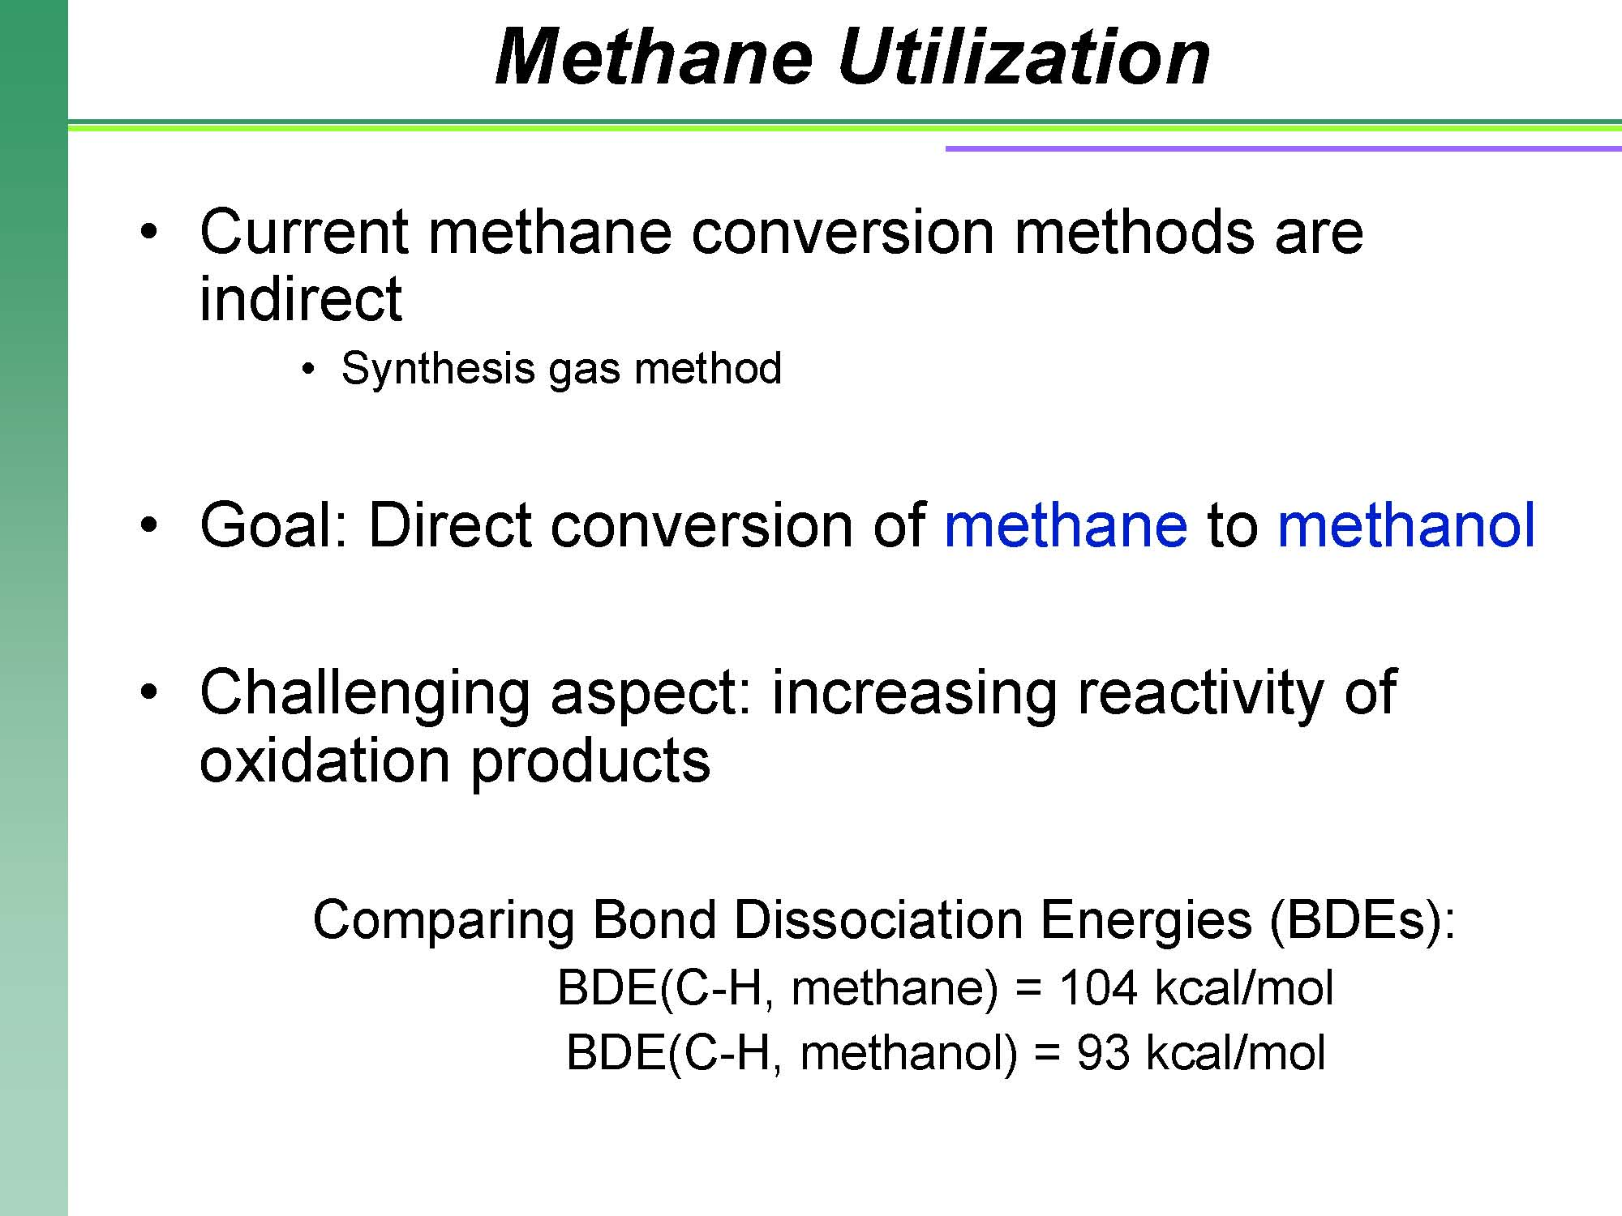
Saturated hydrocarbons are a large constituent of petroleum and natural gas, but there are currently few processes to directly convert these into more valuable, functionalized products. Most alcohols, aldehydes, and carboxylic acids are produced from unsaturated hydrocarbons (typically olefins) rather than alkanes.
Utilizing natural gas resources has been limited due to the fact that gas transportation is prohibitively expensive; therefore, on-site conversion to a readily transportable liquid is quite desirable. The current conversion methods are indirect, and involve producing synthesis gas (hydrogen and carbon dioxide) prior to conversion to methanol. Direct, efficient conversion of methane to methanol has the potential to significantly improve methane utilization.
One complication of direct oxidation of methane to methanol is that the oxidized product is typically more reactive than the starting material. Most oxidants that react with methane proceed by a hydrogen atom abstraction step; therefore, they will react more readily with the weaker C-H bonds of methanol rather than those of methane. This can severely limit yields.

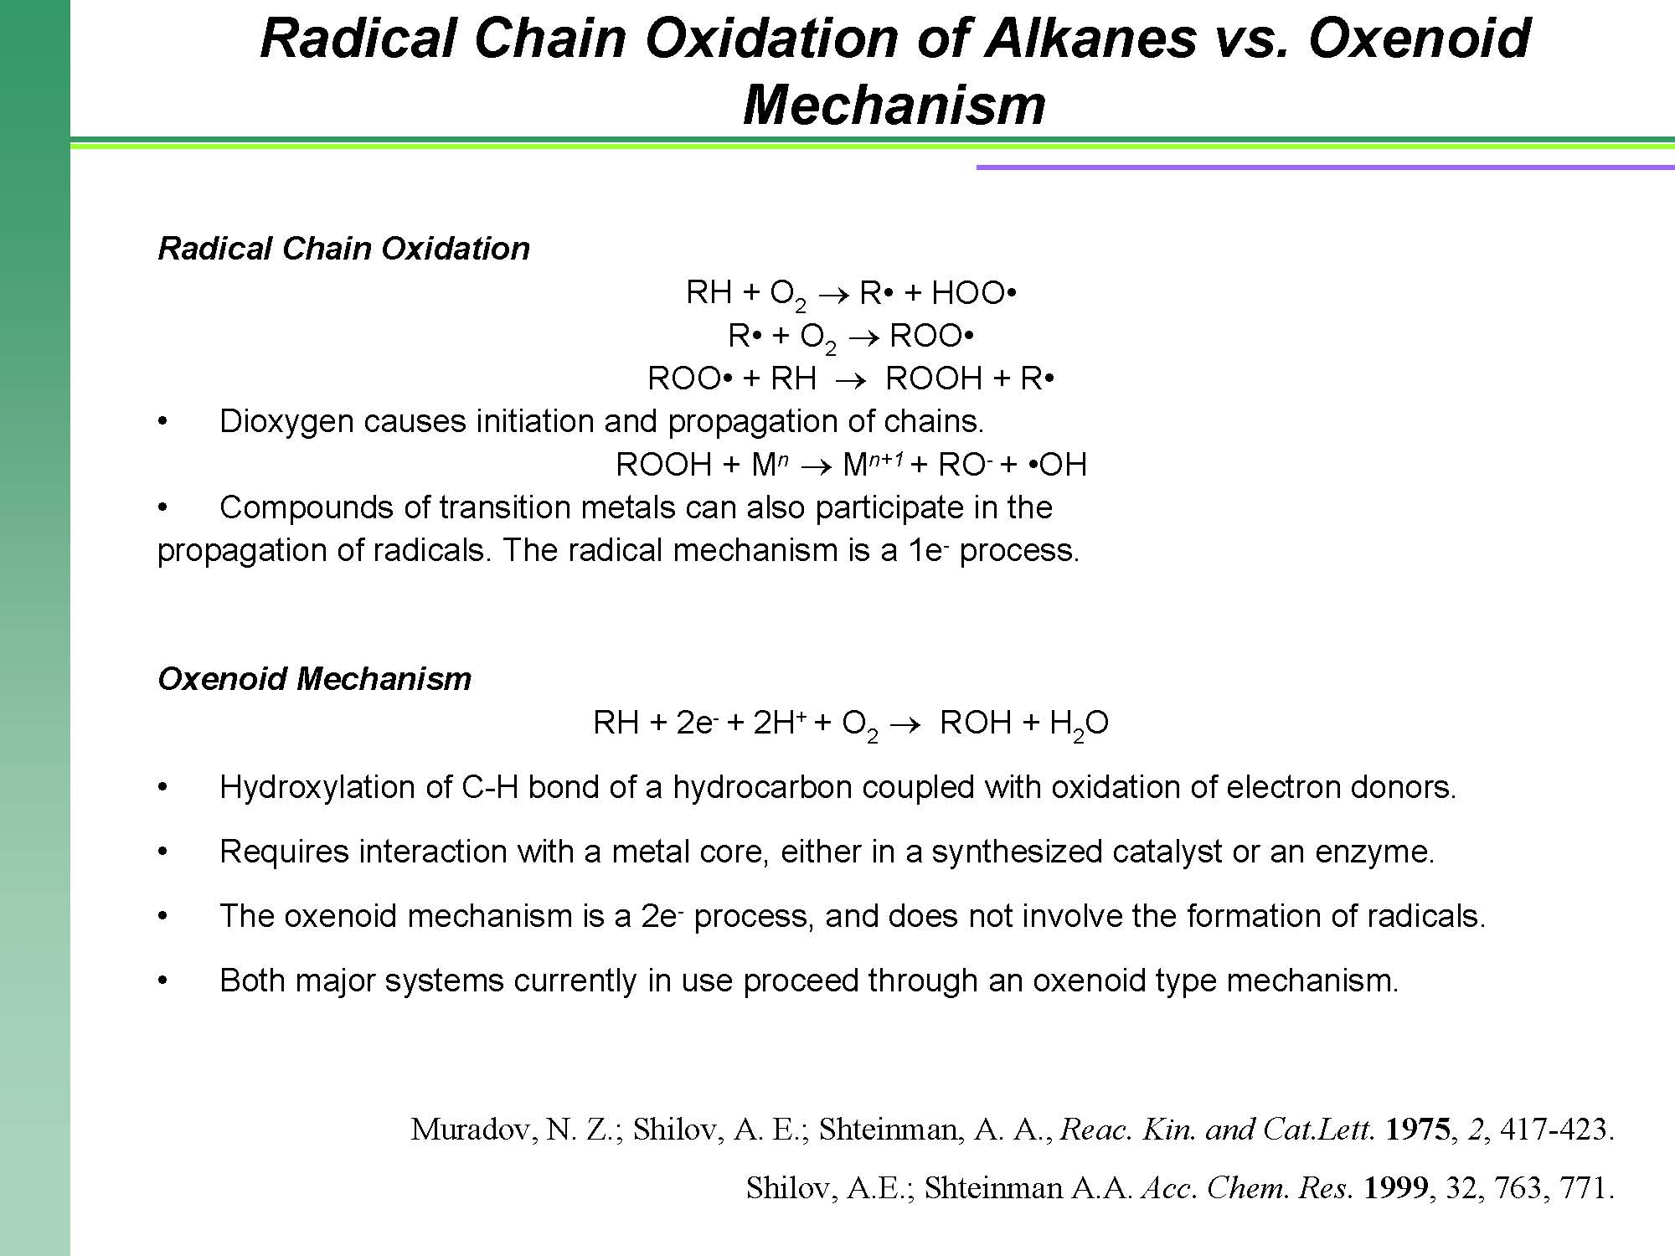
There are two main mechanisms for the oxidation of alkanes: the radical chain and the oxenoid mechanisms. The radical mechanism for the oxidation of alkanes is more easily observed under laboratory conditions than the oxenoid mechanism. With a few exceptions, this radical mechanism was the only kind of alkane oxidation succesfully accomplished without the aid of biological reagents until the advent of Shilov chemistry. The use of radical chemistry is not ideal for the production of alcohols from alkanes on an industrial scale for a number of reasons. The partial oxidation products react even more easily than the starting materials, leading to a high risk of overoxidation. The reaction displays low selectivity except when less active radicals are used. The reaction also occurs without retention of configuration, making it unlikely that the products of such a reaction would be usefully related to the reactants. Metal complexes can participate in the reaction, but only in the context of propagating the radical chain.
The oxenoid mechanism is much more likely to be synthetically useful than the radical mechanism; however, it requires either an enzyme or a synthesized catalyst. It proceeds through the direct interaction of an alkane with the metal core of the catalytic complex, and does not feature the formation of any radicals. The oxenoid mechanism displays selectivity for 1º>2º>>3º, which leads to a predictable pattern of alkane oxidation. It is an efficient manner of carrying out a single oxidation of an alkane, and it also occurs with retention of configuration. This reaction is carried out with nearly 100% efficiency by natural monooxygenases. Synthetic methods are much less efficient, but are constantly being improved.

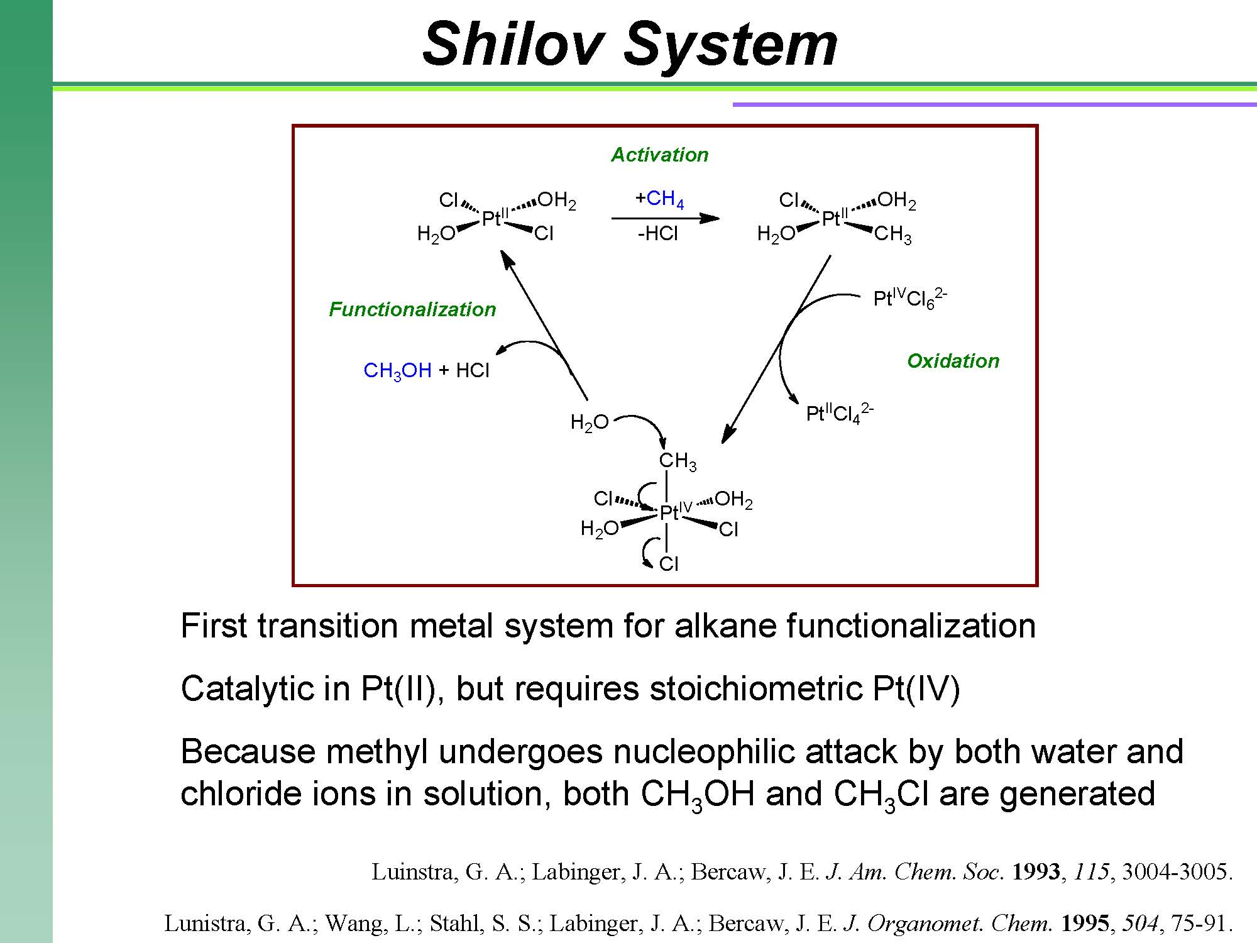
The first catalytic system to convert methane to methanol was reported by Shilov in 1972. A large portion of the research in “Shilov Chemistry” has focused on determining the mechanism of the original Shilov system. Shilov proposed a reasonable mechanism just a few years after the discovery of this system. The first step of this cycle involves the formation of a methylplatinum(II) intermediate by reaction of Pt(II) with methane. Next, the methylplatinum(II) species is oxidized to a methylplatinum(IV) complex. Last, nucleophilic attack at the methyl carbon generates the organic product and reduces the metal center back to platinum(II). The themes of this mechanism (Alkane activation, Oxidation, and Functionalization) are also important within other Shilov-type systems.
There has been considerable controversy surrounding the intimate mechanisms of the individual steps. For example, it has long been debated whether the C-H activation proceeds via an oxidative addition followed by platinum deprotonation or by an electrophilic pathway. Mechanistic studies using model complexes have been used to determine details of the oxidation and functionalization steps. Labeling studies by Bercaw and Labinger have shown that Pt(IV) behaves as an external oxidant. Because external, rather than internal, oxidation occurs, it is possible that a more economical oxidant than Pt(IV) could be utilized. Within the final step that leads to functionalization, studies demonstrating stereochemical inversion at the platinum-bound alkyl ligand have shown that this step occurs via nucleophilic attack rather than reductive elimination of methyl and coordinated water or chloride. It is still not known whether this nucleophilic attack occurs at a five-coordinate or six-coordinate Pt(IV) center.

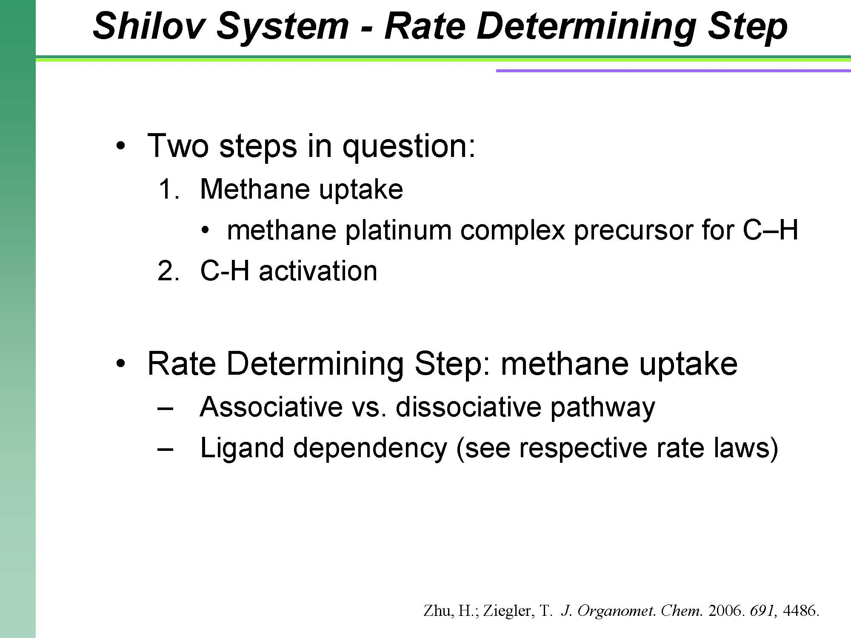

Further expounding upon the mechanistic queries of the Shilov system, Zhu and Ziegler utilized density functional theory (DFT) in order to determine the rate-determining step of the system. Looking solely at the [PtCl₄]²⁻ reagent used in the Shilov system, the authors determined that the methane uptake step of the reaction is rate limiting. Furthermore, the authors present the overall rates for both the associative and dissociative mechanisms; however, which mechanism is operating depends on whether PtCl₄²⁻ or PtCl₂(H₂O)₂ is produced in situ.

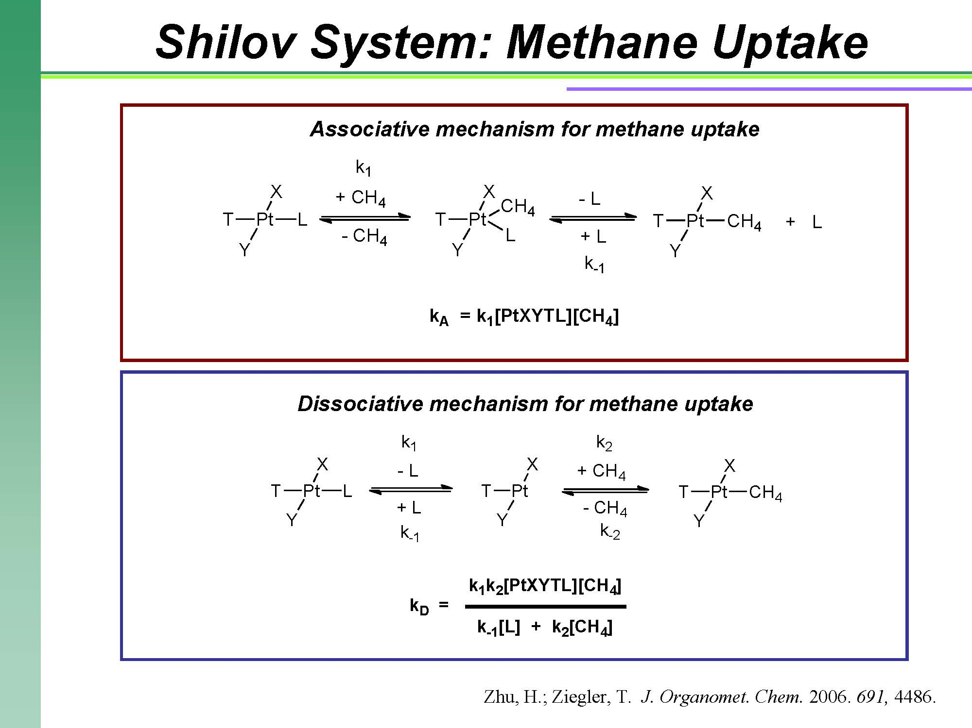
Though Zhu and Ziegler are able to characterize the two possible mechanisms for methane uptake, they are not able to firmly state which mechanism is occurring in the Shilov reaction. Furthermore, in general, Zhu and Ziegler’s findings about Shilov C-H activation may only be helpful on a smaller scale. Pt(IV) is an expensive oxidant, which limits the Shilov system’s industrial utility. Yet, knowledge of this reaction may help more in smaller scale reproduction of C-H activation than in the mass production of methanol. This information could be of use in developing and perfecting a Shilov-type reaction with other catalytic complexes, such as vanadate. For such trials with other oxidants, the authors provided some general mechanistic insights of the Shilov reaction. The authors assessed the energy barrier of the dissociative step in an aqueous environment using DFT, noting that the transition state and the energy of the intermediate ions affected the overall energetics of this mechanism.

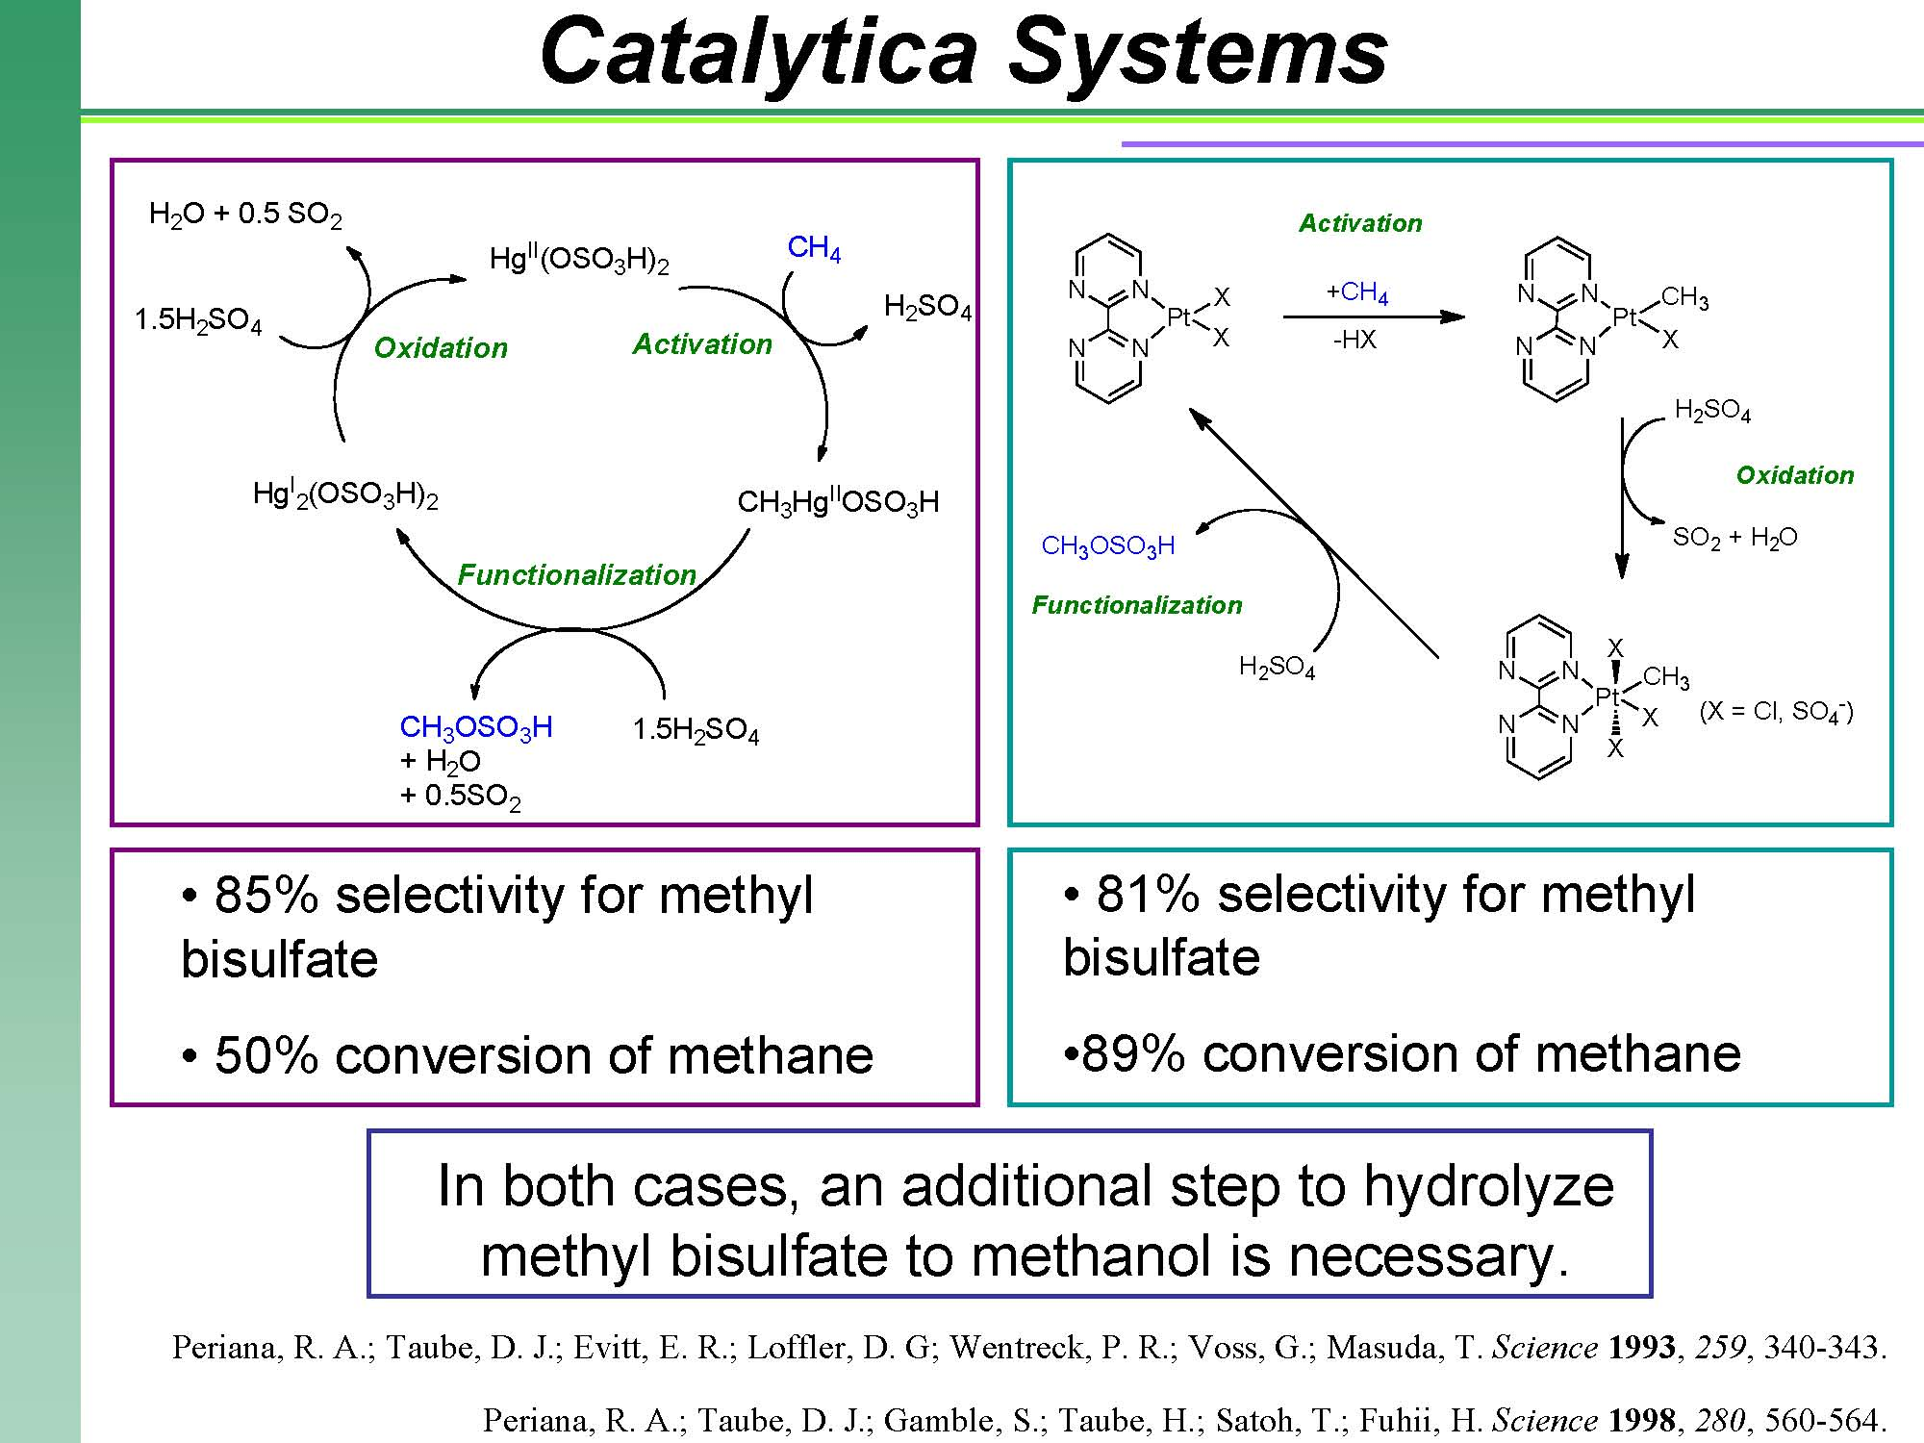
Catalytica has made several important advances in Shilov-type chemistry. The first Catalytica system was reported in 1993, and a possible mechanism for this Hg(II)/H₂SO₄ system is shown. Because Hg(II) does not have an accessible oxidative addition pathway, an electrophilic C-H activation route is believed to occur. The methylmercury(II) intermediate has been detected by NMR spectroscopy. Attack by SO₄²⁻ could lead to nucleophilic abstraction of the methyl group. Oxidation of the reduced Hg(I) species back to Hg(II) could occur by reaction with H₂SO₄. The selectivity for methyl bisulfate and conversion of methane are both quite high for this reaction.
Catalytica reported another significant advance on the original Shilov system in 1998. In this system, methane is converted to methyl bisulfate using a platinum(II) bipyrimidine catalyst in concentrated sulfuric acid. The formal oxidant in this system is SO₃. The mechanism for this reaction is quite close to that of the original Shilov reaction, although the details of the C-H activation step (whether it proceeds via an electrophilic or oxidative addition pathway) have still not been resolved. The percent conversion of methane using this system is impressively high.
It is notable that both Catalytica systems produce methyl bisulfate, which would need to be hydrolyzed to produce methanol. With both systems, an integrated multistep process would therefore be necessary, and with current technology, this strategy is not economically competitive with indirect conversion methods currently in place (methane to methanol via synthesis gas).

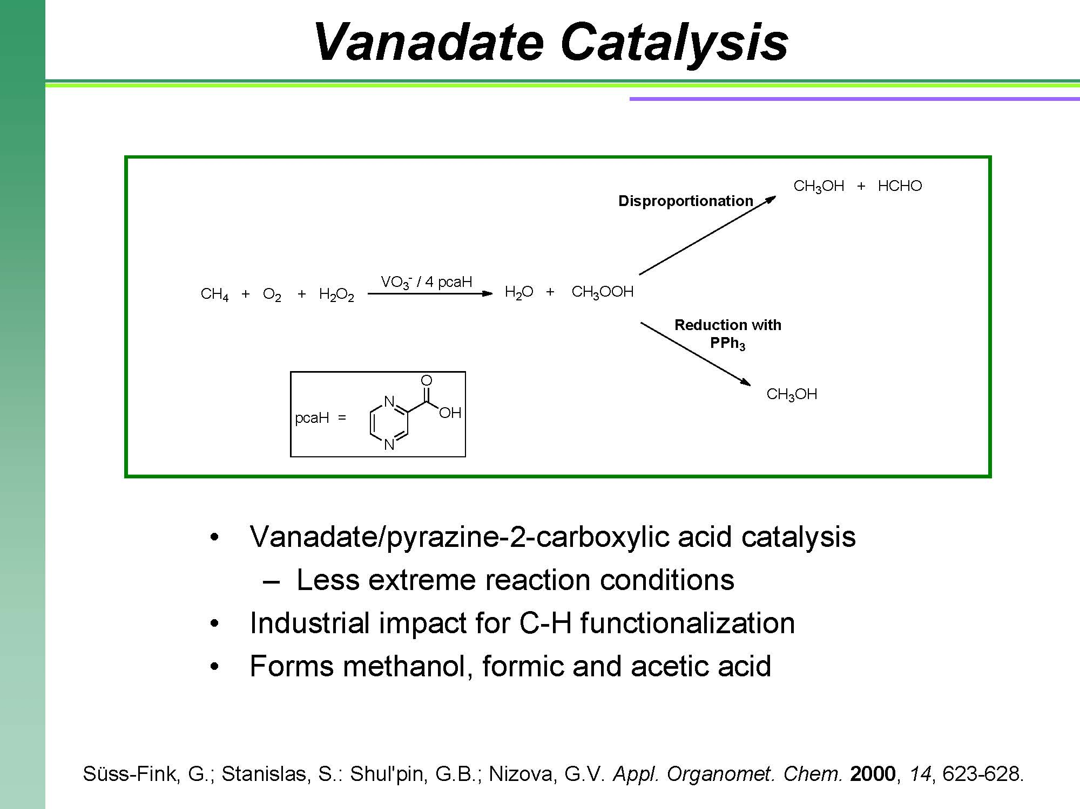
Another advance on the Shilov system was reported in 2000 by Suss-Fink, et al., which replaced the reaction conditions of the mercury or platinum catalyzed C-H activation with the use of vanadate (VO₃⁻) and a co-catalyst pyrazine-2-carboxylic acid (pcaH). On top of being a much more cost effective alternative to the Pt(IV) oxidant, the reaction also takes place under far less extreme conditions (between 25 and 75 ºC). This makes the production of such valuable oxygenates more reproducible on a larger scale without as much hazardous risk associated with the manufacturing process. The vandate/pcaH catalytic process is mechanistically outlined, in that the vanadium system intervenes in the catalytic functionalization of methane as a catalytic pump of hydroxyl radicals, implying vanadium (IV) and vanadium (V) intermediates.

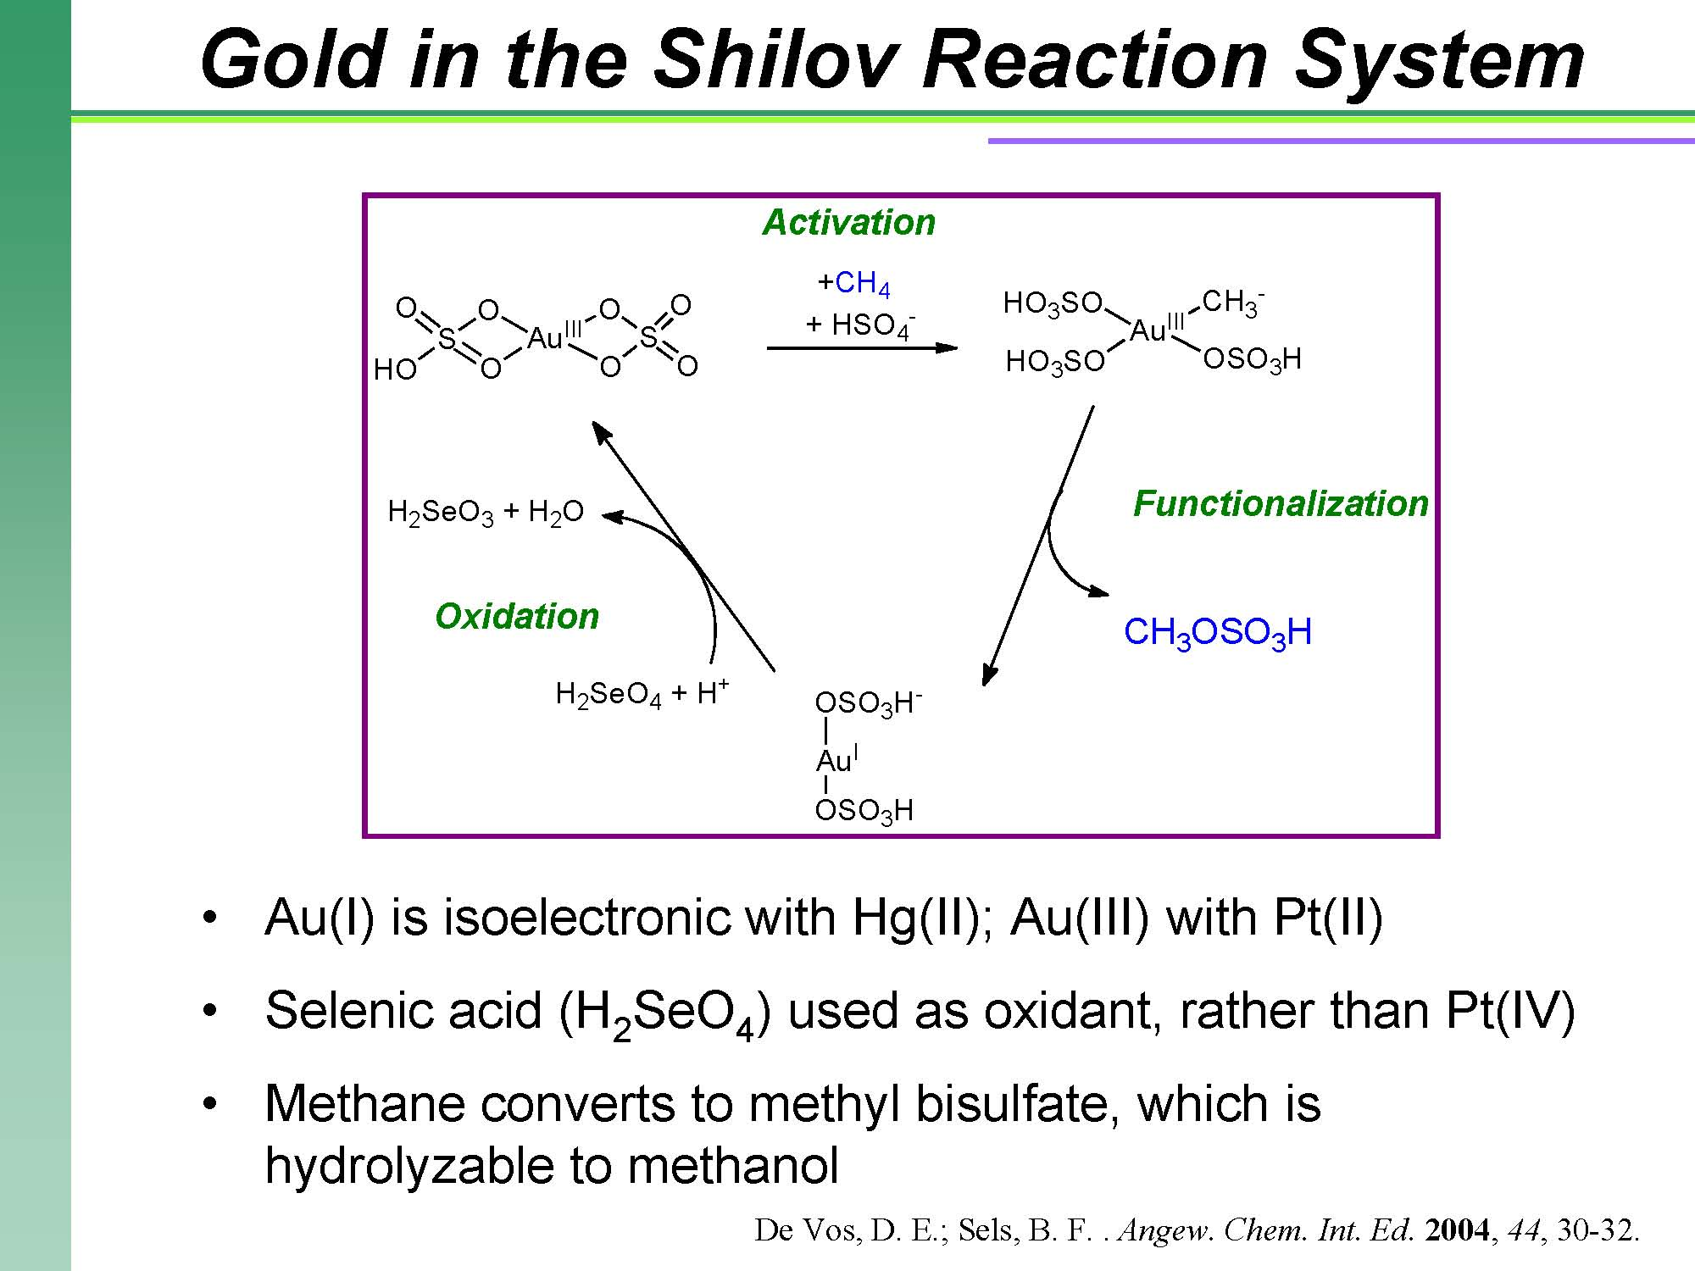
In the oxidation of methane to methanol, Hg(I)/Hg(II) and Pt(II)/Pt(IV) systems have had considerable success. In this paper by De Vos et al., an Au(I)/Au(III) couple was chosen due to the fact that Au(I) is isoelectronic with Hg(II), and Au(III) is isoelectronic with Pt(II), so they should exhibit similar chemistry. This reaction is carried out in highly concentrated (96%), fuming sulfuric acid in order to get the Au to coordinate sulfate ligands. In one proposed mechanism, an Au(III) atom is coordinated with four oxygens of two sulfate molecules, and another sulfate, along with a methane, coordinates to the Au(III) center through electrophilic substitution. The methyl group and bisulfate then combine and come off of the metal center, reducing the Au(III) to Au(I).
An oxidative addition mechanism is also possible, with a methane coordinating to the Au(I) complex, oxidizing it to the Au(III) complex. This complex then could lose an equivalent of H₂SO₄, leaving Au(I) complexed to both a methyl and a bisulfate group. This could be oxidized again to reform the original Au(III) complex, which would lose methyl bisulfate to form the Au(I) complex again.

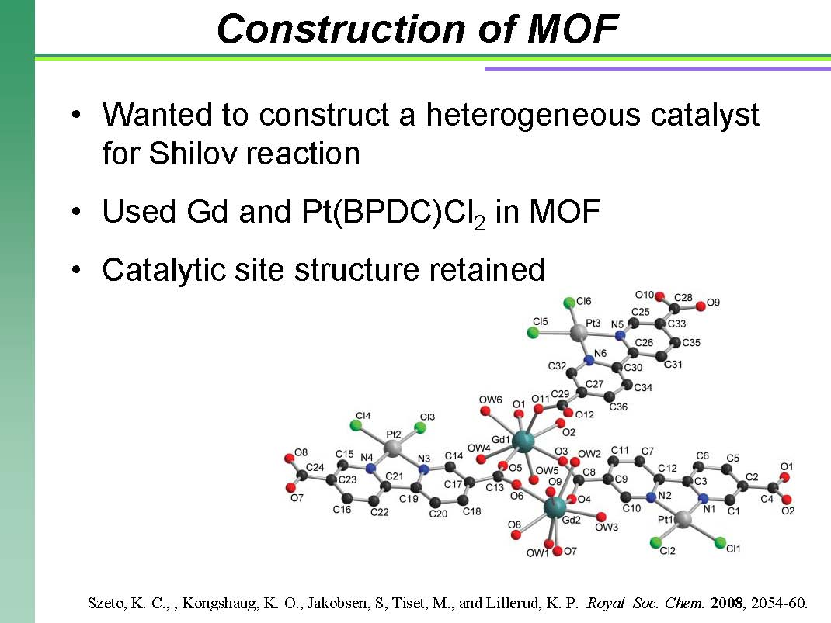
In 2008, Szeto et al. were interested in constructing a heterogeneous catalyst for the Shilov reaction. This would eliminate the need to recover the catalyst from solution after carrying out a reaction. They constructed an efficient Shilov catalyst with 2,2’-bipyridine-5,5’-dicarboxylic acid (BPDC) to give Pt(BPDC)Cl₂. This was then used as a monomer for their MOF (metal-organic framework). The polymer unit contains three Pt(BPDC)Cl₂ molecules connected by carboxylate oxygen atoms to two Gd atoms. The two Gd atoms, with eight coordination sites apiece, are each connected to five carboxylate oxygens, which connect them together, and three water molecules. This structure leaves the square planar geometry of the Shilov catalyst intact while also providing a heterogeneous catalyst.

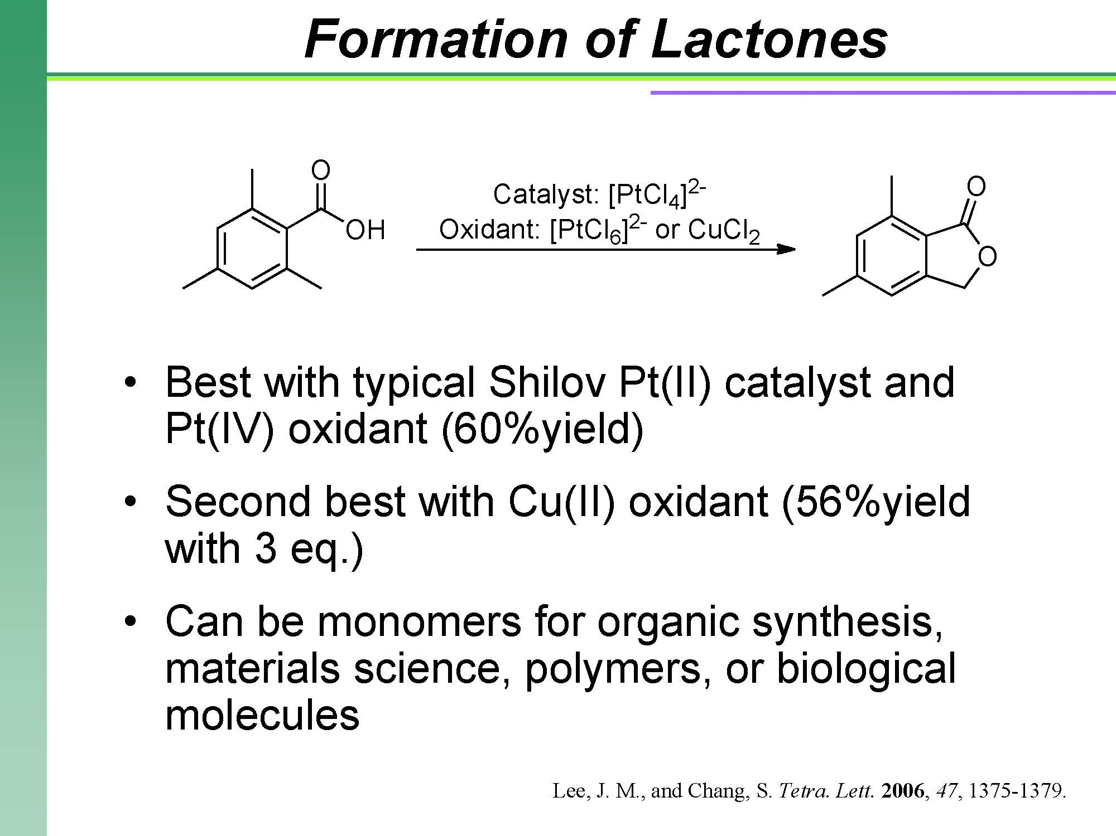

Rather than finding various ways to do the same reaction with Shilov chemistry, Lee and Chang decided to try using the Shilov system to form aryl lactones, which can be used as monomers for organic synthesis, materials science, polymers, or biological molecules. They were able to show that using the classical Shilov reaction system, they could synthesize aryl lactones from the ortho-alkyl substituted aromatic carboxylic acids via sp³ C–H bond activation in fairly high yield. Yield of 60% was obtained using the Pt(II)/Pt(IV) system, and slightly lower yields (56%) were found using a Pt(II)/Cu(II) system.

