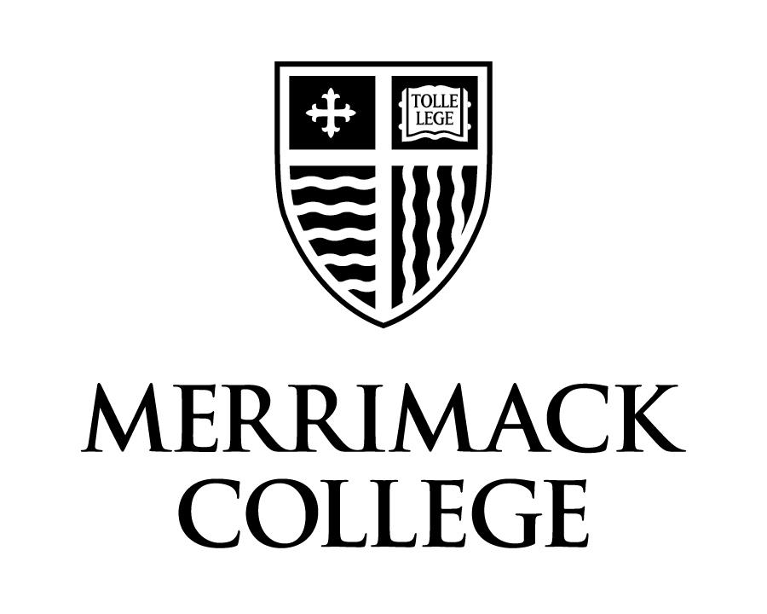

Merrimack College
Department of Chemistry and Biochemistry

CHM 2320
Inorganic Chemistry
Fall 2018

Course Instructor:
Dr. Anthony L. Fernandez
M 321, ext. 5286
anthony.fernandez@merrimack.edu

Office Hours:
M 3:00 - 4:00 p.m.; T 11:00 a.m.– 12:30 p.m.; F 12:30-2:00 p.m.
The office hours listed above are my scheduled office hours each week. As you all know by now, I am usually around and available. Please stop by my office if you have a question at any time. If I am free, I will gladly answer any questions that you might have. If I am busy, I may ask you wait, to come back later, or to make an appointment.

Course Meeting Times: MW 11:00 a.m. - 12:15 p.m., Mendel 141
F 11:00 a.m. - 12:15 p.m., Mendel 140
W 2:00 p.m. - 6:00 p.m., Mendel 339

Textbook:
- Rodgers, G.E. Descriptive Inorganic, Coordination, and Solid-State Chemistry (2nd ed.) Brooks/Cole, ©2002. [ISBN: 0-12-592060-1] (This text is required.)
- The texts below have been placed on reserve at the McQuade library. These will be useful to you in completing homework and literature assignments. I strongly encourage you to spend some time using these additional texts.
    - Bhatt, V. Essentials of coordination chemistry: a simplified approach with 3D visuals, London, Academic Press, ©2016.
    - Cotton, F. A.; Wilkinson, G.; Gaus, P.L. Basic Inorganic Chemistry (3rd ed.) John Wiley & Sons, New York,©1995. [text & answer key are on reserve]
    - Walton, P. H. Beginning Group Theory for Chemistry, Oxford University Press, Oxford, ©1998.
    - Crabb, E.; Moore, E.; Smart, L. Concepts in Transition Metal Chemistry, Royal Society of Chemistry in association with the Open University, ©2010.
    - Ebsworth, E.A.V. ; Rankin, D.W.H.;Cradock, S. Structural methods in inorganic chemistry, Oxford, Blackwell Scientific Publications, ©1987.
    - Lawrance, G.A. Introduction to Coordination Chemistry Wiley, New York,©2010.

Required items:
- Bound laboratory notebook – This laboratory notebook should have consecutively numbered carbon-copy pages. These notebooks may have a stitched or a spiral binding.
- Safety glasses/goggles – These are required for lab and they must be worn at all times when in the laboratory, even if you are not doing experiments.
- Lab coat – This is a required safety item for lab and it must be worn while in the laboratory.

Course Objectives:
In CHM2320, we will cover chapters 2 through 9 in Descriptive Inorganic, Coordination, and Solid-State Chemistry by Rodgers.A more detailed list of learning objectives will be distributed separately.
- Part C: Descriptive Chemistry of the Representative Elements
  - Ch. 9: Building a Network of Ideas to Make Sense of the Periodic Table
    - While much of this this material will be covered at the beginning of the semester, some of it will be interspersed among the material from the other chapters.
- Part A: Coordination Chemistry
  - Ch. 2: An Introduction to Coordination Chemistry
  - Ch. 3: Structures of Coordination Compounds
  - Ch. 4: Bonding Theories for Coordination Compounds
  - Ch. 5: Rates and Mechanisms of Reactions of Coordination Compounds
  - Ch. 6: Applications of Coordination Compounds
- Part B: Solid State Chemistry
  - Ch. 7: Solid State Structures
  - Ch. 8: Solid State Energetics
Material from other sources will also be used when covering topics that are not included in the primary text. These topics include symmetry and group theory, band theory, and electronic spectroscopy.

Course Structure:
In this course you will experience different pedagogic styles (lecture, discussions, and groups assignments to name a few) as we work through the material together. During this semester I ask that you come prepared for class and ready to engage with the material and other members of the class. While you are in class, I need to you be present and engaged so that we can all get the most out of each and every class meeting.
In preparation for class, there will often be a pre-class assignment that will help you arrive to class prepared and ready to work on more-in-depth problems or have a further discussion of the material. You MUST read the material and work through the problems in the relevant sections before coming to class.

Course Communication:
This semester we will be using Google Classroom as our course management system. All of the necessary course information and important course documents will be posted on the course site. Important course notices and other information will also be disseminated via email sent to your Merrimack email address. It is expected that you will check your email and the Google Classroom site on a regular basis.

Grading scheme:
Your final course grade will be determined from your scores on quizzes, assignments, three semester exams, a comprehensive final exam, and your laboratory grade.
 | Contribution to Overall Grade
Class Preparation Assignments | 12%
Literature and Review Assignments | 8%
Semester Exams (4) | 40%
Final exam | 15%
Laboratory | 25%

How do I calculate my grade?
To calculate your grade, determine the number of points earned and divide by the total number of points possible for any item in the list above. For example, let’s say that you have earned a score of 75% on the final exam. You have therefore earned 75% of the 15 possible final exam points, or 11.25 points. You then repeat this calculation for each item and then sum the numbers to get the total number of points earned for the semester (out of 100 points total).
Your final grade will be determined by comparing the points earned to the following scale. The +/- grades are at the high and low ends, respectively, of the ranges.

Letter grade | Points Earned
A | Above 90
B | 80 to 90
C | 70 to 80
D | 60 to 70
F | Below 60

Class Preparation Assignments (CPAs):
As mentioned previously, you will experience a varied learning environment in this course. For you to get the most out of this course, it is crucial that you come to class prepared and ready to work. To guide your preparation for class, you will be assigned a selection of pages to read from the text or a video to be watched. You will have to submit answers to a number of introductory questions based upon the reading/video. When you arrive in class, I will expect that you will be able to recall basic concepts, terms, equations, and information from diagrams and tables. We will begin our class meeting with a check-in about this assignment.
Each CPA will be submitted electronically before the relevant class meeting. I do not expect that you will get every answer correct as you prepare for class, nor do I expect you to always be brilliant and provide the correct answer to every question while you are in class, but I do expect that you will put in your best effort. While you are in class, you can edit and expand upon your answers based upon the in-class discussion. I expect you to participate in class and engage in discussions with your fellow students each and every class meeting. To receive credit for a CPA you must hand in the assignment AND attend class. The CPAs will graded check/no-check and this grade will be based upon an assessment of your effort in completing this assignment. These CPAs must be turned in before the beginning of class and no late assignments will be accepted for any reason. Three assignments will be dropped when calculating the CPA portion of your course grade, which will be equal to the percentage of these assignments you complete over the course of the semester.

Weekly Review and Literature Assignments:
Each Friday, you will be given an assignment that will cover the topics discussed in class that week. You will complete approximately 12 of these assignments over the course of the semester. These assignments will consist mainly of end-of-chapter problems from the Rodgers text. Some assignments will be based upon information from the primary chemical literature and you will be asked to answer a series of questions based upon an article from the primary chemical literature. As with the CPAs, you will receive full credit if you hand in the assignment on time. Late assignments will not be accepted. If you do not submit your assignment by the due date and time, you will receive a grade of 0 on that assignment. No extensions will be given on assignments.
When calculating the portion of the course grade based upon these assignments, the lowest weekly review assignment score will be dropped and the rest of the scores will be averaged.

Exams:
The semester exams will be administered in one of two ways: either in-class or as a take-home exam. In-class exams will last one class period (75 minutes) and will be administered in class. Take-home exams will be distributed electronically and will be due at the beginning of the next class meeting. Exams will be administered on the following approximate dates: Friday, September 27; Friday, October 19; Friday, November 16; Friday, December 7. These dates may vary depending on the type of examination (take-home vs. in-class) and if an exam date needs to be changed, you will be informed at least one week ahead of time.
The final exam will be administered from 8:00 – 11:00 a.m. on Friday, December 14, 2017. This final exam time is scheduled by the college and you must take your final exam at this time.
There are no make-up exams allowed and if you miss an exam you will receive a grade of zero on that exam. Exams scores will not be scaled, but you will be able to earn extra points on the first three exams by submitting corrections to selected problems within 48 hours of receiving your graded exam. The maximum amount of points that can be earned on each exam will be based upon the class average for that exam. Under no circumstances will a student be able to earn a score of greater than 100 points on a semester exam.
If you have a documented learning disability and require extra time on exams, I will be more than happy to accommodate your needs. You must take the exam on the same day as the rest of the class,at a mutually agreed-upon location. Please see the section of the syllabus on academic accommodations.

Laboratory portion of the course:
The laboratory portion of the course is integral to your learning experience and will be fully integrated with the lecture portion of the course. We will meet for the first time on Wednesday, September 5. The lab schedule as well as policies and procedures will be outlined and these will be posted in a separate document on the Google Classroom site. Additionally, we will ensure that all necessary computer software has been installed on each of your computers and we will work through several exercises to get you acquainted with the software. We will begin experimental work on Wednesday, September 12 and we will meet in Mendel 339.

Group work:
While I encourage you to work together on any course assignment (except for exams), I want you, in the end, to submit your own answers. While you may discuss a problem with other students, I expect that you will solve the problem on your own and the answer to the question is yours. For example, if two students work together on an assignment, it is acceptable for them to discuss the theory behind the problem and potential solutions for solving the problem. I would then expect that each student work out and arrive at the final answer to the problem on his or her own.
When working/studying with a group of students, all members should contribute to the work done by the group. There is no benefit to sitting there passively and copying the work done by your fellow classmates.

Academic Integrity:
At Merrimack College, we expect students will comport themselves with integrity and adhere to the highest ethical standards. Our Academic Integrity Code describes the importance of academic integrity in an educational setting, details the different types of infractions that can occur, presents possible penalties for violations, and lays out the review process. The College’s Academic Integrity Code can be downloaded in PDF format directly using the following link: https://www.merrimack.edu/live/files/279-academic-integrity-code. It is your responsibility to read and understand this code, and I would welcome any questions that you might have about it.
In this course, infractions of the Academic Integrity Code will be dealt with severely. In the first instance, you will automatically receive a grade of zero on the assignment in question and will be reported to the Dean. Any further violation of the Academic Integrity Code will result in automatic failure of the course, and further college penalties may also be imposed.

Academic Accommodations:
Merrimack College provides reasonable accommodations for students with documented disabilities. Students who have, or think they may have, a disability are invited to contact the Accessibility Services Office via the online request form (http://www.merrimack.edu/accessibility), email (accessibilityservices@merrimack.edu), or by visiting us on the third floor of McQuade Library.
Students are encouraged to contact the office as soon as possible to ensure adequate time to meet and create a plan. Accommodations can not be made retroactively.

Tips for Success:
The most important factor in succeeding in this course is putting in the requisite amount of work expected each week. The weekly workload, on average, for the non-laboratory portion of the course can be broken down in the following manner:
- three fifty-minute class meetings each week;
- 1½ hours to complete the CPA for each class meeting;
- ½ hour to review the material after each class meeting;
- 2 hours to complete the weekly review or literature assignments.
This adds up to an expected workload of 12 hours per week. Since Chemistry is an experimental science, there is also a significant workload related to the laboratory portion of the course. Each week, the expected laboratory workload will be:
- one four-hour lab meeting each week;
- ½ hours to prepare for the experimental work;
- 1½ hours to complete the laboratory report for and any other work related to the experiment.

The best advice that I can offer is to be prepared and not to let yourself get behind. If you keep up with the material as it is presented, then you will not have to “cram” the night before an exam to try to learn everything at once. This is a less effective way of learning the material and you will not use your time efficiently.

Before coming to lecture, be sure to give your best effort when completing the class preparation assignments. Do not be afraid to suggest an incorrect answer! This is part of the learning process. Be sure to review the material BEFORE attempting the weekly review assignments. It will take you much longer to complete the assignment if you are reviewing the material as you go along.

Finally, ask questions. Do not be afraid to ask questions - there is no such thing as a stupid question. I will try to answer your question so that you can develop a fuller understanding of the concepts and material under consideration.

