What happened to my green solution?

A student was given two vials and each contained a chromium salt. The vial labeled CrCl₃∙6 H₂O contained a dark green solid and the one labeled Cr(NO₃)₃∙9 H₂O contained a purple solid. She made aqueous solutions of these solids and the colors of these solutions were the same as the solids (see image below).
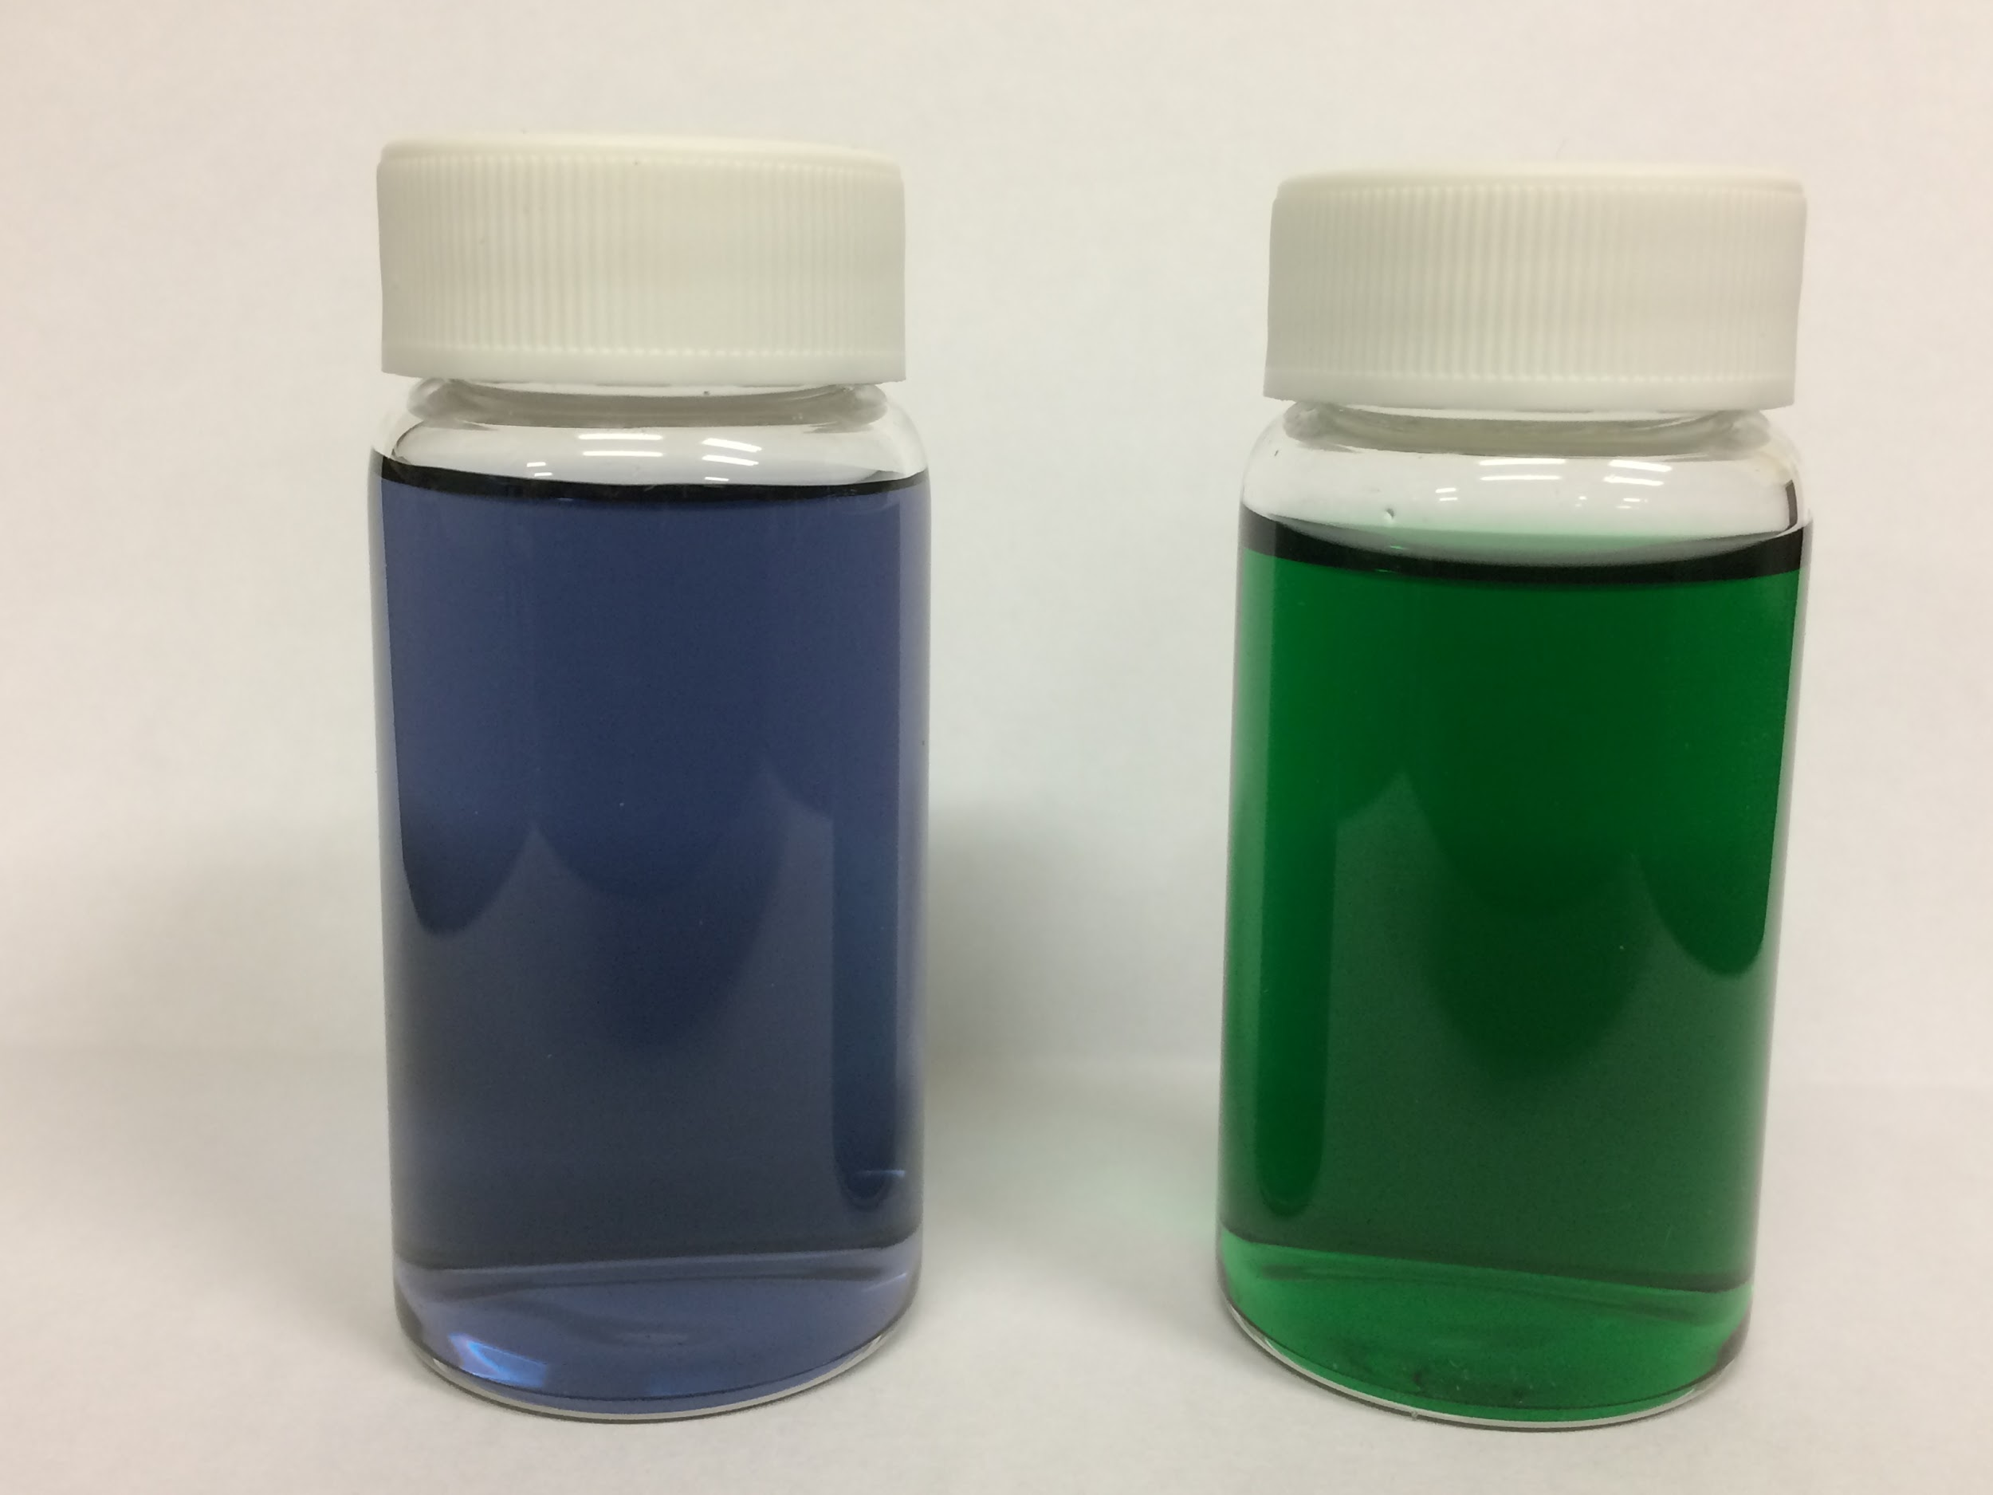
Initial appearance of aqueous solutions (0.05 M) of Cr(NO₃)₃∙9 H₂O (left) and CrCl₃∙6 H₂O (right)

After preparing these solutions, she had to leave the lab and the solutions remained sitting on the bench for 24 hours. When she returned the next day, she found that the aqueous solution of CrCl₃ had changed color and was now purple like the solution containing Cr(NO₃)₃∙9 H₂O (see image below).
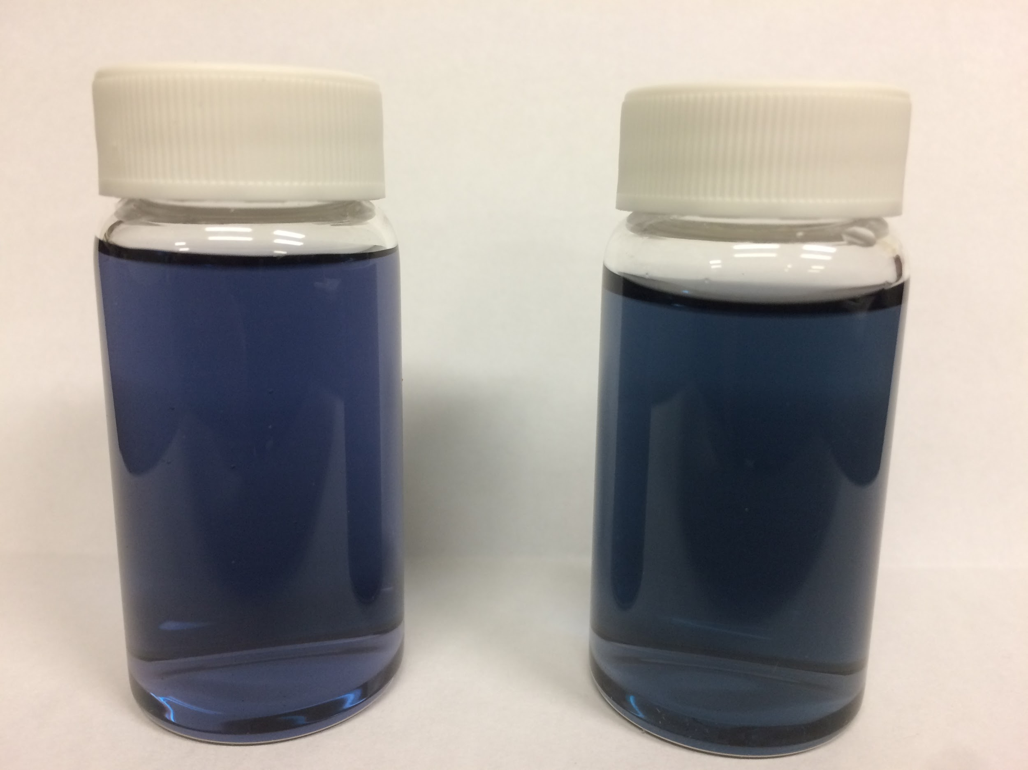
Appearance of the same aqueous solutions (0.05 M) of Cr(NO₃)₃∙9 H₂O (left) and CrCl₃∙6 H₂O (right) after 24 hours

Based upon this observation, please describe what happened in the solution. Write out reactions that describe the changes that took place in the CrCl₃∙6 H₂O solution over the course of 24 hours.

