**Metal-Ligand Multiple Bonds: The Discovery of “Double Nickel” (Hillhouse)**

This Learning Object is dedicated to the memory of Prof. Greg Hillhouse and is part of the VIPEr LGBTIAN+ LO collection created in celebration of Pride Month (June) 2022. Prof. Hillhouse was highlighted in *Chemical & Engineering News* in [June 2021 as one of the “LGBTQ+ chemists you should know about”](https://cen.acs.org/people/lgbtq-scientist-chemist-history/99/web/2021/06#Gregory-L-Hillhouse) and was named a “Historic Trailblazer” in the [“Out and Proud” article](https://cen.acs.org/careers/diversity/LGBTQ-diversity-Trailblazers-2022/100/i12) published in the April 8, 2022 issue of *Chemical & Engineering News*.

In 2001, Mindiola and Hillhouse reported the synthesis of what came to be known as “double nickel” and its complexes with amido and imido ligands. This LO focuses on chemistry reported in this communication [Mindiola, D.J.; Hillhouse, G.L. Terminal Amido and Imido Complexes of Three-Coordinate Nickel**.** *J. Am. Chem. Soc.* **2001,** *123*(19), 4623-4624. DOI: [10.1021/ja010358a](https://pubs.acs.org/doi/10.1021/ja010358a)].

1. According to the authors, what are the two reasons why the chemistry of complexes containing late transition metals and amido or imido ligands is much less developed than that of the early transition metals?
2. What previous work suggested that imido ligands might form with nickel(II) centers?
3. Why were bulky groups used on both the nitrogen and phosphorus donor atoms?
4. The synthetic pathway of the imido complex is shown in Scheme 1. Please classify complexes **1**-**4** according to the covalent bond classification system, [MLlXxZz]q.
5. Complex **2** is a dimer with two chlorides bridging two nickel centers. The characterization of this complex was reported in the Supporting Information that accompanies the article. What methods did the authors use to characterize the complex? What was the primary evidence that proved the dimeric structure? Would we be able to use any of the other characterization methods to distinguish between a monomeric and a dimeric structure?

1. In complex **3**, the nickel is in the +1 oxidation state. Why did the authors oxidize the nickel center to Ni2+ (complex **4**)?
2. The authors report the synthesis of complex **5**. What important details were reported about the structure of this complex? What led the authors to describe the Ni-N bond as a double bond?
3. In complex **5**, there is a π-bond between the nickel and the nitrogen of the imido ligand. Please draw the orbital-lone pair interaction that leads to the formation of this π-bond.
4. What structural evidence did the authors provide to support the assertion that imido complex **5** had been formed from amido complex **3**?
5. In complex **5**, the nickel center is in the +2 oxidation state. Given that the complex is neutral overall, please classify the imido ligand according to the CBC model. As part of your answer, please draw a Lewis structure and explain how it is consistent with the classification of the ligand.
6. Complexes **2** and **3** were both reported to be paramagnetic with *μ*eff of 2.29 and 2.08 *μ*B, respectively (Supporting Information). Given the d-orbital splitting diagrams for trigonal planar (left) and square planar (right) metal centers, please fill them in with electrons to show why this is the case. (The red horizontal line represents the barycenter.)

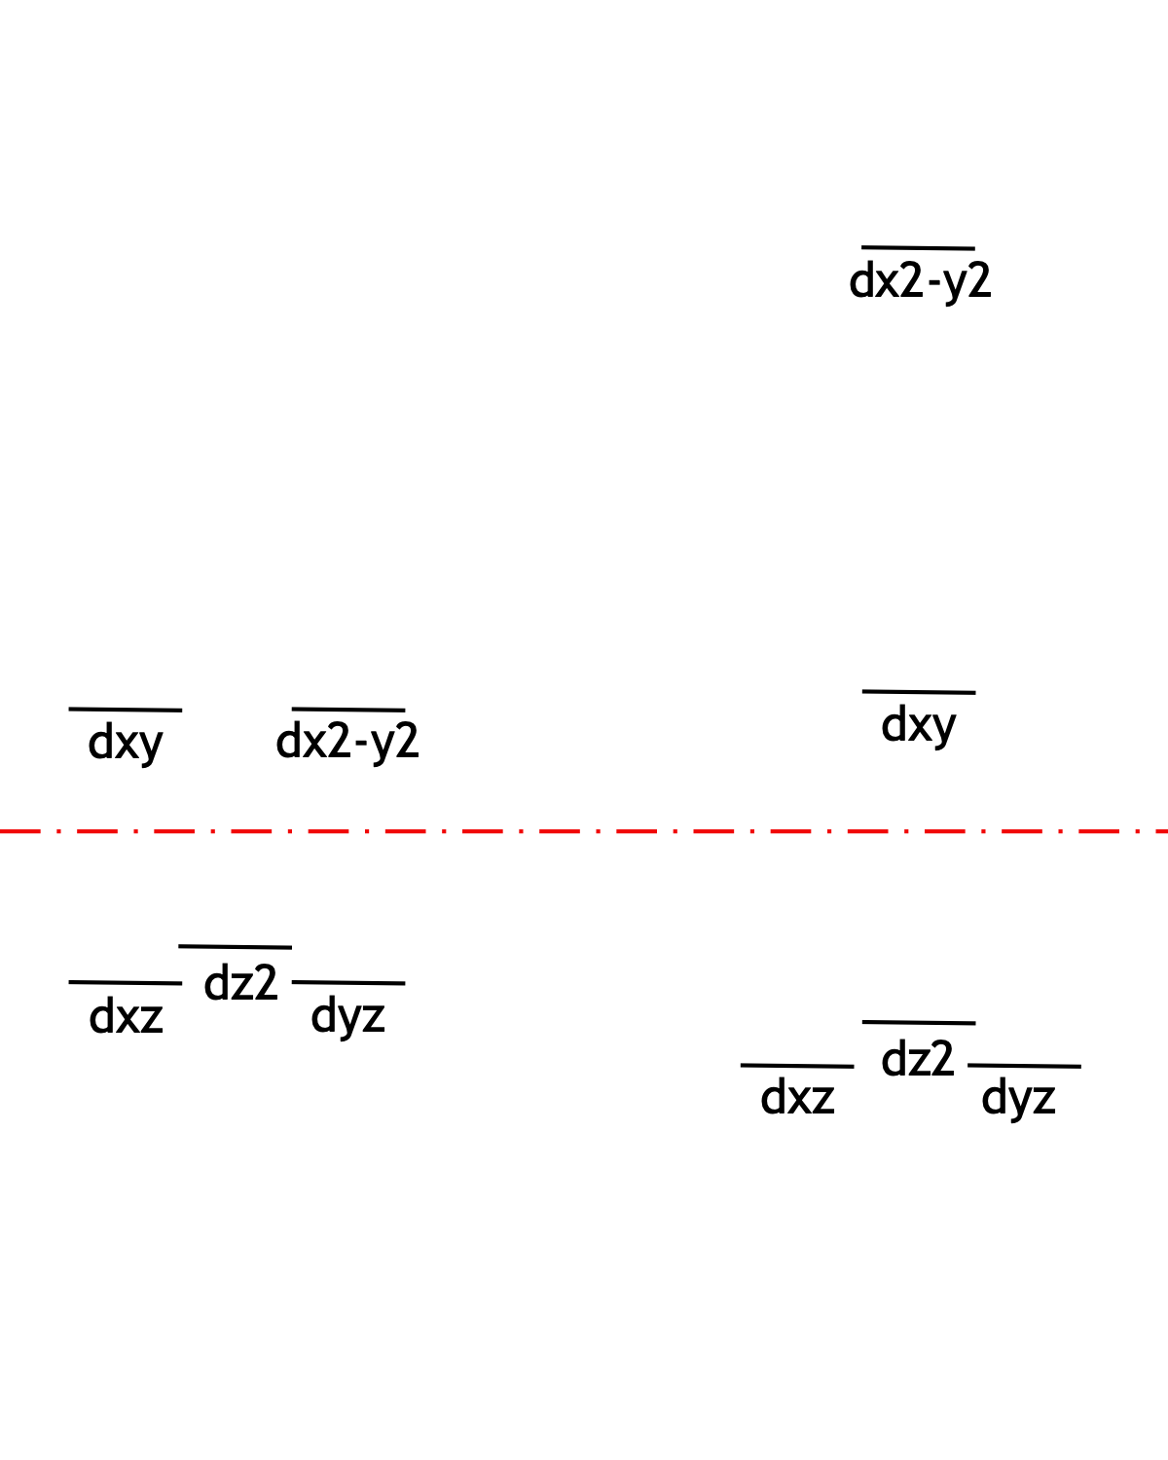

1. Complexes **4** and **5** were both reported as diamagnetic, three-coordinate complexes of Ni(II). Given that they are approximately trigonal planar, does that make sense given your answer to the previous question? What would have to happen for these complexes to be diamagnetic with all paired electrons?