Drawing Chemical Structures with MarvinSketch

ChemAxon is a company that provides software and other applications for chemoinformatics and they offer their powerful Marvin Suite of software tools to academic users for free. Marvin allows users to draw structures and compute a number of chemically important properties (e.g. elemental analysis, pK_{a}, charge, ¹H and ¹³C NMR spectra, and protonation location) about compounds entered into the program.

First, the program must be obtained from ChemAxon using the provided link (https://chemaxon.com/products/marvin). This program is freely available, after creating an account, and there are versions for Mac, Windows (32- and 64-bit), and Linux operating systems.

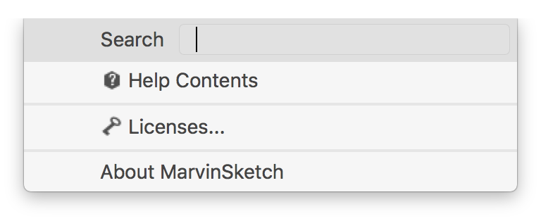
To access all of the features of the software, the license file must be installed. (The license file can be found in the Google Classroom site for this course. Once the program has been installed and you have opened the MarvinSketch program, you can install the license by choosing Help > Licenses… which will open the License Manager window.

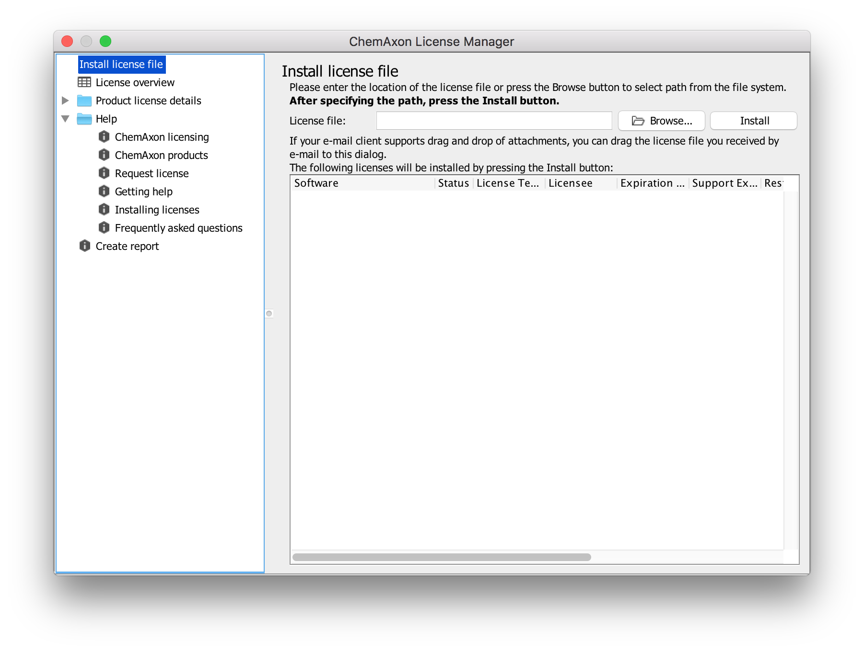
To install the license, choose the Browse button and navigate to where you have the license file saved. Choose the appropriate file and click the blue Open button. The path to the location of the license file will appear in the previously blank text box.
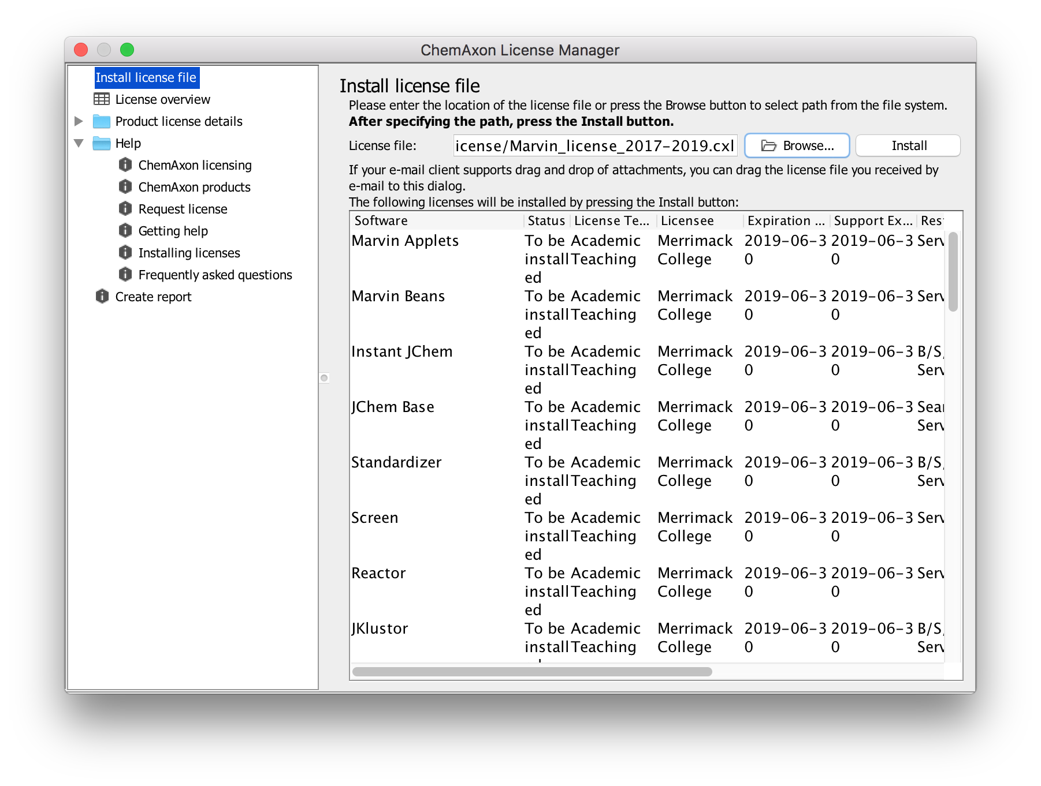
You can see that the status of the software is “To be installed” and this will change to “Valid” after you click on the Install button. After installing the license file, you can close the window and return to the main window of the program (shown below).

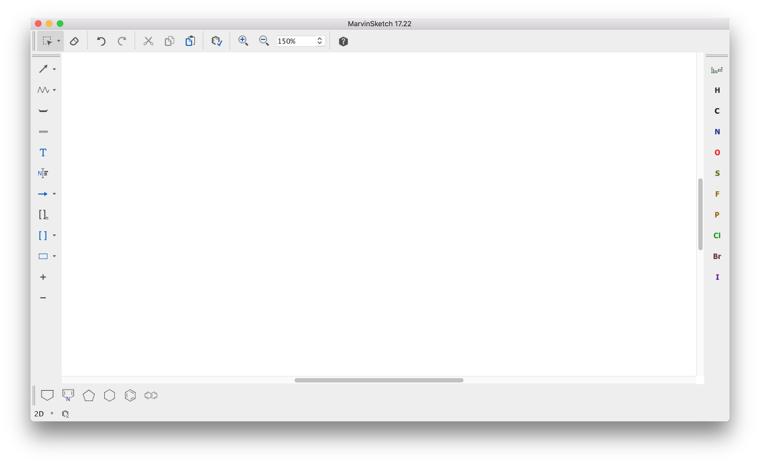
To start drawing the structure for trans-[Ni(NCS)₂(P(CH₃)₃)₂] (which is the structure BAZSUR from the Teaching Subset of the Cambridge Structural Database), you will need to first draw the central nickel. You can choose the button periodic table from the menu on the right-hand side of the screen. A periodic table will appear in a new window and you can choose Ni, which will be highlighted in yellow. Hit the Close button to return to the regular window.
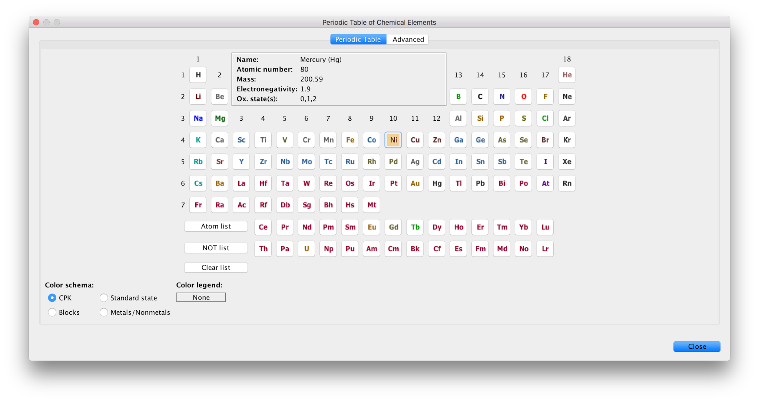
When you move your cursor over the main drawing window and a Ni will appear near the cursor. You can then click anywhere in the window to add a Ni.
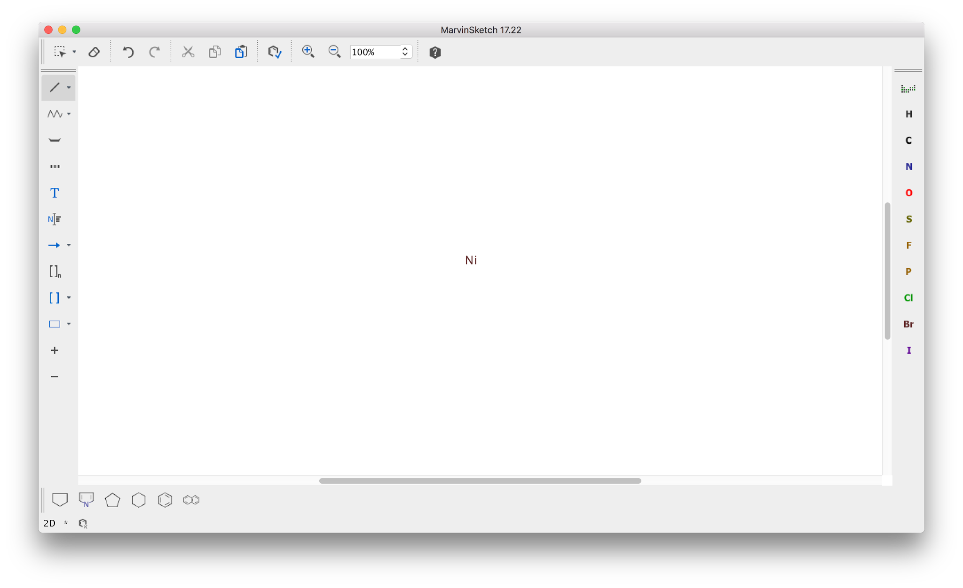

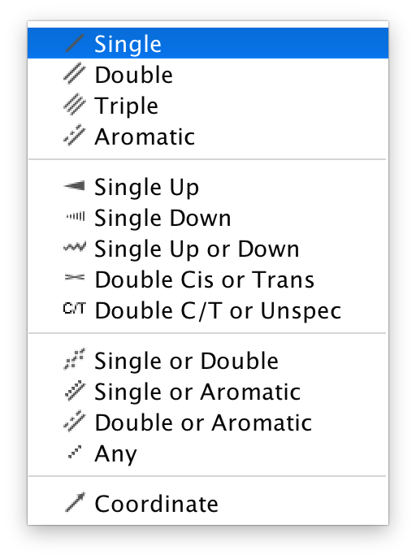
To add the groups around the central atom, you have to choose the bonds that need to be added. On the left-hand side of the window choose the second button from the top and a menu will appear. Choose the single bond and add four of them to the central nickel by clicking and holding the mouse button on the Ni and dragging away from it. When you add the bonds it will automatically put carbons as the atom at the end of the bond and it will add hydrogens to complete its valence (see below).

You can then change these atoms to N and P by choosing the appropriate buttons from the menu on the right-hand side of the window. Again the valences will be filled with hydrogens by default.
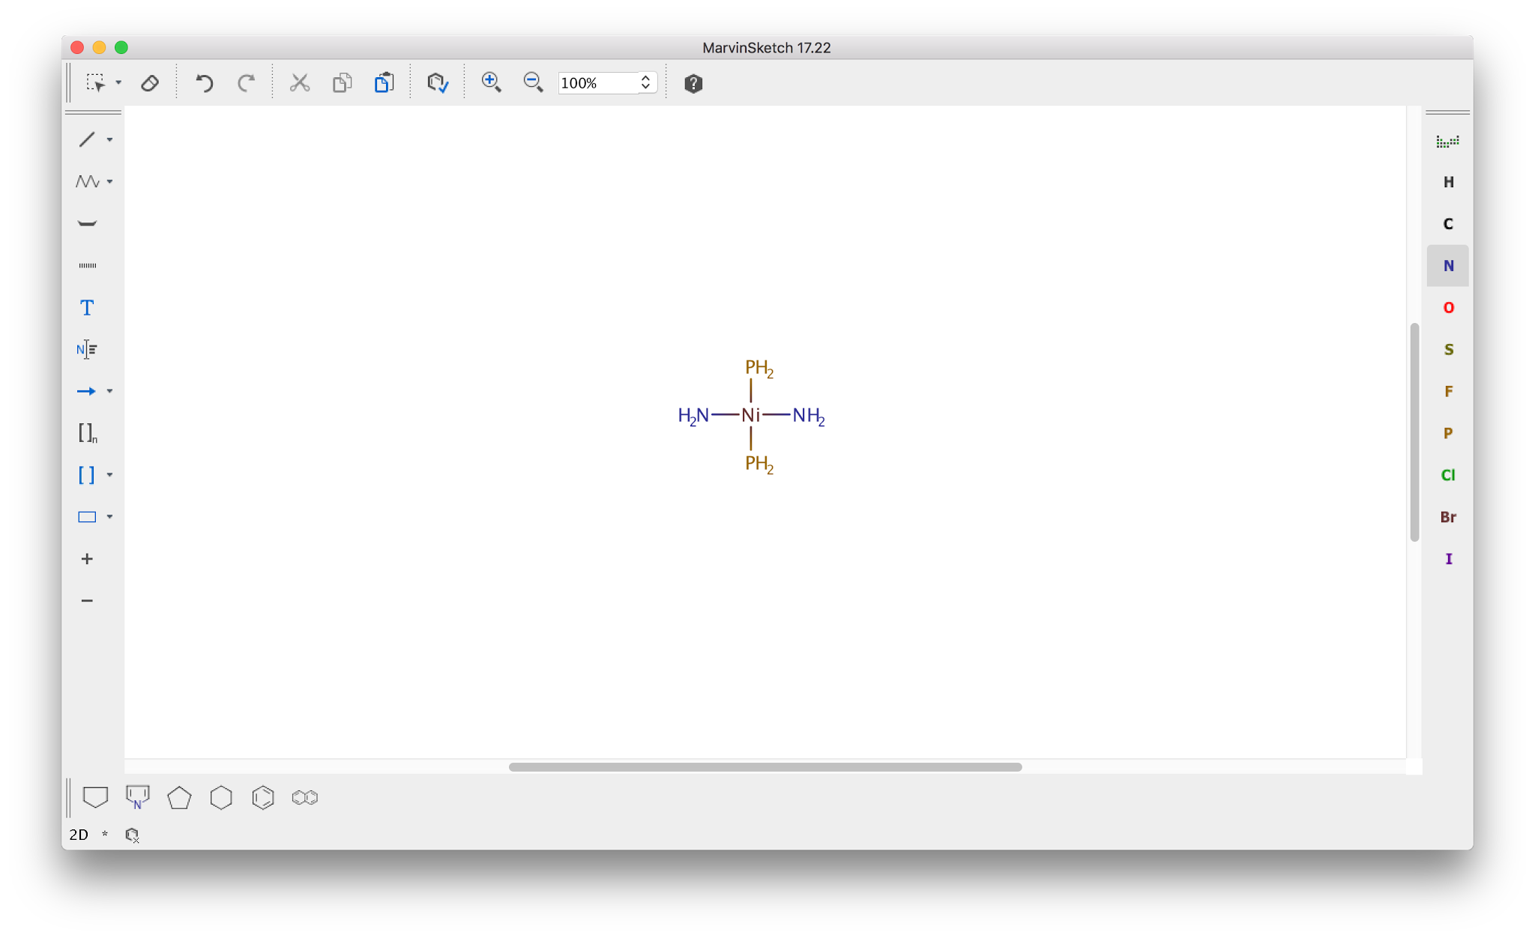
Next, we will convert the NH₂ groups to the NCS groups attached to the nickel. Go back to the bond button and choose the double bond. You can then add a double bond to a carbon to each nitrogen. You can then add another double bond to these carbons and then change the terminal atom to a sulfur. Once you have completed this you will have the following structure.
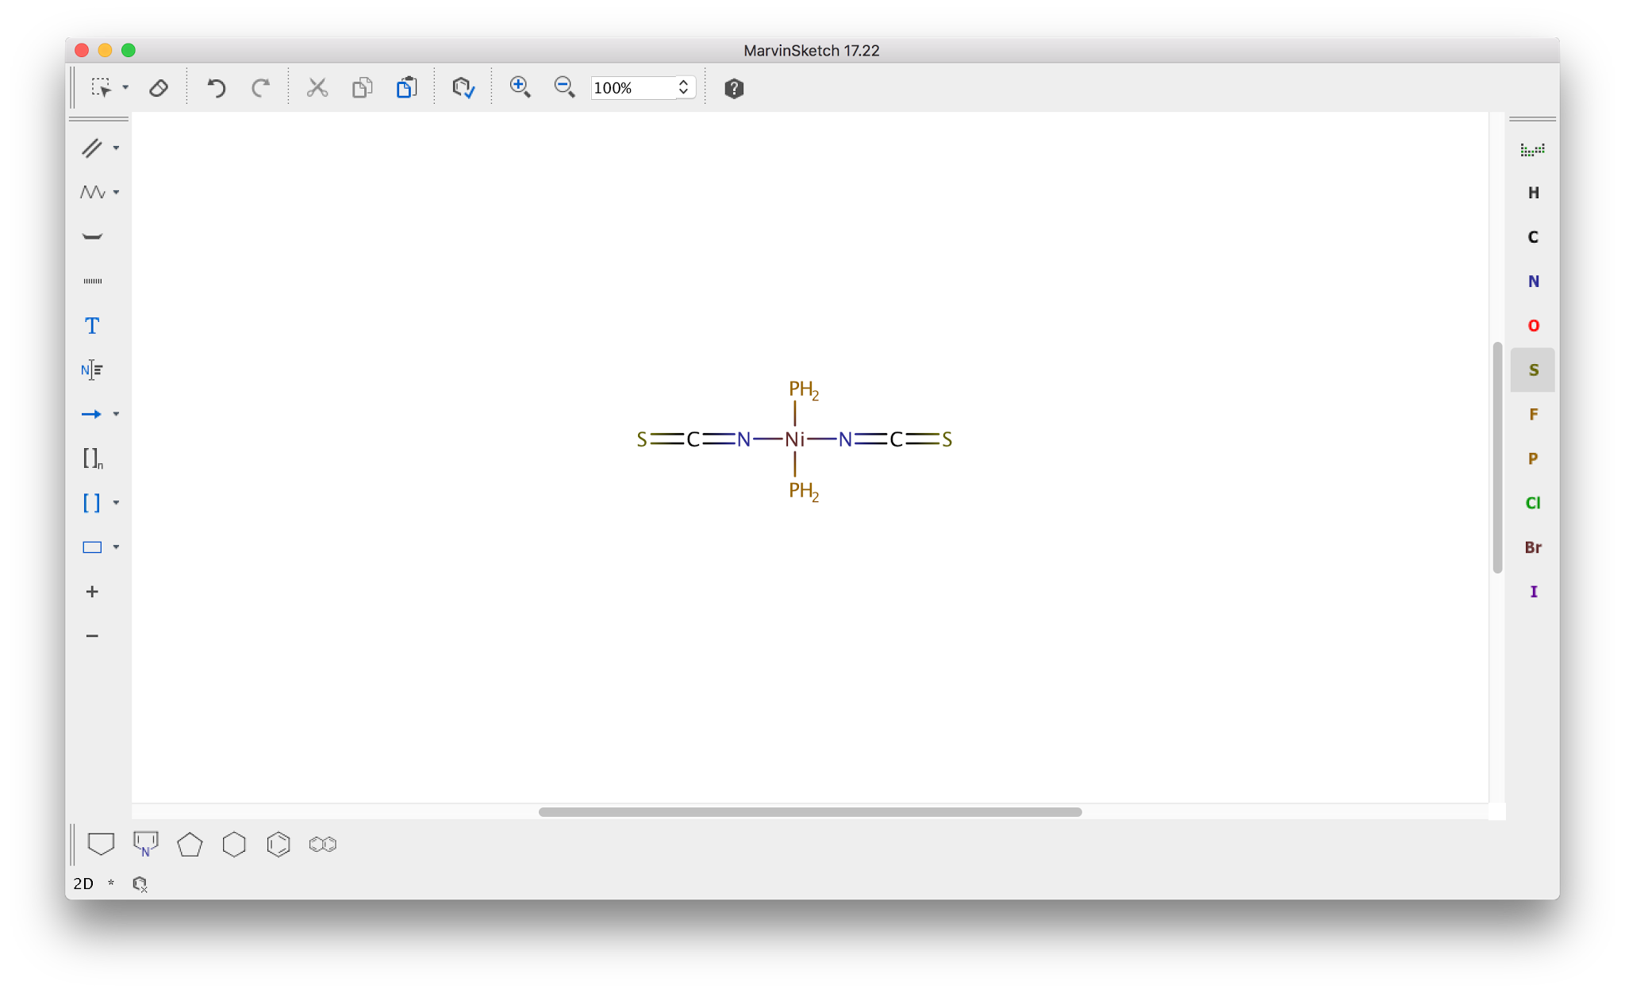
You can now elaborate the phosphorus atoms to the trimethylphosphine ligands found in the structure. You can go to the single bond tool to add three bonds to carbon on each phosphorus. To indicate three-dimensional shape, you can use the dash and wedge bonds to differentiate the methyl groups.
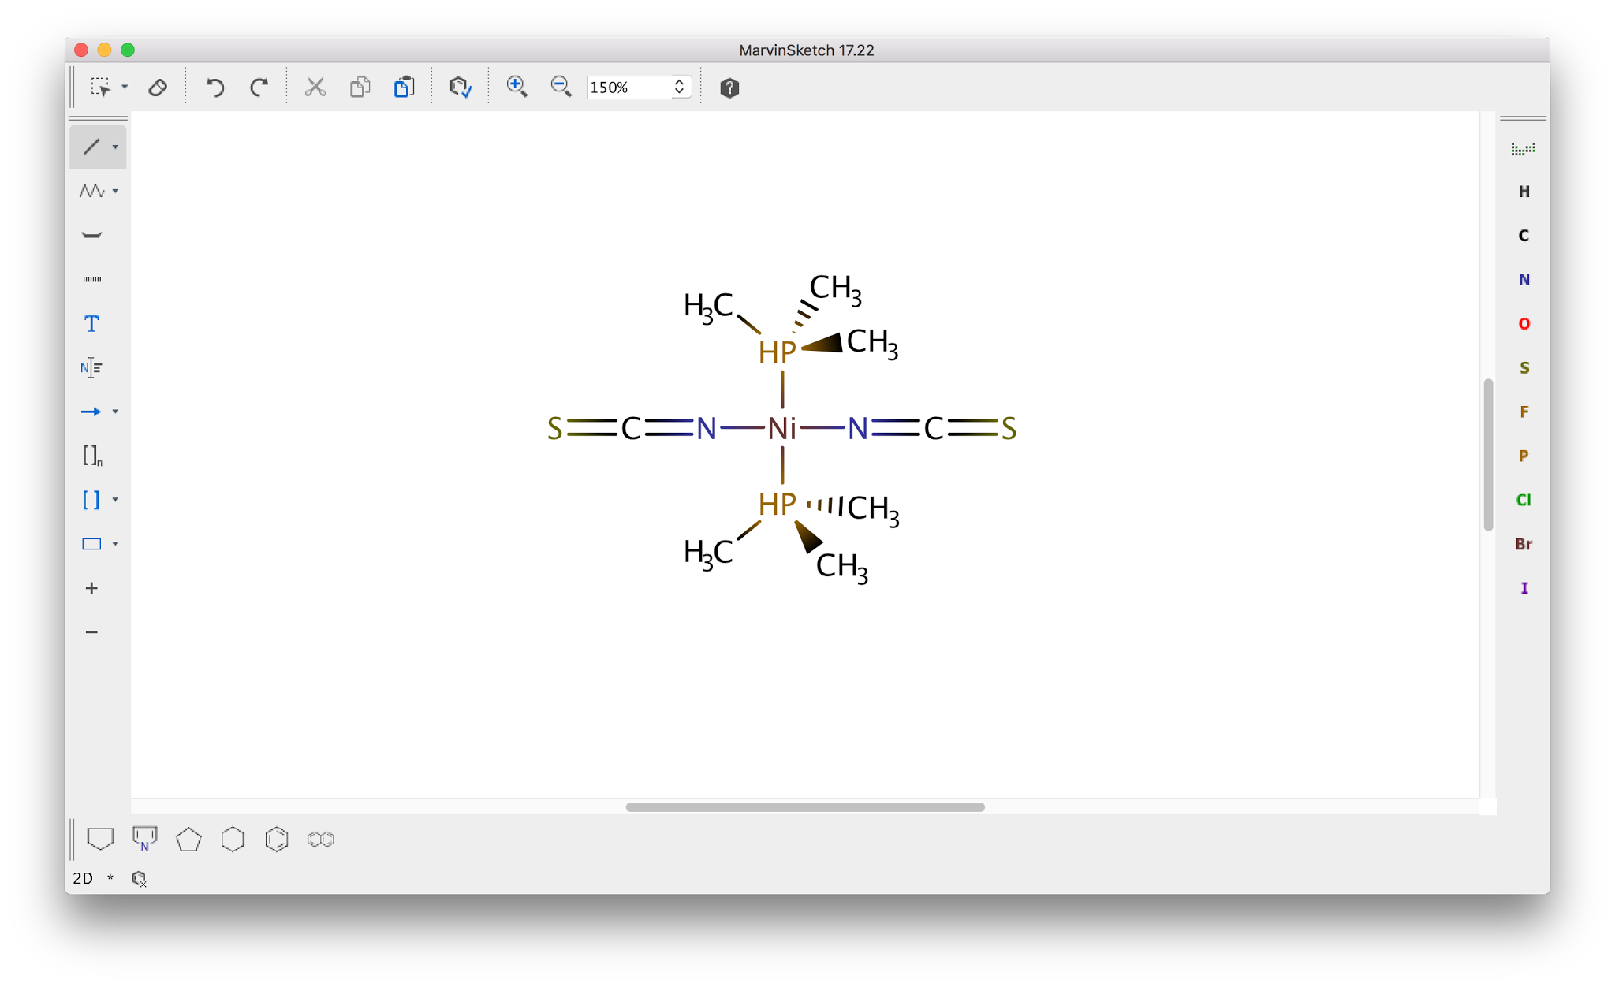
At this point you will notice that the phosphorus has a hydrogen that was automatically placed in the drawing by the program. This is because phosphorus usually forms either 3 or 5 covalent bonds and the program is trying to follow those conventions. The Ni-P bond is best described as a coordinate bond and not a covalent bond. This hydrogen can be removed by changing the Ni-P bond to a coordinate bond. The coordinate bond should be chosen in the bond tool and then you can convert the bonds by clicking on the Ni-P bonds in the structure. The bond will then be an arrow pointing towards the Ni - you may have to click the bond again to reverse the initial direction of the arrow. (The style of coordinate bonds in a document can be changed to a line in the Bonds section of the Preferences box - Edit > Preferences…).
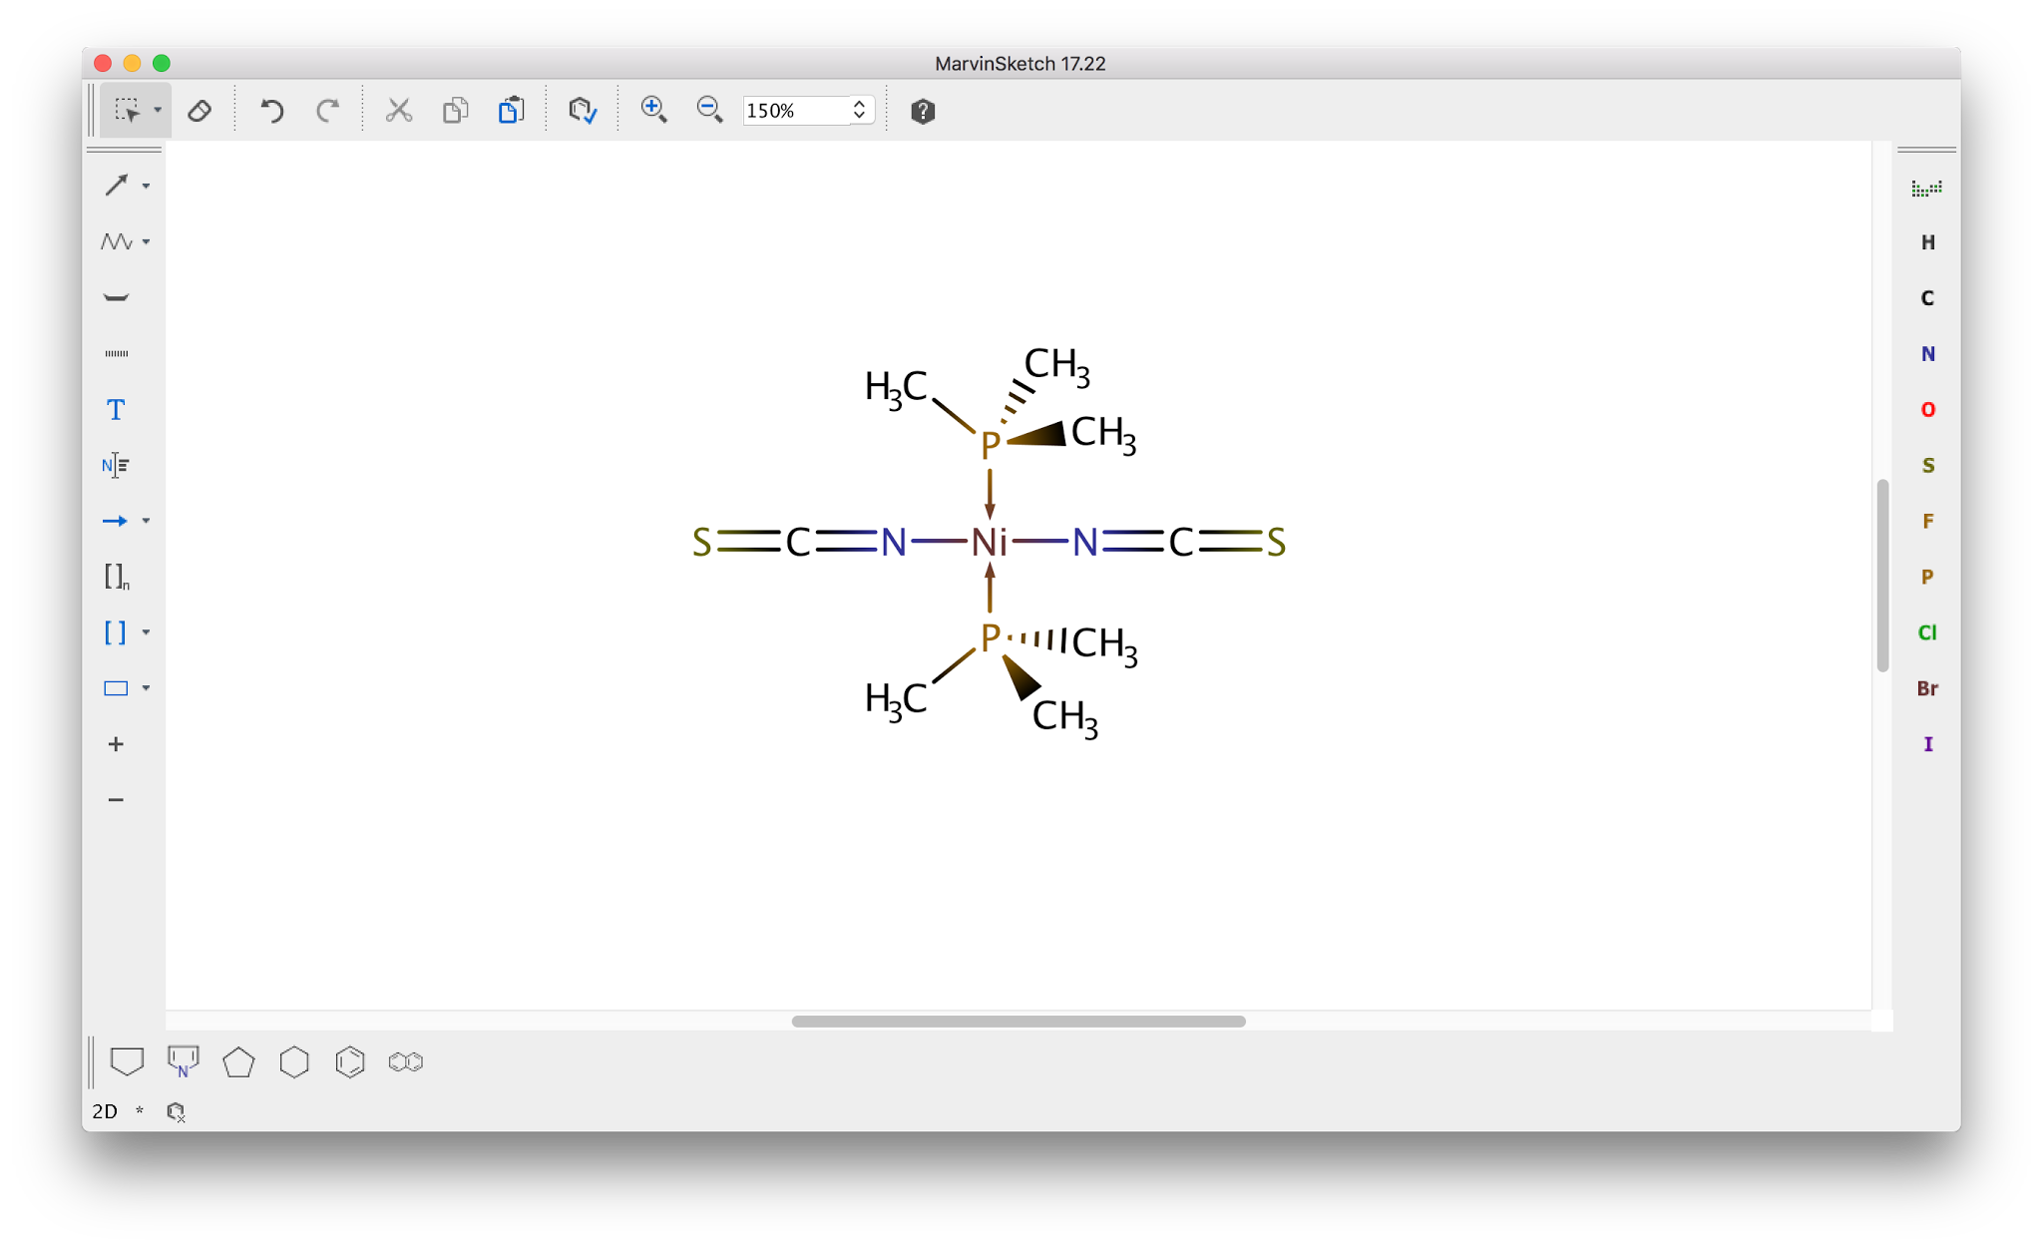

You now have an electronic version of the structure on your screen. You can get this image into another document in one of two ways.
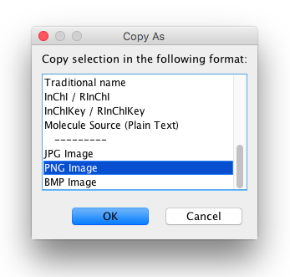
- Select the image. Choose Edit > Copy As... (which can also be accessed from the contextual menu that appears when you right-click on the selected structure). Choose an image type (PNG is a good choice) from the bottom of the list that appears in the pop-up window and hit the OK button. This structure can now be pasted into another program.

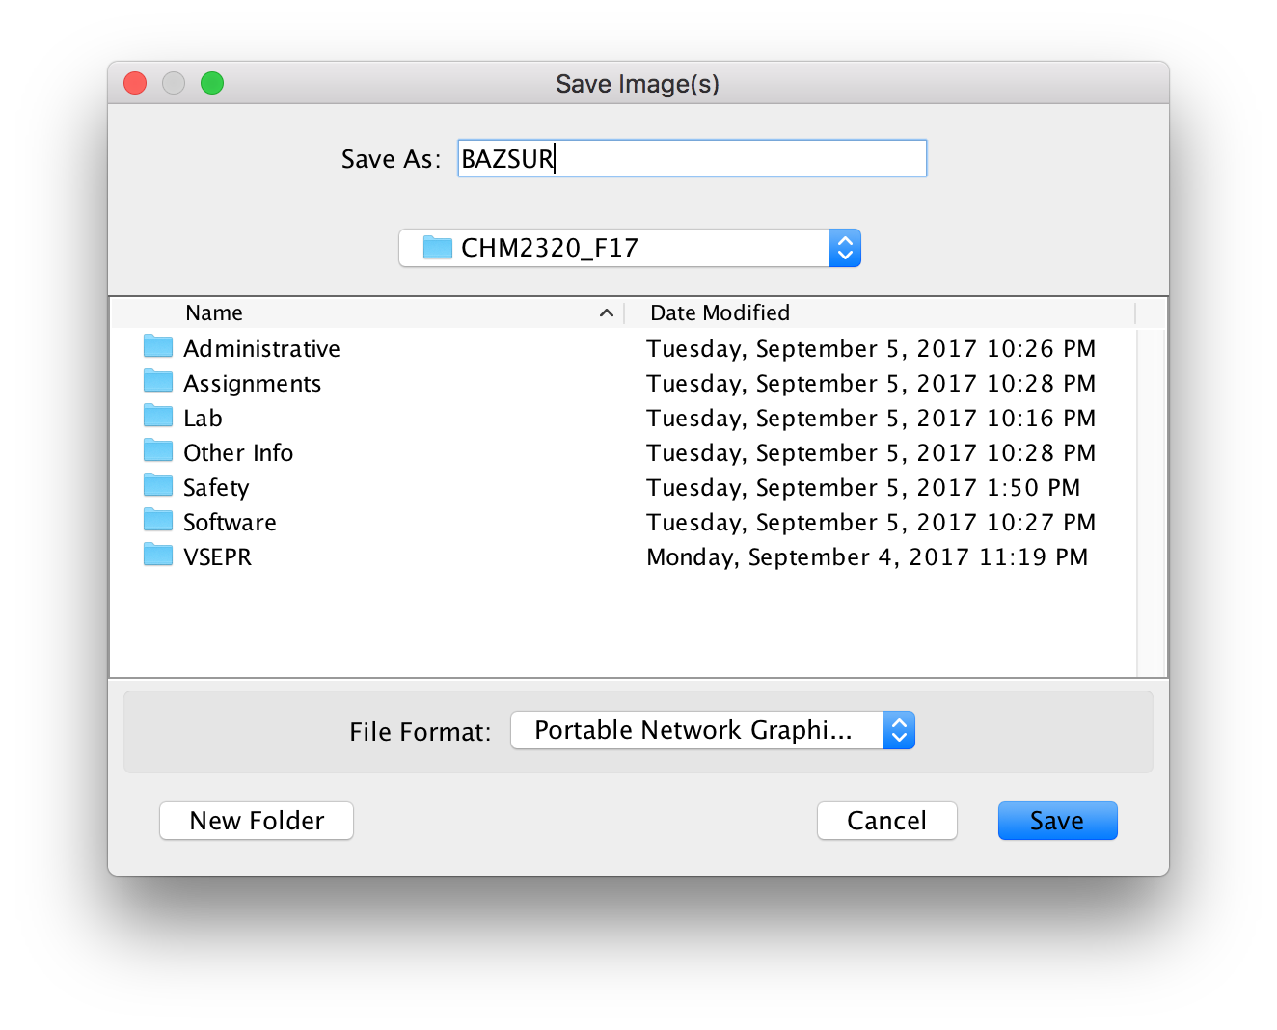
- Select the image. Choose File > Export to Image. Your structure can be saved as an image file on your hard drive. Saving it as a Portable Network Graphics (PNG) file using the default settings is a good choice. Once you have entered a name for the file, chosen where the save the file, and selected the image format from the drop-down menu, choose the Save button. This image can now be inserted into another document by using the appropriate procedure in your desired program.

