**Catalytic Transformation of Lignin**

In fall 2021, Madhi M. Abu Omar was awarded the ACS Award in Green Chemistry for his outstanding contributions to fundamental science and technology development for catalytic lignin conversion to renewable chemicals, fuels, and materials following green chemistry and engineering principles.  In this assignment you will learn about his work when you examine his 2013 paper “Cleavage and hydrodeoxygenation (HDO) of C–O bonds relevant to lignin conversion using Pd/Zn synergistic catalysis” *Chemical Science.* 2013, **4**, 806-813. You will apply a variety of chemical concepts to understand what is so exciting about his work.

1. When Abu Omar wrote this paper, where did he work?  Since then, he has moved.  Where and in what department is he located now? What personal and professional background can you find about him online?
2. Pick one other author on this paper and find out what you can about them, including what they are doing now!
3. In the first paragraph, the authors use the term “lignocellulosic biomass”.  What is lignocellulosic biomass and where does it come from?
4. The authors describe lignin as being the most “recalcitrant” of the three major biopolymers that make up the cell wall. The Oxford dictionary defines this term as “having an obstinately uncooperative attitude toward authority or discipline.”

a.  What is lignin recalcitrant about doing?

b.  How is most lignin currently used?

c.   What are the other two biopolymers that make up the cell wall?

1. An example of lignin structure is shown below.

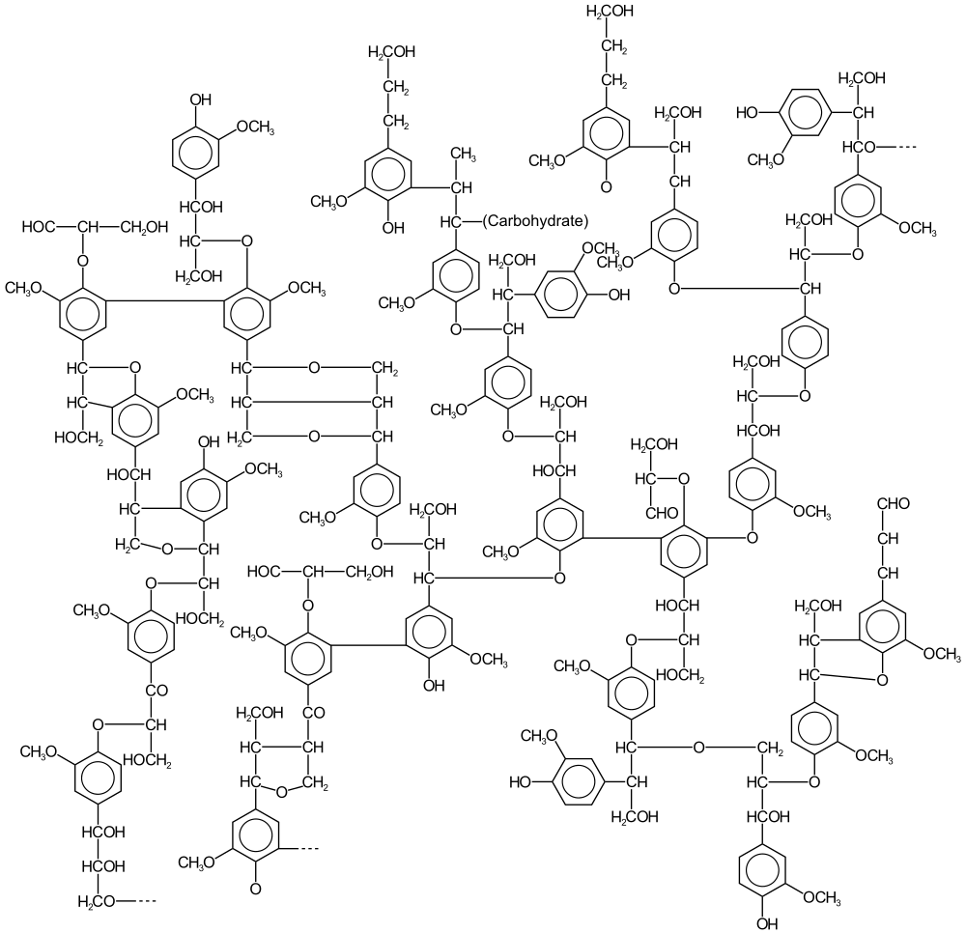

The image above is from the [Wikimedia Commons](https://commons.wikimedia.org/wiki/Main_Page).

This file is licensed under the [Creative Commons](https://en.wikipedia.org/wiki/en:Creative_Commons) [Attribution-Share Alike 3.0 Unported](https://creativecommons.org/licenses/by-sa/3.0/deed.en) license.

1. Which type of functional group is found in lignin but not in other possible sources of biofuels?  (ie, what does lignin have that others do not?)

1. Why is this functional group desirable to retain?

1. Highlight an example of the β-O-4 ether linkage in the structure above.

1. What does it mean to be a homogeneous catalyst?  A heterogeneous catalyst?  Which type is being used in this work?
2. Fill in the blanks: The process of hydrodeoxygenation (HDO) in this paper is adding ________ to to remove covalently bonded _________ from the lignin.

1. To better understand why it is desirable to remove oxygen from the lignin, carry out the following comparison of the fuels ethane (C2H6) and ethanol (CH3CH2OH).

* + 1. Draw Lewis structures for each, and identify the oxidation number of the carbon atoms in each:

C2H6                                         CH3CH2OH

C oxidation number(s) =    C oxidation number(s) =

* + 1. Write the balanced combustion reaction of each fuel with oxygen to form water and carbon dioxide as products.

C2H6    +   _______ →  _______  +   _______

CH3CH2OH   +   _______ →   _______  +   _______

* + 1. What is the oxidation number of carbon in carbon dioxide?

* + 1. Look up the enthalpy of combustion for each fuel.  Why do you think removing the oxygen is important?

C2H6                   ______________

CH3CH2OH            ______________

* + 1. What is the biggest challenge the authors face in trying to eliminate C-O bonds in the lignin material?

1. a. Draw Lewis structures for the following reagents used by the research group in their control experiments.

vanillyl alcohol

veratryl alcohol.

  vanillin

guaiacylglycerol-β-guaiacyl ether

b. Why do you think these starting materials were chosen?

1. The experimental details for both the catalyst preparation and the reactions with the catalyst cautions that the Pd/C is pyrophoric but doesn’t give any instructions about HOW to be careful. How do you think you could prepare to handle such compounds?
2. Table 1 shows the results from the catalyst experiments. What is the take home message from that Table?
3. Why did the authors use MeOH for their reactions?
4. Despite producing a catalyst that contains both Pd and Zn, the authors say that there is no evidence that a Pd/Zn alloy is involved in the reaction. How do they support this conclusion?
5. The authors propose two possible mechanisms for how the Zn2+ could be helping facilitate the breakdown of the model lignin. Which do they think is active and why?