1.a. As a first approximation of the bonding in diatomic nitrogen, N2, draw the Lewis structure. Identify the number of bonding and lone pairs in the Lewis structure.

b. Construct *two* molecular orbital diagrams for the valence orbitals in N2. The first MO diagram should exhibit no sp mixing, the second MO diagram should exhibit sp mixing. Show the electrons in the atomic orbitals and the resulting molecular orbitals. The valence atomic orbital potential energies are -25.6 eV for the 2s and -13.2 eV for the 2p. Calculate the bond order. How does the bonding description from the MO diagrams compare to the bonding description in the Lewis structure?

c. Evaluate the photoelectron spectrum (PES) of N2. Assign the PES bands as either bonding/antibonding or nonbonding. Compare your band assignments from the PES to the bonding description in the Lewis structure. Then compare the PES spectrum to your constructed MO diagrams. Which MO diagram is consistent with the PES? Does N2 exhibit sp-mixing?

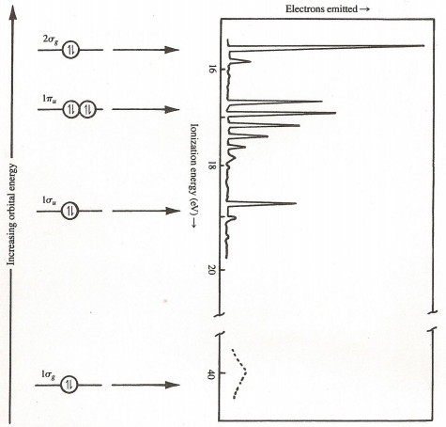

N2 PES is borrowed with permission from ***CHEMICAL STRUCTURE AND BONDING*,** by Roger L. DeKock and Harry B. Gray, copyright University Science Books, all rights reserved, Figure 4-31, pg 239.

2.a. Analyze carbon monoxide in a similar fashion by generating the Lewis structure and two MO diagrams, one without sp mixing, one with sp mixing. The orbital potential energies of the carbon 2s and 2p are -19.4 eV and -10.7 eV, respectively, and -32.4 eV and -15.9 eV for the 2s and 2p orbitals of the oxygen. Then evaluating the provided PES. (Hint: Three peak regions are observed in the PES. Align the lowest energy peak to the HOMO. Anticipate no evidence of fine structure from the 2σ.)

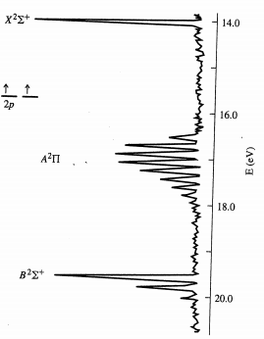

Copyright by Pearson; used with permission. Figure is adapted from ***Inorganic Chemistry***, 5th ed, Gary L. Miessler, Paul J. Fischer, and Donald A. Tarr, Figure 5.13, page 135.

b. Which MO diagram is consistent with the Lewis Dot structure of CO with regards to predicted bond order? Based on the PES bands, circle the molecular orbitals in the MO diagrams you would predict the lone pairs of electrons to reside. Based on the comparison to your Lewis structure and the PES, does CO exhibit sp-mixing?