Organometallic Precursor in [FeFe] Hydrogenase H-Cluster Bioassembly
In Fall 2022, R. David Britt was awarded the ACS Alfred Bader Award in Bioinorganic Chemistry for pioneering pulse electron paramagnetic resonance (EPR) spectroscopy of the photosystem II oxygen-evolving complex, plus the advanced EPR spectroscopic characterization of numerous and varied key metalloenzymes and catalysts.
In this assignment you will learn about his work to uncover the bioassembly of the H-cluster of the enzyme [FeFe] Hydrogenase by reading the paper “A [4Fe–4S]-Fe(CO)(CN)-l-cysteine intermediate is the first organometallic precursor in [FeFe] hydrogenase H-cluster bioassembly,” Nat. Chem. 2018, 10, 555-560 (https://www.nature.com/articles/s41557-018-0026-7)
- Where does Prof. Britt work and what is his educational background?

- This paper investigates the bioassembly of an iron-containing cofactor known as the H-cluster that is the site of catalysis in an enzyme known as [FeFe] hydrogenase. What reaction do [FeFe] hydrogenases catalyze and why are [FeFe] hydrogenases of interest to scientists? Include a chemical equation as part of your answer.

- The H-cluster is a highly unusual organometallic cofactor. Draw the structure of the H-cluster below, which can be found in Figure 2a. Why is the H-cluster an “organometallic” cofactor?

- This paper specifically focuses on one step in the bioassembly process carried out by an enzyme called HydG and uses spectroscopic evidence to demonstrate for the first time that HydG forms the organometallic precursor known as Complex A, shown in Figure 2c. The following questions focus on the “dangler” Fe (the Fe not in the [4Fe-4S] cube) of Complex A.

  - The “dangler” iron is in the 2+ oxidation state. What is the d-electron count for Fe²⁺?

  - Based on Figure 2c in the paper, what is the geometry of the dangler iron?

  - Given the electron count and geometry for the Fe²⁺, draw d-orbital splitting diagrams showing both low-spin and high-spin electron configurations.

  - Using your splitting diagrams, determine the number of unpaired electrons and the total spin (S) for each configuration.

  - In Figure 2c, the HydG auxillary cluster has H₂O coordinated to the dangler Fe, while Complex A has CO and CN. Assign the Fe²⁺ in each form as high spin or low spin and explain your reasoning based on your knowledge of the spectrochemical series. Do your answers agree with the assignments in the paper?

- The “dangler” iron atom is attached through a cysteine amino acid to a [4Fe-4S]⁺ cluster, which has the cubic structure shown at right. In these systems, the iron atoms are typically high spin.
- Write the number of unpaired electrons expected for each iron next to the atoms in the structure.

- The overall spin state for [4Fe-4S]⁺ is S = ½, meaning that there is formally only one unpaired electron. This occurs because the electrons in the structure are antiferromagnetically coupled. Define “antiferromagnetic coupling”, and then propose an explanation for the observed overall spin state of the cluster.

- The net one (1) unpaired electron spin in the above example for a [4Fe-4S]⁺ can further exchange-couple through the cysteine bridge to any unpaired electrons on the “dangler” iron. Using your answer from 4(c), what are the resultant total spins you calculate for the following five-iron systems?

Ferromagnetic coupling between the [4Fe-4S]⁺ and the high-spin dangler:

Antiferromagnetic coupling between the [4Fe-4S]⁺ and the high-spin dangler:

Coupling between the [4Fe-4S]⁺ and the low-spin dangler:

- The primary technique used in this paper is electron paramagnetic resonance (EPR) spectroscopy, which reports on the number and coordination environment of unpaired electrons in a sample. Similar to other spectroscopies like IR and NMR, the shape of the spectrum and position of peaks is like a fingerprint of the unpaired electrons. In Figure 2 of the paper, the authors present a deconvolution of all the S = 1/2 detected. What are the three signals assigned to?

- The hyperfine interaction (A) describes the strength of communication between the magnetic dipole of the total electron spin S (blue arrow), and the magnetic dipole of any magnetic nuclei I (black arrow). The closer the magnetic nucleus is to atoms that carry unpaired electrons, the stronger the hyperfine interaction is. There are also “through-bond” contributions to the magnitude of the hyperfine interaction analogous to the “through-bond” interactions that lead to the splitting of peaks (J-couplings) in liquid NMR spectra ascribed to nearby magnetic nuclei.
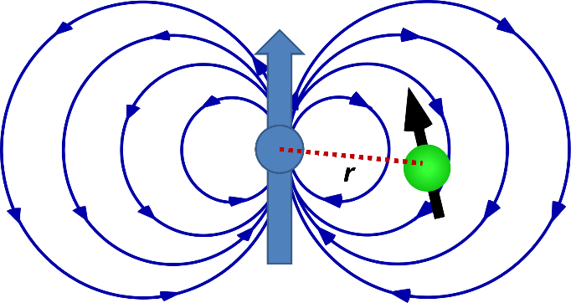
  - The strength of the hyperfine interaction can be measured in several ways using variations of an EPR experiment. Name the two methods employed in this study.

  - When Complex A is formed, the “dangler” iron assumes a low-spin electron configuration and now all the surrounding magnetic nuclei are bound to an ion that possesses no unpaired electron spin of its own. Thus, there should be no hyperfine interaction. However, the nearby [4Fe–4S]⁺, which still has unpaired electrons, is close enough to cause the hyperfine interactions that are detected in Figures 3 and 4. Why is the hyperfine coupling observed for the beta-carbon on cysteine stronger than those observed for the carbons of the CO and CN ligands to the dangler iron of Complex A?

- “Isotope control” is a term used to describe the ability to install magnetic isotopes of elements into molecules (proteins) in specific places. This lets you then measure the strength of the hyperfine interaction between these magnetic nuclei and the unpaired electron spin. We are limited where these probes can be installed by chemistry and the natural abundance of the magnetic isotope.

  - For the hyperfine interactions analyzed in this study, list the magnetic isotopes, their nuclear spins (I), and their corresponding natural abundance. Use the website https://webelements.com/iron/isotopes.html to help.

  - ¹⁴N is also a magnetic isotope (I = 1) of nitrogen and 99.6 % abundant. Why didn’t the authors use ¹⁴N instead of the rarer ¹⁵N?

