Preparation of a Ferrofluid

This laboratory is based (with minor adaptation) on an experiment developed by Patricia Berger and coworkers, and published in the Journal of Chemical Education in 1999.¹

Introduction
A colloid is formed by suspension of particles in a liquid. If the particles are small enough, they do not settle out of the liquid, and a stable colloid is formed. Homogenized milk is an example of a colloidal suspension – insoluble fat is broken up into very small particles that scatter light, making the milk appear white. If the fat particles are large enough to agglomerate, then the cream will separate out from the water-rich whey, as occurs in non-homogenized milk.
A ferrofluid is a colloid made up of small magnetic particles suspended in a solution. Of course, the magnetic particles will be attracted to each other. In order to prevent agglomeration, the particles must be very tiny (about 10 nm in diameter) so that motion due to thermal energy is large enough to disrupt any attractive forces between particles, and also large enough to overcome the force of gravity, which would otherwise cause the particles to precipitate.1
Ferrofluids were first developed by NASA for use in space. The magnetic properties of the liquid make it easy to control remotely using magnetic fields. Ferrofluids have since found many technological applications and are used in speakers, hard drives and medical devices. Oil-based ferrofluids can be used as seals and lubricants in heavy machinery, and other uses are also being explored. These include use as magnetic inks, and as a vehicle for targeted drug delivery.1
The magnetic particles in a ferrofluid are generally made up of a crystal called magnetite, which has a formula Fe₃O₄. The structure of a magnetite crystal is called the inverse spinel structure. The spinels are a group of minerals that share a particular arrangement of atoms within the unit cell. The crystal structure for magnetite is shown in figure 1, below:
Figure 1. Inverse spinel structure of magnetite. Red indicates oxygen atoms, blue Fe(I), and green Fe (II) atoms. (ref 2)

The iron ions in magnetite can be found in two different coordination geometries (fig 2). Electron spins for the Fe³⁺ ions that occupy octahedral positions cancel the spins for Fe³⁺ ions in tetrahedral positions, so there is no net magnetization of the crystal structure from the Fe³⁺ ions. The Fe²⁺ ions have electron spins that align with those of the octahedral Fe³⁺ ions. These spins are not cancelled out by electrons aligned in the opposite direction, and so the iron (II) ions lead to a magnetic field in the crystal.
Figure 2. Iron ions occur in two different environments within the unit cell. Octahedral (purple) and tetrahedral (blue) coordination sites are highlighted for clarity.

During this experiment, you will crystallize magnetite in the inverse spinel structure to obtain magnetic nanoparticles. The particle size is very important, as larger particles will tend to agglomerate rather than remaining in suspension. You will also use a surfactant, tetramethylammonium hydroxide, to coat the particles and prevent them from sticking together.
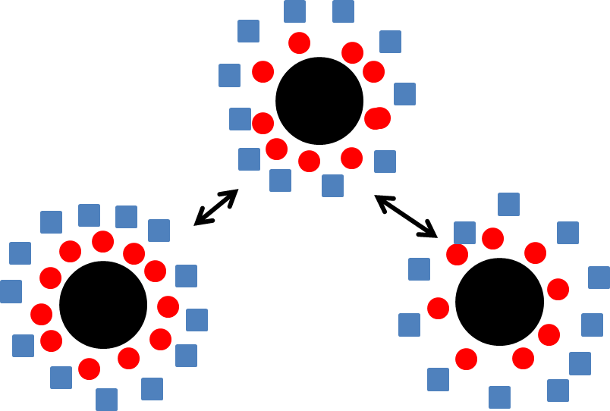

Tetramethyl ammonium cation
Hydroxide anion
Magnetite particles
Figure 3. Surfactant-coated magnetite particles. Negatively charged hydroxide groups surround the magnetite particles, and attract a layer of positively charged tetramethylammonium groups. The similarly charged tetramethyl ammonium groups repel one another, preventing agglomeration of particles in solution. Figure adapted from reference 1.

The magnetite particles will be synthesized by mixing iron (II) and iron (III) ions with ammonia in
the presence of water, to form the iron oxide:

2 FeCl₃ + FeCl₂ + 8 NH₃ + 4 H₂O Fe₃O₄ + 8 NH₄Cl

The size of the magnetite particles formed is controlled by the rate of addition of the various reagents to the reaction.

In addition to testing the magnetic properties of your ferrofluid, you will also use powder x-ray diffraction to determine the particle size that you obtained in your experiment. This can be done by comparing the peak widths for a bulk sample (large particles) with your ferrofluid (nanoparticles). The Scherrer equation shows the relationship between particle size and the peak width at half height for a powder x-ray diffraction peak.

t = (0.9 λ)/(B cos θ_{B})

where t is the diameter of the particle, λ is the x-ray wavelength (1.5418 Å , for our instrument, which uses a CuKα tube to generate x-rays). For our experiment, we will use the peak at 2θ = 35.6°. θ_{B} is the peak location for the bulk material, given in radians. B is the peak broadening, and is given in radians:

$B^{2}=B_{colloid}^{ 2}-B_{bulk}^{2}$

The peak width should be measured at half height for both substances, and the broadening can be calculated from the difference in peak width for the two samples. A sample PXRD pattern is shown in figure 4, below:
2-theta (degrees)
Relative intensity
Figure 4. PXRD pattern of bulk magnetite. Each peak represents a particular spacing of atoms in the crystal structure. Peak at 38.6 is caused by an aluminum sample holder.

Safety:
General Precautions:
Many of the chemicals used in this experiment are toxic and/or corrosive. Ferrofluids are very difficult to remove from fabric and other surfaces. Contact with skin and clothing should be minimized by wearing a lab coat, gloves, and goggles at all times. All reactions and measurement of liquids should be carried out in the hood. If any chemicals come in contact with your skin during an experiment, they should be washed off with water immediately. All chemicals must be disposed of in the appropriate (labeled) waste containers provided in the lab.

Specific hazards:
Hydrochloric acid is a strong acid and is corrosive. We will be combining acids and bases in this experiment; the reaction should be carried out slowly to prevent overheating of glassware. Iron (II) chloride and Iron (III) chloride are both corrosive, and iron (II) chloride is toxic and a mutagen also. The surfactant tetramethylammonium hydroxide is a strong base that is both corrosive and flammable, and is readily absorbed through the skin. It is also toxic to aquatic life, so disposal down the sink should be carefully avoided.

Experiment
1) Using a volumetric pipet, measure 1 mL of stock solution containing 2M FeCl₂ in 2M HCl into a 125 mL Erlenmeyer flask.
2) With a different volumetric pipet, measure out 4 mL of 1M FeCl₃ in 2M HCl into the same Erlenmeyer flask.
Note: The stoichiometric ratio of the two iron compounds is important in determining the quality of your ferrofluid, so it is important to measure these volumes carefully and to note any deviations from the given values.
3) Add a magnetic stir bar to the flask.
4) Place a 50 mL buret in a buret holder that is attached to a ring stand inside the hood. Verify that the stopcock is closed. Position the buret above the stir plate, so that you will be able to use the magnetic stirrer while adding ammonia dropwise.
5) Fill the buret to the 50 mL line with 0.7 M aqueous ammonia.
6) Place an empty flask under the buret tip, and open the stopcock to fill the tip. Discard any extra fluid that ends up in the flask.
7) Re-fill the buret to the 50 mL line, and place the flask containing your iron chloride solutions under the buret tip.
8) Turn on the magnetic stirrer and increase the speed to get vigorous stirring.
9) With your iron chloride solution stirring, slowly open the buret stopcock and add ammonia at a rate of 1mL/3 seconds. Record the time at which you start and finish adding ammonia.
10) Allow the solution to stir for an additional 5 minutes.
11) Turn off the stirrer and allow the solution to settle for 5-10 minutes. It should separate into a clear liquid on top and a black sludge on the bottom. If this occurs, decant off and dispose of the clear liquid, keeping the black sludge for the next step. If your solution does not separate nicely, proceed directly to step 14. If your solution is not clear, discuss with your lab instructor.
12) Transfer the solution to labeled centrifuge tubes using a disposable plastic pipet. Divide equally among tubes if it is necessary to use more than one. Centrifuge for 1 min at 1000 rpm.
13) Decant the supernatant liquid. The remaining black sludge is your sample of magnetite.
14) Measure out 8 mL of 25% tetramethylammonium hydroxide surfactant in a 10-mL graduated cylinder. Divide this solution evenly among your centrifuge tubes from the previous step. (The amounts don’t have to be exact, as you will mix all of the tubes together in the next part of the procedure, but mixing the surfactant in smaller batches helps it to disperse evenly.)
15) Stir each tube with a glass stirring rod until the solid is completely suspended.
16) Add a stir bar to a 250 mL vacuum flask, and then pour in the contents of the centrifuge tubes from the previous step.
17) Set up a vacuum trap, as shown in figure 5 below (you will need a 500 mL vacuum flask to fit a two-holed stopper):
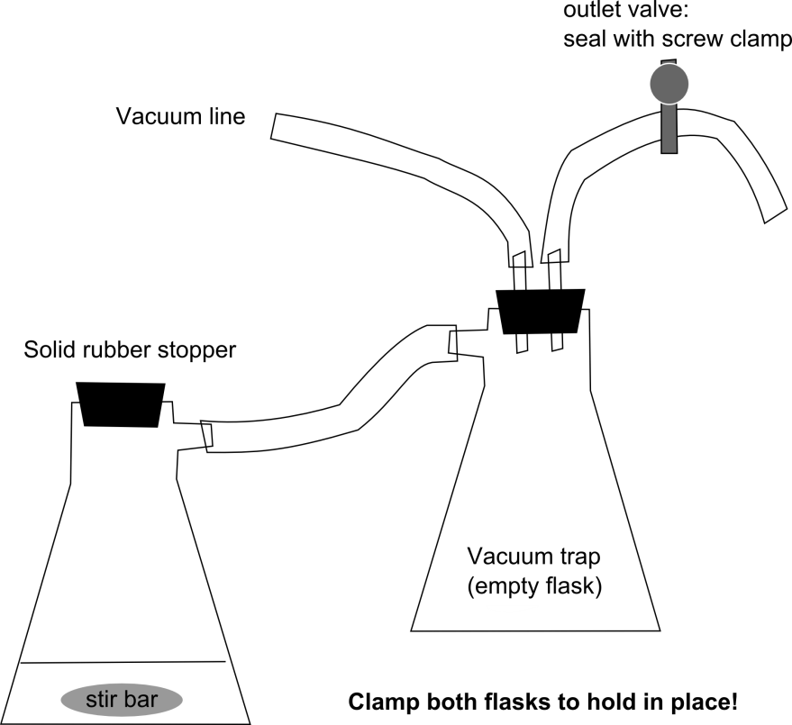
Figure 5. Vacuum trap setup for removing ammonia from solution

17) Use black vacuum tubing to connect the two flasks, and to connect the trap flask to the vacuum line. If there is not enough black rubber tubing, you can use amber latex tubing for the outlet valve.
18) Turn on the stir bar, then open the vacuum line on the hood. Clamp the outlet valve closed using a screw clamp, and place a rubber stopper in the opening of your sample flask. Connect the rubber hose on the vacuum trap sidearm to the sidearm of your sample flask.
19) Stir under vacuum for 30 minutes to remove the ammonia from your solution.
20) When finished, disconnect your sample flask from the vacuum setup by reversing the steps above.
21) Slowly pour off any clear liquid that separates from your magnetite sample, and then transfer your magnetite sample and the magnetic stir bar to a plastic weigh boat.
22) Obtain a strong bar magnet (preferably a neodymium-iron-boron magnet), and slowly bring it up to the bottom of the plastic weigh boat. Be careful never to allow the ferrofluid to get onto the strong magnet or splash on your clothes! The magnet should be kept inside its plastic bag, to keep it from getting contaminated by stray ferrofluid. Remember that the ferrofluid and the stir bar will be attracted to the large magnet, so be careful to have a good grip on the weigh boat as you bring the magnet close, so that it doesn’t pull out of your hand.
23) Using a gloved hand, stand the magnetic stir bar up on its end so that the ferrofluid flows off of it toward the stronger bar magnet.
24) Grasp the stir bar firmly, and pull it away from the ferrofluid. Be careful that the stir bar doesn’t slip from your grip and splash back down into the ferrofluid! If necessary, clean off the other end of the stir bar by touching it to the ferrofluid and then pulling it out of the liquid.
25) Keep the strong magnet beneath the plastic weigh boat, and carefully pour off any excess water. (The magnetite will be attracted to the magnet and should not pour off.)
26) Carefully remove the strong bar magnet from the bottom of the weigh boat, being careful not to allow the ferrofluid to get onto the magnet.
27) Hold a cow magnet up to the bottom of the weigh boat to see if your ferrofluid develops spikes along the magnetic field lines. If it does not, it is possible that the ferrofluid is too concentrated; add one drop of distilled water and mix by moving the magnet under the ferrofluid. Adding more than a few drops of water will dilute the ferrofluid too much to show spiking. If this happens, use the strong bar magnet to hold the magnetite particles in place and pour off the excess water as you did in step 25 above.
28) Ask your instructor or TA for help in preparing a sample for x-ray analysis.
29) While your x-ray sample runs, experiment to understand how your ferrofluid behaves in the presence of the different magnets. Try orienting the magnets in different directions, and record what happens to your ferrofluid.
30) Examine the starting solids FeCl₃ and FeCl₂, provided in small glass vials, and record how they respond to the magnets.
31) Use your x-ray data to calculate the size of your particles.

Post-Lab Questions
1) Why is a surfactant used in making your ferrofluid?
2) Describe how your ferrofluid responds to the magnets, and compare this to the behavior of the iron chloride salts. What can you conclude about the pairing of electrons in the different crystal structures?
3) Why do you think that the surfactant hydroxide ions bind to the surface of your magnetite particles? Explain your hypothesis. (Hint: it may be helpful to look at the crystal structure for magnetite).

Berger, P.; Adelman, N.; Beckman, K.; Campbell, D.; Ellis, A.; Lisensky, G. Preparation and Properties of an Aqueous Ferrofluid. J. Chem. Educ. 1999, 76 (7), 943-48.
Images created using Crystal Maker software and a .cif file from the Crystallography Open Database. Original data: Haavik, C.; Stolen, S.; Fjellvag, H.; Hanfland, M.; Hausermann, D. Equation of state of magnetite and its high-pressure modification: Thermodynamics of the Fe-O system at high pressure Sample at P = 6.6 GPa. American Mineralogist, 2000, 85, 514-523
Rayner-Canham, G.; Overton, T. Descriptive Inorganic Chemistry, 6th ed. W.H. Freeman, 2014, pp 97.

