**Zeolite Synthesis**

**Introduction[1],[2]**

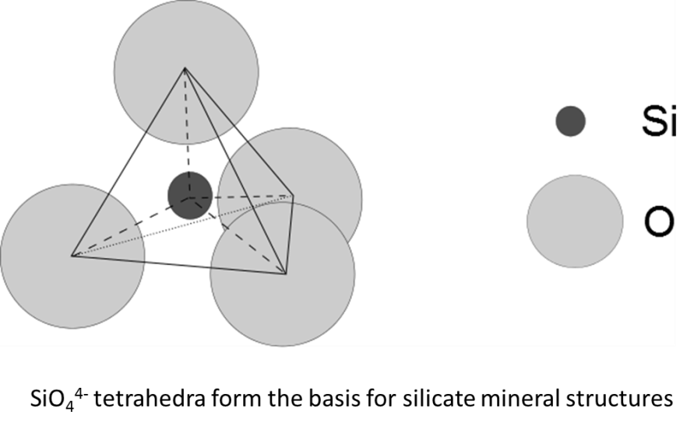Silicate minerals make up a majority (more than 90%) of the earth’s crust, and approximately 30% of all classified mineral structures. This incredibly diverse group of minerals is based on a basic bonding unit composed of silicon bound to oxygen to form a tetrahedral SiO44-ion.

The simplest silicate is the SiO2 (silica) structure, where each oxygen at the corner of a tetrahedron is shared with two silicon atoms, giving the compound an overall ratio of 1Si : 2O. When a single oxygen atom participates in two or more tetrahedra, this creates chains, sheets, or other complicated 3-D structures of interlinked silicate ions. The silicate minerals are formed by reaction of acidic silica with basic metal oxides, and are classified according to the arrangement of silicon tetrahedra within the resulting crystal structures.

It is possible for other metals to substitute for the silicon atom in some of the silicate tetrahedra. One common substitution is that of Al3+ for Si4+. The ionic radii of these two metals are similar (67 and 54 pm, respectively), so the aluminum is able to fit into the space that is usually occupied by the Si atom. However, the charges on the two metals are different. In order to balance the charge on the oxygen atoms, it is necessary to include a second cation with a +1 charge in the crystal structure. The resulting crystal structure has holes in it to leave room for the extra ion. Because of their open structure, these minerals are called *framework aluminosilicates*.

Zeolites are a group of framework aluminosilicates defined by a particular stoichiometric ratio: there must be two oxygen atoms for each metal in the structure, and the number of silicon atoms must be greater than or equal to the number of Al atoms. This can be summarized in the formula [AlxSiyO2x+2y]x- where x ≤ y. The residual charge (x-) is balanced out by incorporation of an additional cation (K+, Ca2+, etc.). A complicated network of pores and channels develops in the crystal structure, depending on how the aluminosilicate tetrahedra are arranged to accommodate these additional cations. The size of these cavities can be tuned by adjusting the size and charge of the cations used.

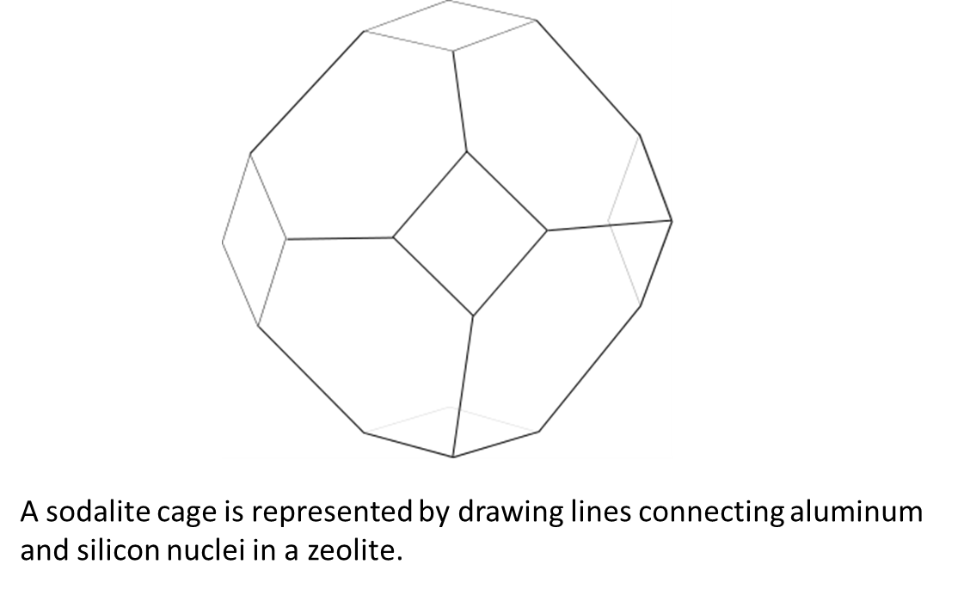The structures of zeolites are often quite complex, and for simplicity are usually represented by drawing lines to connect the aluminum and silicon atoms within the crystal structure. The shape that results is called a “sodalite cage,” shown below. Sodalite cage structures can be arranged in various ways to arrive at an overall zeolite structure, as you will observe in the pre-lab exercise. When packed into a crystal structure, the sodalite cages cannot completely fill space, and so leave open pores and channels that are responsible for many of the important properties of zeolites.

Zeolites have a number of practical applications. The metal cations are often hydrated (bound to water molecules), but the water of hydration can easily be removed by heating, which causes the water molecules to migrate out through the pores in the framework structure. These dried zeolites can then be used as molecular sieves to dry organic solvents. (In fact, the water absorption capacity of zeolites is so good that their primary non-industrial use is in non-clumping cat litter.) By adjusting the pore size, it is possible to adsorb molecules other than water from a liquid. The tunability of the pores allows zeolites to be useful for very precisely separating out small molecules from solution.

The high concentration of charge on the surface of zeolite pores causes them to bind more strongly to some gases than others, and allows them to be used for separation and sequestration of particular gases. This same highly charged surface environment makes them useful for treating “hard” water. Water that is high in calcium ions deposits an undesirable scum in sinks and pipes, and can interfere with detergents. When water containing Ca2+ ions is run through a zeolite filter that contains hydrated Na+ ions, some of the Na+ ions will be displaced, and the unwanted Ca2+ ions will be trapped. The hydrated metal cations in a zeolite can be exchanged relatively easily, and the negatively charged aluminosilicate surface then adsorbs the calcium, softening the water. When the zeolite surface is saturated with Ca2+ ions, a concentrated NaCl solution can be run through the filter to wash out the Ca2+ and regenerate its filtering capacity.

The most industrially important use of zeolites is as reaction catalysts. The metal cations in the crystal structure can be exchanged for H+ instead. When heated, these substituted zeolites dehydrate to form water, leaving behind a positively charged silicon atom. This process creates extremely strong Lewis acids, which are useful for initiating reactions. The size and shape of the zeolite pores also provides selectivity and some conformational control over reaction products. Such catalysts are widely used in the oil and gas industry. The spent solid zeolites can be easily filtered from the reaction products and regenerated, so use of these solid acids is generally more environmentally friendly than reactions that use concentrated sulfuric acid.

In this laboratory experiment, you will synthesize an “Na-Y” zeolite following the procedure presented in the paper:

Blatter, F. Schumacher, E. The Preparation of Pure Zeolite NaY and its Conversion to High-Silica Faujasite. *J. Chem. Educ*. 67(6) **1990**, 519-521.

The “Na” in the name refers to the sodium cation used to balance the charge on the aluminosilicate structure. The “Y” part of the name identifies the particular structure of the zeolite that you will synthesize.

The structure that you will make is a zeolite in the faujasite group. The faujasites have a series of sodalite cages connected through hexagonal prisms. This group of zeolites is divided into “X” and “Y” subgroups, depending on the ratio of silicon and aluminum in the structure. The X zeolites have a Si : Al ratio between 2 and 3, and for Y zeolites it is 3 or higher.

**Experiment**

*Note:* The procedure for this experiment is based on the syntheses reported in references 3 and 4.[3],[4]

**Safety:**

*Specific Hazards:*

Sodium hydroxide is a highly basic, corrosive solid. Care should be taken to avoid breathing aluminum and silicon dioxide dust when weighing out solids. Highly flammable hydrogen gas is evolved when aluminum metal is mixed with strong base, so this reaction should never be carried out in the presence of flames. Mixing sodium hydroxide with aluminum or silicon dioxide can create a vigorous reaction and should only be carried out in the hood.

***Zeolite synthesis:***

1) Working in the hood, dissolve 15.0 g of sodium hydroxide pellets in 15 mL of distilled water in a 50 mL glass beaker. Heat gently if necessary to completely dissolve solids.

2) Add a stir bar to the solution, and add 1.34 g of aluminum powder a bit at a time while stirring vigorously. Continue to stir and heat gently for approximately 15 minutes after the aluminum is fully added to the solution. (The aluminum solution can be placed to the side on the same hotplate that you use to prepare the silicate solution below.)

**Note**: This is a strongly exothermic reaction, and will also produce flammable hydrogen gas. This reaction should only be carried out in the hood, and away from flames.

3) While the aluminum solution is stirring, dissolve 2.40 g of sodium hydroxide in 6 mL of distilled water in a second 50 mL beaker.

4) Heat the beaker on the hotplate to just below boiling. ***Slowly*** add 3.0 g of silica gel powder to the solution, while stirring vigorously with a magnetic stir bar. Be sure to add the powder a little bit at a time to avoid clumping.

5) Cool both solutions to room temperature. The solutions may form a thick, gel-like substance.

6) Mix the two solutions in a 200 mL beaker, and add 21 mL of distilled water, stirring until the mixture is homogeneous. Quickly transfer the solution to a polypropylene wash bottle, and seal the cap.

7) Place your reaction mixture in an oven at 90°C, and hold for 2.5 hours. The temperature is a critical part of this experiment, so record the oven temperature at the beginning and end of your holding time, and be sure to work with your classmates to minimize the number of times the oven door is opened and closed!

8) At the end of the 2.5 hour incubation period, remove your reaction bottle from the oven and fill it to the top with distilled water.

9) Filter your reaction using a plastic Buchner funnel

10) Transfer the filter paper from your reaction to a plastic petri dish. Label the petri dish with your name and the date, and submit it to your instructor. We will analyze the reaction products by x-ray diffraction in a later lab period, and may use your synthesized zeolites to catalyze a reaction later in the semester.

***Growing a chemical garden:***

While your zeolite mixture is growing, perform the following steps to grow a “chemical garden.” The reaction of silicon dioxide with sodium hydroxide produces sodium silicate solution, also called “water glass.” A chemical garden forms when a metal salt reacts with sodium silicate to form a silicaceous precipitate. This is an interesting reaction to observe, and is also similar to chemical processes that deposit minerals around deep sea vents.

1) Dissolve 4.0 g of sodium hydroxide in 10 mL distilled water in a 50 mL beaker.

2) While stirring vigorously, slowly add 6.0 g of silica gel powder. Heat to just below boiling until the silica gel dissolves. (If it does not dissolve, discuss with your lab instructor.)

3) Remove the beaker from the hot plate, and cool to room temperature.

4) Carefully pour the sodium silicate solution into a glass jar and add 110 mL of distilled water. Stir to mix fully.

5) A selection of metal salts has been placed in the laboratory for your use. Many of these salts are older bottles, and have large chunks of material in them. Select a medium-sized chunk of one of the salts, and drop it into your solution. Be sure to make careful observations in your notebook for each salt that you try.

6) One by one, add chunks of a variety of different salts to make a “garden.” Try to make sure that the chunks fall close enough to one another that they will form a network of solids that won’t fall over when you rinse the crystals in step 7, below.

7) When your garden has stopped growing, carefully pour or pipet the sodium silicate solution into an appropriate waste container and replace it with water. Be careful, as your garden is very fragile! Wash the crystals in your garden until the water remains clear.

**Lab report:**

We will analyze your zeolite structures (and the success of the experiment) more fully later. For now, your lab report should focus on discussing the reaction that you carried out in lab. Clearly identify any problems that you encountered in the synthesis, and suggest possible solutions.

Also, propose an explanation for what’s happening in your chemical garden, including example chemical formulas (you may search online for help with this, but should make sure that you understand what’s going on, and must write the explanation in your own words).

**Post-Lab Questions**

1) Many published procedures warn against using glassware in the zeolite synthesis. Why might this be an important consideration? What factors would reduce its importance, and what considerations might cause you to use glassware anyway, even if Nalgene (a plastic) is perhaps a better choice?

2) Why do you think it is important to put your reaction mixture in a sealed bottle before heating for 3 hours at 90°C?

3) Silica gel is an extremely fine powder with a carefully controlled particle size. How might your results change if you used a coarser silicon dioxide powder in your experiment?

4) What would happen to your reaction if you used sand, or oil shale (a rock) instead of silica gel? What additional factors would you need to consider if you wanted to use this reaction to extract silica from rocks?

5) Write chemical formulas for the formation of sodium silicate solution, the reaction of aluminum metal with sodium hydroxide, and for at least 2 of the precipitates formed in your chemical garden. (Note: your textbook should be helpful with this!)

1. Rayner-Canham, G.; Overton, T. Descriptive Inorganic Chemistry, 6th ed. W.H. Freeman, 2014, pp 360-366.
2. Wulfsberg, G. Inorganic Chemistry, University Science Books, 2000, pp 708-711.
3. Blatter, F., Schumacher, E. The Preparation of Pure Zeolite NAY and its Conversion to High-Silica Faujasite. J. Chem. Educ. 1990, 67(6) 519-520.
4. Balkus, K.; Ly, K. The Preparation and Characterization of an X-type Zeolite. J. Chem. Educ. 1991, 68(10) 875-877.