Additive Color Chart (Light Emission) | Subtractive Color Chart (Light Absorption)
B  C  M  W  R  Y  G | 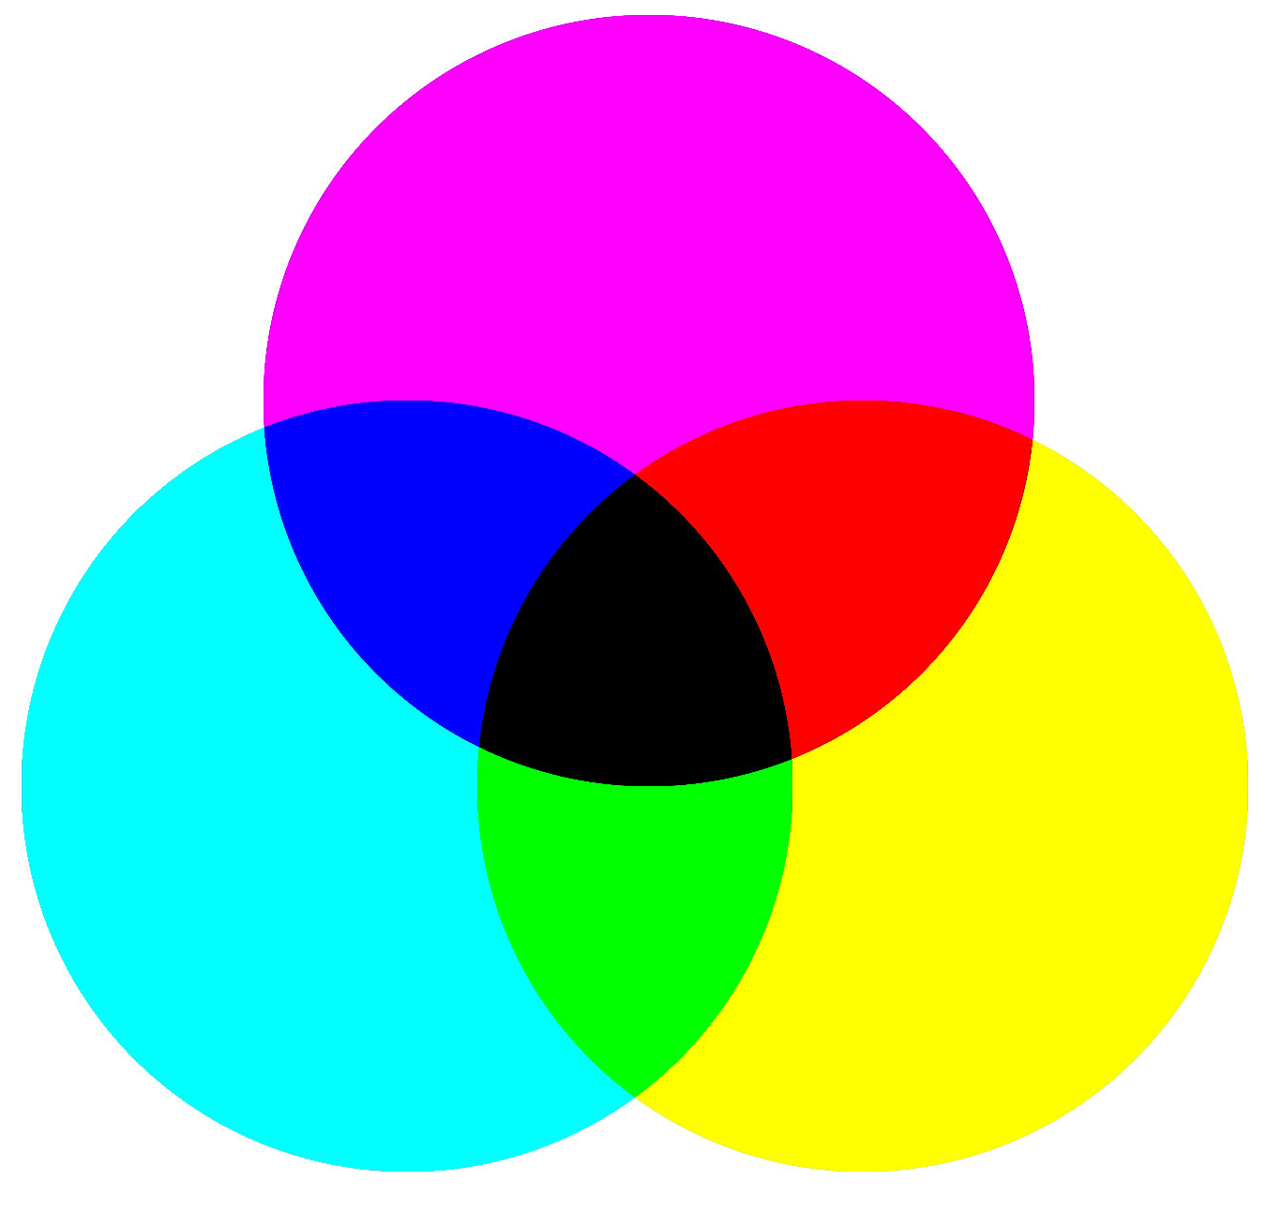  Y  R  G  BlklK  B  C  M

Red |  | R = 255  G = 0  B = 0
Orange |  | R = 255  G = 128  B = 0
Yellow |  | R = 255  G = 255  B = 0
Green |  | R = 0  G = 255  B = 0
Blue |  | R = 0  G = 0  B = 255
Purple |  | R = 128  G = 0  B = 128
Magenta |  | R = 255  G = 0  B = 255
Cyan |  | R = 0  G = 255  B = 255
Brown |  | R = 153  G = 102  B = 51
White |  | R = 255  G = 255  B = 255
Grey |  | R = 128  G = 128  B = 128
Black |  | R = 0  G = 0  B = 0

