Deciphering Mechanisms of Organometallic Reactions
Given the following scheme from“Mechanism for the Activation of Carbon Monoxide via Oxorhenium Complexes” by Smeltz, Boyle, and Ison; J. Am. Chem. Soc. 2011, 133, 13288-13291; answer the following questions.

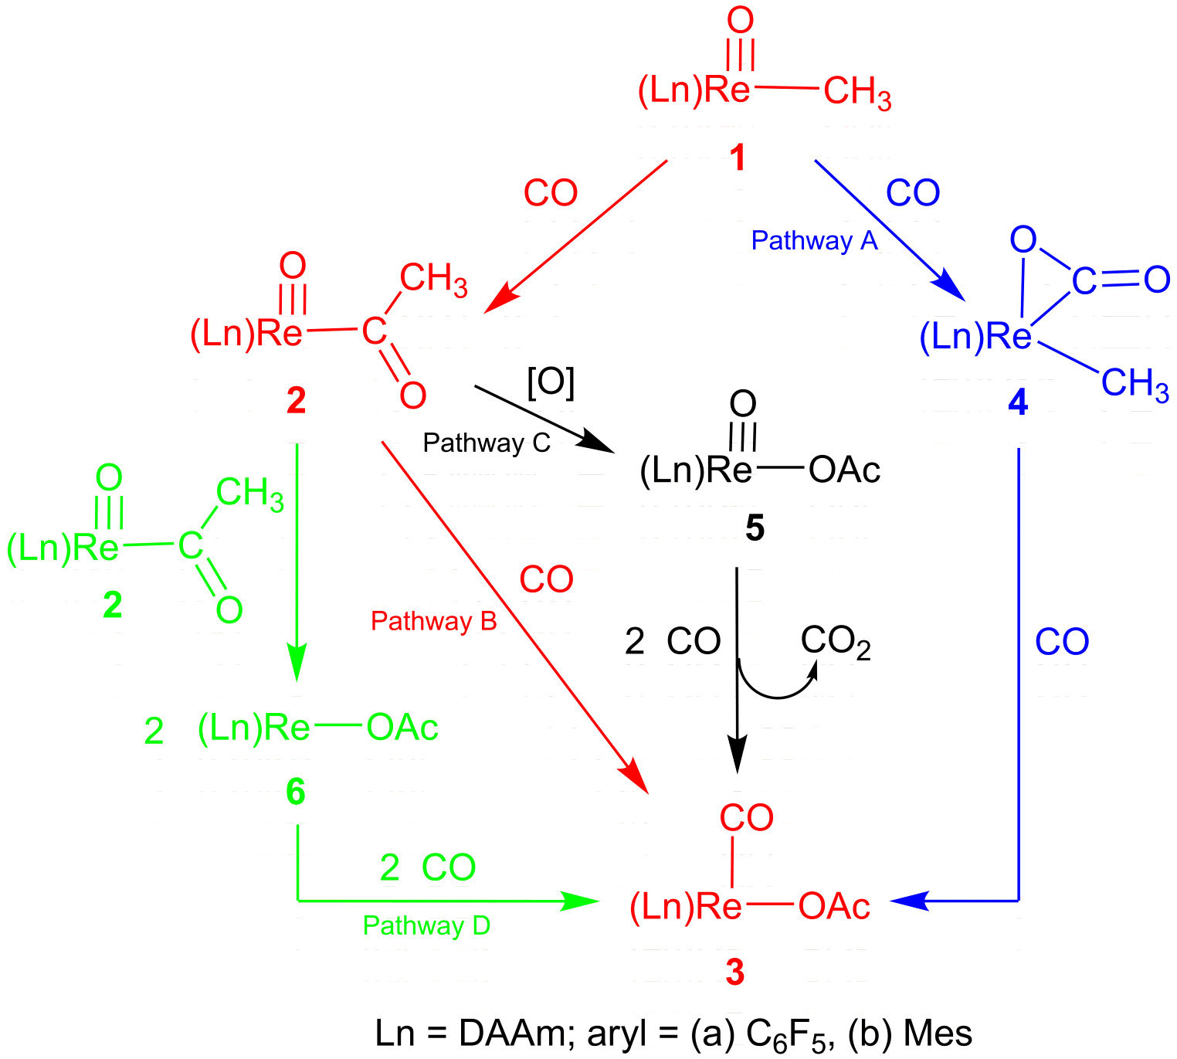

Question 1: Give d^{n} electron count, the oxidation state of rhenium, and overall electron count for compounds 1 through 6.
 | Complex 1 | Complex 2 | Complex 3 | Complex 4 | Complex 5 | Complex 6
Oxidation state of rhenium in the complex
d^{n} count for rhenium in the complex
Overall electron count for the complex

Some of the complexes seem to have very low overall electron counts (< 16 electrons). Are there any ligands that may contribute more than their “standard” number of electrons?

Question 2: Give the type of fundamental reaction for each step in each of the four pathways.
Pathway A:

Pathway B:

Pathway C:

Pathway D:

Question 3: Which pathway would you expect to be most likely? Why? How could you rule out some of the other pathways?

