Demonstration to Segue Between d d and CT Transitions

The following is a simple in class “demonstration” that I use to segue between d d and charge transfer transitions. After teaching about d d transitions and Tanabe-Sugano Diagrams (if you do that), I show my students three solutions that I have put in large test tubes of the same diameter before class. The three solutions I place in the test tubes are:
a. 10 ml of 0.1M Co(H₂O)₆²⁺
b. 10 ml of 0.1M Cu(H₂O)₆²⁺
c. 10 ml of a freshly prepared 0.1 M KMnO₄ solution

You could also use a solution of 0.1 M Ni(H₂O)₆²⁺ in place of a or b (or include it to give a fourth solution). I typically find what I can in our stockroom and dilute it as needed for this demonstration. I almost always need to prepare a fresh solution of KMnO₄ because the solution does not keep well unless stored in the dark.

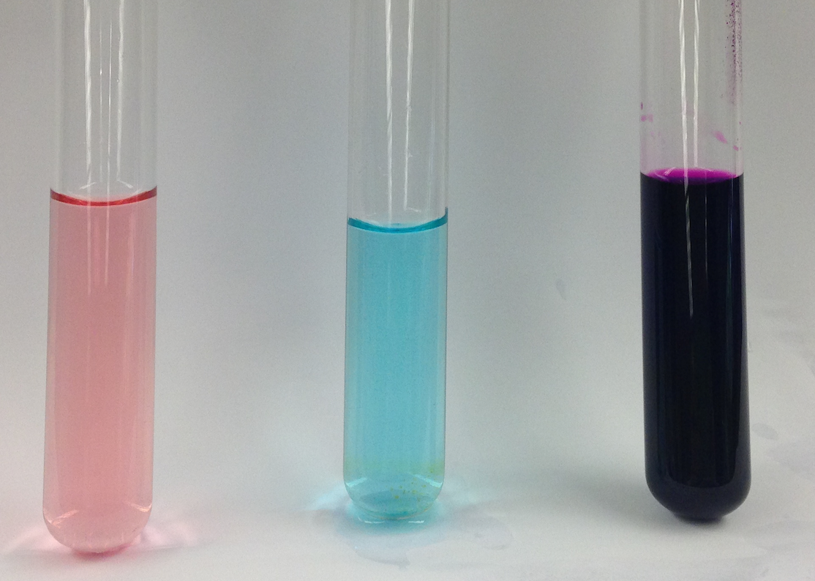

Figure 1: From left to right: ~0.1M Co(H₂O)₆²⁺, ~0.1M Cu(H₂O)₆²⁺, and ~0.1M KMnO₄,

I begin by asking the students to determine the metal oxidation state and d electron count for each complex. I ask them to designate the metal centers as high or low spin if relevant and then to propose the maximum number of d d transitions they might see in the visible spectrum.

We then move to a discussion of the optical spectrum of the 0.1M KMnO₄ solution. See the attached Faculty Only File or any one of a number of texts in inorganic chemistry.

