**Viper Learning Object: In-Class Activity**

**Distinguishing Between Metal Catalysts for Inner- and Outer-Sphere C-H Bond Functionalization**

**By David R. Weinberg of Colorado Mesa University**

**In-Class Discussion:**

**On the following page are a variety of C-H bond functionalization catalysts. The catalysts are all in a state where they could react with a C-H bond (ligand substitution for the C-H bond may be required). In groups of 3 or 4, discuss the following:**

**A) Whether you expect the catalyst to undergo one- or two-electron chemistry based on the metal’s available oxidation states**

**B) What types of reactions, if any, the ligands are likely to undergo**

**C) Whether or not there are any sites available for the metal to coordinate a C-H bond**

**D) Based on your assessment of A – C, determine whether the catalyst performs inner- or outer-sphere C-H bond functionalization**

**E) Based on your assignment of D, will the selectivity of the catalyst be mainly dictated by C-H bond strengths in the substrate?**

**Catalysts:**

**1)**

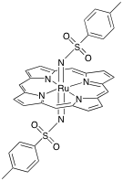

**2) [PtCl2(OH2)2]2-**

**3)**



**4)**

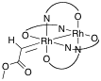



**5)**



**6) Hg(OSO3H)2**

**7)**

