**Modeling of the Flavodiiron Nitric Oxide Reductase Active Site Literature Discussion**

**Before coming to class, read the selected sections of the paper and answer the following questions.**

**Reading:** Abstract, Introduction, Scheme 5 description in the Results Section

**Scheme 5:** You are directed to Section III.4. Mechanism of N2O formation parts Step 3 and Step 4 (pg 4261-4263) for looking at Scheme 5 and the carboxylate shift.

1. NO plays many different roles in biological systems. Why is NO biologically important? What is the function of flavodiiron nitric oxide reductase enzymes discussed in this paper?
2. What cofactors are present in the active site of flavodiiron nitric oxide reductase? What are the roles of the cofactors in converting NO to N2O?
3. In this paper, and in the field of bioinorganic chemistry, model complexes are often synthesized. What purpose does a model complex serve?
4. Draw/write the balanced half-reaction reaction performed by the flavodiiron nitric oxide reductase.

**In-class discussion questions.**

1. What are the main motivations for this study? What methods were employed to accomplish this?
2. Refer to the figure below and answer the following questions. Figure used with the permission of Nicolai Lehnert.

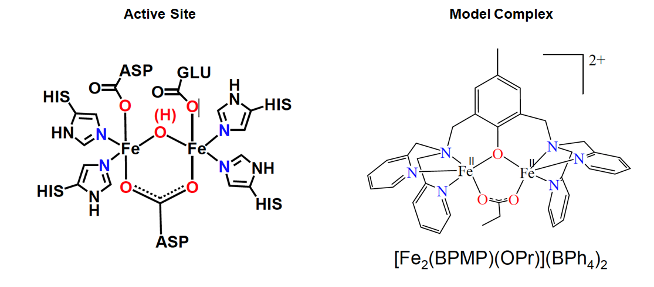

1. Compare the active site in the flavodiiron nitric oxide reductase enzyme to the structure of the model complex. What are the similarities and differences between the structures?
2. When the irons of the diiron site coordinates to the NO ligands to form a complex, determine which acts as the Lewis acid and which acts as the Lewis base.
3. For the model complex, what mechanistic steps may be important for catalysis (which bonds are being formed and which bonds are being broken)? Consider the overall balanced reaction that you wrote before coming to class, and also the reaction steps that might involve the model complex. Scheme 1 b-d in the paper will probably be helpful.
4. Below is the structure of the diiron model complex. Determine the oxidation states of the two metal centers in the structure, and determine the number of d electrons for each metal. What are the coordination numbers of the two metal centers, and suggest their possible geometries? What is the denticity of the BPMP ligand?



1. Scheme 2 in the paper shows three proposed reaction mechanisms. Which of the possible mechanisms has been ruled out, and why? For the two remaining pathways, what are the main differences between them?
2. Consider the following reaction pathway in the diagram below, which is similar to Scheme 4. Figure used with the permission of Nicolai Lehnert.

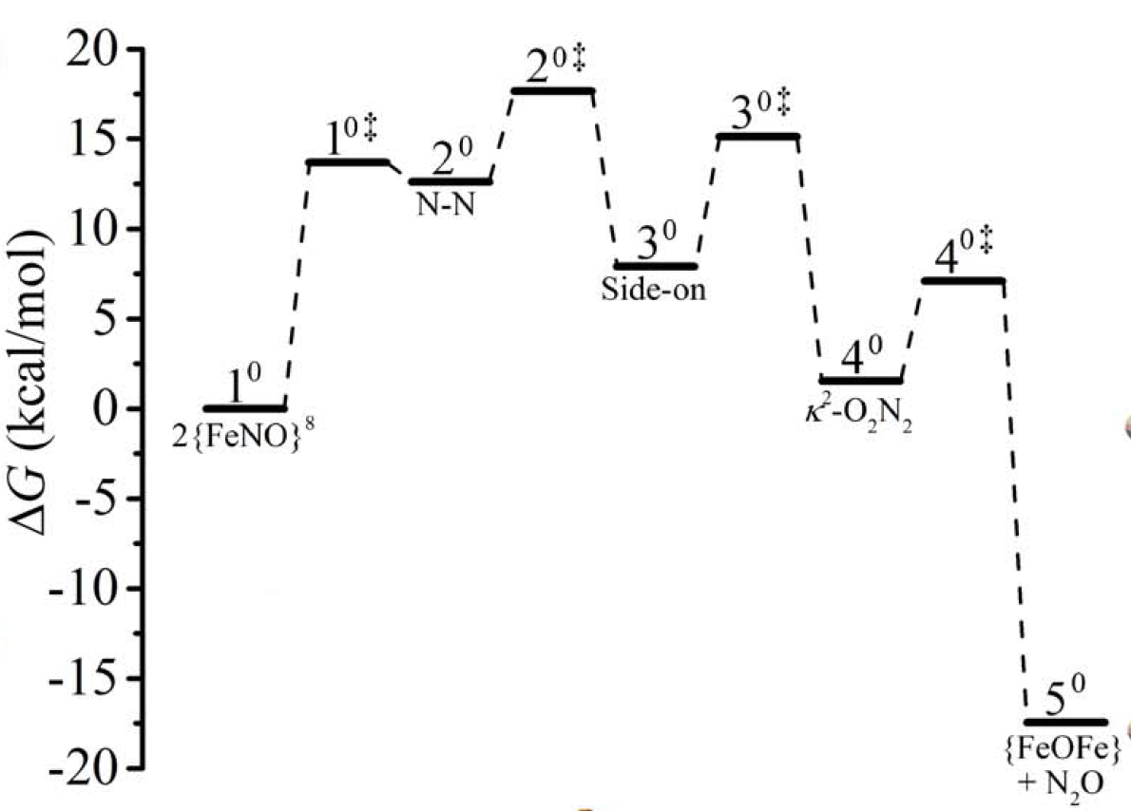

1. Label each species as a reactant, product, transition state, or intermediate species on the diagram.
2. What is the rate limiting step, and what is the approximate activation energy?
3. The second full paragraph on page 4253, which starts “Previous investigations,” describes a mononuclear nonheme iron complex. In the first three sentences of this paragraph, much information is provided about the iron spin states and NO- ligand coordinating to the iron centers. Sketch a partial molecular orbital diagram that shows the antiferromagnetic coupling in a {FeNO}7.
4. Refer to Scheme 5 and answer the following questions.
5. Upon forming hyponitrite (N2O22-), the diiron center is depicted to undergo a carboxylate shift (from 3o to 4odouble dagger). Using hard soft acid base (HSAB) theory, classify N2O22-, FeII, and FeIII as a hard or soft acid/base.
6. Which oxidation state of iron (FeII or FeIII) would you expect to form a more stable adduct with N2O22- based on the classifications above?
7. How might the proposed complex consisting of FeII coordinated to the N2O22- facilitate catalysis? In thinking about this question, it may help to remember that the final step is the release of N2O. Which complex would set up an ideal scenario for product formation, a more or less stable intermediate?