Guess What: The Inorganic Chemistry Version

Number of players
Minimum: 2
Maximum: $∞$
In the case of more than two players, split up participants into two teams. Afterall, two, three, four, + brains are better than one! That being said, too many cooks in the kitchen might not be best either, so find that happy medium!

Objective
Games are a great way to enhance understanding of complex topics. In breaking down important concepts, players draw connections between topics. While traditional education in chemistry focuses on rules, theories, and scientific law, the intriguing discovery process of these essential topics may be a secondary or neglected aspect of the work. There is merit in looking at HOW WE KNOW WHAT WE KNOW.
The objective of this game is to present important aspects of inorganic chemistry through a game format. Since every individual processes information differently, educational material presented in this manner is inclusive of non-traditional learning methods. While engaging the individual, games also further expose them to that material, solidifying the concept. The objective of this project is as follows: “To communicate clearly and effectively with different audiences and in different contexts.”

Required Materials
- Guess What Board game with the corresponding 50 Topic and 50 Clue Cards
- A pad of paper and a writing gadget
- A POSITIVE ATTITUDE

How to play
- Deal 20 “TOPIC” Cards to each team and place the cards into the Guess Who Board. The other team should have the “CLUE” cards corresponding to each topic card.

TOPIC CARD Example
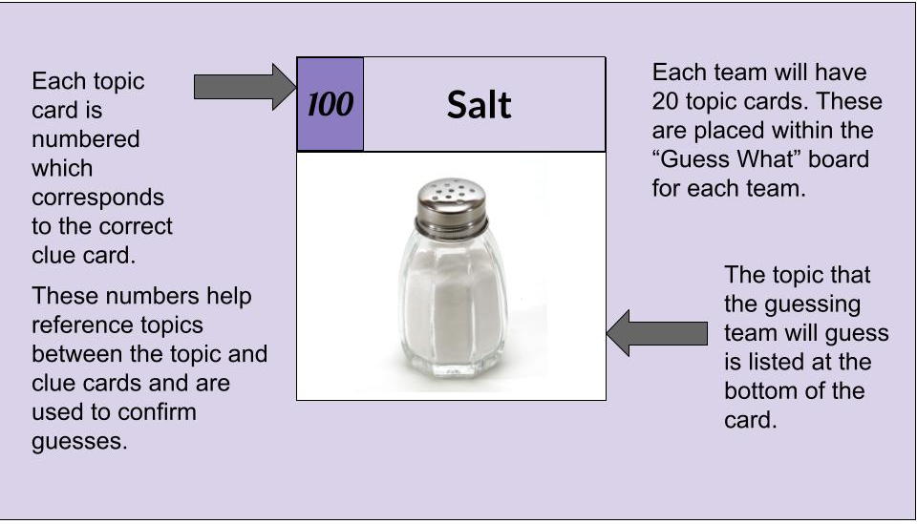

CLUE CARD Example
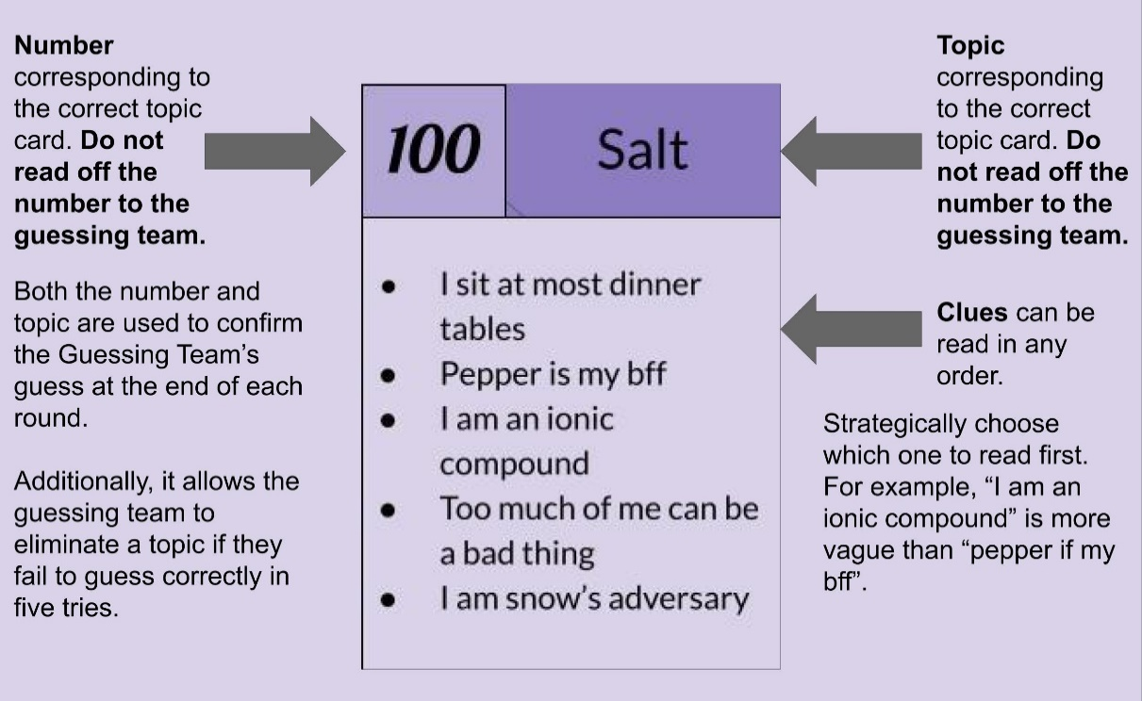

- There are two roles: the guessing team and the prompting team. The youngest player (or the team with the youngest player will be the guessing team first. The prompting team will read off clues from which the guessing team will attempt to correctly discern the topic.
- Each topic card has 5 clues. These clues can be read in whatever order; it is up to the prompting team to strategically reveals clues. Ideally, the vaguest clues would be provided first. The guessing team has 30 seconds after each clue to make a guess.
- The objective of the game is to correctly guess the correct topic with the fewest number of clues. For each clue provided, one point will be added to the guessing team’s score. The team with the smallest number of points in the end is the winner.
Note: If the two teams are tied at the end, a game of sudden death will be played. Each team will choose an additional topic card. Whoever guesses their topic in the fewest number of guesses will be crowned the ultimate winner!

Acknowledgements:
Editor and Mentor: Dr. Bradley Wile
Ohio Northern University: School of Science, Technology, and Mathematics

Mentor: Dr. Forrest Clingerman
Ohio Northern University: Honors Program

References:
Information:
- Inorganic Chemistry, Miessler & Tarr, 5th Edition; Pearson/Prentice Hall, 2013; ISBN: 9780321811059.
- Descriptive Inorganic, Coordination, and Solid-State Chemistry, Glen E. Rodgers, 3rd edition; Brooks/Cole, Text: Cengage Learning: Belmont, CA, 2012; ISBN 978-0-8400-6846-0.
- Britannica. Encyclopædia Britannica, Inc.: 2022.
- Chemistry LibreTexts. LibreTexts. NICE CXone Expert, Department of Education Open Textbook Pilot Project, the UC Davis Office of Provost, the UC Davis Library, the California State University Affordable Learning Solutions Program, and Merlot.
Images:
- Wolfgram, J. Collection of Benzene People. Ohio Northern University: 2022.
- All images were obtained via a Creative Commons Licenses Google.com search
Topic and Clue Cards:
Creative content attributed to Jasmine Wolfgram and Dr. Bradley Wile, Ohio Northern University 2022.
Wolfgram, J.; Wile, B. Guess What Topic and Clue Card Creative Content. Ohio Northern University: Ada, OH, 2022.
Clue cards were designed on Google Drawings.

