Handling Air Sensitive Reagents and Working with a Schlenk Line

One of the learning goals of the lab for the Organometallics portion of the course is to gain experience in handling air sensitive reagents. These reagents may decompose or react (sometimes violently!) with air or moisture. We’re going to look at one way to work with these compounds (a Schlenk line), how to dry and degas solvents, and two ways of transferring air sensitive liquids (Sure-Seal bottles™ and cannulation).

Schlenk Lines:
Read:
https://en.wikipedia.org/wiki/Schlenk_line
https://schlenklinesurvivalguide.com/
https://schlenklinesurvivalguide.com/cycling-onto-the-schlenk-line/
https://schlenklinesurvivalguide.com/schlenk-line-safety/

Watch:
“Schlenk Line and Cannulation Technique” https://www.youtube.com/watch?v=Eov60kI7yw8

Answer:

- Given a Schlenk line set up as below (stopcocks 4-7 are three-way stopcocks that can be opened either to the vacuum or nitrogen manifold), describe exactly how you would attach a Schlenk flask containing a solid to the Schlenk line. Assume the vacuum pump is already on, and the Schlenk line’s vacuum manifold is under vacuum.

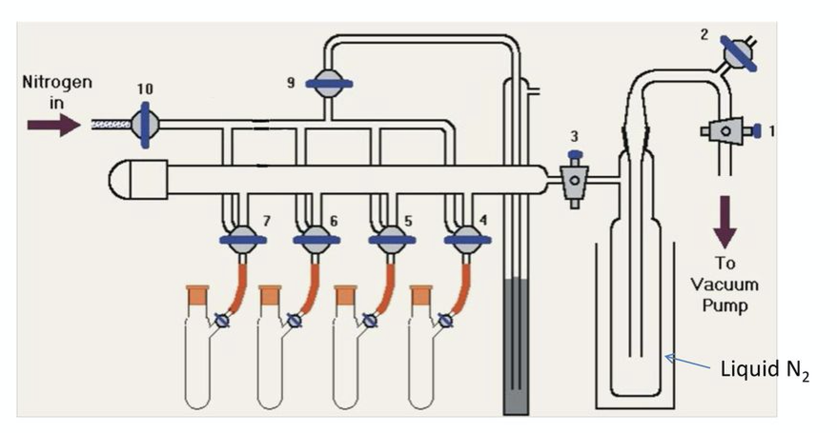

Drying solvents:

Read:
https://schlenklinesurvivalguide.com/solvent-stills/
https://www.chem.tamu.edu/rgroup/gladysz/documents/SPS.pdf (Just scan the document.)

Watch:
“Setting up a THF still with Potassium: https://www.youtube.com/watch?v=W2sIxfmNSqU (Watch about the first 10 minutes, then skip to the end to see the pretty color! Why is the THF solvent still blue when THF itself is colorless?)
“Solvent Purification System” https://www.youtube.com/watch?v=n9Kfj8pmClA

Answer:

- Many labs (including ours) now use a Solvent Purification system very similar to the one in the second video. Why do we use that instead of setting up a solvent still for each of the solvents we commonly use? How is the way it dries solvent different from a solvent still?

Degassing solvents:
Read:
https://schlenklinesurvivalguide.com/freeze-pump-thaw/
https://www.chemistryviews.org/details/education/4308331/Tips_and_Tricks_for_the_Lab_Air-Sensitive_Techniques_2.html (The Degassing Solvents section)

Watch:
“Degassing Solvent on the Schlenk Line” https://www.youtube.com/watch?v=SEVzJp901no
“Freeze, Pump, Thaw” https://www.youtube.com/watch?v=GpbXTk9VbBg

Answer:

- You are about to do a reaction that is very sensitive to any dissolved oxygen in your THF solvent. You have the THF in a flask already under Nitrogen attached to the Schlenk line. Describe how you will degas the solvent. (Hint: consider which method of degassing is best for highly oxygen sensitive reactions first!).

Transferring Liquids:

Read:
https://www.sigmaaldrich.com/content/dam/sigma-aldrich/docs/Aldrich/Bulletin/al_techbull_al134.pdf
https://schlenklinesurvivalguide.com/syringes-and-sure-seals/

Watch:
“Schlenk Line and Cannulation Technique” https://www.youtube.com/watch?v=Eov60kI7yw8 (rewatch the canula transfer part)
“Anhydrous Solvent Removal” https://www.youtube.com/watch?v=Zk9uIG-vgt8
(note: in the Inorganic lab we commonly use a syringe filled with nitrogen we have taken from a flask on the Schlenk line or a needle hooked to the nitrogen line itself. Organic labs without nitrogen lines will often use the balloon method.)

Answer:
- You have the solid you attached to the Schlenk line in Question 1 and the THF you degassed in Question 3. Describe how you will transfer the THF to the flask with your solid.
- To the resulting solution, you are now going to add a reagent from a SureSeal™ bottle that is under Nitrogen via syringe. Describe the steps you will use.

Bonus Learning: Schlenk lines and Schlenk flasks are named after Wilhelm Schlenk, a German chemist who did research on organolithium compounds as well as carbanions and free radical chemistry (all air and moisture sensitive) and died in 1943, having lost two prestigious professorships because of his support of Jewish colleagues and his commitment to democratic ideals. Read more at: Tidwell, Thomas (2001). "Wilhelm Schlenk: The Man Behind the Flask". Angewandte Chemie International Edition. 40 (2): 331–337.

