How to write a Z-Matrix
Adapted from: Exploring Chemistry With Electronic Structure Methods: A Guide to Using Gaussian by James B. Foresman, AEleen Frisch; Gaussian

Sometimes you will want to modify a particular coordinate; a convenient way to do this is by using the Z-matrix functionality. A complete Z-matrix mathematically describes the 3 dimensional shape of a molecule, including its connectivity.
1. Choose an atom to be the origin: Usually, you want this to be one of the central atoms in the molecule. So for:

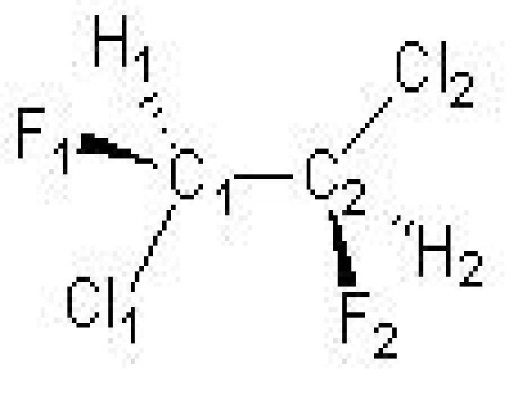

we’ll choose C1. This is the first line of our Z-matrix:

C1
2. Choose another atom bonded to the first atom: This will define the direction of the Z-axis. In the second line, you record which atom you chose, which atom it is bonded to (the 1st line), and its bond distance. So our Z-matrix now looks like:
C1
C2 C1 1.53 Bonded to C1 at a distance of 1.53 Å
3. Choose a third atom bonded to either of the previous two atoms and specify the angle formed by the two bonds: This locates the molecule’s position in the XZ plane. The third line of the Z-matrix will include the new atom’s label, the atom it is bonded to and the bond length, the label of the other atom forming the bond angle, and the angle’s value. FOR GAUSSIAN, ALL ANGLES MUST HAVE AT LEAST ONE DIGIT AFTER A DECIMAL POINT (even if it’s zero). Linear molecules are tricky for some reasons we won’t go into. Your life will be much easier if you never define a bond angle of 180o (trust me!). Unless it is a simple molecule that will be in a linear point group (like a diatomic or something like acetylene) or high symmetry point group, all other “linear” bond angles (like Fe-C-O in Fe(CO)(H2O)5, for example) should be written as 179.99. Anyhow, in our example, our Z-matrix now looks like
C1
C2 C1 1.53
Cl1 C1 1.76 C2 109.5 Bonded to atom C1 with distance 1.76 and angle Cl-C-C=109.5o

4. Describe all subsequent atoms:
a. Write the atom label
b. Specify which atom it is bonded to and the length (must be one already defined)
c. Specify a third atom bonded to it (or to the 2nd atom), and the value of the resulting angle
d. A forth atom bonded to either end of the previous chain, and the value of the dihedral (torsion) angle formed by the 4 atoms
Dihedral angles can be tricky, but they come with practice. If you remember Newman Projections from Organic, these are a good place to start. Your life will again be much easier if you define all dihedral angles greater than 180o as a negative angle (i.e. 240o is –120o). Back to our example—the 4th line reads:

C1
C2 C1 1.53
Cl1 C1 1.76 C2 109.5
Cl2 C2 1.76 C1 109.5 C11 180.0 Bonded to C2 at 1.76 Å;
∠Cl-C-C=109.5o; Cl-C-C-Cl dihedral angle is 180o (the 2 chlorines are on opposite sides of the carbon chain)
Can you finish it? The completed Z-matrix will be:
C1
C2 C1 1.53
Cl1 C1 1.76 C2 109.5
Cl2 C2 1.76 C1 109.5 C11 180.0
F1 C1 1.37 C2 109.5 Cl2 -60.0
H1 C1 1.09 C2 109.5 Cl2 60.0
F2 C2 1.37 C1 109.5 Cl1 -60.0
H2 C3 1.09 C1 109.5 Cl1 60.0

Now, for Gaussian, usually you want to optimize all of these values and so you instead write variables in for the actual numbers, and then give a starting guess. For example:

C1
C2 C1 r2
Cl1 C1 r3 C2 a3
Cl2 C2 r4 C1 a4 C11 d4
.
.
Variables:
r2=1.53
r3=1.76
a3=109.5
r4=1.76
a4=109.5
d4=180.0

So, you ask, where do I find all these angles and distances? The best place to start is the CRC handbook! After a while, you will memorize some common ones (given in Å):
Some ones to know:
C-H: 1.09
C-C: 1.53
C=C: 1.34
CC triple bond: 1.203
C-Cl: 1.76
C-F: 1.37
C-O: 1.4
O-H: 0.9
O-O: 1.4
C=O: 1.22

