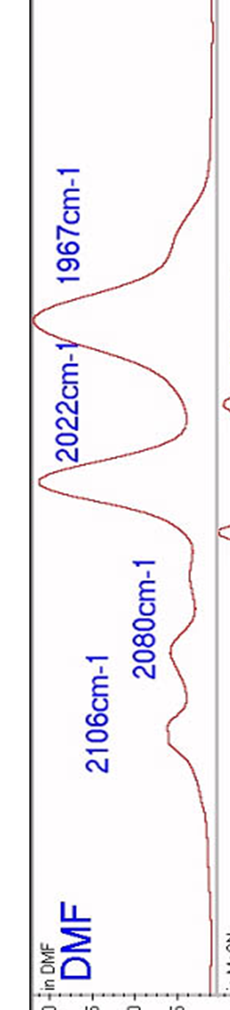
IR Spectrum of cis--[Fe^{II}(CN)₄(CO)₂]²⁻,

