The following activity is based on this YouTube video: https://www.youtube.com/watch?v=w3UgDC9nkf0
The spectrochemical series and color wheel will also be helpful:
I⁻<Br⁻<[NCS]⁻<Cl⁻<F⁻<[OH]⁻<[ox]²⁻≈H₂O<[NCS]⁻<NH₃<en<bpy<DMG<phen<[CN]⁻≈CO
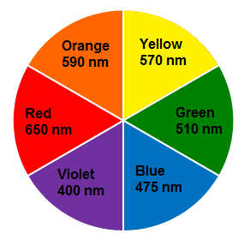
Image from: http://chemistry.miamioh.edu/yezierski/PrattCognateWebsite/Prelab10.html
If you have trouble seeing color, use the Color Blind Pal app (available freely on the Apple App Store and Google Play).
- In the table below, describe the observed color of each beaker (some have been provided). Then, determine what the absorbed (complementary) color would be.
Beaker # | 1 | 2 | 3 | 4 | 5 | 6 | 7
Solution |  |  |  |  |  |  | 
Observed Color |  |  |  |  | blueish-purple | purpleish-blue
Absorbed color (complement)

- Based on your observations, arrange the beakers numbers in order of INCREASING ligand field splitting (Δ):

- Given your ordering, match the ligand(s) with the beaker number. The possible ligands are given below:
Ligands(s) | NH₃ | 1en/4H₂O | DMG | 2en/2H₂O | CN– | H₂O | 3en
Beaker #

Now let’s watch the video. Was your ordering correct?

