IR Spectroscopy: Predicting the Structures of Rhodium Carbonyl Clusters

Inspired by:
Ingmar Swart, Frank M. F. de Groot, Bert M. Weckhuysen, David M. Rayner, Gerard Meijer, and André Fielicke “The Effect of Charge on CO Binding in Rhodium Carbonyls: From Bridging to Terminal CO,” J. Am. Chem. Soc. 2008, 130, 2126-2127.

The structures of neutral rhodium carbonyl clusters containing two, four, and six rhodium atoms have been known for some time. This paper investigates the structures of the monocation rhodium carbonyl clusters via infrared multiphoton dissociation spectroscopy (IR-MPD), comparing experimental results to those predicted from computational modeling. These are ideal problems to apply simple group theory tools to predict the distinguishing features in the IR spectrum of each possible structure.

For this activity, we are going to focus primarily on the ν_{CO} stretching frequencies. The stretching frequencies of terminally bound CO ligands (2060–2100 cm⁻¹) are typically well separated from those of bridging CO ligands (1750–1900 cm⁻¹) and so these could form separate basis sets.

I have reproduced static images of each of these structures below, and there are also Jmol models of each of these structures available on the Advanced I-chem Moodle. Your task is to use the tools of group theory to predict how many ν_{CO} stretching frequencies you would see in the IR spectrum of each possible structure, and specify how many peaks you would expect in the bridging vs. terminal CO regions of the IR.

Lowest energy structures of Rh₂(CO)₈ | Lowest energy structures of [Rh₂(CO)₈]⁺
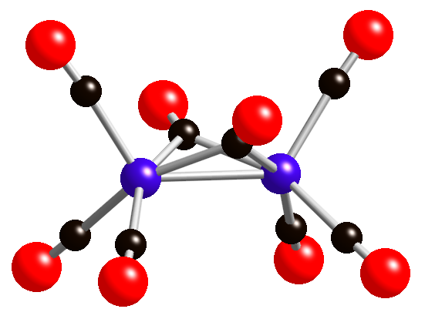 | 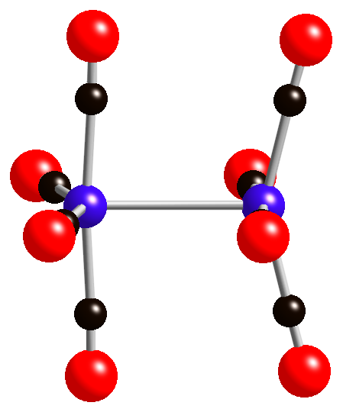
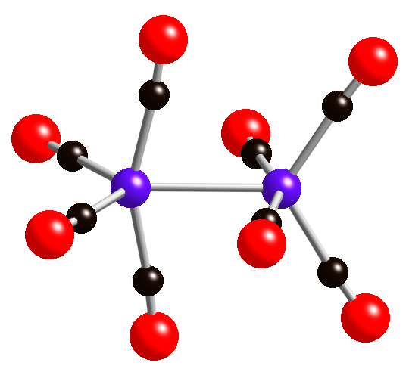 | 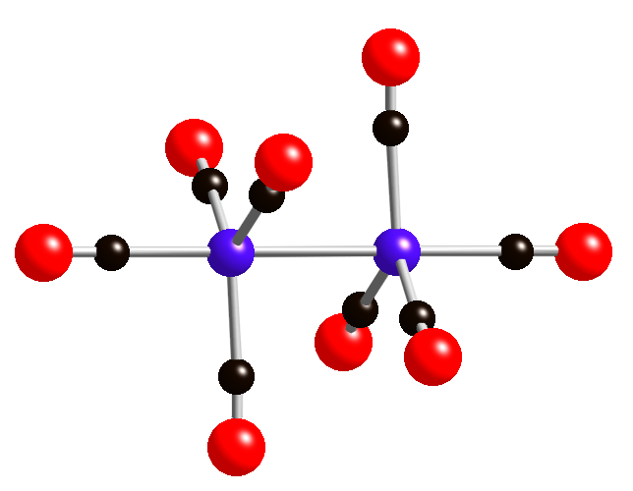
Possible structures of [Rh₃(CO)₉]⁺
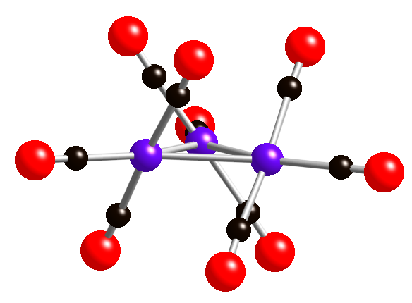 | 