Created by Alycia M. Palmer, The Ohio State University (palmer.475@osu.edu) and posted on VIPEr (www.ionicviper.org) on April 25, 2014. Copyright Alycia M. Palmer 2014. This work is licensed under the Creative Commons Attribution Non-commercial Share Alike License. To view a copy of this license visit http://creativecommons.org/about/license/.
Spectroscopy in Inorganic Chemistry
Learning Goals:
- Describe, in general, how each different region of the electromagnetic spectrum influences molecules.
- Use data in a research article to explain how spectroscopy of metal complexes is different from organic gases.
- Explain how FT-IR is useful in Lab 6 to monitor the linkage isomerism of NO₂ on a cobalt complex
- Design a series of spectroscopic experiments to identify intermediates in an inorganic synthetic pathway
Part 1: The Electromagnetic Spectrum
Label the regions of the electromagnetic spectrum in the picture below (from gamma to radio).

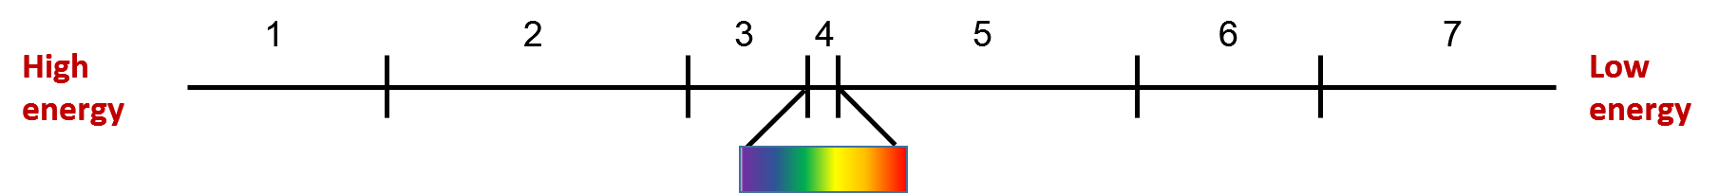
Part 2: Infrared Spectroscopy and Vibrational Modes
Of the 6 molecules used in the “Molecules and Light” PhET sim, CO, H₂O, and NO₂ are common ligands of inorganic complexes; complete the table below for these molecules.
Molecule | Lewis Structure | Coordinating atom(s) | # vibrational modes
CO
H₂O
NO₂

Part 3: Infrared Spectroscopy of Ligands
- Consult the reference by Penland et al. (1956) to fill in the missing vibrational energies.
NO₂ gas
N—O | Asymmetric | 1671 cm⁻¹
N—O | Symmetric | 1353 cm⁻¹
Co(NH₃)₅(NO₂)²⁺
N—O | Asymmetric
N—O | Symmetric
Co(NH₃)₅(ONO)²⁺
N—O | Asymmetric
N—O | Symmetric

- Coordination of a ligand to a metal leads to higher or lower vibrational energies compared to the free ligand? How is this explained?

Part 4: UV-Visible Absorbance Spectroscopy

Electronic transitions in metal complexes
Using your knowledge of the spectrochemical series, rank the energy of the d—d transition for the following cobalt(III) complexes.
[Co(H₂O)₆]³⁺, [Co(ONO)₆]³⁻, [Co(NO₂)₆]³⁻, [Co(NH₃)₆]³⁺

Part 5: Designing an Experiment
Based on your answers above, design a set of spectroscopic experiments according to the guidelines below to determine if the following reaction goes to completion. Assume that the counter ion of the complex does not affect the spectroscopic properties and that Fe(III) is low spin (d⁵).

- Identify a relevant spectroscopy technique
- For that technique, give details about what you expect the data to reveal
- Explain how the data will change for each complex in the reaction

Hint: You have the following materials at your disposal
FeCl₃, [Fe(bpy)₃](PF₆)₃, KCN

References
Penland, R. B.; Lane, T. J.; Quagliano, J. V. Infrared Absorption Spectra of Inorganic Coordination Complexes. VII. Structural Isomerism of Nitro-and Nitritopentamminecobalt(III) Chlorides. J. Am. Chem. Soc. 1956, 78, 887.

