**Interpreting Reaction Profile Energy Diagrams: Experiment vs. Computation**

This activity requires access to the paper by Lehnert, specifically the figures. It is not necessary to read the entire paper, only the synopsis, provided below.

Mechanism of N–N Bond Formation by Transition Metal–Nitrosyl Complexes: Modeling Flavodiiron Nitric Oxide Reductases, Casey Van Stappen*‡ and Nicolai Lehnert*   
*Inorg. Chem.*, 2018, *57*, 4252–4269.

Synopsis:

The flavodiiron nitric oxide reductase model complex [Fe2BPMP(OPr)(NO)2]2+ is capable of N2O production upon either 1 or 2e− reduction. This is accomplished through formation of a N2O22− intermediate via a N−N bond-forming step. The N2O22− is conformationally flexible, such that it is capable of rotating to form a unique κ2-N2O22− bridging mode, from which facile release of N2O proceeds via the assistance of a carboxylate shift.

Upon completing this activity, students will be able to:

1. Interpret reaction profile energy diagrams.
2. Use experimental and computational data to calculate half lives from activation energies and vice versa.
3. Assess the value and limitations of DFT calculations.

Questions:

1. Which of the 12 figures and 5 schemes in the paper show reaction profile energy diagrams?
2. Refer to the reaction profile energy diagram to the right (Scheme 4 from paper). Label the reactant, intermediates, product and all transition state compounds, TS. Use double sided arrows to identify each activation energy for each step and label the overall ΔG‡. Use a double sided arrow and label the Gibbs free energy of the overall reaction, ΔGrxn. 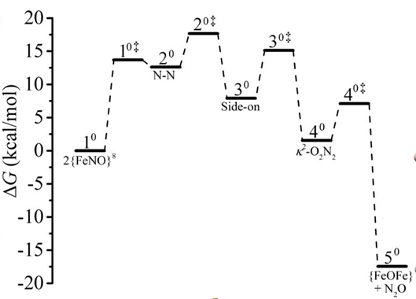

Image provided by N.Lehnert and used with permission.

1. Write the overall balanced reaction starting with the 10.
2. According to the reaction profile, how many steps are involved in the overall reaction?
3. Is the overall reaction exothermic or endothermic?
4. From the reaction profile, estimate a value for the overall activation energy for the overall reaction, which was calculated by DFT using a BP86 functional.
5. Given this activation energy, use equation 8 to calculate the rate constant for the reaction at -80 °C.
6. Assuming a first order reaction, convert the rate constant into a half life. (hint: you learned this simple relationship in a second level chemistry course)
7. In a previous experimental paper, it was determined that this reaction occurs at –80 °C in approximately 1 min. Calculate the experimental activation energy assuming that this reaction is first order with a 1 min half life.
8. How well does the experimental value for the free energy of activation match the computationally calculated value?
9. Figure 12 shows four different reaction profiles that were calculated using four different basis sets for the computations. Is BP86 the best basis set for estimating the activation barrier of this chemical reaction?
10. Imagine experimentally probing intermediates and transition states for a reaction that occurs within a minute at –80 °C. What are two values and one limitation of DFT calculations?