**Introduction to Borane and Carborane Structures: Practice with Point Groups, Electron Counting, and Electronegativity Trends with Computational Support**

Recall from our prior discussion that boron typically forms three bonds (e.g., BH3) and forms molecules that act as Lewis acids on the basis of a B-based empty unhybridized pz orbital. This leads to aggregation where two BH3 units can dimerize to form B2H6 featuring bridging hydrides via 3-center, 2-electron (3c-2e) bonding (check out its structure on the Otterbein symmetry website! Point your browser to <https://symotter.org/gallery> and look under “Prismatic” for diborane). In this activity, we will explore even higher symmetry clusters that boron can form!

1. Determine the point groups of the clusters shown below: B6H62- (structure a), CB5H6- (structure b) and C2B4H6 (structure c).

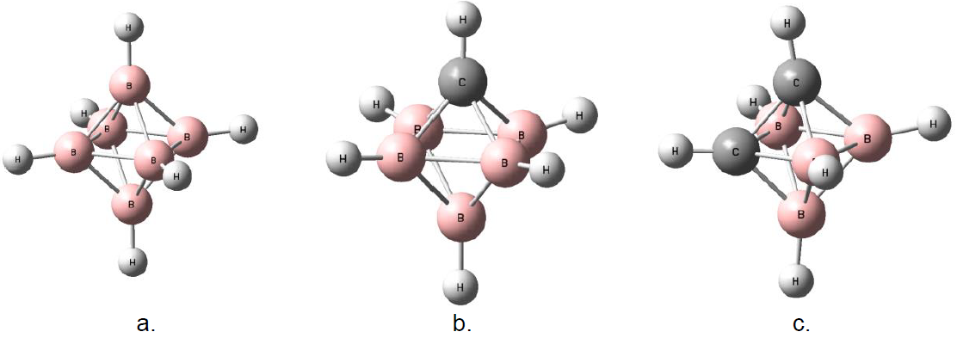

**Bonus Question**: There is a second isomer ofC2B4H6. Draw the structure and assign its point group.

1. When looking at B6H62- (structure a), CB5H6- (structure b), and C2B4H6 (structure c), you may notice that the clusters range in charge from dianionic to neutral.

1. Determine the total number of valence electrons in each complex. How many of these electrons are localized in B-H and C-H bonds? (Hint: 2 e- for each of these bonds)

1. What do you notice about the total number of valence electrons you found for

each cluster in part 2a? In a few sentences, rationalize the different overall charges of the clusters by applying your knowledge of the [isolobal analogy](https://chem.libretexts.org/Bookshelves/Inorganic_Chemistry/Inorganic_Coordination_Chemistry_(Landskron)/10%3A_Organometallic_Chemistry/10.03%3A_The_Isolobal_Analogy) between [C-H] and [B-H]-.

1. The remaining electrons are “skeletal” electrons that are shared between the

boron atoms (i.e., delocalized around the core). How many such skeletal electrons are there for each cluster complex?

1. Determine the number of B-B bonds drawn in structure (a). Based on your answer to part 2c for the number of skeletal electrons, can each of these bonds drawn between boron atoms represent two electrons? Why or why not? This sharing of electrons by many atoms has parallels in the delocalized structures of benzene and other aromatic systems you have learned about in organic chemistry!
2. Pull up a [table](https://chem.libretexts.org/Bookshelves/General_Chemistry/Book%3A_ChemPRIME_(Moore_et_al.)/07%3A_Further_Aspects_of_Covalent_Bonding/7.11%3A_Electronegativity) of electronegativity values.
   1. Based on electronegativities, assign the dipoles of B-H and C-H bonds in a carborane, such as structure b or structure c. Note that while these are all covalent bonds, all heteronuclear bonds have some degree of polarity.
   2. In the presence of a base n-butyllithium is the H in the B-H or C-H bond more likely to be lost as a proton? (Bu = butyl, C4H9-)
   3. A carborane cluster, for example structures b and c in question 1, contains bonds between boron and carbon. Use your electronegativity values from part (a) to predict the partial charges on boron and carbon in the cluster.
3. In #3, you used electronegativity to predict dipoles within a carborane cluster. We can also calculate the distribution of electrons using computational tools. Look at Figure 1 below, which shows calculated Mulliken partial charges obtained using the Gaussian 16* software package for larger borane and carborane clusters, B12H122- (structure a) and CB11H12- (structure b). (Mulliken charges distributions were calculated at DFT/B3LYP/6-31G level of theory). In a few sentences, compare the calculated charges with your predictions in #3.

