Name___________________________________________ CHM-155L

Kool-Aid analysis:
Visible Spectroscopy and Paper Chromatography

Student Learning Objectives:
After completing this experiment, the student will be able to:
- Correlate color to wavelength of light
- Analyze Kool-Aid packets to find the number of dyes present by paper chromatography
- Generate a calibration curve
- Calculate the percent mass of dye

Intro/Background information:
The electromagnetic spectrum (EM) is based on electric and magnetic waves and groups different types of light into categories based upon their wavelength or energy. The part of the electromagnetic spectrum we will be studying is the visible region. The visible region lies between the infrared and ultraviolet regions and has wavelengths of 400-700 nm. Each color of the visible spectrum corresponds to a specific energy (which also corresponds to a specific frequency and wavelength) according to the following equation:
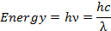

where h is Plank’s constant (6.626 x 10⁻³⁴ J/s), ν is frequency (s⁻¹), c is the speed of light (2.998 x 10⁸ m/s), and λ is wavelength (nm). From this equation, it is determined that longer wavelengths have lower energies and lower frequencies. The visible light spectrum is depicted in figure 1.
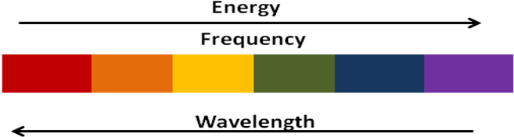
While individual wavelengths correspond to a specific color, the color ‘white’ appears when two of more wavelengths of the visible region are present. Incidentally, the color ‘black’ seems to appear when no wavelengths of visible light are present. Therefore, white and black are not colors, they are just the presence or absence of a variety of wavelengths of light.
In this lab, we will use a spectrophotometer to measure the interaction of light and matter. This instrument splits visible light into its wavelengths and allows light of a selected wavelength to pass through the material being studied. An electronic detector measures the amount of light that has been absorbed by the sample at each wavelength.
Absorbance is the portion of light that gets absorbed by the sample. It is proportional to the concentration of the solution. If no light is absorbed by a solution, it will have zero absorbance and 100% transmittance. Percent transmittance is the percentage of light that passes through (or is transmitted through) the sample. Measurements from a spectrophotometer can be recorded in either absorbance or percent transmittance. To convert between the absorbance and transmittance, use equation 1.

(eq1) Absorbance = 2.000- (1/ % Transmittance)

Chromatography is a technique that separates mixtures into their component parts. Paper chromatrography is one form of chromatography which can be used to separate colored mixtures by having stationary and mobile phases. Paper is made of cellulose, which is a polar substance.² The solvent used travels by capillary action up the paper.² Capillary action is the movement of the water up the paper by the solvent going into the porous holes in the paper.³ The polarity of the sample will determine how far the sample travels up the paper. Based on the rule ‘like dissolves like,’ the more polar a dye is, the more it will adhere to the paper and not travel far. The non polar samples will not interact with the paper will therefore travel farther. In this experiment, paper chromatography using a coffee filter will be used to determine the amount of dees in Kool-aid mixes.
A calibration curve is a technique used to identify an unknown concentration of a sample. Known standard measurements can be measured and a graph of the data is made. From this graph, you can determine the concentration of your unknown.
In this experiment, you will first use chalk to determine the visible region of the electromagnetic spectrum. That is, you will find out which wavelengths correspond to each color of the rainbow. You will then use two different Kool-Aid samples and the Spec20 to determine how the colors of light correspond to the amount of light that is absorbed by the sample. You will also use paper chromatography to determine the amount of dye samples in different Kool-Aid mixes. The second part of the experiment involves generating a calibration curve in order to determine the percent mass of dye in a sample.

Pre-Lab Questions:
- How is a wavelength determined and which wavelengths correspond to the visible region of the electromagnetic spectrum?
- Compare absorbance to transmittance.
- Why is paper chromatography used?
- Once a calibration curve is made, what information can be retrieved from the curve?

Materials Needed:
Supplies:
- White Chalk
- Strawberry, Ice Blue Raspberry, Grape, Cherry Kool-Aid packets
- Coffee Filters
- Q-tips
- Drinking water
- Red Dye #40
- Blue Dye #1
- Gallon jugs
Glassware:
- 25mL, 50mL, 100mL, and 200mL volumetric flasks
- Cuvettes
- Test tubes
- Beakers
Instruments:
- Balance
- Spectrophotometer

Procedure:
Day 1.
- For this lab you will work in pairs.
- Take a half-inch long piece of chalk and rub it down until one end is at a 45 degree angle. Place the chalk in the spectrophotometer test tube and insert into the spectrometer so that the slanted side is pointing to the right.
- Adjust the wavelength on the Spec20 to 500 nm.
- Look at the chalk in the tube while it is still in the Spec20. Raise, lower, and/or rotate the tube until you see a colored band of light.
- Slowly change the wavelength in both directions and see that the light band changes color. Once you go too far either way, you will exit the visible region of the electromagnetic spectrum.
- Record the wavelengths corresponding to the limits of the electromagnetic spectrum (the first wavelength where you see no color) in Table 1.
- Then find out what wavelengths correspond to which color and record in Table 1. You can do this by setting wavelength to 400 nm. Record what color you see. Change the wavelength to 440 nm and record color. Continue this process at 40 nm intervals from 400 to 700 nm. Record in Table 1. which color responds to each wavelength.
- Obtain three tests tubes. Fill one half full with Strawberry Kool-Aid mix, one half full with Ice Blue-Raspberry Kool-Aid mix, and one half full with deionized water.
- Place the water tube “sample” in and set the wavelength to 400 nm and adjust to zero. See attached Spec20 directions for more help.
- Remove the sample and insert the test tube with the Strawberry Kool-Aid. Record in Table 2 the absorbance for this solution at 400 nm. Repeat for the Ice- Blue-raspberry sample.
- Repeat this in 20 nm intervals until you get to 700 nm. Make sure each time you change the wavelength to put the blank (water test tube) into the spec and re-zero it.
- Plot the Strawberry Kool-Aid data (Absorbance vs. Wavelength) and the Ice Blue Raspberry Kool-Aid data (Absorbance vs. Wavelength) on two different graphs using Excel.

Data Tables:

Table 1.
Wavelength limits for eyes: Lowest wavelength_________ Highest wavelength_______

Wavelength (nm) | Color of light band
400
440
480
520
560
600
640
680
700

Table 2. Absorbance for Kool-Aid samples.
Wavelength (nm) | Strawberry Kool-Aid  (Absorbance) | Ice Blue- Raspberry Kool-Aid  (Absorbance)
400
420
440
460
480
500
520
540
560
580
600
620
640
660
680
700

Post-lab Questions:
- At which wavelengths did the Ice Blue Raspberry Kool-Aid have the lowest absorption (greatest transmittance)? Here this solution is absorbing the light. What color of light is the Ice Blue Raspberry Kool-Aid absorbing?
- At which wavelengths did the blue solution have the greatest absorption (lowest transmittance)? What colors of light correspond to these wavelengths?
- Repeat questions 1 and 2 for the Strawberry Kool-Aid solutions.
- Summarize how the color of a solution is related to the colors of light that it absorbs.

Paper Chromatography:
- Obtain a coffee filter and fold in half two times to create four sections.
- Unfold the filter paper and with a pencil, lightly draw a dot about 1.5 inches about the center mark.
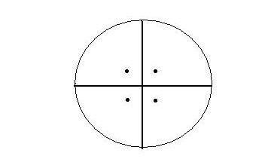
Figure 1. Folded coffee filter with pencil marks.

- Using a Q-tip, place a small dot of each Kool-Aid solution on a pencil mark: Strawberry, Ice Blue Raspberry, Grape, and Cherry. Make sure to use a different Q-tip for each Kool-Aid sample so they do not get mixed together.
- On the top of each section, label which Kool-Aid flavor is dotted.
- Allow to dry for one minute.
- Refold the paper to create a cone shape.
- Place the filter paper, point down, into a 250 mL beaker of water until the tip just reaches the water level, making sure the dots are above the water level.
- Let the filter sit for 5 minutes.
- After the time is up, unfold the filter paper and lay out to dry.

Post- lab Questions:
- How many dots appeared for each Kool-Aid?
- What does each dot that appeared represent?
- From the results, can you tell which dyes are in the Grape and Cherry Kool-Aids?

Day 2:
- Make a calibration curve for each the red dye and blue dyes by following the directions below.
- Make 4 solutions as shown in table below. Use Mohr pipets to transfer desired amount of stock solution and water into a beaker before transferring solution to a cuvette.
 | Red Dye #40 | Blue Dye #1
Solution A | 8 mL stock soln and 2 mL deionized water | 8 mL stock soln and 2 mL deionized water
Solution B | 6 mL stock soln and 4 mL deionized water | 6 mL stock soln and 4 mL deionized water
Solution C | 4 mL stock soln and 6 mL deionized water | 4 mL stock soln and 6 mL deionized water
Solution D | 2 mL stock soln and 2 mL deionized water 8 mL deionized water | 2 mL stock soln and 2 mL deionized water 8 mL deionized water
- Measure each Red Dye solution at 503 nm and each Blue Dye at 629 nm and record values in appropriate places in Table 3.
* Remember when using the Spec20 to zero the machine and insert a blank after changing wavelengths.
- Graph the data using Excel, one for the red dye data and one for the blue dye data as absorbance vs. concentration.
*Graph in Troutman Library and have one of the TA’s check graph before moving on.
- Retrieve each unknown sample.
- Fill a test tube with each unknown and centrifuge for eight minutes.
- Transfer the now-clear solution into a cuvette.
- Measure each sample at the wavelength indicated in Table 4.
- Determine the concentration of dye in each sample by using the calibration curve.

Table 3.
Dye | Solution A | Solution B | Solution C | Solution D
Red (503 nm)
Blue (629 nm)

Table 4.
Kool-Aid Flavors | Mass of sample (g) | Absorbance at 503 nm | Absorbance at 629 nm
Strawberry |  |  | XXXXXXX
Ice Blue Raspberry |  | XXXXXXX

Post lab Calculations:
1. Use the calibration curves to determine the concentration of the Kool-Aid samples.
2. Milligrams of dye per package of Kool-Aid analyzed
3. Milligrams of dye per serving.
4. Percent by mass of dye in sample.

References:
This lab is adapted from Sigmann, S; Wheeler, D. J. Chem. Ed., 2004, 81, p. 1475.
- “Paper Chromatography.” Texas A&M University. peer.tamu.edu
- Miller, F.P.; Vandome, A.F.; McBrewster, J. Capillary Action. Alphascript publishing. 2010. Pg.15

Spectronic® 20 and 20+ Spectrophotometers

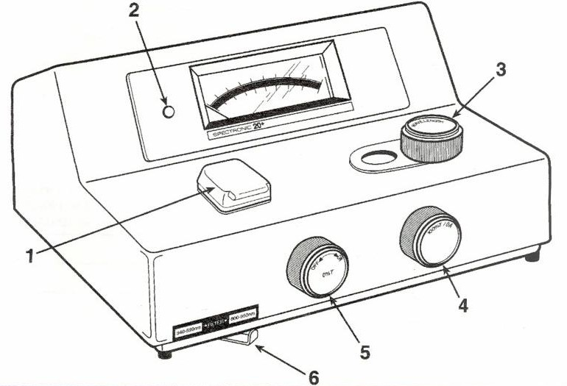
The main components for the operation of the instrument are the (1) sample compartment, (2) pilot lamp, (3) wavelength control, (4) transmittance/ absorbance control, (5) power switch/zero control, and (6) filter lever (only on the Spectronic 20+).

Spectronic® 20+ Series Spectrophotometers Operators Manual, Spectronic Instruments, Inc., Rochester NY, 1995.

Technique Notes

- Make sure there are no bubbles in the solutions.

- The cuvettes should be at least half-way full.

- Ideally, the same cuvette should be used for the blank (reference) and sample solution.

- Align the cuvette with the marking on the sample compartment.

- Always use clean cuvettes. Do not clean the inside with a test tube brush as scratches will result. Wipe fingerprints off the outside surface using Kimwipes.

- Every time the wavelength is changed, the instrument must be reset to read 100% transmittance using the blank (reference) solution. It is also a good idea to check the zero setting.

Operation

- Turn on the instrument by turning the power switch (5) clockwise. Allow for a 15 minute warm-up period.

- Set the desired wavelength using the wavelength control dial (3).

- Set the filter lever (6) to the correct setting based upon the wavelength selected. This is not necessary for the Spectronic® 20 model.

- Adjust the meter to read 0% transmittance using the power switch/zero control (5). During this procedure the sample compartment must be empty and the cover down.

- Fill a cuvette with the blank or reference solution. This is typically the solvent used in preparing the samples. Wipe the outside of the cuvette with a Kimwipe. Insert the cuvette in the sample compartment (1) making sure to align the tube with the mark. Close the lid.
- Adjust the meter to read 100% transmittance using the transmittance/absorbance (4) control.

- Remove the cuvette containing the blank solution. Insert a cuvette with the sample solution taking care to align the tube with the mark. Ideally, the cuvette should be rinsed several times with small portions of the sample before filling.

- Close the lid to the sample compartment and read the % transmittance from the meter.

- Remove the sample and repeat steps 7 and 8 for any additional samples.

- When all measurements are completed turn off the spectrophotometer by turning the power switch (5) counterclockwise. The power indicator lamp (2) will go out.

- Unplug the instrument, cover, and store in its proper location.

