Synthesis and Characterization of MoO₂(acac)₂
Adapted from: Patricia L. Stan (ptstan@taylor.edu) “Simple synthesis of MoO2(acac)2 and evaluation of spectra” posted on www.ionicviper.org July 16, 2012 under the Creative Commons Attribution Non-commercial Share Alike License.

In this experiment, you will prepare the air-stable coordination complex MoO₂(acac)₂, bis(acetylacetonato)dioxomolybdenum(VI), from molybdenum trioxide and 2,4-pentanedione. MoO₂(acac)₂ is a good starting material for the preparation of other oxo-molybdenum compounds because the acetylacetonate ligand can be displaced rather easily.

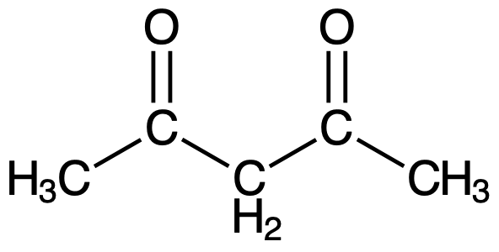
2,4-pentanedione is also known as acetylacetone or acac, the structure of which is shown at right. There is a second form of this compound, called a tautomer, in which a proton moves from the central carbon to one of the oxygen atoms (Note: this is not a resonance structure as it involves more than the movement of electrons). Although this second form (right bottom) is present at only a small concentration, it is the form that binds to the metals. In order for the acetylacetone ligand to react with a metal, a proton must be removed from Hacac. This is easily accomplished by the addition of some base to the reaction. The removal of one H⁺ will leave the ligand with an overall charge of –1 as shown below.
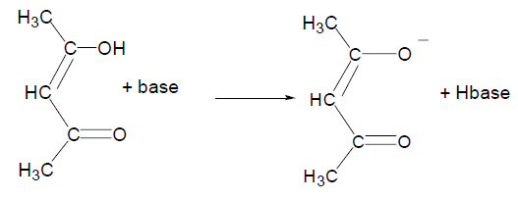

MoO₂(acac)₂ has an octahedral structure derived from both monodentate and bidentate ligands. Based on the ligand composition and molecular geometry, two isomers (cis- and trans-) can be formed for MoO₂(acac)₂. You will use melting point, NMR, and IR data to confirm the identity of the product and determine the geometric arrangement of the ligands.
As you will learn in lecture, the number of vibrational modes associated with a particular molecule is related to the symmetry of that molecule. You will need to predict the number of expected molybdenum-oxo stretching modes for each isomer. This is done by considering the vectors along the Mo−O bonds in each possible isomeric structure and applying the operations of the appropriate point groups to find their reducible representation. This reducible representation can be resolved into a set of irreducible representations (IRR) and based on the symmetry of each IRR, you can determine if a particular mode will be IR active. Based on the predicted number of IR active modes, you can then assign the geometry of each isomer by comparison with experimental IR spectroscopic data.

Synthesis of MoO₂(acac)₂
Complete all work in the fume hood and wear gloves at all times.
In a 25 mL round bottom flask equipped with a stir bar, combine 1.7 mmol (0.25 g) MoO₃ (solid) with 22 mmol (0.40 g) H₂O (liquid) and 5.5 mmol (0.40 g) of concentrated aqueous NH₃ (24% w/w solution; 13 M) and stir until the solution is transparent (approximately 10-15 min). Add 7.5 mmol (0.75 g) 2,4-pentanedione (liquid). Then add 10 mmol (1.0 g) concentrated HNO₃ (63% w/w) dropwise with stirring. Continue to stir until the solution has returned to room temperature.

Collect the solid product by vacuum filtration using a Hirsch funnel and wash it with 3x2 mL deionized water, 3x2 mL ethanol, and 2x2 mL diethyl ether. Allow air to be pulled through the solid for several minutes to dry the sample. Determine the yield of the product and calculate a percent yield. Transfer the product to a labeled vial for storage.

Characterization of MoO₂(acac)₂

Obtain a melting point and an IR spectrum for your product. As you are primarily interested in the Mo=O stretching region of the IR spectrum, print out both a full range spectrum and a spectrum zoomed in on the area of interest. Also collect an IR spectrum of the starting MoO₃ complex.

Prepare a sample for NMR by dissolving a small amount of product (5 – 25 mg) in 0.5 mL CD₂Cl₂. Transfer to an NMR tube and collect a ¹H-NMR spectrum.

Analysis

For each of the compounds you synthesized, conduct a group theory analysis of the Mo−O stretching vibrations to determine the expected number of IR active vibrational modes. Use this information along with your experimental IR spectra to assign the geometry of each compound.

Waste Disposal

All waste should be disposed of properly in the appropriate waste containers. Please read labels carefully to ensure that each chemical is disposed of in the proper container. All glassware should be rinsed with acetone into the proper waste container prior to washing in the sink.

References
- Arnaiz, F J. Microscale Synthesis of MoO₂(acac)₂. J. Chem. Ed. 1995, 72-73.
- Chakravorti, M.C.; Bandyopadhyay, D.; Chisholm, M.H.; Hammond, C.E. “31. Dioxobis(2,4-pentanedionato)molybdenum(VI), MoO₂(acac)₂, and μ-oxodioxotetrakis(2,4- pentanedionato)dimolybdenum)(V), Mo₂O₃(acac)₄. Inorg. Synth. 1992, 29, 129-134.

