This LO is part of a collection celebrating the “Out in Inorganic Chemistry: A Celebration of LGBTQIAPN+ Inorganic Chemists” Inorganic Chemistry special issue. Check out the editorial and issue here:
Editorial: https://pubs.acs.org/doi/10.1021/acs.inorgchem.2c00729
Special Issue: https://pubs.acs.org/page/inocaj/vi/out-inorganic-chemistry-2022?ref=vi_collection
The questions below refer to the following 2020 publication by Dr. Jonathan Kuo and Dr. Karen Goldberg
“Metal/Ligand Proton Tautomerism Facilitates Dinuclear H₂ Reductive Elimination”
Jonathan L. Kuo and Karen I. Goldberg*
J. Am. Chem. Soc. 2020, 142, 21439-21449
https://pubs.acs.org/doi/10.1021/jacs.0c10458

- Describe the ligands on compound [3-LH]⁺ and [4-LH]⁺ in terms of their denticity (e.g. κ¹) and their L and X character (see Reaction 1). Also, do the same for [1-MH·^{t}BuPy]⁺ from Figure 1.

- Why are Ir(II) monomeric species paramagnetic, but compounds 7²⁺ and 8 are diamagnetic?

- What is the definition of a conformer? Of a tautomer?

- Metal-hydride bonds can form and break via several methods. What happens to the metal’s oxidation state for each of the following cases of breaking a M-H bond?
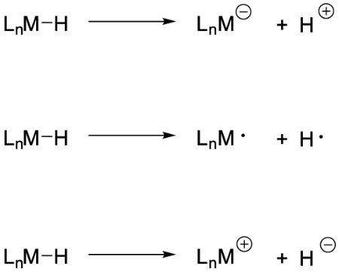

5) Solutions of [1-MH·^{t}BuPy][PF₆] are noted to be thermochromic (Figure 8).
- What does “thermochromic” mean?
- Draw the equilibrium that is responsible for thermochromicity.
- Why is the position of this equilibrium affected by temperature?

- In the paper, equation 7 simplifies to equation 6 when k_{–1}[tBuPy] ≫ k₂[Ir^{III}–H]. What would equation 7 simplify to if the opposite were true (k₂[Ir^{III}–H] ≫ k_{–1}[tBuPy])?

- For the interconversion between [2-LH]⁺/^{t}BuPy to [1-MH]⁺,
- Which order of events is more reasonable: (1) slow ligand association followed by fast tautomerism or (2) slow tautomerism followed by fast ligand association?
- How could you distinguish between these two possibilities using kinetic experiments, assuming that accessing the reactive intermediate is the rate determining step (hint: check out Figure 13)?
- NMR data provides valuable information for this dynamic system. Answer the following questions:
- Why do the chemical shifts in Figure 6 move in the upfield direction upon incremental additions of ^{t}BuPy?
- How many Ir(III)-Hs are present in solution in total?
- Write a mathematical expression for the observed chemical shift δ_{obs} as a function of the mole fraction (χ) of the various Ir(III)-Hs. Think of it as a weighted average of the true chemical shift for each species multiplied by their mole fraction.

