**Literature Discussion of “Air-Stable Thermoluminescent Carbodicarbene-Borafluorenium Ions”**

Please complete these guiding questions to *Journal of the American Chemical Society* **2022**, *144*, 590-598. https://doi.org/10.1021/jacs.1c11861

1. Examples of Lewis acid-base complexes, or donor-acceptor complexes, exist for both carbenes and carbone ligands where the central carbon atom makes a bond with boron. Examples of carb*ene*-boron complexes can be found in Figures 1b and 1c. The carbodicarbene-borafluorenium (CDC-borafluorenium) complexes **2** and **3** featured in this work are carb*one*-boron complexes, found in Figure 1G. Note: you may want to look up the structure of fluor**ene** (hint: it is different from fluor**ine**).
   1. What is the hybridization of the boron atom in these examples of carbene and carbone complexes?
   2. In both carbenes and carbone ligands, the central carbon atom is *sp*2 hybridized. With respect to the plane of the page, what is the orientation of the unhybridized *p* orbital on the central carbon? What is the orientation of the unhybridized *p* orbital on boron in the donor-acceptor complexes?

* 1. The figure below depicts the carbon center from a “top down” view. Draw a view of the carbon center from the side including the unhybridized *p* orbital.

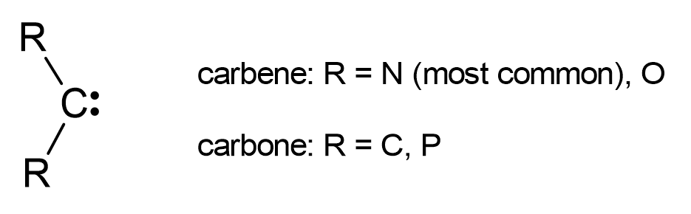

1. What orbitals do you think overlap to make the carbon-boron bonds in carbene and carbone complexes? What type of bonds are these? Be sure to consider the possibility that multiple bonds can form between carbon and boron, and provide a sketch of the orbitals to support your response.
2. The primary difference between a carbene and carbone center is the oxidation state of carbon. A carbene is C(II) and carbone is C(0).
   1. Why might there be a difference in oxidation state for these two types of carbon centers?
   2. Considering the oxidation states, how many electrons does a carbene have to donate to a boron acceptor? How many electrons can a carbone donate to boron?
3. Consider the structure and bond lengths of the carbodicarbene-borafluoene (CDC-borafluorene) complex shown in Figure 2a. How do the lengths of the carbon-boron bonds compare: B1-C1 versus C24-B1? Explain any differences, considering your response to question 3b.
4. How does the C1-C2 bond distance in the free CDC ligand compare to those in the CDC-borofluorenium complexes **2** and **3**? These values can be found in the text of the journal article. Propose a reason for why the bond lengths might be different.
5. Carbene-boron complexes like the example in Figure 1b are unstable because they are prone to protonation in air and in solution, which results in breaking the carbon-boron bond. In contrast, the CDC-borafluorenium complexes featured in this article are air stable. Using your responses to the previous questions about structure and bonding in carbene and carbone complexes, propose an explanation for this critical difference in stability.
6. Look at the variable temperature fluorescence spectra in Figure 4b. How are the spectra changing as the temperature decreases from 20 C to -60 C?
7. In a “charge transfer excited state” the HOMO is localized to the donor part of the molecule and the LUMO is localized to the acceptor part of the molecule. Looking at Figure 5, which moiety in this system is the “donor” and which is the “acceptor” considering the borafluorene and the carbone?
8. Consider Figure 6 and its relationship to Figure 4b. What does Figure 6 illustrate about the trend in Figure 4b?
9. What does AIE stand for? How do the results in Table 2 support the authors’ claims that these materials exhibit AIE? (Hint-consider the quantum yield of the single crystals to the quantum yield of the solutions.)
10. The authors mention that boron cations may be useful in “stimuli responsive materials”.
11. What are stimuli-responsive materials used in? Give an example.
12. Why is it important that the materials are air-stable?