# Worksheet: The Shapes of Orbitals of Hydrogen

**Name**:____________________________ Section____________

In this exercise, we will use web-based tools to visualize orbitals developed by Prof. Dr. Stefan Immel at the Technical University of Darmstadt in Germany.

**1. Quantum Numbers**

The atomic orbitals of hydrogen represent regions of space around the nucleus. These regions define a given probability of finding the single electron of the hydrogen in the volume they represent.

We describe the orbitals by so-called quantum numbers. Let’s review the labels and the meaning of these quantum numbers. Point your browser to the following web-page:

<http://csi.chemie.tu-darmstadt.de/ak/immel/script/redirect.cgi?filename=http://csi.chemie.tu-darmstadt.de/ak/immel/tutorials/orbitals/>

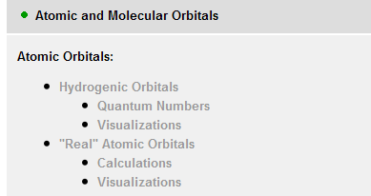

**Task** Select the “*Hydrogenic Atomic Orbitals - Quantum Numbers*” link in the listing. Using the information provided, fill out the following table.

|  |  |  |  |
| --- | --- | --- | --- |
| Symbol | Name | Function (describes what about the orbital) | Possible values |
|  |  |  |  |
|  |  |  |  |
|  |  |  |  |
|  |  |  |  |

As chemists, we commonly do not refer to atomic orbitals by their quantum numbers, but by labels such as the 2*p*x orbital, where the number refers to the principal quantum number *n*, and the letter labels describe the angular quantum number *l* and the magnetic quantum number *ml*.

**Task** For *n* = 3, list the possible values of *l* and *ml*, and provide the letter label for the orbitals.

|  |  |  |  |
| --- | --- | --- | --- |
|  | *l* values | *ml* values | *Letter labels for orbitals* |
| *n* = 3 | *l* = |  |  |
| *n* = 3 | *l* = |  |  |
| *n* = 3 | *l* = |  |  |

Let’s examine the visualizations of the orbitals.

**2. H 1*s* orbital**



Scroll down to the “*Hydrogenic Atomic Orbitals – Visualizations*”

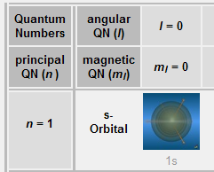

It is impossible to determine the exact position of an electron in an atom. We therefore represent the “location of the electron” as a volume or shape with a certain probability of finding the electron in that volume - say 90%. We refer to this shape as an orbital.

Let’s look at the 1*s*-orbital by clicking on the picture of the orbital. You should see 4 images or representations of the 1*s* orbital. These images help to illustrate the various representations of the volume of space, and how the representation changes with a given percentage probability or likelihood of finding the electron of hydrogen.

Image 1 shows the surface of the volume in which you have a 90% probability of finding the 1*s* electron. Images 2 and 4 show the contour surfaces at various % probability levels of the electron density.

Click on Image 4 to see slices of the 90, 80, 70, 60, 50, 40, and 25% probability levels. Think of the contour lines similar to the contour lines of a trail map.

**Task** In the space below, **sketch the 90 and 25% probability levels** to approximate scale.

25% probability

90% probability

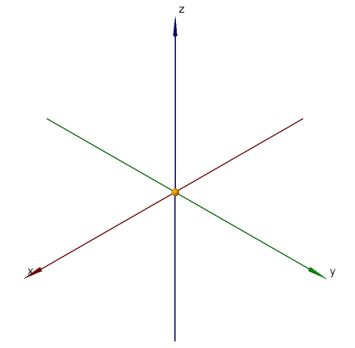 

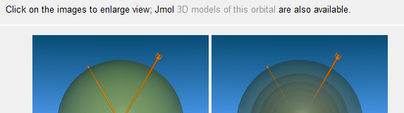

Now click on the Jmol [3D models of this orbital](http://csi.chemie.tu-darmstadt.de/ak/immel/misc/oc-scripts/orbitals.html?id=1?orbital=1s) (located above images)

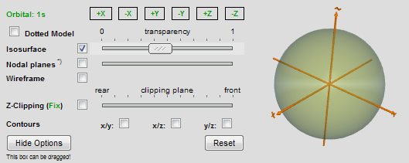To the left side of the screen, you will see a navigation box (shown to the right). Familiarize yourself with this navigation box.

To the right of the screen, Java will load – the orbitals will be displayed there. You may encounter a number of security warnings. Check the appropriate boxes and run the app.

Make sure the isosurface box is checked. If no image is visible, click the ‘dotted model’ box, and then unclick it again. The image of the isosurface should refresh.

Now slide the transparency marker to 0, and then to 1 and watch what happens. Leave it somewhere in the middle setting.

Now check the x/y and x/z contours boxes: this will show a 2D contour map of the electron density in the xy plane and in the xz plane. You may need to re-adjust your transparency level to see the contour lines: move the bar closer to 1 to make the surface more see-through.

By pressing the coordinate boxes in your navigation window, you can orient the s-orbital in various directions. Give it a try.

You can also rotate the orbital by pointing the pointer onto the orbital window, and depressing the left mouse button while moving the mouse.

To get an appreciation of the 3-D nature of the orbital, point the mouse on the Jmol viewer of the orbital, right click and select Style – Stereographic – Red+Cyan Glasses. Put on the 3D glasses provided and rotate the orbital around.

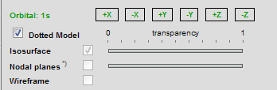Next click on the *Dotted Model* box. This representation shows the probability of finding the electrons by showing lots of dots in areas of high probability, and few dots in areas of low probability.

**Task** Are there dots near the sides of the box drawn around the orbital representation? What is the probability of finding an electron outside the sphere shown above? Are there dots near the nucleus (represented by the origin of the 3 axes)? To zoom in, point the mouse into the JMol window, right click and select zoom. What does this tell you about the probability of finding an electron near the nucleus?

**3. 2*p* Orbitals**

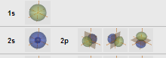

Let’s look at the 2*p*-orbitals by clicking on the picture of these orbitals. Note that the orbitals appear yellow and blue, signifying the different phases (or signs) of the wavefunctions.

**Task** In the space below, **sketch the 90 and 25% probability levels for the 2px orbital**. To help you in your sketch, click the x/y contours, make the surface quite transparent and rotate the orbital.

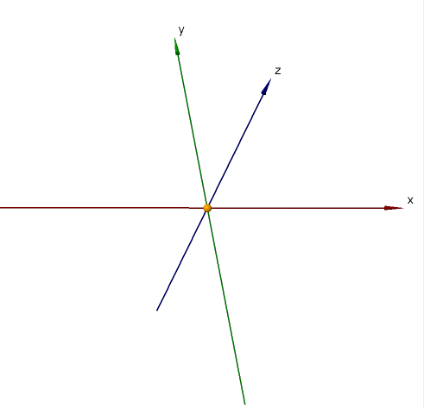

Draw in the nodal plane (you can check the nodal plane box to help you).

Check out

* the Dotted Model by clicking the box – notice the spread of the spheres.
* the 3D shape by selecting the stereoview (right click, select Style – Stereographic – Red+Cyan Glasses)
* one other 2*p*-orbital and do some of the above exercises with it.

The objective here is for you to get an appreciation of the shape of the orbitals and their spatial orientation.

**4. 3*d* Orbitals**

Let’s look at the 3*d*-orbitals by clicking on the picture of these orbitals.

Note that the orbitals appear yellow and blue, signifying the different phases (or signs) of the wavefunctions.

**Task** In the space below, **sketch the 75% probability levels for all 5 3*d* orbitals**. Draw in the nodal planes (you can check the nodal plane box to help you). Label the orbitals with their commonly used designations:

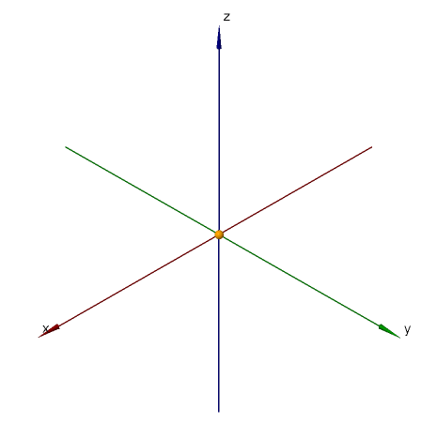





If you have extra time, check out

* the Dotted Model by clicking the box – notice the spread of the spheres.
* the 3D shape by selecting the stereoview (right click, select Style – Stereographic – Red+Cyan Glasses)