Literature Discussion: Directed Reading Questions

Article: Tsitovich, P. B.; Spernyak, J. A.; Morrow, J. R., Angew. Chem. Int. Ed. 2013, 52, 14247-14250.

Title: A Redox-Activated MRI Contrast Agent that Switches Between Paramagnetic and Diamagnetic States

In preparation for this literature discussion, read through the assigned journal article. Pay particular attention to the first page and the first two paragraphs of the second page, and peruse the remainder of the article. You will also need to access the supplemental materials for this article (follow the link at the bottom left of the first page).

It may help your understanding of the article to look up a brief description of MRI and contrast agents. To further guide you in your reading of the work, answer the following questions and be prepared to discuss your answers in class.

Morrow et al. are investigating the use of a cobalt complex as a MRI contrast agent. Let’s begin by looking at the nature of this complex.

1) Draw the Lewis structure of the TPT ligand, clearly showing the lone pairs.

2) Identify the denticity of the ligand.

3) What is the geometry of the two complexes in Scheme 1?

4) The [Co(TPT)]³⁺ was shown to be diamagnetic. Draw a crystal field energy diagram for the cobalt in this complex to explain the magnetism observed.

5) The [Co(TPT)]²⁺ was shown to be paramagnetic. Draw the crystal field energy diagram for the cobalt in this complex to explain the magnetism observed.

6) Calculate the magnetic moment of [Co(TPT)]²⁺ and comment on how it compares to the measured value.

Both forms of the cobalt-TPT complex were analyzed by ¹H-NMR (data available in the supplemental materials and shown here).

7) Examine the ¹H-NMR spectrum of [Co(TPT)]²⁺ shown below. Given the symmetry of the molecule, why are there 8 signals in the spectrum (you can ignore the large peak around 0 ppm)?
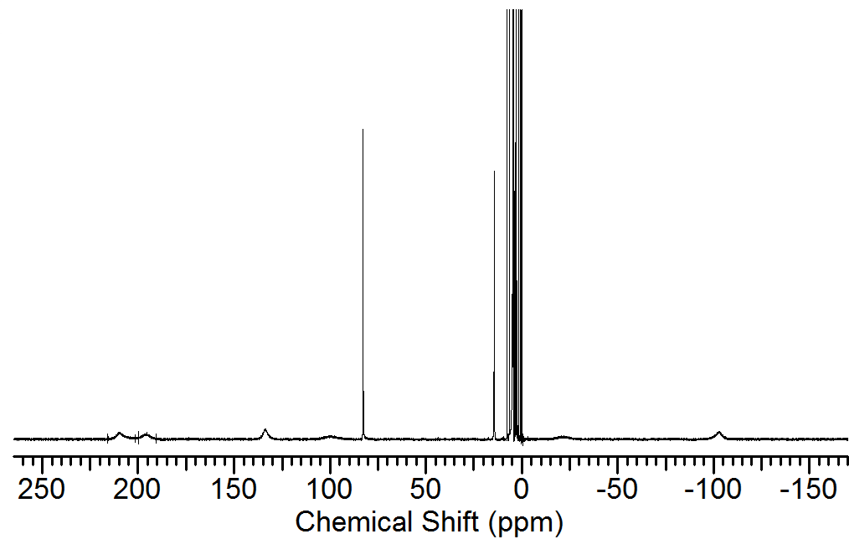

8) Examine the two ¹H-NMR spectra of (a) [Co(TPT)]²⁺ and (b) [Co(TPT)]³⁺ shown below. Provide the chemical shift ranges for the Co(II) and Co(III) complexes, and describe how the spectra differ in terms of observing the coupling between nuclei.
a) [Co(TPT)]²⁺
b) [Co(TPT)]³⁺

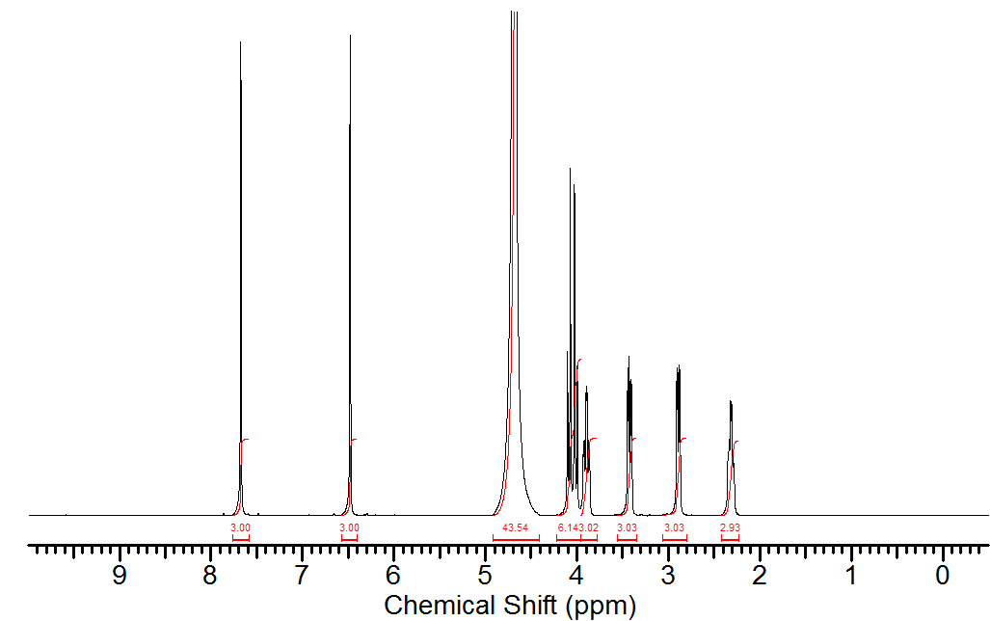

9) Considering that the magnetic moment of an electron is about 1000 times greater than the magnetic moment of a nucleus, explain the difference in chemical shift ranges for the two cobalt complexes and the lack of H-H coupling for the Co(II) complex.

The following questions deal with a modern diagnostic medical technique MRI (Magnetic Resonance Imaging), and contrast agents.

10) What does paraCEST stand for?

11) In order to be used as a paraCEST contrast agent, a compound must have exchangeable protons. Identify the exchangeable protons in [Co(TPT)]²⁺.

The following questions will be discussed in class after a short presentation on MRI and contrast agents;

12) Explain why the Co(III) complex could not be used as a paraCEST contrast agent.

13) What does Figure 1 say about the suitability of [Co(TPT)]²⁺ as a paraCEST contrast agent?

14) Use Figures 3a and 3b to describe the relationship between the %CEST effect and the oxidation state of the metal in the MRI contrast agent?

