A discussion on the “Electrochemical formation of a surface-adsorbed hydrogen-evolving species”

Read the paper entitled “Electrochemical hydrogenation of a homogeneous nickel complex to form a surface adsorbed hydrogen-evolving species” before answering the following questions (Reference: Martin, D. J.; McCarthy, B. D.; Donley, C. L.; Dempsey, J. L. Chem Comm 2015, 51, 5290–5293 DOI: 10.1039/c4cc08662g).

1. Consider the coordination environment of compound 1 and give the following information:
- The d-electron configuration
- oxidation state of nickel
- The coordination number
- electron count
- geometry
- charge
- Does 1 fulfill the 18 electron rule?

2. What do the authors mean when they refer to 1 as mer- and 2 as fac-?

3. Provide some reasoning why a Ni⁰ 6-coordinate complex might be more unstable and more readily lose a ligand than a Ni^{II} 6-coordinate complex.

4. Compare the hybridization of the non-pyridyl N atoms in 1 and 2. What impact does the hybridization have on the geometry of the ligand?

5. How are complexes 1 and 2 related to one another?

6. What does it mean to hydrogenate a substance?

7. Where do the hydrogen atoms come from for the hydrogenation of the imine bonds in compound 1?

8. Why are the imine double bonds the only place where 1 is hydrogenated?

9. The ligand used for compound 1 is an example of a Schiff base ligand. This type of ligand contains an imine (which is a compound with a C=N bond) that binds to the metal through the nitrogen lone pair. An imine is formed from a primary amine and a ketone or aldehyde according to the following reaction:
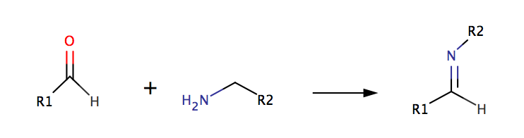
What starting materials are needed to make the ligand used for compound 1?

10. Examine the cyclic voltammograms in Figure 2.
a) Sketch the voltammograms and label each peak with the corresponding change in oxidation state for nickel.

b) How is the CV of compound 2 different from that of compound 1? What does this suggest is different about the electrochemistry of compound 2?

c) Revisit Question 3. What does the irreversibility of the reduction of Ni⁺ to Ni⁰ suggest about the relative stability of the different oxidation states for these compounds?

11. When the authors electrochemically reduce complexes 1 and 2 they observe formation of a Ni-containing film on the electrode surface.
- What oxidation states of Ni are present in this catalytically active film?

- How (using what techniques) do the authors determine the oxidation states of Ni?

12. What happens to the voltammetry as increasing amounts of acid are added to a solution of compound 1 (as shown in Figures 1 and 3)? What process does this new signal correspond to? How does it compare to the response to acid in the absence of compound 1 (see Supplementary Information, Figure S11)?
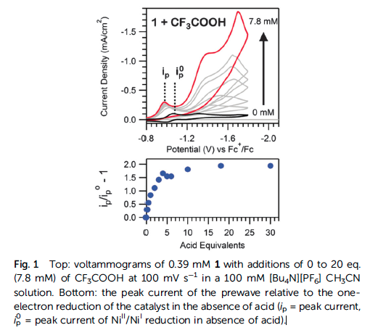
(Figure taken from Martin, et al. Chem Comm 2015, 51, 5290–5293)

13. Use Figure S8 from the paper to answer the questions below.
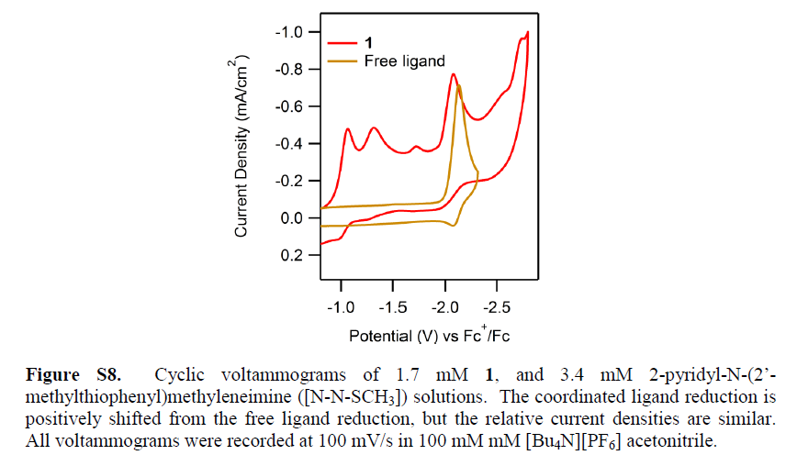
(Figure taken from Martin, et al. Chem Comm 2015, 51, 5290–5293)

- Discuss the validity of the author’s statement that “A irreversible reduction is also observed (Ep,c = 2.0 V) with twice the intensity and current integration of the Ni^{II}/Ni^{I} reduction (Fig. S7, ESI). The wave is likely the direct reduction of the [N–N–SCH₃] ligands, as suggested by voltammograms of the ligand alone (Fig. S8, ESI).”

- In terms of electron density on the ligand, speculate why the reduction potential of the ligand alone differs from that of complex 1.

14. What was the goal of the electrochemical experiments using a Ni(ClO₄)₂•6H₂O solution?

15a. What is a “rinse test” and why did the authors use this test? (What information does the result of this experiment give the authors?)

b. Is this a good experiment? Why or why not?

16. Prepare a 30-second explanation for each of the following techniques. What is the most important information obtained from each of the techniques and one limitation?
-CV

-SEM

-TEM

-XPS

-EDS

17. Examine the XPS spectra in Figure 4. Figure 4A and 4C have a different appearance. However, Figure 4B and 4D are very similar. What does this suggest?

