Opening the structures in Mercury

- Download and install Mercury if it is not already on the computer you are using.
- Download the cif from the Organometallics website.
- Open Mercury and then open the cif. Alternately, you may be able to just click on the cif and it will open in Mercury. During the installation of Mercury it was probably set to be the default program to view a cif.
- This should open the cif and have a picture of the structure.
- One the right side of the Mercury window there should be a secondary window named Structure Navigator. Depending on the computer you used and institutional licenses, your window may look slightly different than the one shown below. The important thing is that Structures>om400494t_si_001.cif is listed. The first two structures are the ones of interest for this activity. Clicking on either of them will switch between the structures.
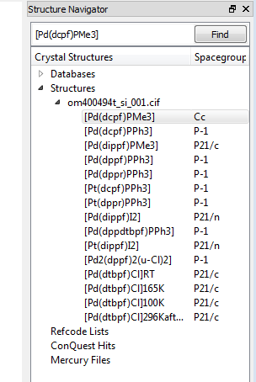
- The structure will first appear with the hydrogen atoms shown. This tends to make the structure very difficult to see. In the bottom center is the options box. Click off show hydrogens.
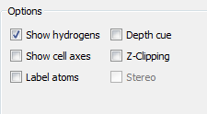
- If you hold a left click on the structure and drag the mouse, you should be able to rotate the structure in three dimensions. You can also manipulate the size of the structure by holding a right click and dragging the mouse.
- Toward the top right of the window is a pulldown menu for Picking Mode. Change this to Measure Distances.
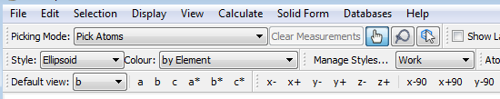
- Click on any two atoms of interest and the bond length should appear on the screen. Unfortunately, this does not list the estimated standard deviation (esd) for this measurement. The esd values are a measurement of the precision of the data and are considered to be the accuracy in the last reported value. For example, if a bond length were reported as 2.5794(2) Å, the length is considered to be 2.5794 + 0.0002 Å. To get that value, go to Display>More Information>Bond List and then find the two atoms you are interested in. To get the bond length with the esd you may need to scroll right in the window. You will want to close this window when you are done.
- Next to Picking Mode is a button for Clear Measurements. You will not be able to click on this button until you have made a measurement. You will likely want to do this between measurements. You also need to click on any atoms you have previously selected, or they will be used to make the next measurement.
- Measuring bond angles is performed similarly except you choose three atoms. When you go to Picking Mode you will want to choose Measure Angles. The order that you choose the atoms for this is important; the second atom you choose will be defined as the vertex of the angle. The bond angles with esd values are found under Display>More Information>All Angles List.
- Again, don’t forget to Clear Measurements and unselect atoms.
- The next step is to calculate the centroids (geometric center) of the C₅ rings. To do this change Picking Mode to Pick Atoms. Choose five carbon atoms of one of the C₅ rings. Go to Calculate>Centroids. A new window (Centroids) will appear, click on New Centroids. This will bring up another new window (Centroid Properties) in which you should hit Ok. You should notice a new ball in the center of the C₅ ring, the disappearance of the Centroid Properties window and a centroid being listed in the Centroids window. You can now click on the five carbon atoms of the other C₅ ring and then on New Centroids to add the centroid to the second ring.
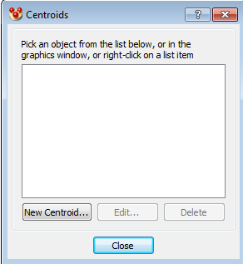

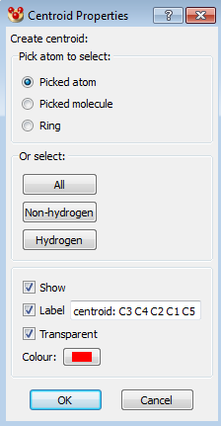
- The centroids can now be used in measurements such as bond angles. You must actively have the angle measured in order to obtain the value which you do by going to Display>More Information>Angles List, however esd values are not available in the list. If you wish to remove a centroid, click on the centroid you wish to remove in the Centroids window and click Delete.
- To calculate a plane for the C₅ ring, choose the five carbon atoms of one of the C₅ rings. Go to Calculate>Planes. A new window (Planes) will appear, click on New Plane. This will bring up another new window Plane Properties) in which you should hit Ok. You should notice a plane passing through the C₅ ring, the disappearance of the Plane Properties window and a plane being listed in the Planes window. You can now click on the five carbon atoms of the other C₅ ring and then on New Plane to add the plane to the second ring.
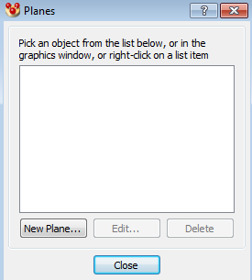

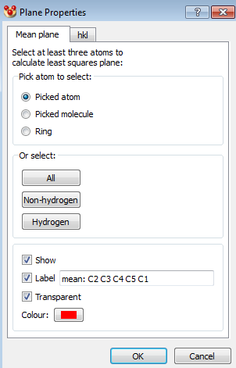
- The planes can now be used in measurements such as bond angles. In this case, with Measure Angle selected in the Picking Mode, just click on the two planes. The order does not matter. You must have the angle measured in order to get a value which is done by going to Display>More Information>Angles List. As with the centroid measurements, esd values are not available in the list. If you wish to remove a plane, click on the plane you wish to remove in the Planes window and click Delete.
- There are many other options available in Mercury. One other one you may wish to use is Display>Styles>Spacefill (the default is Ellipsoids). This allows you to get a feeling for the steric crowding in your structure. You may wish to Show hydrogens for this view to get a fuller appreciation for the steric bulk.

