Literature Discussion of “Spectroscopic, Structural, and Computational Analysis of [Re(CO)₃(dippM)Br]^{n+}
(dippM = 1,1’-bis(diisopropyl)phosphino metallocene,
M = Fe, n=0 or 1; M = Co, n = 1)

by Nataro et al., Dalton Trans, 2016, 45, 4819-4827.
This VIPEr Learning Object is dedicated to Dr. Nataro, the recipient of the ACS Award for Research at an Undergraduate Institution at the ACS National Meeting Spring 2022.
Electron counting - ionic method
1. a) Inorganic chemists often use abbreviations for the ligands in a complex to simplify the formula. Using the information in Table 1, identify the ligands dppf, dippf, and dippc.

b) These ligands are interesting in that they also contain a metal center, which leads to some of the interesting redox consequences seen in the paper. Give the oxidation state, d electron count, and valence electron count for the central metals in dippf, [dippf]⁺, and [dippc]⁺.

c) The bis(phosphino)metallocene ligands also have some interesting steric considerations. What are these factors? Consider Table 3 and information in the introduction in answering this question.

Electron Counting - CBC method
2. Use the Covalent Bond Classification (CBC) method to count the electrons in (a) Re(CO)₃(dippf)Br and (b) [Re(CO)₃(dippf)Br][BF₄].

a) Re(CO)₃(dippf)Br

b) Re(CO)₃(dippf)Br⁺

Backbonding

3. The IR vibrations of metal carbonyls are strong reporters of the electron density on the metal. Look at Table 2 in the paper to answer the following questions:

- Use the IR data of the CO stretches to compare the bidentate phosphines dppf and dippf as ligands to rhenium. Which one is a stronger donor and why? Justify your answer in complete sentences.

- Upon oxidation of the dppf or dippf ligand, what happens to the IR signals for the CO stretches? What does that mean for the Re center in terms of electron density and back-donation? Justify your answer in complete sentences.

Molecular Orbital Theory

Rough key provided for now. Will clean it later. (jan 13, 2022)
4. a) Draw a qualitative σ-only MO diagram for ReBr(L₂)(CO)₃. Treat the molecule as octahedral as an approximation. (use the generating LGOs method which is listed as a related activity https://www.ionicviper.org/class-activity/generating-lgos-salcs)

b) CO ligands are strong pi ligands. Are they pi-acids or pi-bases? Modify your MO diagram to indicate the major effect of the pi interaction on the MO diagram

c) Challenge question: let’s derive the MO diagram for ferrocene in the D_{5h} point group. Each Cp ligand is an XL₂ ligand, and the LGOs for bonding can be derived using a qualitative approach. This is a challenging problem. To make it easier, the LGOs are described here and shown below: p_{z} orbital unhybridized, s/d_{z2} hybrid orbital, p_{x}/p_{y} unhybridized, d_{xz}/d_{yz} unhybridized. There is also a weak delta bond between d_{xy}/d_{x2-y2} to the Cp rings… the d_{xy}/d_{x2-y2} orbitals are slightly bonding.

Here are the LGOs for 2 Cp rings in ferrocene in D_{5h} and their generator functions. They are drawn so the top ring is above your eye’s view and the bottom ring is below your eye’s view. Thus, for the p_{z}, A₂” LGO, the top ring is shaded below the ring and the bottom ring is unshaded above the ring, so it can overlap with the pz orbital (from which it was generated).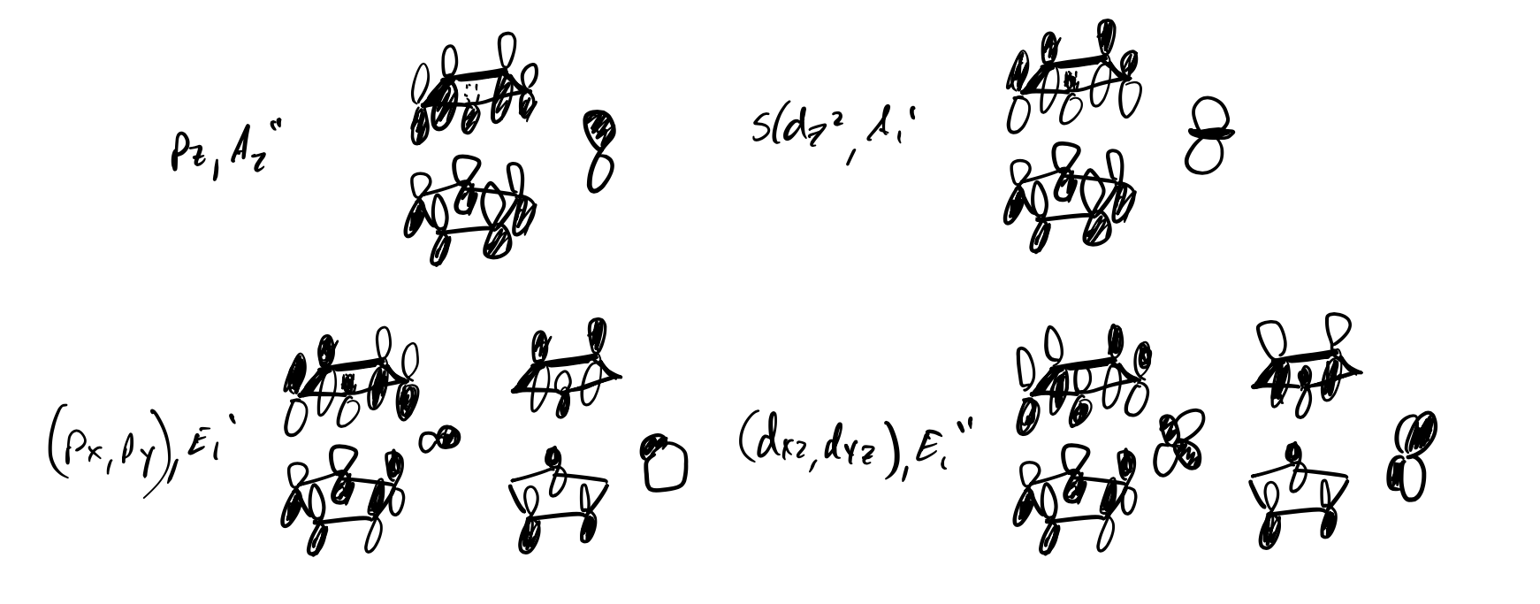

d) Can you use the MO diagrams to rationalize why an electron is removed from ferrocene upon oxidation of the complex and not from the Re orbital?

Mossbauer Spectroscopy
5. Figure 2 in the paper shows the Mössbauer spectra of dippf, [Re(CO)₃(dippf)Br] and [Re(CO)₃(dippf)Br]⁺. Please read the entry on Mössbauer spectroscopy on Wikipedia (https://en.wikipedia.org/wiki/M%C3%B6ssbauer_spectroscopy) and answer the questions below:
a) What kind of electromagnetic radiation is emitted by the source and absorbed by the sample in Mössbauer spectroscopy?

b) What physical state (solid, liquid, or gas) must the sample be in to perform Mössbauer spectroscopy and why is this the case? How was this accomplished with the samples in the paper?

c) Use the information in Table 1 to describe the difference between the dippf and dippc ligands. Given this difference and the information you’ve learned about Mössbauer spectroscopy, why do you think the authors did not take the Mössbauer spectrum of dippc?

d) The y axis in Figure 2 plots the transmittance of the electromagnetic radiation in the sample. What quantity is plotted on the x axis of this figure? How is this quantity related to the energy of the electromagnetic radiation and the chemical environment of the sample?

Magnetic Moment
6. In the article, it states that [Re(CO)₃(dippf)Br] was oxidized to [Re(CO)₃(dippf)Br]⁺ using [NO][BF₄]. The oxidized species was determined to be paramagnetic, with a μ_{eff} of 2.72 B.M. at 22 °C.
a) In the neutral complex, both metal centers (Re and Fe) have six d-electrons. Given the ligands attached to the metal centers, would you expect these metal centers to have high- or low-spin electron configurations?

b) Please fill in the d-orbital splitting diagrams provided below. Would you expect the neutral complex to be paramagnetic or diamagnetic?
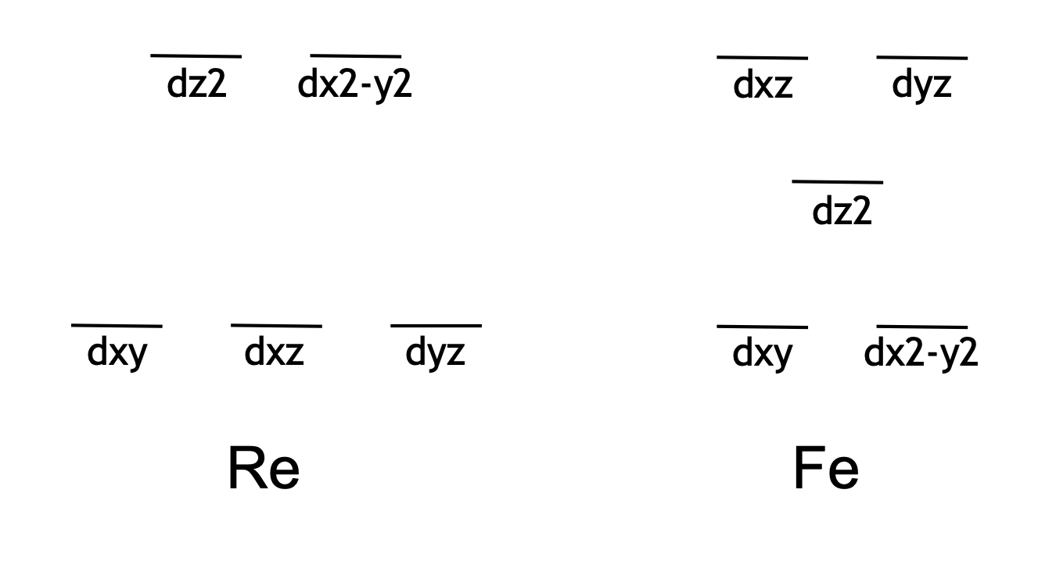

c) Upon reaction with [NO][BF₄], one-electron oxidation of the complex occurred. What spectroscopic evidence suggested that oxidation had occurred?

d) After oxidation of the iron to Fe(III), the cationic complex was determined to be paramagnetic. How did the paramagnetism impact the NMR spectroscopy of the complex?

e) One technique used to determine the effective magnetic moment (μ_{eff}) was the Evans method. Please provide a short description of how this method works.

f) Since all electrons would be paired in the neutral complex, we would expect that an electron is removed from the d_{z2} orbital, leaving one unpaired electron. Using the equation provided below (n = number of unpaired electrons), calculate the spin-only magnetic moment (μ_{s}) that would be expected for a complex with one unpaired electron. Does this value match the experimentally determined μ_{eff}?
$$μ_{s}=\sqrt{n\left(n+2\right)}$$

g) Is the experimentally determined value for μ_{eff} consistent with values measured for similar complexes?

DFT study
7. a) In the article, it states that the molecules were studied using DFT calculations. What does DFT stand for, and why might you use that method to study an inorganic complex?

b) From Figure 3: What does “UB3LYP” mean? What is an isosurface?

c) What is spin density? Why does the presence of the majority of it on the Cp₂Fe unit support the presence of Fe(III) in [Re(CO)₃(dippf)Br]⁺?

8. What is the title of the article that is cited as reference 6? Why did Nataro et al. cite this article in the introduction of their work?

9. Identify the corresponding author of the paper. Use Google Scholar to answer these questions.

a) How many items has this author published?

b) What is the year of the author’s first publication?

c) What is the title of the author’s most cited publication? How many citations does that paper have?

d) How many publications did this author publish in 2019? How many of the author’s 2019 publications are peer-reviewed?

10. The corresponding author, Dr. Nataro, is also a well-reviewed author outside of chemistry. Use Amazon (www.amazon.com) to answer these questions.
- What is the title of the author’s book?

- In your own words, provide a brief summary of the book.

- The book focuses on a certain type of animal. Which elemental symbols can be used to spell the name of the animal?

