**Inorganic Nomenclature Worksheet: Names of Coordination Compounds**

**NAME:**

***Instructions****: Do your best to complete the questions below in order. Our goal is to try to derive the official rules for transition metal nomenclature. Begin by looking at Figure 1, the last page.*

Both of the metal complexes in **Scheme 1** have the same type and number of ligands connected to the metal ion. List 3 differences you can identify between the complexes:

**Scheme 1**



1. _____________________________________
2. _____________________________________
3. _____________________________________

**Note:** Nomenclature for inorganic compounds refers to the process of naming those compounds. All of the aspects that make a compound unique must be included in a comprehensive chemical name. This assignment is designed to help you develop the skill of correctly naming inorganic complexes. It will guide you through the process of identifying important attributes of complexes that are relevant to properly name complexes. By the end of this assignment you will (hopefully!) be able to confidently connect an inorganic complex’s name to its structure.

1. Determining the charge on the ligands and the metal in a metal complex

The first thing you need to do when looking at a metal complex is understand the type and the charge of the ligands. You can refer to a table of ligands but usually a simple analysis of the ligands in the complex will allow you to figure out the charge that it has.

**Consider the following octahedral metal complex: CoCl63-**

1. What is more electronegative between Cl and Co? Cl or Co
2. What is the typical charge of Cl as an ion? ­­­­­_________
3. If there are 6 Cl- ligands and the overall charge is 3-, what’s the charge of Co? __

What other ligands would you expect to behave the same as Cl-?_________

What is the typical charge on an NH3 molecule? On H2O? On CO? ___ ___ ___

**Key Point:** If a molecule is neutral it remains neutral when bonded to a metal ion (this goes against the oversimplified view using *formal charge*). NH3 is neutral and if bonded to a metal it is still viewed as neutral. If a molecule or ion is negative and it bonds to a metal it is still viewed as negative. A trick to understand the characteristics of a ligand is to push both electrons in an M-L bond back onto the ligand and analyze its charge in that state.

Determine the charge on the Co ion in complex **A,** **Scheme 2** considering that NH3 has no charge? _________

**Scheme 2**



Determine the charge on the Co ion in complex **B, Scheme 2** considering the -1 charge of chloride? _________

In the space at the right, draw a complex with an overall charge of 0. Use Ni2+ as the metal and NH3 and Br- ligands. The complex should have 4 total ligands and be square planar.

1. Determining the charge on a cation/anion in a complex: It is important to know the charge on the metal but it is also critical to understand how charge is distributed in more complicated complexes. Charge is always balanced in simple salts and this is the same with metal complexes. Take for example CoCl63-, this complex must have a positively charged species to balance its charge.

**Scheme 3** shows the *chemical formula* and the *structure* of two metal complexes. Use these to answer questions **a** – **d.**

* 1. In the *chemical formula* what is written first: the cation or anion?

**Scheme 3**

**Chemical Formula Structure**

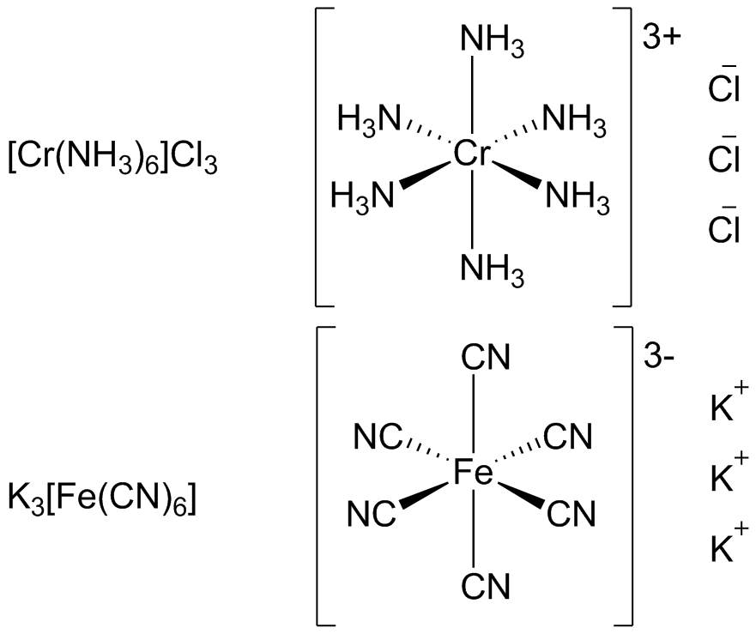

_____________________________

* 1. What is the charge on the Cr ion and the Fe ion?

Cr:_________ Fe: _________

* 1. What is the cation and anion in the following chemical formula K2[Pt(ox)2]

_____________________________

* 1. Why are some molecules located in brackets in the chemical formula and others not?

_____________________________

_____________________________

_____________________________

**Key Point:** The ligands bonded to the metal make up the ***inner coordination sphere* (ICS)**. The other ions that balance charge are simply the counter ions or outer coordination sphere. Ligands that are part of the ICS are written in brackets in the chemical formula. Counter ions are written outside the brackets.

1. Interpreting chemical names of complexes: Given the following metal complex chemical names and chemical formulas in **Scheme 4**. Answer the following questions aimed at helping you identify naming patterns.

**Scheme 4 Chemical Name Chemical Formula**

Diamminesilver(I) chloride [Ag(NH3)2]Cl

Potassium hexacyanoferrate(III) K3[Fe(CN)6]

Hexacarbonylmanganese(I) perchlorate [Mn(CO)6]ClO4

Ammonium tetrachlororuthenate(III) NH4[RuCl4]

* 1. Which chemical formulas indicate the TM and the ICS has an overall positive charge? ___________________. A negative charge? ___________________
  2. What is named 1st, the cation or anion? _____________________
  3. What does the number in parentheses mean? ________________________

__________________________________________________________________

Is the name of the TM complex different if it is positive or negatively charged? How is it different? __________________________________________________________________

__________________________________________________________________

* 1. Is the name of a ligand changed from that of the free species? How?

__________________________________________________________________

* 1. Is the name changed if the species is a counter ion?  **Yes No**
  2. Are the name of the ligands or the metal written first for the ICS?

__________________________________________________________________

Considering **Scheme 4** write reasonable names for the following compounds:

[Au(NH3)2]Br __________________________________

[Cr(H2O)6]Cl2 __________________________________ (H2O as a ligand is called *aqua*)

Na4[Co(CN)6] __________________________________

**Key Point:** Ligands in the ICS of a TM have their name changed. Unfortunately, it can be in unpredictable ways. You should familiarize yourself with a table of common ligands like H2O (aquo), NH3 (ammine) or NH2- (amido) that have less than obvious names.

1. Isomerism in metal complex nomenclature: For the remainder of this assignment you can reference **Figure 1** which contains a collection of metal complex structures with their chemical names and chemical compositions. Answer questions **a** – **e**.
2. Regarding the example structures in **Scheme 5**, what is different about the arrangement of the B ligands?

**Scheme 5**



____________________________________________

____________________________________________

Find two structures in **Figure 1** with the same difference in structure. How is this difference identified in their names?

____________________________________________

____________________________________________

1. How are the number of ligands indicated in the chemical names? Make a list indicating how the number of ligands from one to six are indicated. There are times where the exact same number of ligands (2 or 3) are named two different ways. What are the two prefixes and why might this be done?

_______________________________________________________________________

_______________________________________________________________________

_______________________________________________________________________

_______________________________________________________________________

_______________________________________________________________________

1. What dose *fac-* and *mer-* indicate about the orientation of the ligands?

_______________________________________________________________________

_______________________________________________________________________

1. If the ligands in a complex are arranged in a *cis*, *trans*, *fac*, or *mer* arrangement is there a change in the name of those ligands?

**Yes No**

1. Ligands commonly bridge between or connect two metal atoms. Is the presence of a bridging ligand indicated in the name of the complex? How?

_______________________________________________________________________

_______________________________________________________________________

_______________________________________________________________________

**Comprehension Check**: For the following chemical names, draw the chemical structure and the chemical formula. If the ICS portion is charged then show the charge but do not include the counter ions.

1. *cis-*diaquatetraiodopalladium(IV)

**Chemical Formula**

**Structure**

1. Potassium *trans*-bisacetylacetonatodicyanoferrate(III)

**Structure**

**Chemical Formula**

1. *mer-*Triaquatribromocobalt(III)

**Structure**

**Chemical Formula**

1. **-oxo-bis(pentaamminechromium(III)) iodide; (both Cr are octahedral)

**Structure**

**Chemical Formula**



**Ti(acac)3+**

**NiCl42-**

**Co(en)2I2**

**Cr(H2O)3(CN)3+**

**PtCl4Br22-**

**Mn(CO)4Cl2+**

**Mn(CO)4Cl2+**

**PdCl2(NH3)2**

**MnCl3Br32-**

**Fe(NH3)5Cl2+**

**[(en)2Co(-OH)2Co(en)2]5+**

**[(NH3)4Co(-OH)(-NH2)Co(NH3)4]4+**

**Ni(H2O)2Br2**

**Fe(NH3)62+**

**Figure 1** Metal complexes and chemical names or partial chemical names for use in answering above questions.