PROTEIN DATA BANK
A Beginner’s Guide

The goal of this document is to provide some basic information about an important, free resource for viewing structures of biological molecules – the Protein Data Bank or PDB. The PDB is a website where people who have solved structures of biological molecules (proteins, nucleic acids, etc.) can deposit their data for the public to use. While the PDB has many, many different features, this document focuses on ways for new users to get started with this resource and provides examples of exercises I have asked students to do in my biochemistry and bioinorganic courses.

In my classes, students are asked to write short (~4-5 page) papers about the structure and function of a particular biomolecule. As part of this assignment, they need to be able to view and explore the structure of the molecule as well as to be able to generate their own figures so that they can show things like which ligands are bound to a metal. This assignment starts with students being given the PDB ID code for their assigned biomolecule. Next, they find their molecule on the PDB website, explore what information is provided, and use one of the viewing resources to examine the structure of the molecule.

Important Disclaimer: As with any resource on the web, the PDB and some of the viewing programs change over time. This document was current when submitted to VIPEr, but my experience is that I’ve had to check that the links, menus on the website, etc. were current each year when I’ve given this assignment in my classes.

Online PDB Tutorials:
When students are new to the PDB site, I give them an assignment to view the narrated tutorial. This feature used to be on the PDB site itself, but is now located at http://www.openhelix.com/pdb. There are 9 sections in this tutorial – ranging from 2-20 min long. One could tailor which sections you ask students to view. Sections that might be particularly helpful for viewing an assigned structure are:

Introduction and Credits
Basic Searching and Browsing
Structure Summary Page
Tools & Education

I ask them to turn in answers for some questions about the PDB site after viewing the tutorial. Examples of some things I have asked in the past are:

1. Name 3 pieces of information that can be obtained on the “Structure Summary” page.
2. Briefly state the difference between the asymmetric unit and the biological molecule.

Generally, each year I refresh my memory by viewing the tutorial and come up with a few, straightforward questions about points I want to make sure students understand after seeing it.

Viewing Structures and Making Pictures:
In order to access their molecule, students need to go to the PDB website (www.rcsb.org/pdb). They find their molecule by typing in their assigned PDB ID code into the search box at the top of the page. For example, if your assigned protein was cytochrome c peroxidase, you would type in 2CYP and be brought to the entry for the structure of yeast cytochrome c peroxidase. Once at this page, students can access lots of information about the structure, as described in the online tutorials mentioned above.

On the right-hand side of the page is a picture of the molecule. Clicking on “More Images” shows other pre-made images of the structure. Underneath the structure are options for various viewing programs. You can do all sorts of things to make your own protein pictures with these molecular viewing programs. You can display side chains to look at metal ion binding sites, zoom in on particular regions, change colors, etc. Some of these viewing programs are more complicated than others, but all require some kind of learning curve.

What I normally do is to give an assignment asking the students to explore a few of the programs and to print and turn in a picture of their molecule that they have made using one of these program. I suggest a few that are simple to use and have decent help menus below:

Jmol is one viewer that has been around a long time and is relatively easy to use. Help is available for Jmol and the other viewers on the PDB site at: http://www.rcsb.org/robohelp_f/ - molecular_viewers/introduction_to_molecular_viewers.htm. This help site gives a good overview of some of the programs that are available as well as links to find additional help for each program.

Another simple molecular viewer that has come out recently is StarBiochem http://web.mit.edu/star/biochem/. I have found this program very easy to use to generate figures.

A final, more powerful molecular-viewing program is Deep View (formerly known as the SwissPDB Viewer). Two Journal of Chemical Education articles that use Deep View as part of a class or lab exercise are:
N.J. Ship and D.B. Zamble, J. Chem. Ed., 2005, 82, 1805-1808
T.L. Schneider and B.R. Linton, J. Chem. Ed., 2008, 85, 662-665

These articles give some good ideas of what kind of things are possible to do using these viewing programs.

Molecule of the Month:
Finally, I would be remiss not to point out the “Molecule of the Month” feature on the PDB site. Each month the website features a new molecule, providing a good summary of its structure and function. The Molecule of the Month is featured in the center of the PDB home page (www.rcsb.org/pdb). Previous features can be found at:
http://www.rcsb.org/pdb/explore/motm.do.

I have found this a great place to find interesting molecules and PDB codes to assign to students in my classes.

Examples:
Below are a couple of examples of figures I’ve made using various viewing programs:
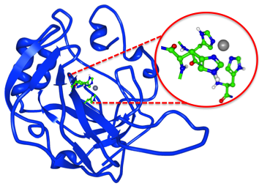

Figure of carbonic anhydrase generated from PDB file 1ZNC using the program Protein Workshop to obtain the protein and active site structures. I added the red lines and circle in PowerPoint. Note: This figure is on a slide in the Metals in Biological Systems – Who? How? and Why? Five Slides About Learning Object on VIPEr.
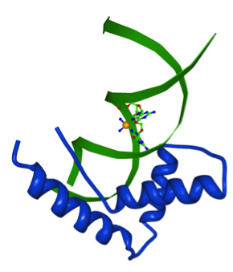

Figure of HMG1 domain A bound to a cisplatin-modified DNA duplex generated from the PDB file 1CKT using the program StarBiochem.

