Application of binomial distribution to interpret ³¹P NMR for aqueous solution of α-dodecatungstophosphoric acid, α-H₃[PW₁₂O₄₀]

Russel F. Algera and Mariusz Kozik
Department of Chemistry and Biochemistry, Canisius College, Buffalo, NY 14208

α-Dodecatungstophosphoric acid, H₃[PW₁₂O₄₀], is a strong acid whose anion has so-called "Keggin" structure. The anion structure has overall T_{d} symmetry and is based on a central PO₄ tetrahedron surrounded by twelve WO₆ octahedra, arranged in four groups of three edge-shared octahedra, W₃O₁₃. These groups are linked together and to the central PO₄ tetrahedron by sharing corners.

The structure is shown below in the polyhedral form in which the tungstens reside in the centers and oxygen atoms are at vertices of the white octahedra. The central tetrahedral PO₄ unit is shaded and is surrounded by twelve WO₆ octahedra. Note that all tungsten atoms in this structure are identical.

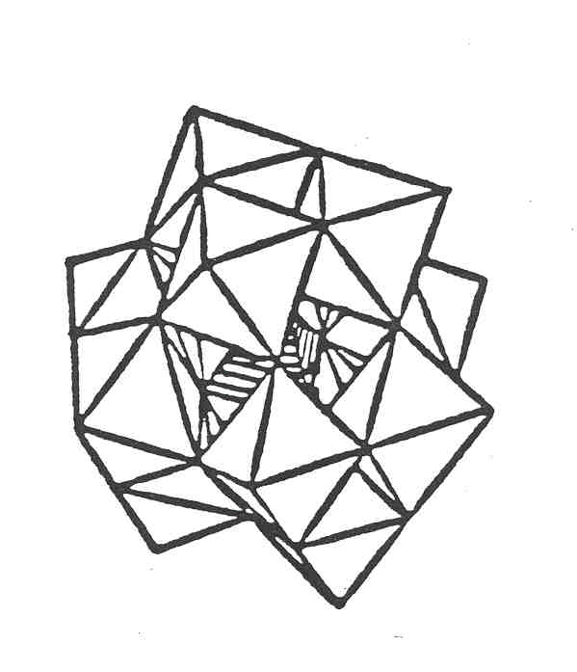
Figure 1. Polyhedral representation of α-[PW₁₂O₄₀]³⁻ structure.

³¹P NMR of aqueous solution of H₃[PW₁₂O₄₀] consists of a symmetrical heptet with approximate intensities 1 : 4 : 11 : 16 : 11 : 4 : 1. See Figure 2.

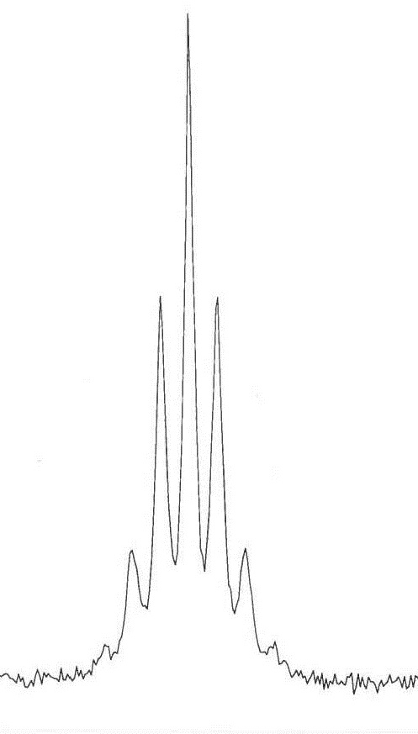

Figure 2. ³¹P NMR of 0.1M H₃[PW₁₂O₄₀](aq)

Interpret the spectrum knowing that the only NMR active isotope of tungsten, ¹⁸³W, with spin ½, is 14.3% abundant. The other isotopes, ¹⁸⁰W, ¹⁸²W, ¹⁸⁴W, and ¹⁸⁶W, all have a nuclear spin equal to zero. Assume that the only observed coupling is two-bond P-W coupling.

To do your interpretation answer the following questions 1-7.
1. Group all isotopes with zero nuclear spin into one group and mark them all as ¹⁸⁴W. Then any [PW₁₂O₄₀]³⁻ anion (PW₁₂) can be written as P(¹⁸³W)_{k}(¹⁸⁴W)_{12-k}. List all PW₁₂ anions which exist in aqueous solution, but differ in isotopic distribution of W. Which anions contribute to the spectrum?

2. Write the general expression for the multiplet observed for each individual anion with the formula P(¹⁸³W)_{k}(¹⁸⁴W)_{12-k}.

3. Consider the probability mass function used to predict the probability of exactly k successes in n trials, where success probability in individual trial is p.

$f= \left({n \atop k}\right){(p)}^{k}{(1-p)}^{n-k}$ where $\left({n \atop k}\right)=\frac{n!}{k!∙\left(n-k\right)!}$

Apply this equation to calculate mole fraction of the PW₁₂ anions with k ¹⁸³W isotopes.

4. Recall that the intensities within the multiplets, due to coupling with spin ½ nuclei, follow the Pascal’s triangle.

1
1 1
1 2 1
1 3 3 1
1 4 6 4 1
etc…

For example the quartet has intensities 1 : 3 : 3 : 1.

In order to use the triangle to predict relative intensities of all signals in the observed spectrum, these values need to be normalized, so that the sum of all signals for a given multiplet equals to 1. For example, in the triplet, 1:2:1 needs to be replaced by 0.25:0.5:0.25. Calculate the normalized intensities for the Pascal triangle. Limit your calculations to the multiplets originating from the anions with mole fractions greater than 0.001.

5. Combine your answers in 3 and 4 to calculate the relative intensities of all signals within each multiplet.

6. All multiplets are centered around the same chemical shift. As a result some signals from different multiplets superimpose. Draw the pattern demonstrating all spectra, showing which signals superimpose. Calculate the expected intensities for all signals in the final spectrum.

7. Fully interpret the observed spectrum and the intensities of all peaks.

