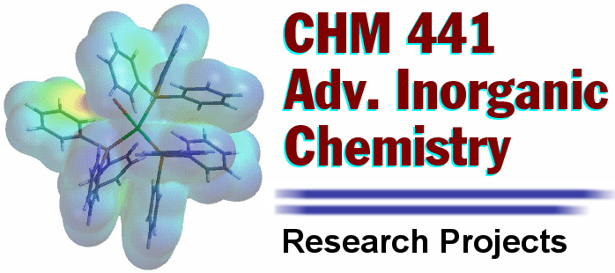

Assignment #1
Preliminary literature search and topic selection

Step 1:

Begin thinking about topics that may interest you. Feel free to search the web, pick up a book or journal in the library, or simply flip through your text. At the beginning, only concern yourself with a general area of research (i.e. fullerenes, catalysts, main group compounds, transition metal complexes, or zeolites to name a few). After you look around a bit you will begin to focus in on a particular research topic (i.e. metallofullerenes, hydrogenation catalysts, interhalogen compounds, metal-metal bonded complexes, or catalytic zeolites). Once you have a few in mind, try your best to narrow your choices down to three topics.

Step 2:

Next, you must conduct a brief preliminary literature search for each of your three topics utilizing the American Chemical Society (ACS) website (www.acs.org) and SciFinder Scholar as demonstrated in class. You are very fortunate to have access to ALL of the ACS journals. Take a few minutes to explore the variety of articles that appear for each search. Remember that you can save any of the journals that appear since they are all available in Adobe Acrobat PDF format.

Step 3:

For each of your three selected topics: (1) Write a paragraph or two (~500 words) explaining why you are interested in the particular area and what type of project you might be willing to try in this area. (2) Give the abstract and reference information for two journal articles you found interesting during your literature search. Use the reference format below. (3) For each journal article you cite, give a short description (couple of lines) of the article and why it is useful.

Proper Reference Format:

Sharp, P. R.; Schrock, R. R. J. Am. Chem. Soc. 1980, 102, 1430.

Step 4:

Rank your four topics by personal preference (1 = favorite, 3 = least favorite). Turn in the above at the beginning of class on Friday, September 1st. We will meet and discuss possible research project topics as soon as I look over your submissions. See me with any questions or for any clarifications.

