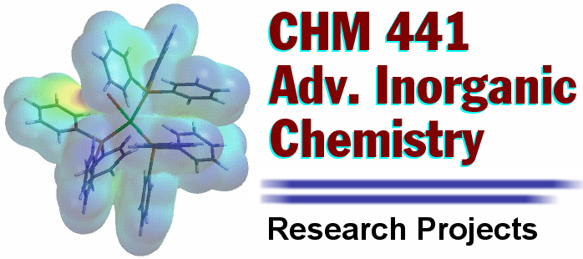

Assignment #2
Preliminary Project Proposals

First, you must visit the CHE 441 Moodle site and download:

Research Project Full Proposal Solicitation (Document CHE441-F10)

In the previous assignment, you chose topics of interest to you. Next, you and your research partner must consider which of these topics is of significant interest and will yield a reasonable research project for the time allotted in lab, given our facilities. Your group must now develop a specific idea for a research project you wish to pursue in the ~5 laboratory periods set aside for this project. You will prepare a preliminary proposal consisting of: (1) a brief, ~300 word statement of your group’s research goals; (2) an outline of the goals for each laboratory period; and (3) a preliminary budget for supplies and chemicals. Once your group has developed a preliminary proposal you must schedule a brief meeting with Dr. Porter (outside of regularly scheduled class time) to gain approval to move forward the development of a full proposal for your idea.

Note: The proposal solicitation document is the rulebook for that specific grant program. Instructions must be followed EXACTLY or your proposal, regardless of how amazing the science might be, will end up in the trash! Funding agencies receive an incredible amount of proposals for virtually every grant program. If you don’t take the time to follow the rules listed in the program solicitation, they won’t even take the time to read it!

