La₉RbIr₄O₂₄: A Rubidium-Containing Oxide with a New Structure Type

Please complete these questions using the communication Inorganic Chemistry 2006, 45(3), 946-948. https://doi.org/10.1021/ic051890s

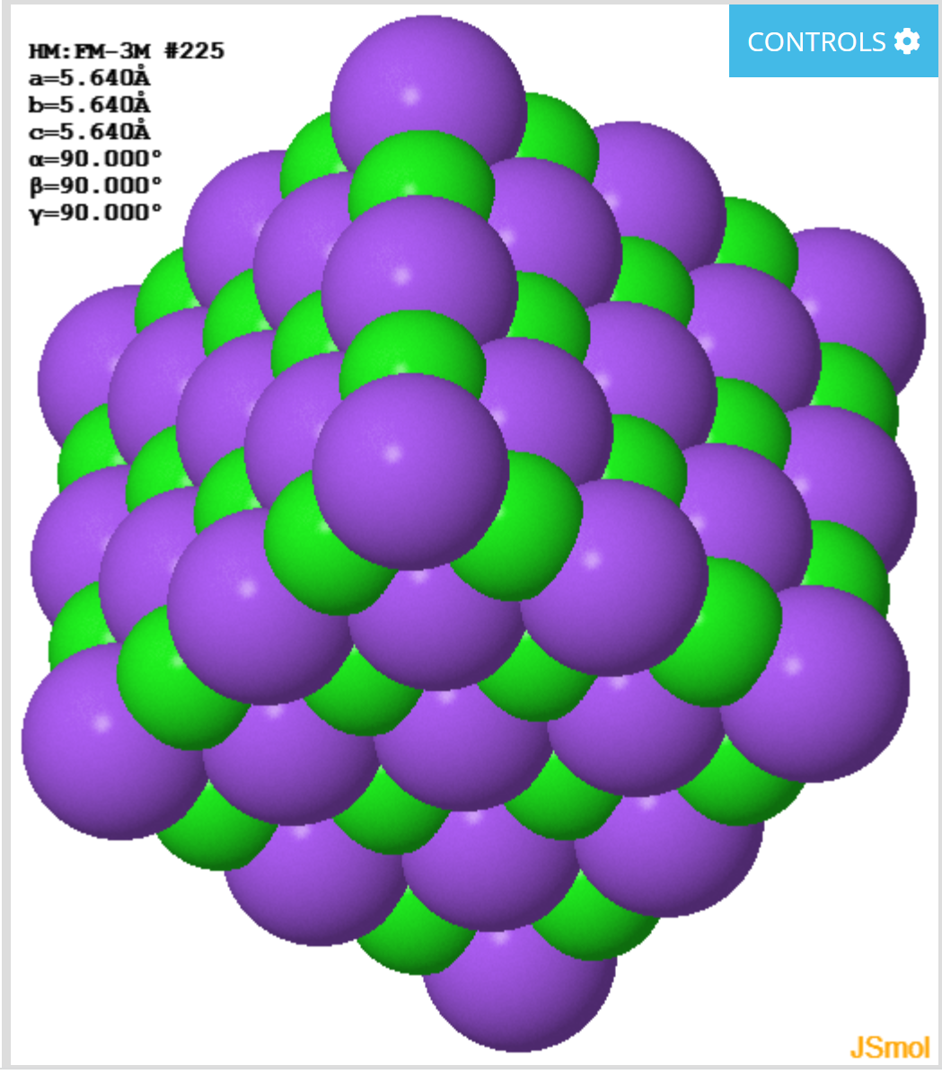
1. The first sentence of the article refers to rock salt, spinel and perovskite structures of metal oxides.

a) View an interactive structure for rock salt at https://www.chemtube3d.com/_rocksaltfinal/. Note that multiple unit cells are depicted.

i) The identity of each atom in the structure is shown when the cursor is placed over that atom. Identify the atoms that correspond to each color.

purple = ________________ green = ________________

ii) If the chloride ions are considered to form a face-centered cubic (fcc) / cubic close packed (ccp) lattice, the sodium ions occupy which type of holes in the structure? What percentage of these holes are occupied?

iii) State the coordination number (CN) for Na and for Cl.

b) View an interactive structure for spinel (MgAl₂O₄) at https://www.chemtube3d.com/_spinelfinal/. Note that multiple unit cells are depicted.
The oxygen atoms form a fcc / ccp lattice within the structure.

i) The identity of each atom in the structure is shown when the cursor is placed over that atom. Identify the atoms that correspond to each color.

red = __________ gray = __________ green = __________

ii) Which metal occupies an octahedral site? What is the % occupancy of the octahedral sites?

iii) Which metal occupies a tetrahedral site? What is the % occupancy of the tetrahedral sites?

iii) Provide the coordination numbers for Mg and for Al.

c) View an interactive structure for perovskite (CaTiO₃) at https://www.chemtube3d.com/_perovskitefinal/. Note that multiple unit cells are depicted.

i) The identity of each atom in the structure is shown when the cursor is placed over that atom. Identify the atoms that correspond to each color.

red = __________ gray = __________ green = __________

ii) Provide the coordination numbers for Ca and for Al and for O.

ii) Draw a 2D projection of the perovskite unit cell from two perspectives, the face of the unit cell (containing Ti and O) on the left and the middle of the unit cell (containing Ca and O).

unit cell (face) unit cell (middle)

2. What novel aspect of the title compound did the authors highlight in the first paragraph?

3. a) Use SciFinder to find the melting point of RbOH. The authors describe the synthesis of their metal oxide being conducted in a “molten rubidium hydroxide flux.” What temperature was used for the synthesis and was that temperature high enough to melt RbOH?

b) The work-up step of the reaction was to dissolve the molten flux containing the metal oxides in deionized water. What was the purpose of this part of the procedure?

3. What characterization technique was used to establish the identity of the title compound? What type of data from this technique did the authors cite in the communication?

4. Refer to Figure 2. What is the difference between the A and A’ layers of the unit cell?

5. i) According to Figure 2(c), what is the CN of the Rb atom?

ii) How did the authors convert the Rb polyhedron in Figure 2(c) to an octahedron (Figure 3)?

6. In Figure 3, the authors relate their novel Rb-containing oxide structure to which known solid-
state structure?

